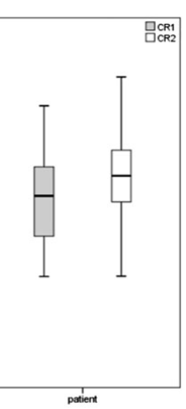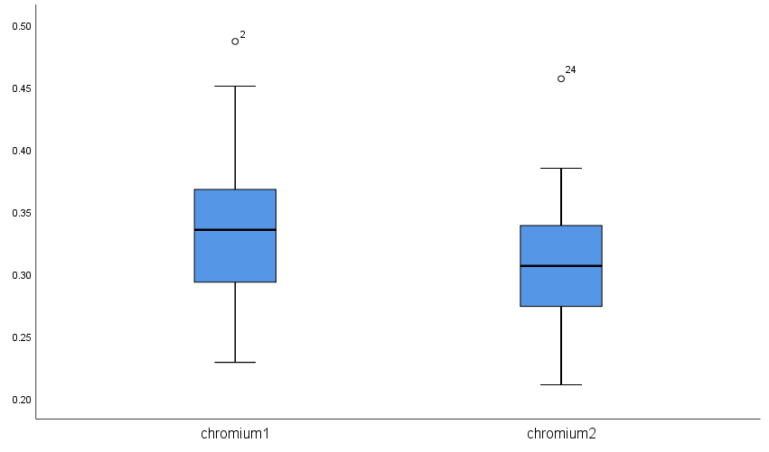

Appendix 1. On the left: Chromium levels of patients shown in Figure 1 of Jamshidi et al ¹; On the right: Chromium levels of patients summarized by this author from the raw data presented in Table 2 of Jamshidi et al ¹.

