Systematic assessment of salivary inflammatory markers and dental caries in children: an exploratory study

Børsting, T., Venkatraman, V., Fagerhaug, T.N., Skeie, M.S., Stafne, S.N., Feuerherm, A.J., Sen, A.

Supplementary Material

Supplementary Table S1. List of excluded inflammatory markers
Excluded markers were: ARTN, AXIN1, β-NGF, CCL11, CCL25, CD244, CD6, FGF21, FGF23, FGF5, GDNF, IFN gamma IL10RA, IL13, IL15Ra, IL17C, IL2, IL20, IL20RA, IL22RA1, IL24, IL2RB, IL33, IL4, IL5, MCP3, MCP4, NRTN, NT3, PDL1, SLAMF1, TNF, TNF-Beta, TSLP, and VEGFA
For full names of inflammatory markers see: https://www.olink.com/products/inflammation/biomarkers/

Supplementary Table S2. Descriptive statistics of salivary inflammatory markers
included in the statistical analyses
Inflammatory marker | Mean NPX | SD | Median NPX | Min | Max
Chemokine receptor
CD40 | 8.21 | 1.05 | 8.31 | 5.93 | 10.48
Chemokines
IL8 | 12.32 | 0.89 | 12.32 | 10.10 | 14.18
MCP1 | 8.08 | 0.92 | 8.07 | 5.60 | 11.23
CXCL11 | 4.54 | 1.74 | 4.10 | 1.34 | 9.13
CXCL9 | 7.71 | 1.24 | 7.62 | 4.55 | 12.16
CXCL1 | 9.37 | 1.87 | 9.49 | 5.14 | 13.15
CCL4 | 3.05 | 1.60 | 2.66 | 1.37 | 7.08
SCF | 2.08 | 0.81 | 2.24 | 1.08 | 5.50
CCL19 | 2.05 | 1.35 | 1.92 | 0.63 | 6.66
CXCL5 | 10.28 | 2.24 | 10.96 | 4.63 | 12.98
CCL23 | 1.07 | 0.48 | 0.90 | 0.90 | 4.58
CCL3 | 3.53 | 1.23 | 3.41 | 1.62 | 8.20
CXCL6 | 6.46 | 1.82 | 5.88 | 3.53 | 11.18
CXCL10 | 6.63 | 2.80 | 6.47 | 1.03 | 13.33
CCL28 | 6.02 | 1.31 | 5.99 | 2.57 | 8.87
MCP2 | 2.12 | 1.10 | 1.71 | 1.17 | 5.49
CX3CL1 | 5.21 | 1.36 | 5.47 | 1.63 | 8.07
CCL20 | 5.72 | 2.20 | 5.12 | 1.77 | 11.42
Cytokine receptors
OPG | 7.67 | 0.92 | 7.65 | 5.51 | 10.37
LIFR | 2.75 | 1.35 | 3.34 | 1.14 | 5.07
IL10RB | 3.07 | 0.81 | 3.21 | 1.29 | 4.86
IL18R1 | 6.07 | 1.27 | 6.18 | 3.54 | 9.34
TNFRSF9 | 2.82 | 1.07 | 2.71 | 1.25 | 6.12
Cytokines
CSF1 | 5.49 | 0.67 | 5.49 | 3.93 | 8.09
IL7 | 3.33 | 0.57 | 3.39 | 1.67 | 4.92
IL6 | 4.27 | 1.92 | 3.94 | 1.33 | 9.43
IL17A | 0.75 | 0.29 | 0.65 | 0.65 | 2.26
TRAIL | 8.74 | 0.62 | 8.66 | 7.31 | 10.48
IL1alpha | 8.17 | 2.77 | 9.38 | 3.11 | 12.16
IL18 | 8.42 | 1.62 | 8.65 | 4.98 | 11.60
TNFSF14 | 6.41 | 1.15 | 6.38 | 3.71 | 9.82
TRANCE | 1.94 | 0.87 | 1.56 | 1.32 | 5.28
IL12B | 1.29 | 1.05 | 1.09 | 0.32 | 6.16
IL10 | 1.34 | 0.61 | 1.08 | 0.84 | 3.68
Flt3L | 1.92 | 0.63 | 1.83 | 1.23 | 3.96
LIF | 1.70 | 0.59 | 1.45 | 1.28 | 5.07
TWEAK | 6.73 | 0.81 | 6.72 | 4.53 | 9.21
Enzymes
uPA | 8.31 | 1.21 | 8.20 | 6.00 | 12.11
MMP1 | 8.85 | 1.93 | 8.86 | 0.66 | 13.01
MMP10 | 4.27 | 1.36 | 4.17 | 1.13 | 10.37
CASP8 | 4.64 | 1.59 | 5.17 | 1.46 | 7.59
ST1A1 | 1.90 | 1.06 | 1.94 | 0.43 | 4.65
STAMPB | 3.11 | 0.90 | 3.06 | 1.37 | 6.41
ADA | 4.51 | 1.16 | 4.60 | 1.61 | 7.25
Growth factors
LAPTGFbeta1 | 3.73 | 0.94 | 3.65 | 1.63 | 6.40
TGFalpha | 4.24 | 0.88 | 4.20 | 2.24 | 7.04
HGF | 7.22 | 0.94 | 7.17 | 5.14 | 10.47
FGF19 | 0.94 | 0.58 | 0.76 | 0.47 | 3.08
Other
CDCP1 | 6.09 | 0.98 | 6.06 | 3.89 | 8.59
CST5 | 8.24 | 0.84 | 8.30 | 5.96 | 10.28
OSM | 6.08 | 1.35 | 6.22 | 2.65 | 9.75
CD5 | 3.26 | 1.31 | 3.22 | 1.00 | 6.45
EBP1 | 6.10 | 1.45 | 6.05 | 2.40 | 9.39
SIRT2 | 1.77 | 1.05 | 1.50 | 0.87 | 5.18
DNER | 9.59 | 0.64 | 9.84 | 8.02 | 10.50
ENRAGE | 7.01 | 0.87 | 7.10 | 4.02 | 9.11
For full names of inflammatory markers see: https://www.olink.com/products/inflammation/biomarkers/

Supplementary Figure S1. Heatmap of salivary inflammatory markers by dental caries status among healthy children aged 7-9. The NPX values of the 56 inflammatory markers included in the analysis were transformed into Z-scores to account for the different inflammation factor scales. Each cell of the heatmap has its respective Z-score, with a scale from the highest (7.4) to lowest (-4.2) concentration, highlighted as green to red, respectively. The top row represents the caries experience of the child participants (d₁₋₅mft/D₁₋₅MFT index score from 0 to 7, from the left towards the right). All the selected inflammatory markers are listed in the last column and were classified according to their corresponding biological group.
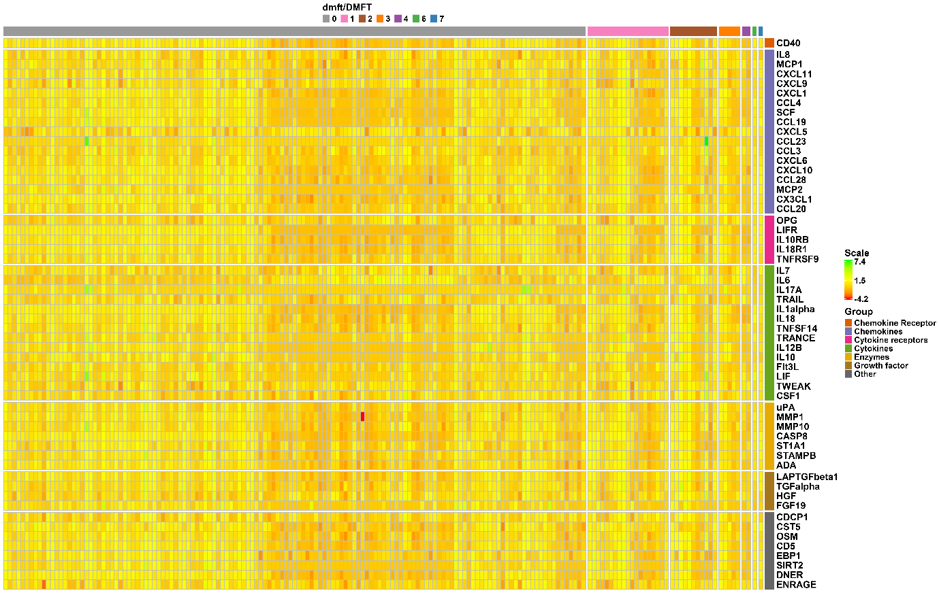

Supplementary Text S1. Calibration procedure and results

Calibration procedure
Prior to and during the dental examination period, two experienced examiners underwent calibration courses for dental caries, including theory and training. Three calibration exercises were performed using a five-graded caries diagnosis system. An experienced specialist in pediatric dentistry (MSS) constituted the gold standard. For Caries Test 1 and 3, inter-examiner reliability was measured, while intra-examiner reliability was measured for Caries Test 2. Caries Test 1 was based on the examination of eight children, of which the results from each examiner were compared to the gold standard. In Caries Test 3, eleven children underwent caries assessment and the decisions of the two examiners were compared. For Caries Test 2, each examiner assessed the same bitewing radiographs (n=20) at two time-points, to see how their first assessment compared with their second assessment.

Calibration results
The mean weighted Cohen’s kappa value was 0.95 for intra-examiner reliability. The inter-examiner reliability when compared to the gold standard was 0.63 and reached 0.90 for inter-examiner reliability between the two examiners.

