Supporting Information:
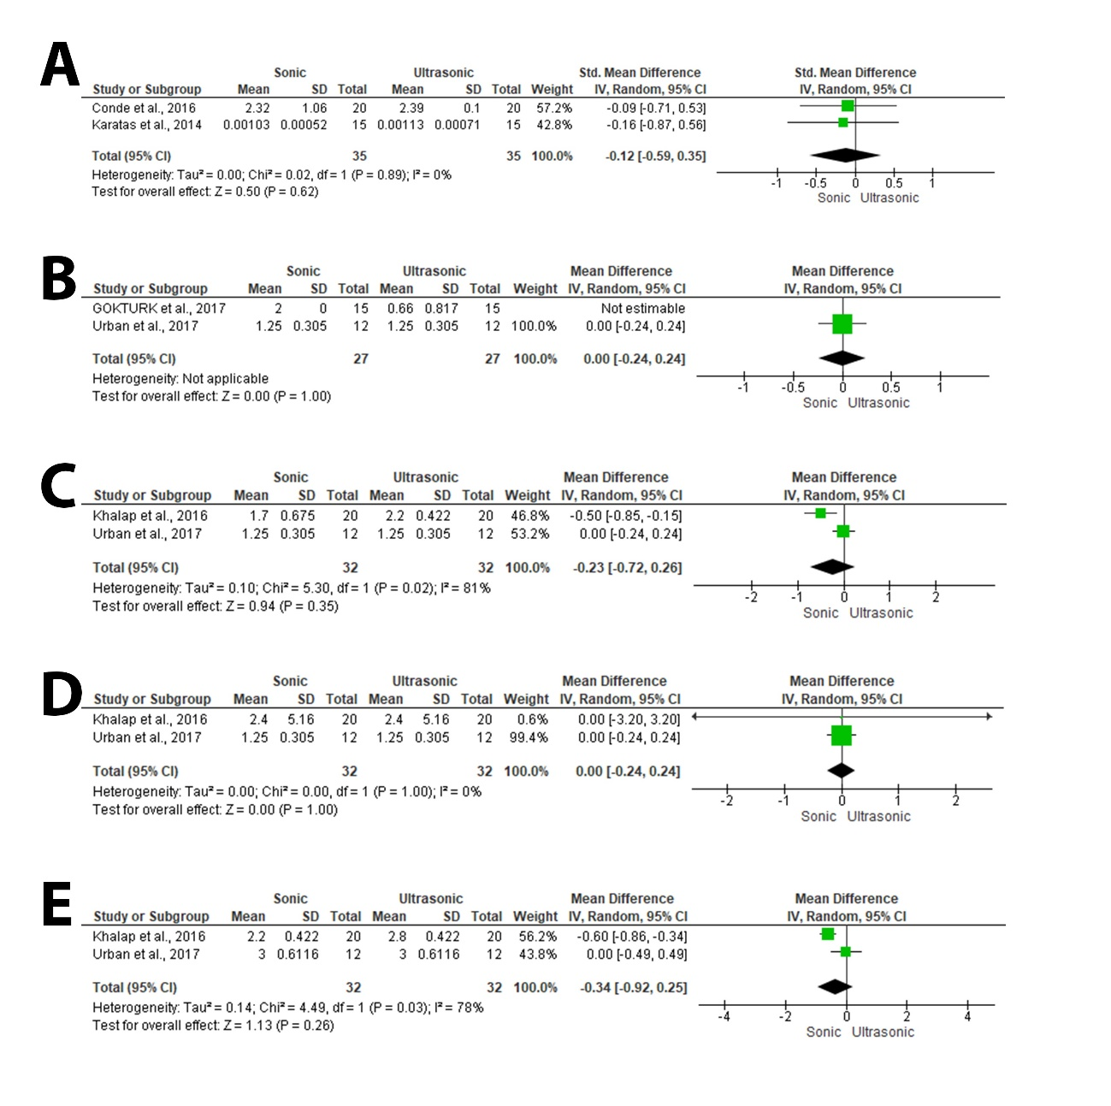
Supplementary Figure.1: (A) Standardized mean difference of the change in root weight. (B) Mean difference of the mean debris score at the coronal level, (C) middle level, (D) apical level. (E) Mean difference of mean smear layer score at the middle level.

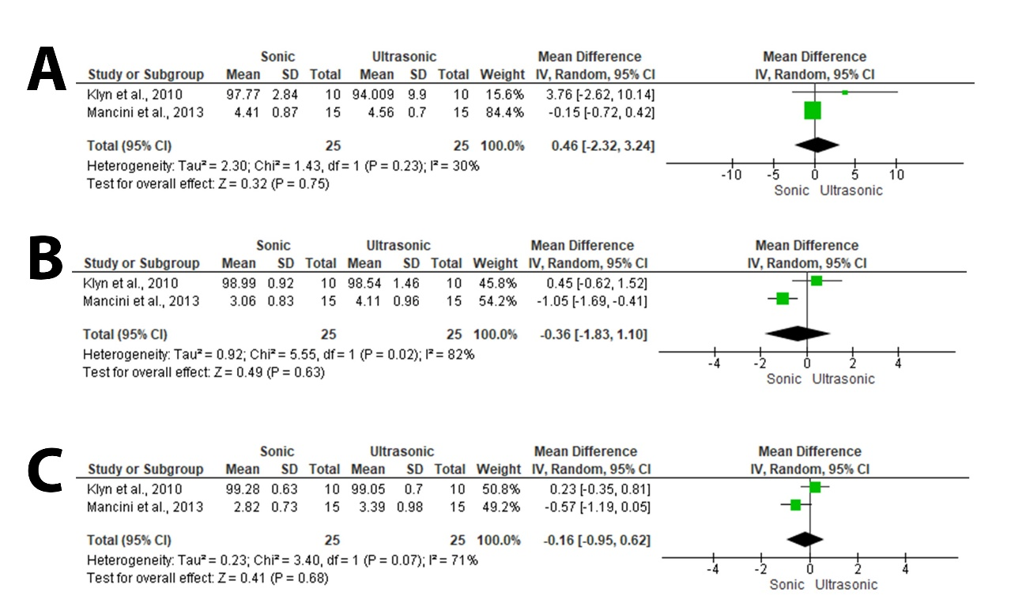
Supplementary Figure.2: (A) The percentage of canal cleanliness at 1mm between activation groups. (B) The percentage of canal cleanliness at 3mm between activation groups. (C) The percentage of canal cleanliness at 5mm between activation groups.

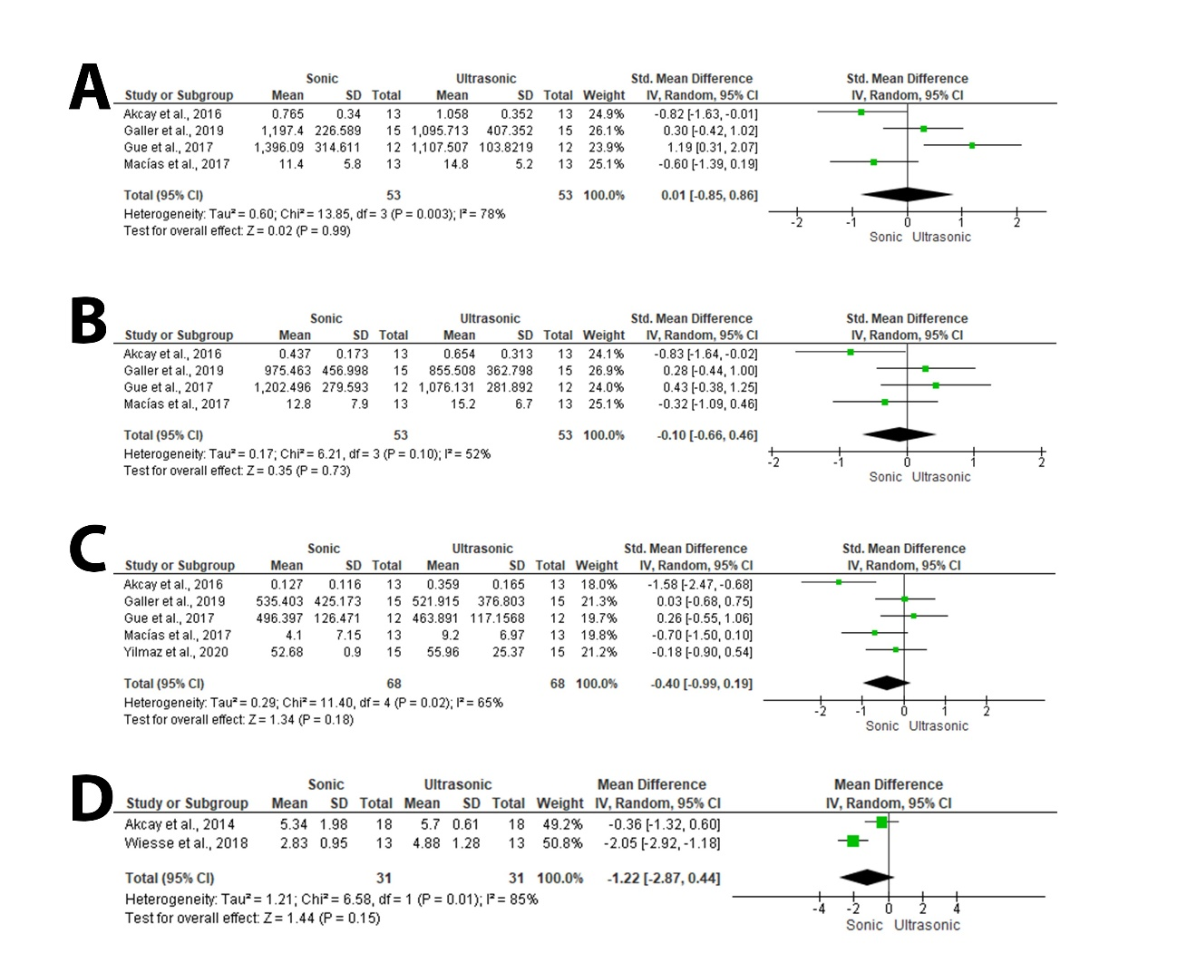
Supplementary Figure.3: (A) Meta-analysis of the standardized mean difference of irrigants penetration depth between groups at coronal level, (B) at middle level, (C) at apical level. (D) Meta-analysis of the mean difference of the push-out bond strength value at the coronal level.

