Supplementary Online Content

Table S1: Demographic and disease-related characteristics of the cancer sample, weighted (n=2,141)
 | n | %
Age, mean (SD), years | 58.6 (10.98)
< 40 | 120 | 6.0
41-69 | 1668 | 77.9
≥ 70 | 352 | 16.1
Sex
Male | 1082 | 50.5
Female | 1059 | 49.5
Tumor site
Breast | 437 | 20.4
Prostate | 359 | 16.8
Colorectal | 284 | 13.3
Lung | 188 | 8.8
Female genital organs | 177 | 8.3
Hematologic cancers | 162 | 7.5
Stomach/esophageal | 84 | 3.9
Kidney/urinary tract | 77 | 3.6
Head and neck | 65 | 3.0
Bladder | 50 | 2.3
Pancreas | 50 | 2.3
Malignant melanoma | 37 | 1.7
Other | 171 | 8.0
Disease stage
Curable/unclear | 1658 | 77.4
Incurable | 483 | 22.6
Time since current diagnosis, mean (SD), months | 13.0 (24.2)
< 12 months | 1338 | 73.5
12-24 months | 226 | 12.4
> 24 months | 256 | 14.0
Treatment setting
Inpatient | 936 | 43.7
Outpatient | 648 | 30.2
Rehabilitation, inpatient | 558 | 26.0

General population sample, weighted (n=4,483): Age M=62.4 (SD=12.9); 46.4% female

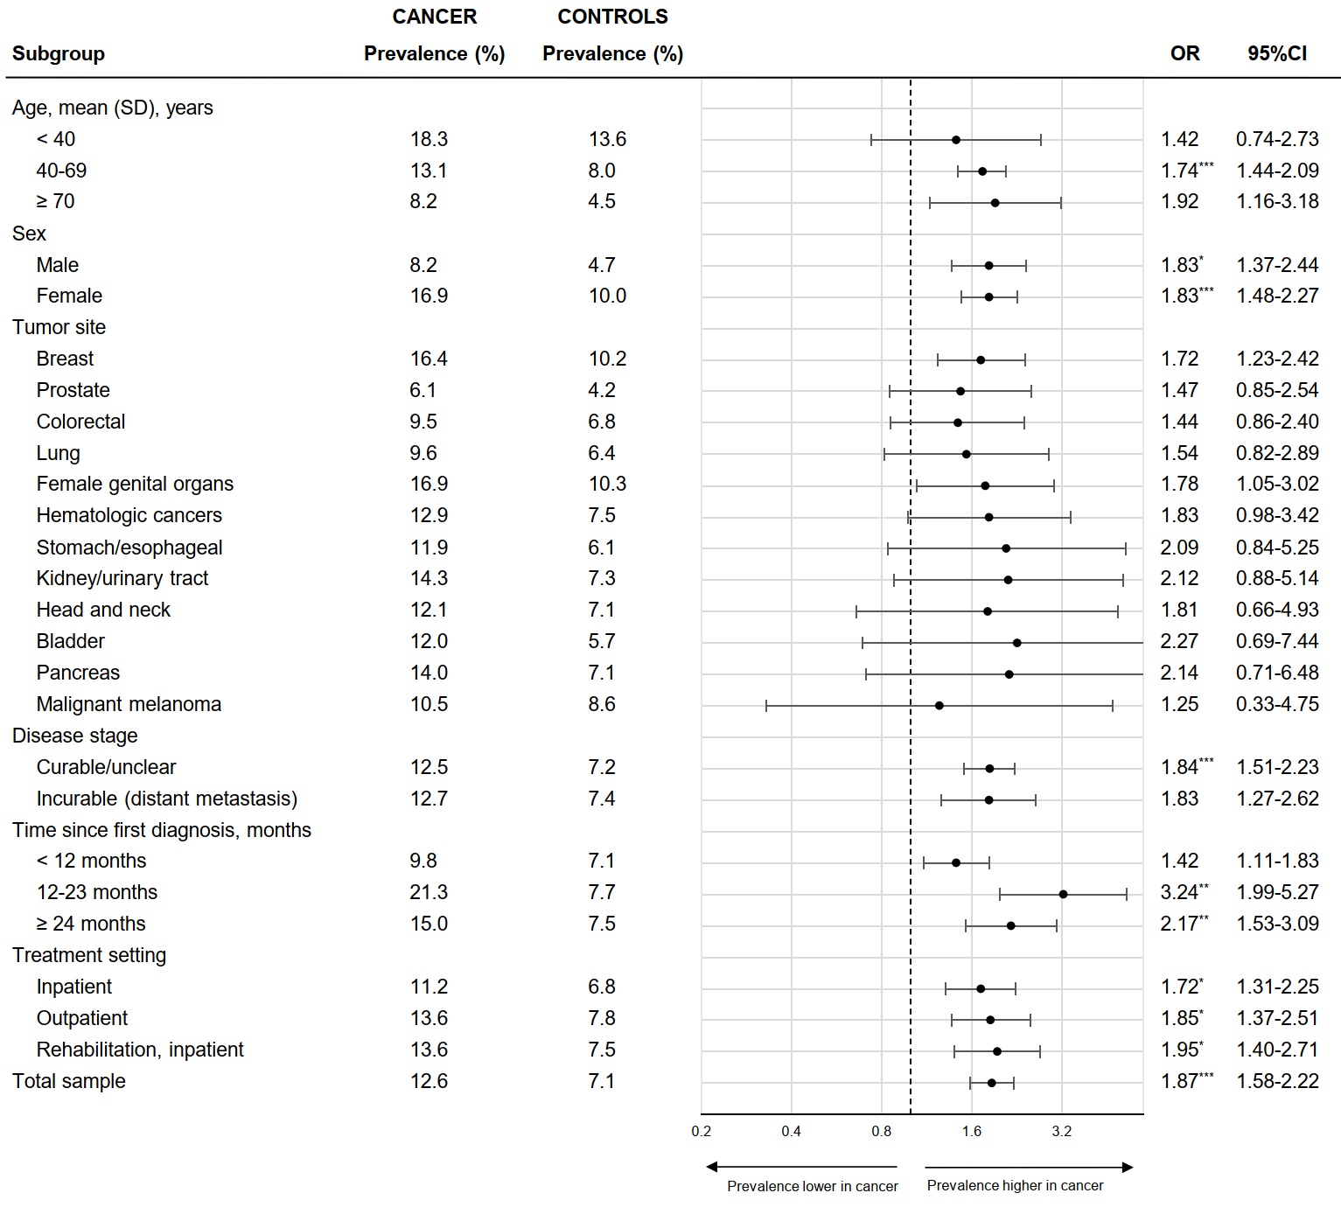
Figure S1: Prevalence rates for any mood disorder in patients with cancer vs. age and gender matched controls by disease-related and demographic subgroups. Prevalence rates in controls were weighted based on propensity score-matching. Matching accounted for age, gender, and age×gender interaction. 12-month-prevalence rates were assessed. Mood disorder diagnoses included mania and bipolar I disorder, hypomania and bipolar II disorder, major depressive episode, and dysthymia. *p<.05, **p<.01, ***p<.001

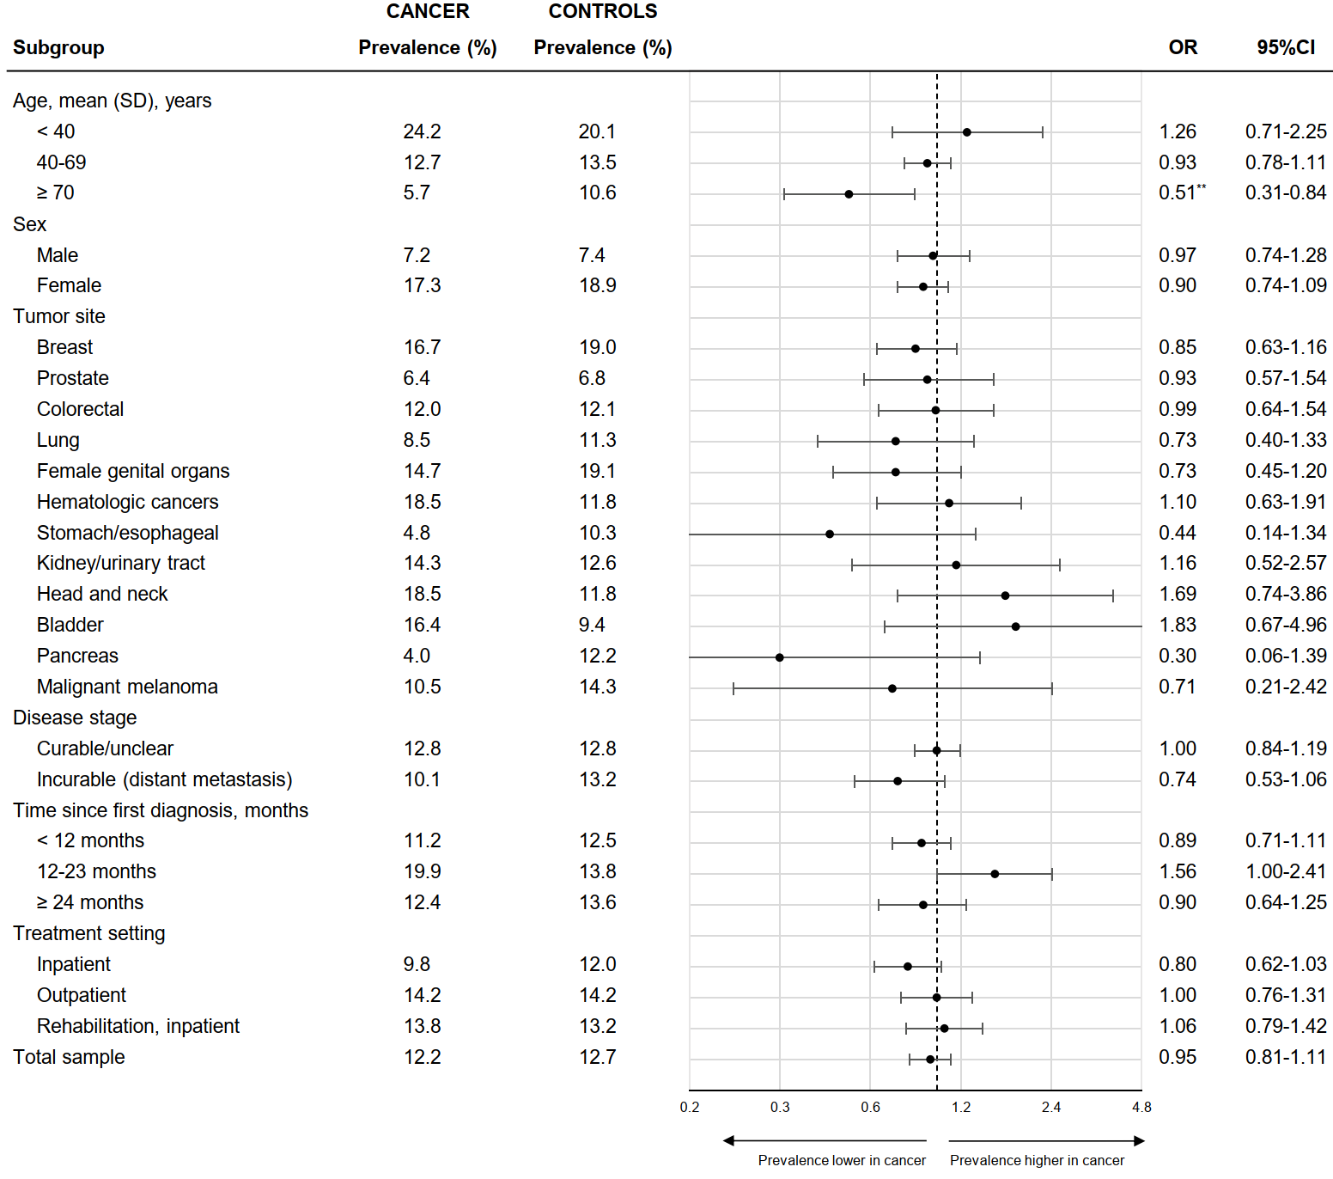
Figure S2: Prevalence rates for any anxiety disorder in patients with cancer vs. age and gender matched controls by disease-related and demographic subgroups. Prevalence rates in controls were weighted based on propensity score-matching. Matching accounted for age, gender, and age×gender interaction. 12-month-prevalence rates were assessed. Anxiety disorder diagnoses included agoraphobia with panic disorder, panic disorder without agoraphobia, generalized anxiety disorder, social phobia, any specific phobia, and posttraumatic stress disorder. *p<.05, **p<.01, ***p<.001

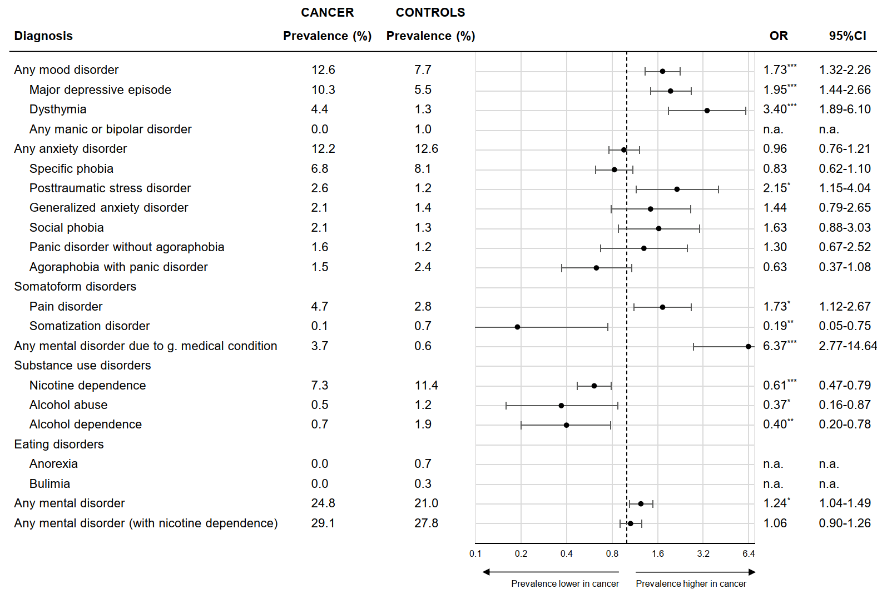
Figure S3: Comparison of mental disorder prevalence rates in patients with cancer (n=2,141) vs. matched healthy controls (n=990, subgroup of general population without diagnosis of a chronic health condition including musculoskeletal, cardiovascular, gastrointestinal, neurologic, allergic, thyroid, or lower respiratory tract diseases, cardiometabolic conditions, and cancer). Prevalence rates in controls were weighted based on propensity score-matching. Matching accounted for age, gender, and age×gender interaction. 12-month-prevalence rates were assessed.

