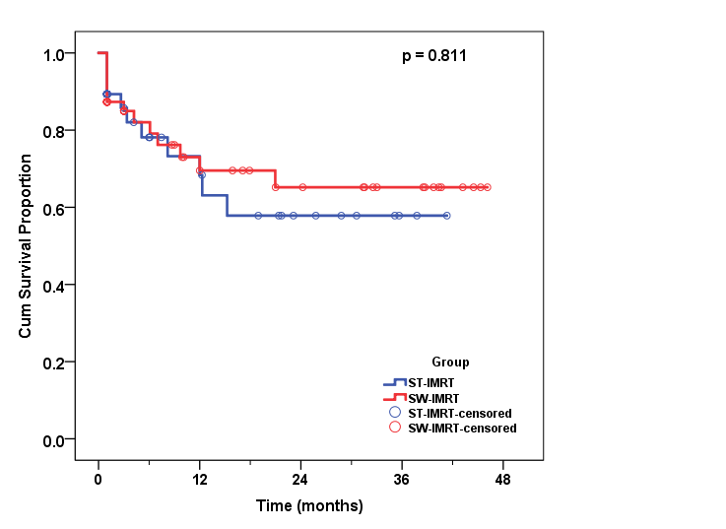
Supplementary Figure 2a: Overall survival of the SW-IMRT and ST-IMRT groups

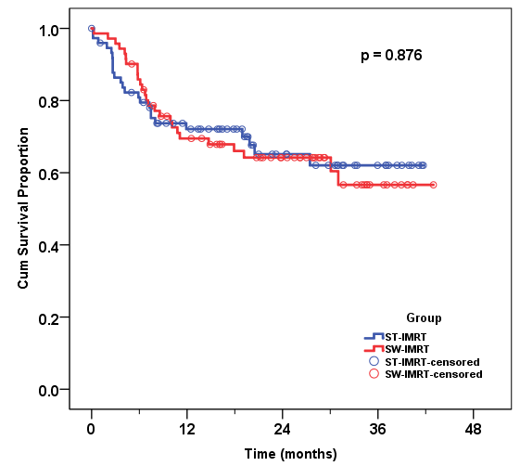
Supplementary Figure 2b: Disease-free survival of the SW-IMRT and ST-IMRT groups

Supplementary Table 1: Swallowing organs at risk dose constraints used in acceptance
Critical Organs | Mean dose (Gy) | V30 | V50
Superior and middle constrictor muscles [18] | 55
Inferior constrictor muscle [27] | 54
Cricopharyngeus muscle | 54
Esophageal inlet muscle [26] | 60
Cervical esophagus | 54
Larynx [18] | 60 |  | 50%
Base of tongue | 40
Parotids | 26 | 50%

Supplementary Table 2: Possible patients’, disease, and treatment factors that may affect the development of dysphagia at six months
 |  | Dysphagia ≥ G1  n=62 | No Dysphagia  n=50 | p-value
Age (years) |  | 49.6±13.2 | 51.8±12.7 | 0.381
Sex | Male | 34 (44.2%) | 43 (55.8%) | 0.001
 | Female | 27 (77.1%) | 8 (22.9%)
Tumor Location | Nasopharynx | 24 (61.5%) | 15 (38.5%) | 0.157
 | Oropharynx | 4 (44.4%) | 5 (55.6%)
 | Hypopharynx | 5 (62.5%) | 3 (37.5%)
 | Larynx | 13 (38.2%) | 21 (61.8%)
 | Oral cavity | 15 (68.2%) | 7 (31.8%)
Performance Status | 0 | 31 (54.4%) | 26 (45.6%) | 0.986
 | 1 | 30 (54.5%) | 25 (45.5%)
Disease Stage | 1-2 | 7 (53.8%) | 6 (46.2%) | 0.962
 | 3-4 | 54 (54.5%) | 45 (45.5%)
Treatment Modality | ST-IMRT | 41 (75.9%) | 13 (24.1%) | < 0.001
 | SW-IMRT | 20 (34.5%) | 38 (65.5%)
Type of RTH | Radical | 46 (50.5%) | 45 (49.5%) | 0.083
 | Adjuvant | 15 (71.4%) | 6 (28.6%)
Concomitant CTH | Yes | 46 (53.5%) | 40 (46.5%)
 | No | 14 (56.0%) | 11 (44.0%) | 0.824
as mean±SD, or number(%)
RTH: Radiotherapy, CTH: Chemotherapy

Supplementary Table 3: Multivariate analysis using logistic regression model for factors associated with development of dysphagia after 6 months
 | B | p value | Odds Ratio | 95% C.I. for OR
 |  |  |  | Lower | Upper
Treatment Modality | -1.980 | < 0.001 | 0.14 | 0.06 | 0.35
Sex | 1.736 | 0.001 | 5.68 | 2.02 | 15.97
Type of RTH | 1.115 | 0.066 | 3.05 | 0.93 | 10.02
B: regression coefficient

