Supplement A
Table A1: Available combinations of averaging techniques, secondary particles and characteristic implementation parameters to score linear energy transfer (LET) in the environments presented in this study. Further scoring combinations may be available through user extensions, further developments, additional base data files and post processing.
 |  | LET definition |  |  |  |  |  |  |  |  | Characteristic implementation parameters
 |  | Averaging |  |  | Ions |  |  |  |  |  | Delta electrons |  |  | Scoring in
 |  | dose | track |  | primary protons only | all protons | all ions  with Z=1 | all ions  with Z≤2 | all particles |  | unrestricted | restricted |  | water | local material
RayStation Research |  | y | y |  | y | y | n | y | n |  | y | n |  | n | y
FRoG |  | y | n |  | n | n | y | n | n |  | y | n |  | y | n
TOPAS |  | y | y |  | y | y | n | n | n |  | y | y |  | y | y
GATE |  | y | y |  | y | y | y | y | y |  | y | y |  | y | y
PlanIt |  | y | n |  | y | n | n | n | n |  | y | n |  | y | n
4SeePlan |  | y | n |  | n | y | n | n | n |  | y | n |  | n | y
TRiP98 |  | y | y |  | n | n | n | n | y |  | y | n |  | n | y
y: yes/available, n: no/ not available; Z: atomic charge; RayStation, RaySearch Laboratories AB, Stockholm, Sweden; Eclipse, Varian Medical Systems, Palo Alto, CA, USA; FRoG: Fast dose Recalculation on GPU (Graphics Processing Unit); TOPAS: TOol for PArticle Simulation; GEANT4: GEometry ANd Tracking; GATE: GEANT4 Application for Emission Tomography; TRiP: TReatment plannIng for Particles.

Table A2: Relative standard deviation of volume-histogram parameters (standard deviation of a volume-histogram parameter reported by the centres divided by the according mean value) for dose and linear energy transfer (LET) for each region of the three field arrangements. Levene’s test was used to compare the variations of centre-specific volume parameters for relative biological effectiveness (RBE) weighted dose and LET. Significant p-values are marked in bold. For definition of harmonized LET, please see section on Simulation of LET in the main manuscript.
 |  |  |  | Relative standard deviation / % |  |  |  |  |  | p-values for Levene’s test
 | Region | Volume-histogram  parameter |  | - D_{1.1} | - D_{RBE},  not harmonized | - D_{RBE},  harmonized | - LET,  not harmonized | - LET,  harmonized |  | (A) vs. (B) | (A) vs. (C) | (B) vs. (C) | (D) vs. (E)
Single-field SOBP |  | near-min |  | 2.2 | 3.1 | 3.4 | 57.1 | 4.3 |  | 0.661 | 0.467 | 0.779 | 0.039
Single-field SOBP | prox | mean |  | 1.9 | 2.8 | 2.5 | 24.1 | 4.4 |  | 0.507 | 0.542 | 0.919 | 0.076
Single-field SOBP |  | near-max |  | 1.7 | 2.9 | 2.7 | 23.7 | 7.1 |  | 0.226 | 0.186 | 0.937 | 0.125
Single-field SOBP |  | near-min |  | 1.7 | 3.8 | 2.8 | 25.2 | 7.5 |  | 0.134 | 0.282 | 0.537 | 0.107
Single-field SOBP | CTV | mean |  | 0.3 | 3.4 | 0.8 | 21.7 | 4.4 |  | 0.063 | 0.298 | 0.107 | 0.121
Single-field SOBP |  | near-max |  | 1.3 | 5.1 | 3.2 | 20.5 | 10.0 |  | 0.137 | 0.357 | 0.542 | 0.294
Single-field SOBP | distal | mean |  | 18.8 | 19.3 | 16.1 | 24.4 | 13.9 |  | 0.718 | 0.830 | 0.502 | 0.337
Single-field SOBP |  | near-max |  | 2.4 | 5.9 | 3.4 | 26.5 | 17.5 |  | 0.371 | 0.254 | 0.667 | 0.533
Perpendicular fields |  | near-min |  | 33.5 | 32.9 | 32.2 | 26.1 | 4.6 |  | 0.963 | 0.950 | 0.910 | 0.062
Perpendicular fields | prox | mean |  | 9.9 | 11.3 | 9.8 | 27.7 | 6.8 |  | 0.623 | 0.988 | 0.608 | 0.039
Perpendicular fields |  | near-max |  | 2.4 | 6.0 | 3.3 | 27.3 | 9.6 |  | 0.035 | 0.447 | 0.110 | 0.198
Perpendicular fields |  | near-min |  | 2.7 | 6.1 | 2.4 | 24.8 | 5.6 |  | 0.223 | 0.951 | 0.194 | 0.093
Perpendicular fields | CTV | mean |  | 0.4 | 5.9 | 1.1 | 22.9 | 5.7 |  | 0.047 | 0.236 | 0.073 | 0.136
Perpendicular fields |  | near-max |  | 1.1 | 6.7 | 2.6 | 21.3 | 10.7 |  | 0.042 | 0.193 | 0.155 | 0.323
Perpendicular fields | distal | mean |  | 10.5 | 11.8 | 9.3 | 27.5 | 5.9 |  | 0.795 | 0.857 | 0.658 | 0.206
Perpendicular fields |  | near-max |  | 2.1 | 6.6 | 2.0 | 26.2 | 14.2 |  | 0.057 | 0.897 | 0.051 | 0.201
Opposing fields |  | near-min |  | 11.0 | 21.3 | 15.3 | 52.1 | 30.3 |  | 0.267 | 0.483 | 0.556 | 0.237
Opposing fields | prox | mean |  | 10.7 | 12.0 | 10.5 | 48.3 | 7.1 |  | 0.675 | 0.997 | 0.667 | 0.097
Opposing fields |  | near-max |  | 2.7 | 8.0 | 1.3 | 52.4 | 7.4 |  | 0.158 | 0.343 | 0.075 | 0.119
Opposing fields |  | near-min |  | 2.5 | 7.0 | 1.7 | 25.5 | 5.1 |  | 0.147 | 0.136 | 0.062 | 0.126
Opposing fields | CTV | mean |  | 0.6 | 7.1 | 1.6 | 27.3 | 7.7 |  | 0.045 | 0.197 | 0.088 | 0.198
Opposing fields |  | near-max |  | 1.1 | 8.1 | 3.1 | 32.1 | 14.0 |  | 0.076 | 0.220 | 0.220 | 0.332
CTV: Clinical Target Volume; D_{1.1}: constant (1.1) RBE-weighted dose; D_{RBE}: variable RBE-weighted dose; SOBP: Spread-Out Bragg Peak

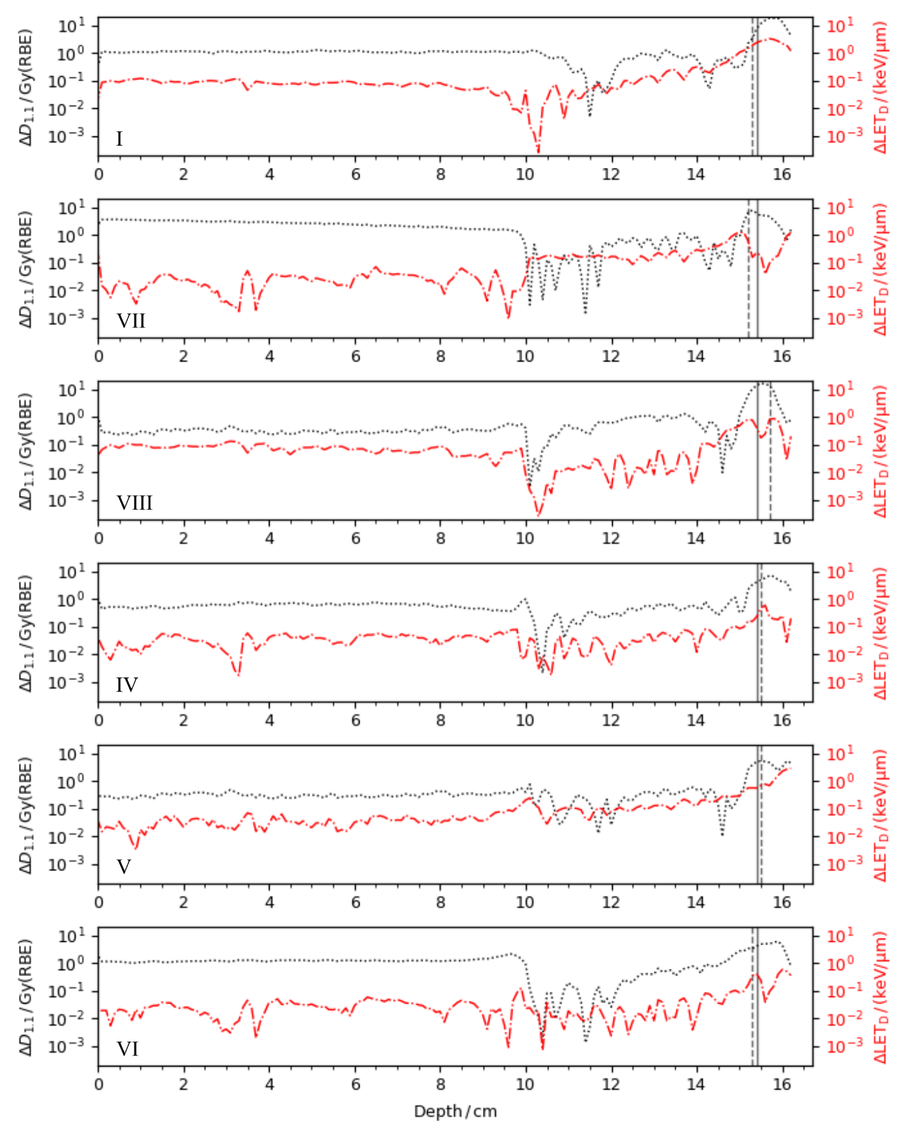
Figure A1: Absolute differences between centre-specific line profiles at beam central axis for the single-field spread-out Bragg peak and median of profiles from all centres: harmonized linear energy transfer (LET_{D}, red dashed-dotted) and biologically equivalent dose assuming a relative biological effectiveness of 1.1 (D_{1.1}, black dotted). Centre-specific and median proton beam ranges (distal depth at 80% of the maximum dose) are shown as dashed and solid vertical line, respectively. Roman numerals correspond to characteristic implementation parameters for LET calculation according to Table 2 in the main manuscript. For definition of harmonized LET, please see section on Simulation of LET 2.2 in the main manuscript.

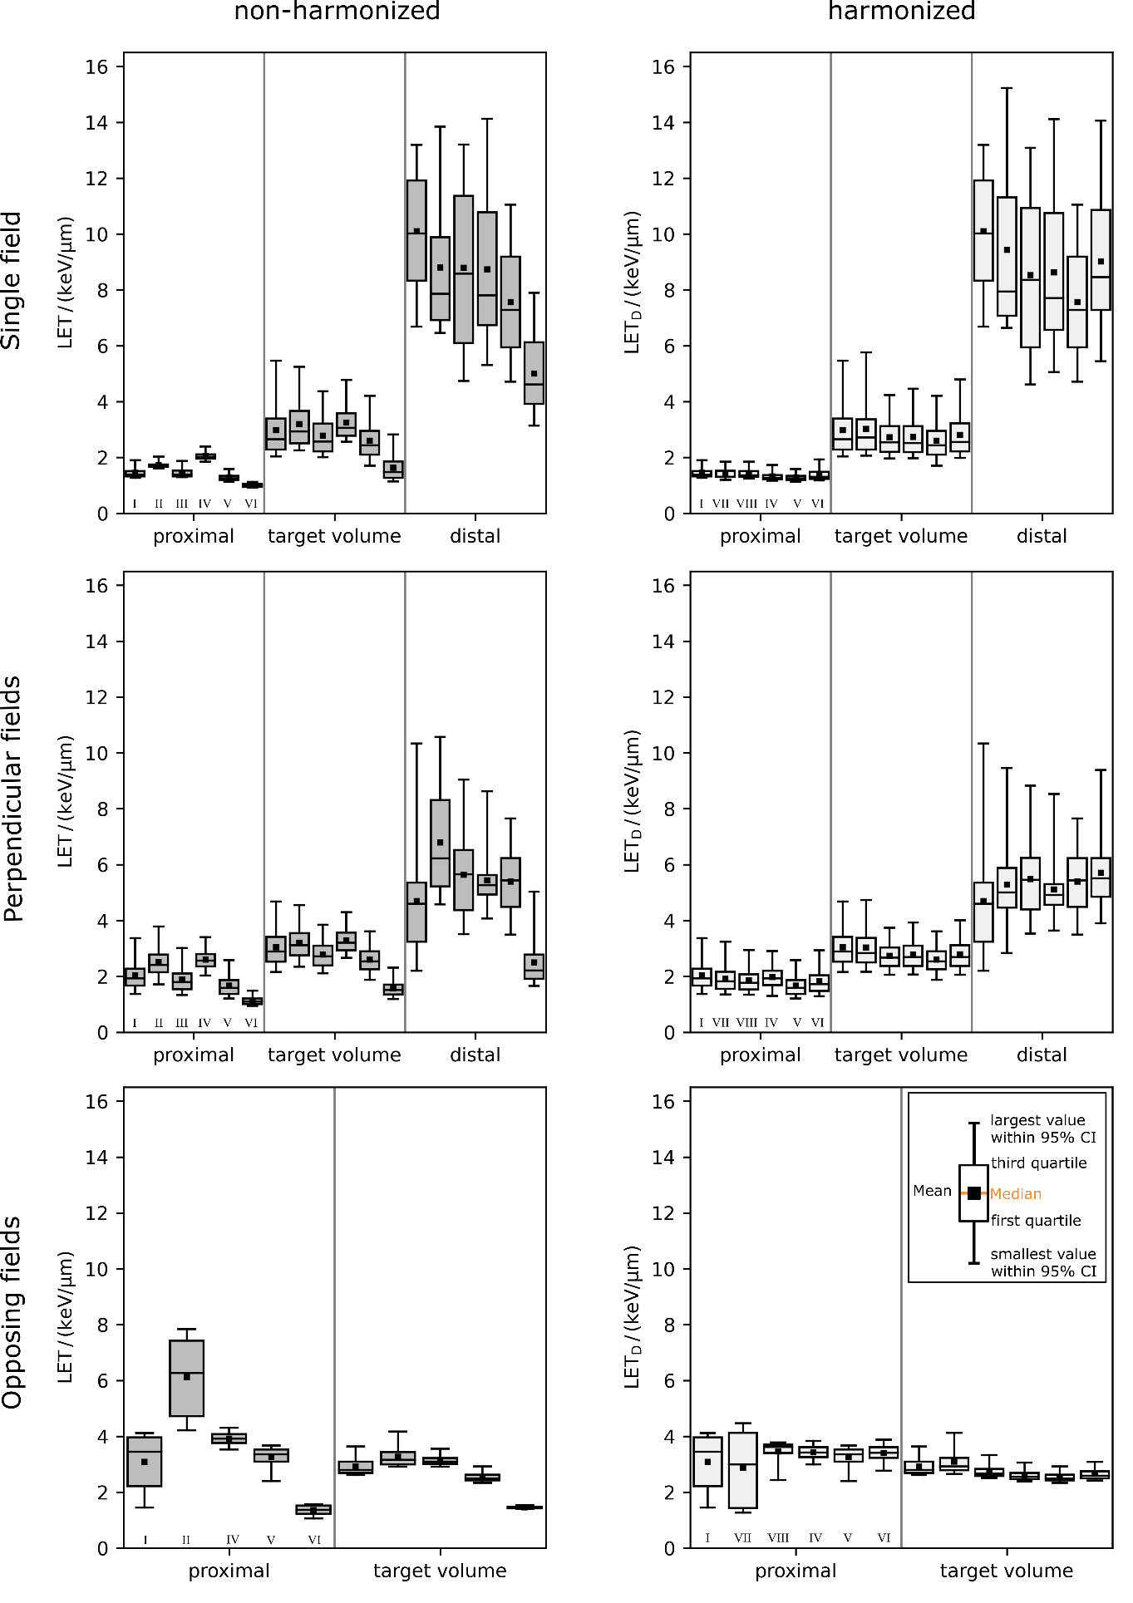
Figure A2: Linear energy transfer (LET) distributions in the regions proximal, within and distal to the target volume of all institutions and for all three beam arrangements. Left column: non-harmonized LET distributions (grey). Right column: harmonized LET, i.e. dose-averaged LET (LET_{D}) for all protons (light grey). One institution did not provide non-harmonized LET distributions for the opposing field arrangement. Note that two of six centres changed their simulation environment during the study. Roman numerals correspond to characteristic implementation parameters for LET calculation according to Table 2 in the main manuscript. For definition of harmonized LET, please see section on Simulation of LET in the main manuscript. CI: confidence interval.

