Appendix

Auxiliary structures
Manual treatment plan creation involved the use of the following auxiliary structures: four structures limiting the dose to the non-overlapping parts of target volumes (divided into an overlapping caudal and a non-overlapping cranial structure for PTV50), three structures representing the parts of the OARs more than 3 mm (rectum) or 5 mm (bladder and bowel bag) from PTV50, and three ring structures limiting dose to normal tissue (in addition to automatic Normal Tissue Objective (NTO) [1]).
In the RP models, only three of the auxiliary structures were utilized; zPTV_67.5, zPTV_60 and zPTV_50, cropped with a margin of 3 mm, 3 mm and 10 mm, respectively, from the higher dose levels. RP generated line objectives (preferring OAR) limited dose to OARs, while the dose outside the PTVs in general was limited using NTO (Priority: 100, Dist.: 0.4 cm, Range: 102-50%, Fall-off: 0.15).

Goodness of fit
R² measures the fit of the training plan data over the regression line, scaling from 0.0 to 1.0, where a larger value indicates a better model fit. χ² is measured from the residuals, i.e. the difference between the original data and the estimated data, where the quality of the regression model is more likely to be good the closer the value is to 1.0.
Table A 1: Goodness of fit statistics for both RP models.
 | RPm_v1 |  | RPm_v2
 | R² | χ² | R² | χ²
Bladder | 0.57 | 1.05 | 0.93 | 1.03
Rectum | 0.45 | 1.05 | 0.84 | 1.09
Bowel bag | 0.94 | 1.07 | 0.98 | 1.00

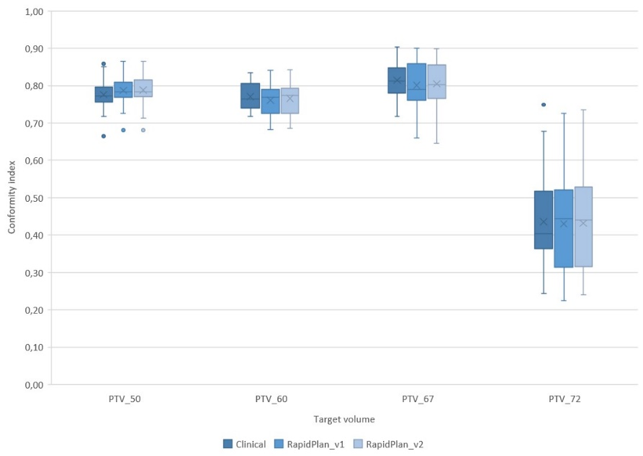
Figure A1: Conformity indexes with respect to 95% of the prescribed dose. Clinical (dark blue) represents the original clinical treatment plans manually created for the patients in the validation group. The whiskers span from minimum to maximum of the data set. Mean value is presented with an x and median with a line, enclosed in the box limited by the lower quartile (25th percentile) and upper quartile (75th percentile), where outliers are represented as dots. The upper outliers (PTV_50 and PTV_72.5) are from clinical plans where extra help structures have been utilized to specifically conform the dose. The lower outliers (PTV_50) are all from the same patient that had a lateral bone metastasis included in the PTV_50.

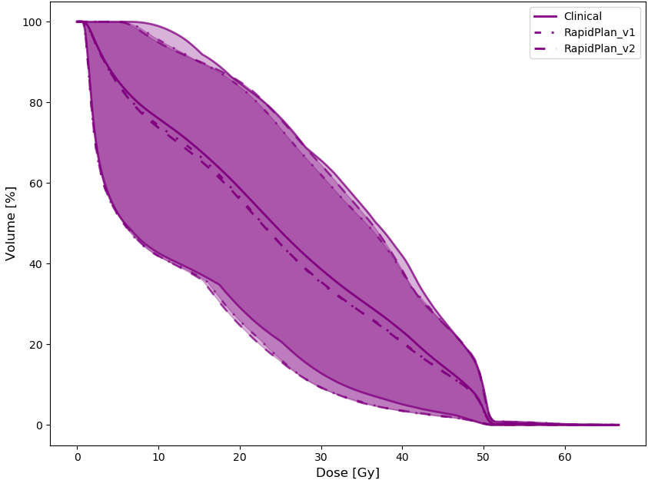
Figure A2: Population average plan DVH for bowel bag with 95% CI. Solid lines are used for CP, dashed dotted lines for RP_v1 and dashed lines for RP_v2.

References
[1] Varian Medical Systems. Eclipse Photon and Electron Algorithms Reference Guide. 2017;Eclipse, version 15.5:187.

