Supplementary data 1: Comparison of the characteristics of the two groups of patients
Characteristics | Nb | p
Median pre-surgical volume (cm³, IQR) | 255 (136 – 525) | 0.007
Tomotherapy | 540 (211 – 1187)
Proton + tomotherapy | 201 (74 – 367)
Median post-surgical volume (cm³, IQR) | 241 (46 - 643) | 0.38
Tomotherapy (NA=8) | 332 (151-738)
Proton + tomotherapy (NA=23) | 43 (18-360)
Median HR – CTV (cm³, IQR) | 411 (207 – 717) | < 0.001
Tomotherapy | 846 (530 – 988)
Proton + tomotherapy | 329 (184 – 431)
Median HR – PTV (cm³, IQR) | 644 (402 – 1163) | 0.001
Tomotherapy | 1239 (757 – 1579)
Proton + tomotherapy | 486 (387 – 713)

Supplementary data 2: Cumulative incidence of locoregional relapse and death for all groups
Solid line: locoregional relapse, broken line: death.

Supplementary data 3: Overall survival
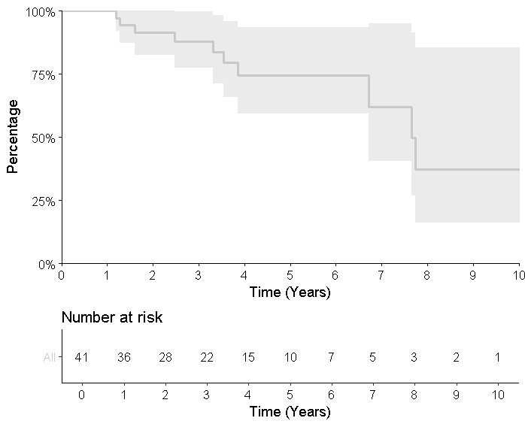
Solid line: overall survival. Grey area: confidence interval

Supplementary data 4: Local relapse risk: univariate analysis

 | n | SHR | IC95%(SHR) | p-value
Histological subtypes
Myxoid | 12 | 1 |  | 0.55
No myxoid | 29 | 1.64 | [0.32 – 8.4]
Initial (pre-surgical) tumour volume* (cc/100)
Initial (pre-surgical) tumour volume* (cc/100) |  | 0.98 | [0.88 - 1.09] | 0.75
Post-surgical tumour volume* (cc/100)
Post-surgical tumour volume* (cc/100) |  | 1.48 | [1.19 - 1.85] | p <0.001
Volume* of the HR-PTV (cc/100)
Volume* of the HR-PTV (cc/100) |  | 1.05 | [0.95 - 1.16] | 0.31
Volume* of the HR-CTV (cc/100)
Volume* of the HR-CTV (cc/100) |  | 1.09 | [1.02 - 1.17] | 0.016
Technique
Tomotherapy | 13 | 1 |  | 0.66
Proton + tomotherapy | 28 | 0.73 | [0.18 - 2.96]

*SHR should be seen for an increase of 100 units (100c)

Supplementary data 5: Comparison of the mean dose in main organs at risk between photon therapy alone et proton – photon combination

 | Technique | Mean (Gy) | p-value
Rectum | Photon | 45.6 (28 – 63) | 0.008
Rectum | Photon + Proton | 27.6 (0 – 58) | 0.008
Anal canal | Photon | 26 (1 – 63) | 0.17
Anal canal | Photon + Proton | 15.5 (0 – 65) | 0.17
Bladder | Photon | 24.8 (9 – 45) | < 0.001
Bladder | Photon + Proton | 4.7 (0.4 – 32) | < 0.001
Skin | Photon | 44.6 (15 – 62) | < 0.001
Skin | Photon + Proton | 17.5 (0 – 42) | < 0.001
Cauda Equina | Photon | 38 (10 – 62) | 0.33
Cauda Equina | Photon + Proton | 31.3 (2 – 71) | 0.33

Supplementary data 6: For the 13 patients in this Tomotherapy group: Comparative Tomotherapy (real) vs Proton – Tomotherapy (simulated) plans
 | Technique | Mean (Gy) | p-value
Rectum | Photon (real) | 45.6 (28 – 63) | <0.001
Rectum | Photon + Proton (simulated) | 25.2 (8 – 43) | <0.001
Anal canal | Photon (real) | 26 (1 – 63) | 0.006
Anal canal | Photon + Proton (simulated) | 14.7 (0.1-51) | 0.006
Bladder | Photon (real) | 24.8 (9 – 45) | <0.001
Bladder | Photon + Proton (simulated) | 3.98 (0.02-8) | <0.001
Skin | Photon (real) | 44.6 (15 – 62) | 0.21
Skin | Photon + Proton (simulated) | 39.4 (8.0-59.0) | 0.21
Cauda Equina | Photon (real) | 38 (10 – 62) | 0.036
Cauda Equina | Photon + Proton (simulated) | 34.3 (1.0-60.0) | 0.036

The highlighted lines are the doses that the 13 patients in the tomotherapy group would have received if they had been treated with the Proton -Tomo combination. Student tests for paired values were used for comparison.

Supplementary data 7: Comparison of the simulated Tomo - Proton plans for the 13 patients in the tomotherapy group and the real Tomo – Proton plans for the 26 patients in the Proton - Tomo group

 | Group | Technique | Mean (Gy) | p-value
Rectum | Tomotherapy alone | Photon + Proton (simulated) | 25.2 (8 – 43) | 0.64
Rectum | Proton - Tomo | Photon + Proton (real) | 27.6 (0 – 58) | 0.64
Anal canal | Tomotherapy alone | Photon + Proton (simulated) | 14.7 (0.1-51) | 0.92
Anal canal | Proton - Tomo | Photon + Proton (real) | 15.5 (0 – 65) | 0.92
Bladder | Tomotherapy alone | Photon + Proton (simulated) | 3.98 (0.02-8) | 0.66
Bladder | Proton - Tomo | Photon + Proton (real) | 4.7 (0.4 – 32) | 0.66
Skin | Tomotherapy alone | Photon + Proton (simulated) | 39.4 (8.0-59.0) | 0.005
Skin | Proton - Tomo | Photon + Proton (real) | 17.5 (0 – 42) | 0.005
Cauda Equina | Tomotherapy alone | Photon + Proton (simulated) | 34.3 (1.0-60.0) | 0.74
Cauda Equina | Proton - Tomo | Photon + Proton (real) | 31.3 (2 – 71) | 0.74

The highlighted lines are the doses that the 13 patients in the Tomotherapy group would have received if they had been treated with the Proton – Tomo combination.
Supplementary data 8: Literature review of local control, overall survival, and late toxicities rates for sacral chordoma patients after radiation therapy (majority of Proton – IMRT)

 | number of patients | surgery (%) | sacral chordoma (%) | photon alone (%) | proton-photon (%) | 2-year LC | 5-year LC | 2-year OS | 5-year OS | late rectitis | late cystitis | late cauda eq sd | late pain
Park et al., 2006 [11] | 27 | 78 | 100 | 0 | 100 | na | 71.7% | na | 82.5% | na | 18% | 11% | 29%
Zabel-du Bois et al., 2010 [25] | 34 | 70 | 100 | 100 (IMRT) | 0 | 55% | 27% | 91% | 70% | na | na | Na | 48%
Chen et al., 2013 [20] | 24 | 0 | 79 | 0 | 100 | na | 79.8% | na | 71.8% | 20% | na | 21% | na
Kabolizadeh et al., 2017 [13] | 40 | 0 | 67.5 | 0 | 100 | na | 85.4% | na | 81.9% | 10% | na | 15% | na
Present study | 41 | 73 | 100 | 32 | 68 | 88.6% | 71% | 91.4 | 74.5% | 22% | 19% | 44% | 62%

