Supplementary Table S1. 3D gamma analysis results between the MCsquare simulation and the RayStation TPS calculation.
Patient Number | 3%/3mm | 2%/2mm | Patient Number | 3%/3mm | 2%/2mm
1 | 99.8% | 97.6% | 11 | 99.9% | 97.6%
2 | 99.8% | 98.3% | 12 | 99.9% | 98.1%
3 | 99.9% | 98.3% | 13 | 99.9% | 98.8%
4 | 99.9% | 98.5% | 14 | 99.9% | 97.4%
5 | 99.8% | 96.8% | 15 | 99.9% | 97.5%
6 | 99.8% | 97.6% | 16 | 99.9% | 97.9%
7 | 99.9% | 97.4% | 17 | 100.0% | 98.4%
8 | 98.9% | 93.3% | 18 | 99.8% | 97.4%
9 | 99.6% | 97.4% | 19 | 99.5% | 96.5%
10 | 99.8% | 98.1% | 20 | 98.5% | 95.3%

Supplementary Table S2. Comparison of the current study with the previously published studies.
OAR dose metrics [reference] | Dose(LETd) / Dose(RBE=1.1) |  | No. of patients in the previous studies | equations used for dose conversion
OAR dose metrics [reference] | Current study | Previous studies | No. of patients in the previous studies | equations used for dose conversion
Ribs D0.5cc BED [20] | 1.18 | 1.22 | 190 | 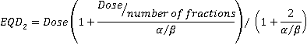  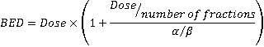
Brachial plexus D0.1cc EQD2 [19] | 1.12 | 1.13 | 56

