Supplementary material

Supplementary material - Table 1 - Amplitude of the diaphragm in cm, difference with the planning CT scan
Patient | Repeat CT 1 | Repeat CT 2 | Repeat CT 3 | Repeat CT 4 | Repeat CT 5 | Repeat CT 6 | Maximum | mean | SD
1 | -0.40 | -0.60 | -0.23 | -0.40 | 0.00 |  | -0.60 | -0.33 | 0.20
2 | 0.40 | 0.40 | 0.60 | 0.60 | 0.40 |  | 0.60 | 0.48 | 0.10
3 | 0.00 |  | 0.40 | 0.40 | 0.60 |  | 0.60 | 0.35 | 0.22
4 | -0.40 | 0.20 | -0.60 | 0.40 | -0.40 |  | -0.60 | -0.16 | 0.39
5 | 0.25 |  | -0.19 | 0.25 | 0.20 |  | 0.25 | 0.13 | 0.18
6 | 0.00 |  | -0.25 | 0.00 |  |  | -0.25 | -0.08 | 0.12
7 | 0.20 | 0.00 | -0.20 | -0.15 | -0.20 | 0.00 | -0.20 | -0.06 | 0.14
8 |  | 0.01 | 0.01 | 0.01 | 0.01 |  | 0.01 | 0.01 | 0.00
9 | - | - | - | - | - | - | - | - | -
10 | 0.24 | 0.19 | 0.20 | 0.40 | 0.20 |  | 0.40 | 0.25 | 0.08
11 | -0.40 | 0.00 | -0.65 | -0.20 | -0.40 |  | -0.65 | -0.33 | 0.22
12 | 0.00 |  | 0.20 | -0.20 | 0.00 |  | 0.20 | 0.00 | 0.14
13 | -0.20 | 0.20 | 0.00 | 0.59 | 0.40 |  | 0.59 | 0.20 | 0.28
14 | -0.20 | -0.40 | -0.20 | -0.20 | 0.20 |  | -0.40 | -0.16 | 0.20
15 | - | - | - | - | - | - | - | - | -
16 |  | -0.20 | 0.60 | 0.00 | 0.80 | 0.60 | 0.80 | 0.36 | 0.39
17 | - | - | - | - | - | - | - | - | -
18 | - | - | - | - | - | - | - | - | -
19 | 0.00 | 0.40 | 0.00 | 0.00 | 0.00 |  | 0.40 | 0.08 | 0.16
Supplementary material - Table 2 – Offset of the diaphragm expiration delineation in cm.
Patient | Repeat CT 1 | Repeat CT 2 | Repeat CT 3 | Repeat CT 4 | Repeat CT 5 | Repeat CT 6 | Maximum | mean | SD
1 | -0.14 | -0.13 | -0.18 | 0.69 | 0.25 |  | 0.69 | 0.10 | 0.33
2 | -0.18 | -0.60 | 0.25 | 0.21 | 0.12 |  | -0.60 | -0.04 | 0.32
3 | -0.88 |  | -1.68 | -0.96 | -1.10 |  | -1.68 | -1.16 | 0.31
4 | 0.21 | 0.21 | 0.53 | 0.20 | 0.05 |  | 0.53 | 0.24 | 0.16
5 | 1.06 |  | 0.79 | 1.93 | 1.92 |  | 1.93 | 1.43 | 0.51
6 | -0.06 |  | -0.28 | -0.17 |  |  | -0.28 | -0.17 | 0.09
7 | 0.62 | -0.13 | -0.18 | 0.22 | 0.50 | 1.49 | 1.49 | 0.42 | 0.56
8 |  | -0.89 | -0.22 | -1.33 | -1.52 |  | 1.52 | -0.81 | 0.46
9 | - | - | - | - | - | - | - | - | -
10 | 0.18 | 0.42 | 0.76 | -0.08 | 0.17 |  | 0.76 | 0.29 | 0.28
11 | 0.40 | -0.30 | -1.01 | -0.10 | -0.42 |  | -1.01 | -0.29 | 0.46
12 | 0.35 |  | -0.43 | -0.83 | -0.17 |  | -0.83 | -0.27 | 0.43
13 | -0.24 | 0.10 | -0.49 | 0.13 | -0.07 |  | -0.49 | -0.11 | 0.23
14 | -0.48 | -0.33 | -0.11 | -0.28 | -0.31 |  | -0.48 | -0.30 | 0.12
15 | - | - | - | - | - | - | - | - | -
16 |  | -1.05 | -0.41 | -0.84 | -0.61 | -0.31 | 1.05 | -0.64 | 0.27
17 | - | - | - | - | - | - | - | - | -
18 | - | - | - | - | - | - | - | - | -
19 | 0.64 | 0.32 | 0.49 | 0.52 | 0.16 |  | 0.64 | 0.43 | 0.17
Supplementary material - Table 3 – Offset of the diaphragm inspiration delineation in cm.
Patient | Repeat CT 1 | Repeat CT 2 | Repeat CT 3 | Repeat CT 4 | Repeat CT 5 | Repeat CT 6 | Maximum | mean | SD
1 | 0.26 | 0.47 | 0.05 | 1.09 | 0.25 |  | 1.09 | 0.42 | 0.36
2 | -0.58 | -1.00 | -0.35 | -0.39 | -0.28 |  | -1.00 | -0.52 | 0.26
3 | -0.88 |  | -2.08 | -1.36 | -1.70 |  | -2.08 | -1.51 | 0.44
4 | 0.61 | 0.01 | 1.13 | -0.20 | 0.45 |  | 1.13 | 0.40 | 0.47
5 | 0.81 |  | 0.98 | 1.68 | 1.72 |  | 1.72 | 1.30 | 0.41
6 | -0.06 |  | -0.03 | -0.17 |  |  | -0.17 | -0.09 | 0.06
7 | 0.42 | -0.13 | 0.02 | 0.37 | 0.70 | 1.49 | 1.49 | 0.48 | 0.53
8 |  | -0.90 | -0.23 | -1.34 | -1.53 |  | 1.53 | -0.82 | 0.46
9 | - | - | - | - | - | - | - | - | -
10 | -0.06 | 0.23 | 0.56 | -0.48 | -0.03 |  | 0.56 | 0.04 | 0.34
11 | 0.80 | -0.30 | -0.36 | 0.10 | -0.02 |  | 0.80 | 0.04 | 0.41
12 | 0.35 |  | -0.63 | -0.63 | -0.17 |  | -0.63 | -0.27 | 0.40
13 | -0.04 | -0.10 | -0.49 | -0.46 | -0.47 |  | -0.49 | -0.31 | 0.20
14 | -0.28 | 0.07 | 0.09 | -0.08 | -0.51 |  | -0.51 | -0.14 | 0.23
15 | - | - | - | - | - | - | - | - | -
16 |  | -0.85 | -1.01 | -0.84 | -1.41 | -0.91 | 1.41 | -1.00 | 0.21
17 | - | - | - | - | - | - | - | - | -
18 | - | - | - | - | - | - | - | - | -
19 | 0.64 | -0.08 | 0.49 | 0.52 | 0.16 |  | 0.64 | 0.35 | 0.27
Supplementary material - Figure 1 - 1a) Diaphragm off-set values of the expiration phase. 1b) Diaphragm off-set values of the inspiration phase. 1c) Difference in amplitude of the diaphragm in the weekly CTs, with respect to the planning CT scan

Supplementary material – Figure 2 - Patients individual diaphragm expiration and diaphragm inspiration off-sets and amplitude differences of weekly CT scan compared with the planning CT scan in cm.

Supplementary material figure 3a – Scatterplot of the diaphragm amplitudes in cm with the regression line of the mixed model analysis.

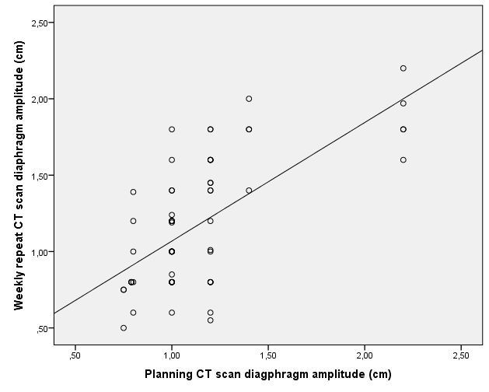

Supplementary material figure 3b- Scatterplot of the distance from the thoracic vertebra 12 to the diaphragm expiration delineation in cm with the regression line of the mixed model analysis
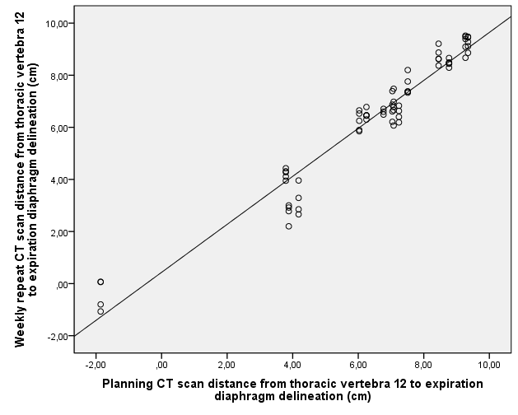

Supplementary material figure 3c – Scatterplot of the distance from the thoracic vertebra 12 to the diaphragm inspiration delineation in cm with the regression line of the mixed model analysis

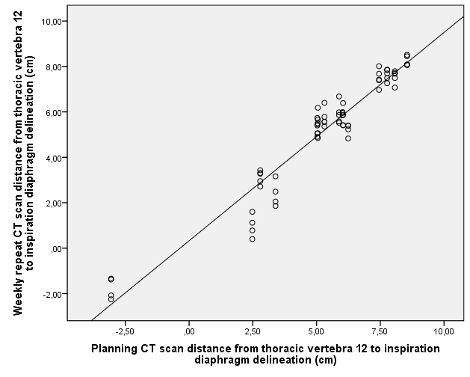

Supplementary material Figure 4 - Dose distribution comparisons of VMAT plans with IMPT plans of patients with a diaphragm position off-set exceeding the 0.8cm PTV margin. The planning CT-scan is compared with the voxelwise minimum and maximum distributions of the repeat CT-scan. For the VMAT and the IMPT plans the ITV is shown.

Supplementary material - Table 4 - Literature overview mean breathing amplitudes
Mean amplitude breathing motion [mm] for different tumor locations
 |  |  |  |  |  |  |  |  | Proximal |  |  | Middle |  |  | Distal |  |  |  | All
Nr. | Study |  |  | Imaging |  | What is measured |  | # Pat. | AP | LR | SI | AP | LR | SI | AP | LR | SI | AP | LR | SI
1 | P. Jin 2017¹¹ |  |  | 4D-CBCT |  | fiducials |  | 24 | 1.4 | 1.8 | 4.4 | 1.6 | 1.9 | 4.9 | 3.0 | 3.0 | 7.1 | - | - | -
2 | P. Jin 2016¹² |  |  | 4D-CBCT |  | fiducials |  | 20 | 1.6 | 1.5 | 2.9 | 1.4 | 1.5 | 3.7 | 3.3 | 2.6 | 5.4 | - | - | -
3 | F. Liu 2016¹³ |  |  | 4D-CT |  | fiducials |  | 11 | - | - | - | - | - | - | 6.4 | 3.2 | 13.7 | - | - | -
4 | J.Z. Wang 2015¹⁴ |  |  | 4D-CT |  | Centroid tumor |  | 38 | 1.0 | 1.2 | 2.3 | 1.2 | 1.5 | 2.7 | 1.7 | 2.1 | 3.5 | 1.4 | 1.6 | 3.1
5 | W. Wang 2014¹⁵ |  |  | 4D-CT |  | Centroid tumor |  | 29 | 0.9 | 1.1 | 1.7 | 0.9 | 1.3 | 4.3 | 3.0 | 2.4 | 5.6 | - | - | -
6 | F. M. Lever 2014¹⁶ |  |  | Cine-MRI |  | caudal tumor border |  | 36 | - | - | - | - | - | - | - | - | - | 4.9 | 2.7 | 13.3
7 | H. Yamashita 2011¹⁷ |  |  | 3D-CT in insp. and exp. |  | fiducials |  | 12 | 0.6 | 0.9 | 1.1 | 1.0 | 0.9 | 3.0 | 3.0 | 2.8 | 5.1 | 1.6 | 1.5 | 3.3
8 | A. Patel 2009¹⁸ |  |  | 4D-CT |  | Centroid tumor |  | 35 | - | - | - | - | - | - | 2.5 | 3.3 | 8.9 | - | - | -
9 | B. P. Yaremko 2008¹⁹ |  |  | 4D-CT |  | Centroid tumor |  | 31 | - | - | - | - | - | - | - | - | - | 2.5 | 1.3 | 7.7
10 | K. L. Zhao 2007²⁰ |  |  | 4D-CT |  | Centroid tumor |  | 25 | - | - | - | - | - | - | 3.8 | 3.9 | 8.7 | - | - | -

Supplementary material - Figure 5 – Literature overview mean breathing amplitudes
