Training and validation of a knowledge-based dose-volume histogram predictive model in the optimisation of intensity-modulated proton plans for locally advanced gastroesophageal carcinoma.
Complementary materials

Figure 1Suppl. Explanation of the principal component analysis concept for the DVH parametrization.

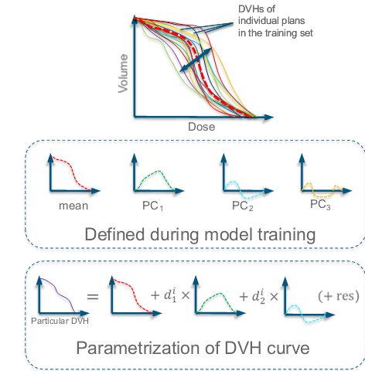
Figure 2 Suppl: exemplification of the logic in the generation of the optimisation (line-type) constraints in RP. The dotted line is the objective automatically generated “below” the lower limit of the uncertainty band in the DVH prediction for each OAR.
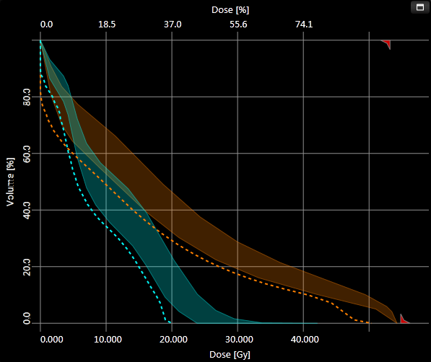

From the structure set of current plan
Regression coefficients from the DVH Estimation model
The estimated DVH PC coefficient
DVH estimates
Automatic objectives

Figure 3 Suppl: the distribution of the Dose Volume Histograms for the main organs at risk in the training set. The relatively large variance observed for some of these might be mitigated by considering a much greater cohort. 