Supplementary Table 1: Treatment Protocol Roadmap adopted from modified COG AAML 1031
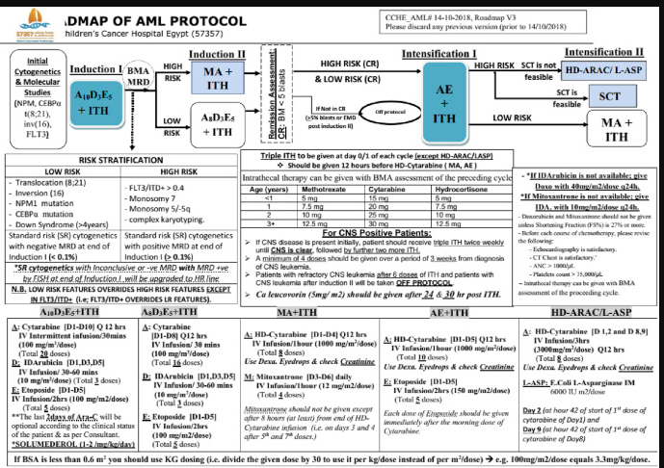

Supplementary Table 2: (Oligonucleotide primer and probe sequences used for quantitative real-time PCR)
Primer F EVI-1 | GAAAGACCCCAGTTATGGATGG
Primer R EVI-1 | CTTCTTGACTAAAGCCCTTGGA
Primer F  EVI-1/MDS | GTACTTGAGCCAGCTTCCAACA
Primer R  EVI-1/MDS | TCTCTTCCCCAAATACAACCAAG
Primer F ABL | TGGAGATAACACTCTAAGCATAACTAAAGGT
Primer R ABL | GATGTAGTTGCTTGGGACCCA
Probe A (EVI1) | TCTTAGACGAATTTTACAATGTGAAGTTCTGCATAGA.TG
Probe B (EVI1/MDS) | TCTTAGACGAATTTTACAATGTGAAGTTCTGCATAGATG
Probe ABL | CCATTTTTGGTTTGGGCTTCACACCATT

Supplementary Table S3: Impact of MECOM gene overexpression on survival among whole cohort, (A) OS, (B) EFS, (C) CIR
(A)
MECOM gene overexpression | Total N | Deaths | 3 yrs OS | 95%Confidence interval |  | p-value
no | 162 | 33 | 78.9% | 72.4% | 85.4% | <0.001
yes | 53 | 31 | 38.7% | 23.4% | 54% | <0.001

(B)
MECOM gene overexpression | Total N | N of Events | 3 yrs EFS | 95%Confidence interval |  | p-value
no | 162 | 51 | 68.4% | 61.2% | 75.7% | <0.001
yes | 53 | 34 | 37.3% | 24.2% | 50.4% | <0.001

(C)
MECOM gene overexpression | 3 years CIR | 95%confidence interval |  | p-value
Yes | 49.5% | 32.1% | 64.7% | 0.002
No | 23.5% | 17% | 30.6%
OS, Overall survival; EFS, Event-free survival; CIR, Cumulative incidence of relapse

Supplementary Table 4: Impact of MECOM gene overexpression on survival within disease risk group

Initial risk | MECOM gene overexpression | Total N | N of Events | 3 years OS | P-Value | N of Events | 3 years EFS | P-Value
High Risk | No | 20 | 10 | 49.5% | 0.047 | 11 | 45% | 0.06
High Risk | Yes | 16 | 13 | 18.8% | 0.047 | 13 | 18.8%
Intermediate risk | No | 78 | 19 | 75.0% | 0.03 | 31 | 60.1% | 0.14
Intermediate risk | Yes | 35 | 17 | 46.8% | 0.03 | 20 | 45.1%
Low Risk | No | 64 | 4 |  |  | 9
Low Risk | Yes | 2 | 1 |  |  | 1
OS, Overall survival; EFS, Event-free survival,

Supplementary Table 5: Impact of MECOM gene overexpression on MRD response post induction I in Intermediate risk group
Intermediate risk |  |  |  |  | N=113
 |  | MECOM gene overexpression |  |  |  | P-Value
 |  | no |  | yes |  | P-Value
 |  | N | % | N | % | P-Value
MRD Induction I | MRD -ve | 35 | 44.8% | 22 | 62.8% | 0.06
MRD Induction I | MRD +ve | 43 | 55.1% | 13 | 37.1% | 0.06
MRD, minimal residual disease

Supplementary Table 6: Logistic regression analysis to evaluate impact of MECOM gene overexpression and MRD on relapse in intermediate risk patients
Logistic regression - Intermediate Risk
 |  | P-value | Odds ratio | 95% CI for odds ratio
 |  | P-value | Odds ratio | Lower | Upper
Step 1ª | MECOM^{pos}(1) | 0.018 | 2.89 | 1.19 | 6.57
Step 1ª | MRD1(1) | 0.411 | 1.41 | .62 | 3.20
Step 1ª | Constant | 0.001 | .29
CI, confidence interval; MRD, minimal residual disease; MECOM^{pos}, MECOM gene overexpression

(A) (B)
P<0.001

P<0.001 P<0.001

0.001

Supplementary Figure 1: Survival outcome between different disease risk groups, (A) Overall survival, (B) Event-free survival

