Supplementary Table 1 Characteristics and treatment among breast cancer patients by breast cancer subtype and birth origin

 | HR-positive breast cancer  (n_{cases} = 356)ª |  | HER2-positive breast cancer (n_{cases} = 62)ª |  | Triple-negative breast cancer (n_{cases} = 49)ª
 | Western European  (n_{cases} = 294) | Ethnic minority (n_{cases} = 35) | Western European  (n_{cases} = 49) | Ethnic minority (n_{cases} = 13) | Western European  (n_{cases} = 38) | Ethnic minority (n_{cases} = 11)
 | Mean (SD) | Mean (SD) | Mean SD) | Mean (SD) | Mean (SD) | Mean (SD)
Age at diagnosis (years) | 61.9 (12.8) | 53.9 (8.09) | 55.4 (10.8) | 51.5 (9.13) | 62.1 (13.2) | 55.6 (10.2)
Tumor characteristics
Histological subtype (%)
Invasive carcinoma NST | 76.1 | 94.1 | 89.8 | 100 | 92.1 | 81.8
Invasive lobular carcinoma | 14.3 | 2.90 | 10.2 | 0 | 2.60 | 0
Tumor size (mm) | 21.4 (16.3) | 18.7 (13.5) | 31.8 (30.3) | 32.1 (33.3) | 29.7 (21.8) | 30.9 (19.4)
Lymph node stage (%)
1–3 | 33.1 | 25.0 | 62.8 | 38.5 | 36.6 | 18.2
Disease stage (%)
1–2 | 87.0 | 91.4 | 71.4 | 69.2 | 71.1 | 81.8
3 | 10.6 | 8.60 | 24.5 | 22.1 | 21.1 | 18.2
4 | 2.40 | 0 | 4.10 | 7.70 | 7.80 | 0
Histological grading (%)
1 | 30.4 | 28.6 | 6.30 | 16.7 | 0 | 0
2 | 52.3 | 48.6 | 37.5 | 8.30 | 27.0 | 18.2
3 | 17.3 | 22.9 | 56.3 | 75.0 | 73.0 | 81.8
ER positive (%) | 100 | 100 | 53.9 | 57.1 | 0 | 0
PgR positive (%) | 79.2 | 92.5 | 32.7 | 28.6 | 2.40 | 0
HER2 positive (%) | 0 | 0 | 100 | 100 | 0 | 0
Ki-67 percent | 24.5 (17.4) | 26.7 (15.6) | 46.7 (21.3) | 38.3 (11.6) | 57.3 (25.8) | 60.4 (18.7)
Treatment
Breast cancer surgery (%)
Mastectomy | 30.8 | 20.6 | 55.1 | 46.2 | 50.0 | 63.6
Breast-conserving treatment | 61.3 | 76.5 | 34.7 | 46.2 | 44.7 | 36.4
SN dissection | 68.2 | 79.4 | 44.9 | 53.8 | 60.5 | 63.6
Axillary dissection | 28.4 | 20.6 | 55.1 | 46.2 | 42.1 | 36.4
Treatment intention (%)
Curative | 94.9 | 100 | 95.9 | 92.3 | 92.1 | 100
Palliative | 5.10 | 0 | 4.10 | 7.70 | 7.90 | 0
Chemotherapy (%) | 34.6 | 48.6 | 90.3 | 83.3 | 86.8 | 100
Anthracyclines | 34.6 | 48.6 | 77.6 | 83.3 | 86.8 | 90.9
Number of anthracycline courses^{b} | 4.82 (1.10) | 4.79 (1.08) | 4.27 (1.34) | 4.60 (0.97) | 4.46 (1.34) | 4.40 (1.26)
Taxanes | 14.0 | 27.5 | 69.4 | 46.2 | 47.4 | 72.7
Number of taxane courses^{c} | 11.2 (2.52) | 11.4 (0.92) | 11.5 (1.37) | 11.0 (4.17) | 10.7 (1.91) | 9.63 (2.83)
Endocrine therapy (%) | 69.9 | 71.4 | 47.9 | 46.2 | 2.60 | 0
Tamoxifen | 33.6 | 37.1 | 20.8 | 23.1 | 2.60 | NA
Aromatase inhibitors | 46.6 | 31.4 | 33.3 | 23.1 | 2.60 | NA
Trastuzumab | 0 | 0 | 85.7 | 76.9 | 0 | 0
Radiotherapy (%) | 73.6 | 91.2 | 81.6 | 84.6 | 68.3 | 70.0
Local radiation | 67.1 | 77.4 | 27.5 | 36.4 | 67.6 | 57.1
Locoregional radiation | 32.9 | 22.6 | 72.5 | 63.6 | 32.4 | 42.9
ªNumbers may vary due to missing information.
^{b}All anthracycline-based chemotherapy (FEC60, FEC100, EC90, EC60).
^{c}Weekly paclitaxel.

ER, estrogen receptor; HER2, human epidermal growth factor receptor-2; HR, hormone receptor; n_{cases}, number of cases; NST, no special type; PgR, progesterone receptor; SN, sentinel node.

Supplementary Table 2 Age-adjusted breast cancer risk in all ethnic minority women and in ethnic minority subgroups compared to western European women (reference)

Western European womenª | Ethnic minority women
(n = 11 012) | All ethnic minority women  (n = 2 790) | South Asian women  (n = 1 097) | Middle Eastern and north African women  (n = 724) | All other non-western origin women^{b}  (n = 969)
HR (95% CI) | HR (95% CI) | HR (95% CI) | HR (95% CI) | HR (95% CI)
1.00 (reference) | 0.71 (0.55 – 0.92) | 0.83 (0.57–1.20) | 0.64 (0.38 –1.05) | 0.63 (0.41–0.96)
Cox’s proportional hazard regression
ªWestern European women: women born in Norway with Norwegian ancestry and western immigrants; Nordic countries, western Europe, Australia and North America. ^{b}Eastern Europe, East Asia, sub-Saharan Africa, South and Central America.

Abbreviations: CI, confidence interval; HR, hazard ratio; n; number of participants

Supplementary figures

All women Oslo Health Studiesª
n = 15 310

Excluded: - breast cancer diagnosed before study enrollment, n = 29.

Excluded:
- missing information, birth origin, n = 269
- age < 20 years at study enrollment, n = 24. - missing information, BMI, WHR, BP, TG and HDL-cholesterol, n = 88.
- missing information, reproductive factors, n = 1 098
Study population The Oslo Ethnic Breast Cancer Study n = 13 802

Breast cancer cases, n = 557
Western European, n = 487 Ethnic minority, n = 70

Non-cases, n = 13 245
Western European, n = 10 525
Ethnic minority, n = 2 720

Excluded:
– missing information ER, PgR and HER2 status, n = 117

Breast cancer death, n = 95
Western European, n = 84
Ethnic minority, n = 11
Breast cancer cases, n = 440
Western European, n = 381 Ethnic minority, n = 59

Supplementary figure 1. Flow chart The Oslo Ethnic Breast Cancer Study

ª Oslo Health Studies include: the Oslo Health Study, the Oslo Immigrant Health Study, and the Romsås in Motion Study.
Western European women: Women born in Norway with Norwegian ancestry, and western immigrants; Nordic countries, Western Europe, Australia and North America.
Abbreviations: BMI, body mass index; BP, blood pressure; ER, estrogen receptor; HER2, human epidermal growth factor receptor-2; PgR, progesterone receptor; TG, triglyceride; WHR, waist:hip ratio

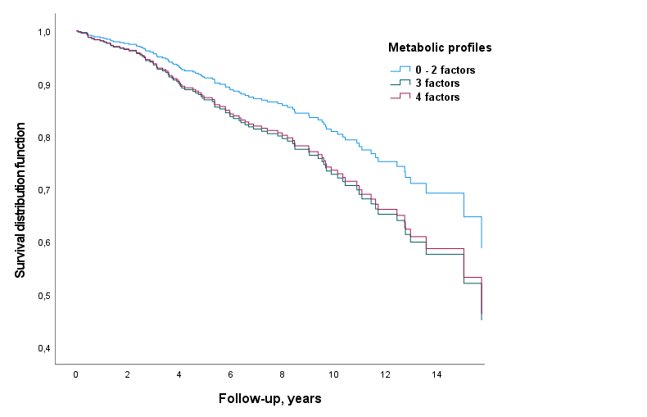

Supplementary figure 2 Overall survival among breast cancer patients by metabolic profile
Factors = Unfavorable metabolic factors

