SUPPLEMENTAL MATERIAL

Table S1. Definition of subtypes of haematological malignancies by ICD-7 codes in the Swedish Cancer Registry 1970-2018.

Subtype | Type | ICD7 | N | %
B-cell lymphoma (BCL) | Lymphoid  Lymphoid  Lymphoid | 200.1  200.2  200.3 | 7695 | 36.2
Hodgkin lymphoma (HL) | Lymphoid | 201 | 2166 | 10.2
Other lymphoma | Lymphoid  Lymphoid  Lymphoid | 202.1  202.2  202.4 | 514 | 2.4
Myeloma | Lymphoid | 203 | 2562 | 12.1
Acute lymphoblastic leukaemia (ALL) | Lymphoid | 204.0 | 496 | 2.3
Chronic lymphocytic leukaemia (CLL) | Lymphoid | 204.1 | 1766 | 8.3
Acute myeloid leukaemia (AML) | Myeloid  Myeloid  Myeloid  Myeloid | 205.0  205.9ª  206.0  206.9 | 2481 | 11.7
Chronic myeloid leukaemia (CML) | Myeloid | 205.1 | 845 | 4.0
Other Leukaemia | Missing type  Missing type  Missing type  Missing type  Myeloid  Missing type  Missing type | 207.0  207.1  207.2  207.3  207.9^{b}  204.9  206.1 | 330 | 1.6
Essential Thrombocytemia (ET)  Polycythemia vera (PV)  Myelofibrosis (MF) | Myeloid  Myeloid  Myeloid | 207.9^{c}  208  209 | 2382 | 11.2
Total |  |  | 21,237
ª Code 205.9 also includes myelodysplastic syndromes (MDS), which were reported since 1993 to the registry.
^{b} Code 207.9 excluding Essential Thrombocytemia (ICD7=207.9, Patho-Anatomical Code (PAD) 293).
^{c} Code 207.9 and PAD 293

In total, 15199 (72.4%) lymphoid type, 5804 (27.6%) myeloid type and 234 missing type.

Figure S2. Net survival by parity and age at diagnosis (top), and age at first birth and age at diagnosis (bottom) for all haematological subtypes combined. Comparing estimates with and without standardization to education level within each age group.

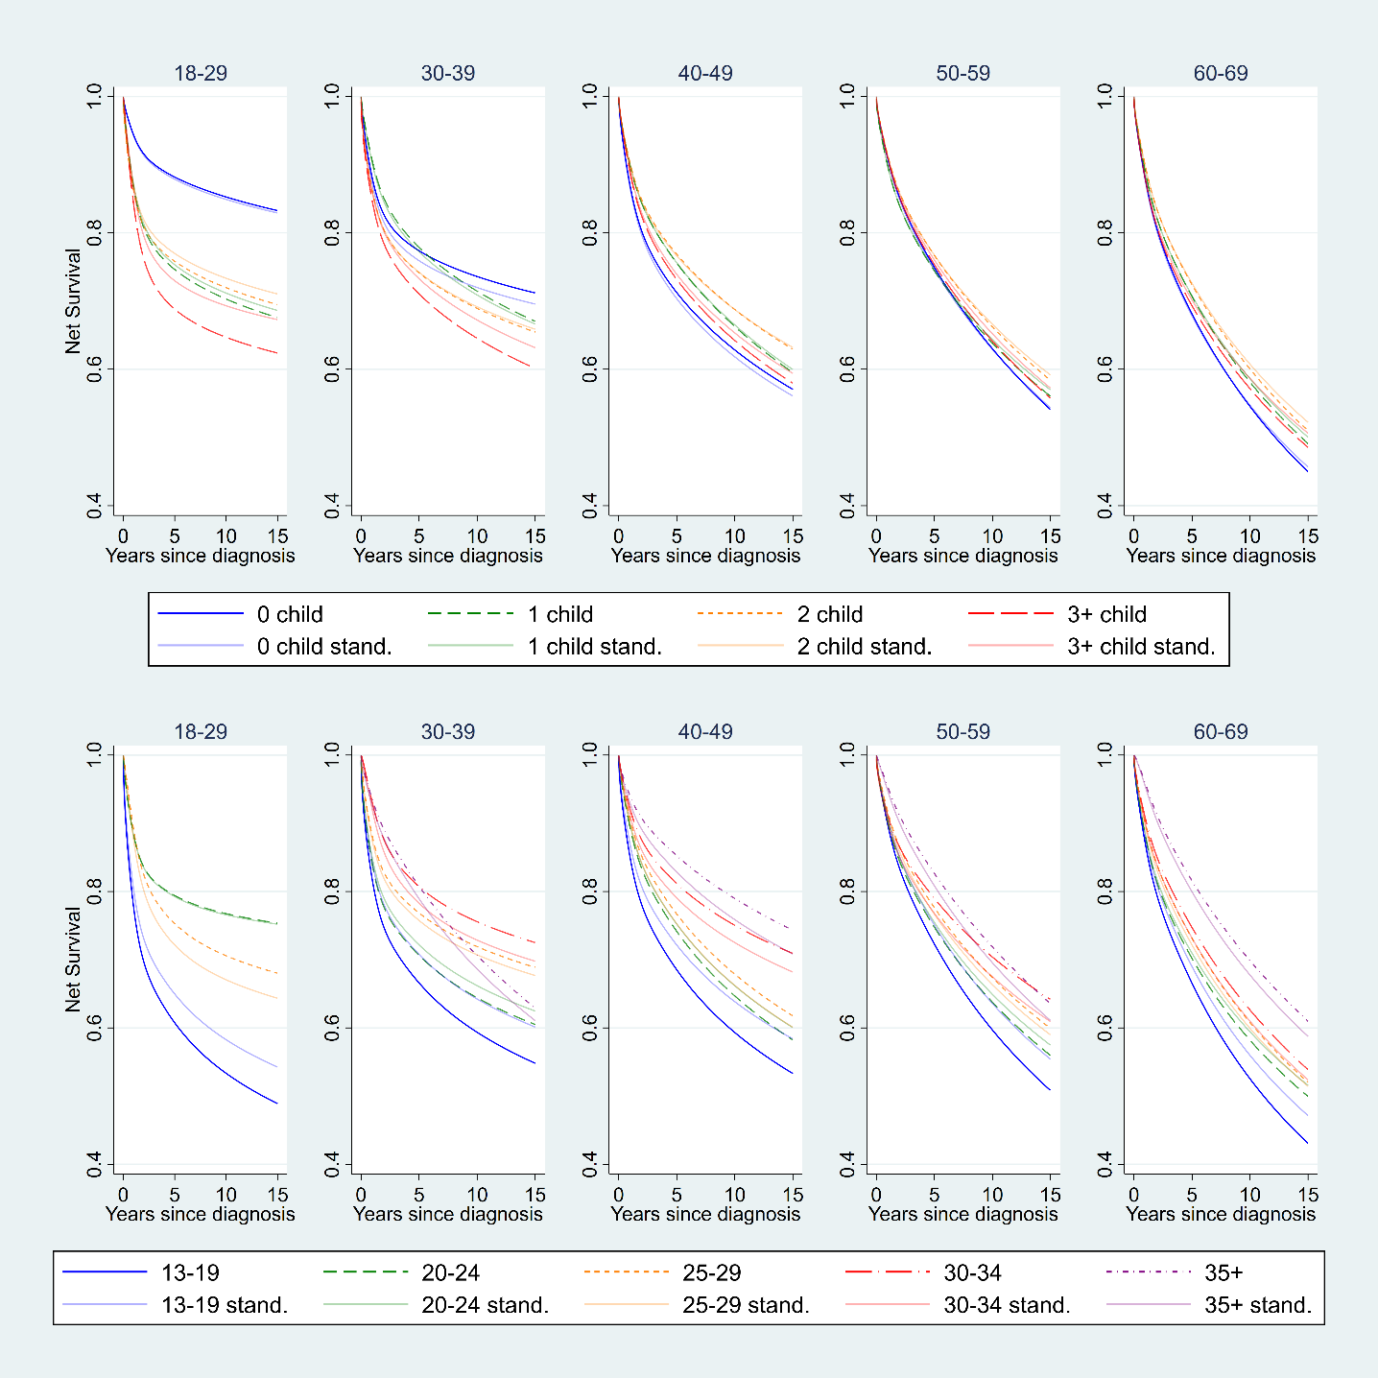

Table S3. Time-dependent (at 1, 5 and 10 years of follow-up) associations between reproductive factors and excess mortality for all haematological malignancies combined. Sweden 1970-2018, 18-69y.

 | All subtypes  1y | All subtypes  5y | All subtypes  10y
 | EHR [95% CI] | EHR [95% CI] | EHR [95% CI]
Parous
Nulliparous | 1.05 (0.89-1.23) | 1.03 (0.86-1.23) | 0.98 (0.77-1.24)
Parousª | 1.00 [ref] | 1.00 [ref] | 1.00 [ref]
Parity
0
1 | 1.00 [ref] | 1.00 [ref] | 1.00 [ref]
2 | 0.91 (0.83-1.01) | 0.91 (0.81-1.02) | 0.86 (0.72-1.02)
3+ | 0.97 (0.87-1.08) | 0.99 (0.88-1.13) | 0.93 (0.77-1.13)
Age at first birth
No children
13-19 | 1.04 (0.95-1.15) | 1.12 (1.00-1.25) | 1.18 (1.00-1.39)
20-24 | 1.00 [ref] | 1.00 [ref] | 1.00 [ref]
25-29 | 1.00 (0.91-1.10) | 1.03 (0.93-1.14) | 1.01 (0.86-1.19)
30-34 | 0.91 (0.79-1.06) | 0.96 (0.81-1.13) | 1.08 (0.85-1.36)
35-49 | 0.74 (0.57-0.96) | 1.07 (0.82-1.39) | 1.03 (0.69-1.53)
Time-since-latest-birth, yrs
No children
0-9 |  | 1.13 [1.00, 1.27]
10-19 |  | 1.00 [ref]
20-29 |  | 1.02 [0.92, 1.12]
30+ |  | 1.15 [1.03, 1.29]
ª The reference group “parous” corresponds to women with one child (parity=1), age at first birth 20-24 years and 10-19 years since latest birth. Effect of nulliparous group estimated separately to avoid collinearity between reproductive variables.
Adjusted for age and year (interaction), education and haematological subtype (stratified with separate baselines), and with time-varying effects of parity and age at first birth.
P-values from Wald tests. EHR=Excess hazard ratio.

Table S4. Associations between number of girls/boys and excess mortality for all haematological malignancies combined. Sweden 1970-2018, 18-69y.
 | EHRª [95% CI]
Among women with 1 child:
1 girl | 1.00 [ref]
1 boy | 1.06 [0.93,1.20]
 | P=0.3823
Among women with 2 children:
0 boy, 2 girls | 1.00 [ref]
1 boy, 1 girl | 1.02 [0.91,1.13]
2 boys, 0 girl | 1.04 [0.92,1.17]
 | P=0.8179
Among women with 3+ children:
0 boy, 3+ girls | 1.00 [ref]
1 boy, 2+ girls | 0.93 [0.78,1.10]
2 boys, 1+ girl | 1.04 [0.88,1.23]
3+ boys, ≥0 girls | 1.15 [0.96,1.38]
 | P=0.0126
Among women with 1+ child:
Order of girls/boys
1 child: boy | 1.00 [ref]
1 child: girl | 0.94 [0.83,1.06]
2 children: boy-boy | 0.88 [0.78,0.99]
2 children: boy-girl | 0.90 [0.80,1.01]
2 children: girl-boy | 0.84 [0.75,0.95]
2 children: girl-girl | 0.85 [0.75,0.96]
3 children: boy-boy-boy | 0.91 [0.76,1.08]
3 children: boy-boy-girl | 0.94 [0.79,1.12]
3 children: boy-girl-boy | 0.91 [0.75,1.10]
3 children: boy-girl-girl | 0.80 [0.65,0.98]
3 children: girl-boy-boy | 0.95 [0.78,1.14]
3 children: girl-boy-girl | 0.79 [0.65,0.97]
3 children: girl-girl-boy | 0.74 [0.62,0.90]
3 children: girl-girl-girl | 0.88 [0.73,1.06]
4+children | 1.03 [0.91,1.16]
 | P=0.0062
ª Adjusted for age and year (interaction), education, haematological subtype and age at first birth.
P-values from Wald tests. EHR=Excess hazard ratio.

