Supplementary Materials
Supplementary Figure 1. Patient disposition

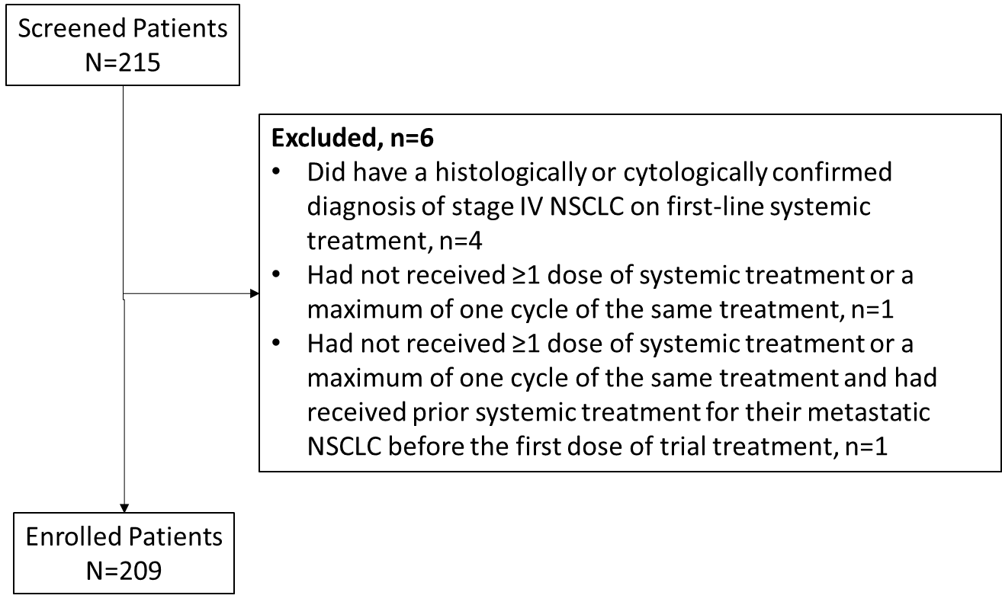

Variables included on the electronic case report form
Patient demographics: Age, sex, weight loss (≤5% vs. >5%), smoking status (current, former, never, unknown), Eastern Cooperative Oncology Group (ECOG) performance status (0, 1, 2, 3/4), patient preference (yes, no)
Medical history: Disease stage (M1a, M1b, M1c), tumor burden (tumor size, number of metastatic sites), brain metastases (no, symptomatic, asymptomatic, treated with stereotactic radiotherapy [SRT], treated with whole brain radiotherapy [WBRT]), liver metastases (present, not present), concomitant malignancies, histology (squamous, nonsquamous), immunohistochemistry PD-L1 TPS (<1%, 1%–49%, ≥50%), high tumor mutation burden (≥10 mutations/Mb: present, not present), testing (turnaround time, not tested, biopsy available, type of next-generation sequencing)
Comorbidities: Myocardial infarction in the last year, congestive heart failure, peripheral vascular disease, hypertension, cerebrovascular event in the last year, transient ischemic attack in the last year, diabetes without complications, renal disease, liver disease, hematological disease, chronic obstructive pulmonary disease, chronic infections, mental disorders
Autoimmune disease: Active interstitial lung disease (ILD), nonactive ILD, active inflammatory bowel disease (IBD), nonactive IBD, active inflammatory joint disease, nonactive inflammatory joint disease, active psoriasis, nonactive psoriasis, active connective tissue disease, nonactive connective tissue disease.
Current/recent medication: Low-dose corticosteroids, high-dose (≥10 mg/day prednisolone or equivalent) corticosteroids, other immunosuppressants (i.e., anti–tumor necrosis factor [TNF]-α and mycophenolate mofetil [MMF]), antibiotics.
Prior cancer treatment in earlier stage NSCLC: Single modality treatment, multimodality treatment, surgery/radiotherapy, previous IT treatment, year of treatment.
Patients excluded from the statistical models
- PD-L1 TPS <50% who had IT alone (N = 1)
  - 71 years old, 7-kg weight loss, ex-smoker, PS 1, M1a, no brain metastases, previous multimodality
  - Factors indicated as having an impact: metastatic status (M1a/b/c), ECOG, concomitant malignancy, renal & hematological disease
- PD-L1 TPS ≥50% who had CT alone (N = 5)
  - Patients 2 & 3: active ILD indicated as having an impact, although no oral corticosteroids and no immunosuppressants; both PS 1
  - Patients 99, 100, & 101: age (64, 55, 69 years, respectively) and metastatic status indicated as having an impact; PS 3, 2, 1, respectively
  - Patient 101: had brain metastatic status (M1a/b/c); although asymptomatic and untreated, metastatic status had impact, tumor size was 99 (RECIST sum)
  - Furthermore: none of the patients had OCS or immunosuppressants, except for patient 2, patient preference did not interfere, and all patients were current or ex-smokers
- PD-L1 TPS ≥50% who had BSC (N = 2)
  - For both patients, factors indicated as having an impact: metastatic status, age, PS, weight loss, patient preference; in patient 75, PD-L1 status also; and in patient 129, pulmonary disease (although no OCS/IS mentioned) and liver metastases were also indicated as of importance
    - Patient 75 had PS 2 and M1a disease; Patient 129 had PS 3 and M1c with liver metastases
Supplementary Table 1. Patient characteristics according to site type
Parameters | High diagnostic volume |  | Low diagnostic volume |  | Overall
 | Clinical trial  N = 94 | No clinical trial  N = 22 | Clinical trial  N = 58 | No clinical trial  N = 35 | N = 209
Age, years, mean (SD) | 68.1 (9.3) | 67.3 (11.6) | 66.7 (8.8) | 71.5 (7.4) | 68.2 (9.2)
Sex, n (%)
Female | 37 (39.4) | 8 (36.4) | 16 (27.6) | 12 (34.3) | 73 (34.9)
Male | 57 (60.6) | 14 (63.6) | 42 (72.4) | 23 (65.7) | 136 (65.1)
Smoking status, n (%)
Current | 50 (53.3) | 6 (27.3) | 28 (48.3) | 15 (42.9) | 99 (47.4)
Former (≥1 year) | 40 (42.6) | 15 (68.2) | 30 (51.7) | 16 (45.7) | 101 (48.3)
Never | 3 (3.2) | 1 (4.5) | 0 (0) | 4 (11.4) | 8 (3.8)
Unknown | 1 (1.1) | 0 (0) | 0 (0) | 0 (0) | 1 (0.5)
ECOG PS, n (%)
0 | 9 (9.6) | 6 (27.3) | 18 (31.0) | 7 (20.0) | 40 (19.1)
1 | 58 (61.7) | 12 (54.5) | 30 (51.7) | 21 (60.0) | 121 (57.9)
2 | 19 (20.2) | 3 (13.6) | 7 (12.1) | 5 (14.3) | 34 (16.3)
3/4 | 6 (6.4) | 1 (4.5) | 2 (3.4) | 2 (5.7) | 11 (5.3)
Unknown | 2 (2.1) | 0 (0) | 1 (1.7) | 0 (0) | 3 (1.4)
Histology, n (%)
Squamous | 18 (19.1) | 4 (18.2) | 20 (34.5) | 15 (42.9) | 57 (27.3)
Nonsquamous | 63 (67.0) | 17 (77.3) | 37 (63.8) | 20 (57.1) | 137 (65.6)
Not otherwise specified | 13 (13.8) | 1 (4.5) | 1 (1.7) | 0 (0) | 15 (7.2)
PD-L1 TPS, n (%)
<1% | 28 (29.8) | 8 (36.4) | 24 (41.4) | 9 (25.7) | 69 (33.0)
1%–49% | 15 (16.0) | 7 (31.8) | 11 (19.0) | 12 (34.3) | 45 (21.5)
≥50% | 48 (51.1) | 5 (22.7) | 22 (37.9) | 13 (37.1) | 88 (42.1)
Unknown | 3 (3.2) | 2 (9.1) | 1 (1.7) | 1 (2.9) | 7 (3.3)
Metastatic disease status, n (%)
M1a | 33 (35.1) | 3 (13.6) | 12 (20.7) | 11 (31.4) | 59 (28.2)
M1b | 9 (9.6) | 5 (22.7) | 9 (15.5) | 5 (14.3) | 28 (13.4)
M1c | 52 (55.3) | 13 (59.1) | 37 (63.8) | 19 (54.3) | 121 (57.9)
Unknown | 0 (0) | 1 (4.5) | 0 (0) | 0 (0) | 1 (0.5)
Brain metastases, n (%)
Yes | 15 (16.0) | 4 (18.2) | 17 (29.3) | 5 (14.3) | 41 (19.6)
No | 71 (75.5) | 18 (81.8) | 38 (65.5) | 30 (85.7) | 157 (75.1)
Unknown | 8 (8.5) | 0 (0) | 3 (5.2) | 0 (0) | 11 (5.3)
Comorbidities, n (%)
Cardiovascularª | 15 (16.0) | 2 (9.1) | 18 (31.0) | 13 (37.1) | 48 (23.0)
Other^{b} | 11 (11.7) | 2 (9.1) | 9 (15.5) | 9 (25.7) | 31 (14.8)
Autoimmune disease^{c} | 7 (7.4) | 2 (9.1) | - | 4 (11.4) | 13(6.2)
Current/recent medications, n (%)
Corticosteroids | 15 (16.0) | 4 (18.2) | 8 (13.8) | 4 (11.4) | 31 (14.8)
Antibiotics | 6 (6.4) | 2 (9.1) | 1 (1.7) | 1 (2.9) | 10 (4.8)
Prior therapies, n (%)
Surgery or radiotherapy | 13 (13.8) | 4 (18.2) | 10 (17.2) | 2 (5.7) | 29 (13.9)
Multimodality therapy | 6 (6.4) | 2 (9.1) | 7 (12.1) | 1 (2.9) | 16 (7.7)
ECOG PS: Eastern Cooperative Oncology Group performance status; PD-L1 TPS: programmed death ligand 1 tumor proportion score; SD: standard deviation.
ªIncludes myocardial infarction, congestive heart failure, and peripheral vascular disease.
^{b}Includes liver, renal, or hematological disease.
^{c}Defined as inflammatory joint disease, inflammatory bowel disease, or interstitial lung disease.

Supplementary Table 2. Impact of patient characteristics per systemic treatment choice
Systemic treatment choice | No impact  N (%) | Impact  N (%) | Important impact  N (%)
CT (N = 26)
PD-L1 TPS | 5 (19.2) | 3 (11.5) | 18 (69.2)
ECOG PS | 5 (19.2) | 10 (38.5) | 11 (42.3)
Metastatic disease status | 3 (11.5) | 15 (57.7) | 8 (30.8)
Histology | 5 (19.2) | 14 (53.8) | 7 (26.9)
Age | 15 (57.7) | 3 (11.5) | 8 (30.8)
Patient preference | 19 (73.1) | 3 (11.5) | 4 (15.4)
Renal disease | 21 (80.8) | 2 (7.7) | 3 (11.5)
ILD | 21 (80.8) | 2 (7.7) | 3 (11.5)
IT (N = 68)
PD-L1 TPS | 2 (2.9) | 2 (2.9) | 64 (94.1)
Metastatic disease status | 10 (14.7) | 21 (30.9) | 37 (54.4)
ECOG PS | 18 (26.5) | 19 (27.9) | 31 (45.6)
Histology | 32 (47.1) | 22 (32.4) | 14 (20.6)
Age | 43 (63.2) | 18 (26.5) | 7 (10.3)
IT-CT (N = 99)
PD-L1 TPS | 7 (7.1) | 16 (16.2) | 76 (76.8)
ECOG PS | 19 (19.2) | 18 (18.2) | 62 (62.6)
Metastatic disease status | 21 (21.2) | 32 (32.3) | 46 (46.5)
Histology | 24 (24.2) | 33 (33.3) | 42 (42.4)
Age | 59 (59.6) | 17 (17.2) | 23 (23.2)
BSC (N = 16)
ECOG PS | 3 (18.8) | 2 (12.5) | 11 (68.8)
Patient preference | 4 (25.0) | 3 (18.8) | 9 (56.3)
Metastatic disease status | 2 (12.5) | 7 (43.8) | 7 (43.8)
PD-L1 TPS | 4 (25.0) | 6 (37.5) | 6 (37.5)
Age | 8 (50.0) | 3 (18.8) | 5 (31.3)
Renal disease | 13 (81.3) | 1 (6.3) | 2 (12.5)

BSC: best supportive care; CT: chemotherapy; ECOG PS: Eastern Cooperative Oncology Group performance status; ILD: interstitial lung disease; IT: immunotherapy; IT-CT: immunotherapy + chemotherapy; PD-L1 TPS: programmed death ligand 1 tumor proportion score.
Supplementary Table 3. Systemic treatment choice by patient characteristics
Categories, n (%) | CT  26 (12.4) | IT  68 (32.5) | IT-CT  99 (47.4) | BSC  16 (7.7) | All patients  209 (100)
Age, years, mean (SD) | 70.9 (10.0) | 68.7 (9.5) | 66.5 (8.3) | 71.9 (10.7) | 68.2 (9.2)
Sex, n (%)
Female | 6 (8.2) | 30 (41.1) | 34 (46.6) | 3 (4.1) | 73 (34.9)
Male | 20 (14.7) | 38 (27.9) | 65 (47.8) | 13 (9.6) | 136 (65.1)
Smoking status, n (%)
Current | 13 (13.1) | 36 (36.4) | 43 (43.4) | 7 (7.1) | 99 (47.4)
Former (≥1 year) | 11 (10.9) | 31 (30.7) | 52 (51.5) | 7 (6.9) | 101 (48.3)
Never | 2 (25.0) | 1 (12.5) | 3 (37.5) | 2 (25.0) | 8 (3.8)
Unknown | 0 (0) | 0 (0) | 1 (100) | 0 (0) | 1 (0.5)
ECOG PS, n (%)
0 | 3 (7.5) | 14 (35.0) | 21 (52.5) | 2 (5.0) | 40 (19.1)
1 | 14 (11.6) | 36 (29.8) | 68 (56.2) | 3 (2.5) | 121 (57.9)
2 | 7 (20.6) | 16 (47.1) | 7 (20.6) | 4 (11.8) | 34 (16.3)
3/4 | 2 (18.2) | 2 (18.2) | 0 (0) | 7 (63.6) | 11 (5.3)
Unknown | 0 (0) | 0 (0) | 3 (100) | 0 (0) | 3 (1.4)
Histology, n (%)
Squamous | 8 (14.0) | 16 (28.1) | 30 (52.6) | 3 (5.3) | 57 (27.3)
Nonsquamous | 16 (11.7) | 47 (34.3) | 62 (45.3) | 12 (8.8) | 137 (65.6)
Not otherwise specified | 2 (13.3) | 5 (33.3) | 7 (46.7) | 1 (6.7) | 15 (7.2)
PD-L1 TPS, n (%)
<1% | 10 (14.5) | 0 (0) | 51 (73.9) | 8 (11.6) | 69 (33.0)
1%–49% | 7 (15.6) | 1 (2.2) | 33 (73.3) | 4 (8.9) | 45 (21.5)
≥50% | 5 (5.7) | 67 (76.1) | 14 (15.9) | 2 (2.3) | 88 (42.1)
Unknown | 4 (57.1) | 0 (0) | 1 (14.3) | 2 (28.6) | 7 (3.3)
Metastatic disease status, n (%)
M1a | 8 (13.6) | 23 (39.0) | 24 (40.7) | 4 (6.8) | 59 (28.2)
M1b | 7 (25.0) | 7 (25.0) | 13 (46.4) | 1 (3.6) | 28 (13.4)
M1c | 11 (9.1) | 38 (31.4) | 61 (50.4) | 11 (9.1) | 121 (57.9)
Unknown | 0 (0) | 0 (0) | 1 (100) | 0 (0) | 1 (0.5)
Brain metastases, n (%)
Yes | 4 (9.8) | 15 (36.6) | 21 (51.2) | 1 (2.4) | 41 (19.6)
No | 21 (13.4) | 48 (30.6) | 74 (47.1) | 14 (8.9) | 157 (75.1)
Unknown | 1 (9.1) | 5 (45.5) | 4 (36.4) | 1 (9.1) | 11 (5.3)
Comorbidities, n (%)
Cardiovascularª | 10 (20.8) | 15 (31.2) | 18 (37.5) | 5 (10.4) | 48 (23.0)
Other^{b} | 3 (9.7) | 12 (38.7) | 14 (29.2) | 2 (6.5) | 31 (14.8)
Autoimmune diseases^{c} | 3 (11.5) | 4 (5.9) | 6 (6.1) | - | 13 (6.2)
Current/recent medications, n (%)
Corticosteroids | 5 (16.1) | 8 (25.8) | 16 (51.6) | 2 (6.5) | 31 (14.8)
Antibiotics | 2 (20.0) | 4 (40.0) | 2 (20.0) | 2 (20.0) | 10 (4.8)
Prior therapies, n (%)
Surgery or radiotherapy | 4 (13.8) | 8 (27.6) | 17 (58.6) | 0 (0) | 29 (13.9)
Multimodality therapy | 1 (6.3) | 5 (31.3) | 10 (62.5) | 0 (0) | 16 (7.6)
Patient preference, n (%)
Yes | 8 (11.4) | 21 (30.0) | 29 (41.4) | 12 (17.1) | 70 (33.5)
No | 10 (13.0) | 23 (29.9) | 42 (54.5) | 2 (2.6) | 77 (36.8)
Unknown | 8 (12.9) | 24 (38.7) | 28 (45.2) | 2 (3.2) | 62 (29.7)
BSC: best supportive care; CT: chemotherapy; ECOG PS: Eastern Cooperative Oncology Group performance status; IHC: immunohistochemistry; IT: immunotherapy; IT-CT: immunotherapy + chemotherapy; PD-L1: programmed death ligand 1; SD: standard deviation; TPS: tumor proportion score.
ªIncludes myocardial infarction, congestive heart failure, and peripheral vascular disease.
^{b}Includes liver, renal, or hematological disease;
^{c}Defined as inflammatory joint, bowel, or lung disease.

