Sepsis: Documented or suspected infection along with a systemic inflammatory response syndrome (SIRS) manifested by two or more of the following conditions:

Temperature ≥38.3 or <36.0 C
Heart rate ≥90 beats/min
Respiratory rate ≥20 breaths/min or Pa_{CO2} ≤32 mmHg
White blood cells >12,000 cells/mm³, <4,000 cells/mm³, or >10% band forms

Severe Sepsis: Sepsis associated with organ dysfunction, hypoperfusion, or hypotension. Organ failure must be of acute onset and at least one failure must be present in the first 24 hours of intensive care. Organ failure variables:

Circulatory: Hypotension (SBP <90 mmHg or MAP <70 mmHg)

Renal: Oligurea (urine output <0.5 ml/kg/hr for at least two hours) or,
Acute creatinine increase (≥44 μmol/L) within two days

Respiratory: Arterial hypoxemia (PaO₂/FiO₂ <250)

Liver: Hyperbilirubinemia (>34 μmol/L)
AST/ALT ≥ 2x over normal range

CNS: Altered mental status

Coagulation: Thrombocytopenia (platelet count <100,000/mm³) or,
aPTT >60 sek or INR >1.5
Tissue
perfusion: Metabolic acidosis (pH <7.30) or,
Elevated lactate (>2.0 mmol/L)

Septic Shock: Sepsis with hypotension, despite adequate fluid resuscitation. Patients who need vasopressor or inotropic agents to maintain SBD ≥ 90 mmHg.
Figure S1. The definitions of sepsis, severe sepsis, septic shock and organ dysfunction criteria that were used for patient selection into the study. In data analysis, the later Sepsis-3 criteria were utilized for identifying patients with septic shock. In the Sepsis-3 definitions, septic shock is the subset of patients with a vasopressor requirement and a serum lactate over 2 mmol/l.

Cancer diagnosis
Solid tumours  n=100 |  |  | Metastatic tumours  n=69 |  |  | Haematological malignancies  n=66
Colorectal | 22 | Lung |  | 9 | Non-Hodgkin lymphoma |  | 24
Lung | 13 | Pancreas |  | 8 | Multiple myeloma |  | 14
Bladder | 10 | Breast |  | 8 | AML |  | 13
Pancreas | 7 | Colorectal |  | 7 | MDS |  | 5
Oesophagus | 7 | Kidney |  | 5 | ALL |  | 4
Prostatic gland | 7 | Prostatic gland |  | 5 | CLL |  | 3
Breast | 5 | Bladder |  | 4 | CML |  | 1
Sarcoma | 4 | Sarcoma |  | 4 | Hodgkin lymphoma |  | 1
Liver/bile ducts | 4 | Ovaries |  | 4 | WM |  | 1
Gastric | 3 | Melanoma |  | 3
Kidney | 3 | Cervical/vagina |  | 3
Pharyngolaryngeal | 3 | Endometrium |  | 1
Anal/vulval | 3 | Oesophagus |  | 1
Testicular | 2 | Gastric |  | 1
Melanoma | 2 | Anal |  | 1
Ovarial | 2 | Nasopharynx |  | 1
Endometrial | 1 | Unknown |  | 2
Missing | 2 | Missing |  | 2
Table S1. The cancer diagnoses in the group of 235 cancer patients admitted to Icelandic ICUs because of sepsis in the study period.
Abbreviations: AML: Acute myeloid leukemia, MDS: Myelodysplastic syndrome, ALL: Acute lymphocytic leukemia, CLL: Chronic lymphocytic leukemia, CML: Chromic myelogenous leukemia, WM: Waldenström’s macroglobulinemia

Propensity score-matched cohorts
 | Solid tumour patients  N=100 | Controls  N=99 | Standardized difference
Age (years) | 70.0 (9.4) | 66.2 (16.4) | -0.23
Males | 64% (64/100) | 60% (59/99) | -0.089
APACHE II score | 20.1 (7.2) | 20.6 (6.8) | 0.07
SOFA score | 8.0 (2.9) | 8.0 (3.0) | -0.003
Modified Charlson CI | 3.7 (2.1) | 3.4 (2.2) | -0.097
Admission category:
ED | 25% (25) | 25% (25) | 0.006
Medical ward | 17% (17) | 27% (27) | 0.23
Surgical ward | 58% (58) | 47% (47) | -0.21
Outcome parameters: |  |  | p-value
Invasive mechanical ventilation (IMV) | 58% (58/100) | 62% (61/99) | 0.60
Duration of IMV (days) | 4 [2-12.5] | 5 [1.5-10] | 0.82
New-onset renal replacement therapy | 6% (6/100) | 7% (7/97) | 0.73
ICU LOS (days) | 5 [2-10.75] | 4 [2-9] | 0.47
Hospital LOS (days) | 18 [10.25-33.75] | 19 [9-41] | 0.67
Limitations of treatment | 23% (23/100) | 19% (19/99) | 0.51
ICU mortality | 21% (21/99) | 13% (12/96) | 0.11
Hospital mortality | 35% (34/98) | 31% (29/93) | 0.61
28-day mortality | 25% (25/100) | 22% (21/95) | 0.63
One-year mortality | 50% (50/100) | 40% (38/95) | 0.16

Table S2: Standardized difference analysis of matching variables for sepsis patients with solid tumours and propensity score matched controls of sepsis patients without cancer (upper half) and a comparison of outcome parameters between the matched groups (lower half). Continuous variables are presented as means (SD) or medians [IQR] and categorical variables as percentages.

Propensity score-matched cohorts
 | Metastases  N=69 | Controls  N=69 | Standardized difference
Age (years) | 62.8 (14.0) | 63.8 (18.0) | 0.052
Males | 51% (35/69) | 58% (40/69) | 0.15
APACHE II score | 22.2 (7.6) | 21.7 (6.9) | -0.073
SOFA score | 7.9 (3.0) | 8.2 (3.3) | 0.11
Modified Charlson CI | 2.4 (1.7) | 3.3 (2.4) | 0.38
Admission category:
ED | 39% (27/69) | 36% (25/69) | -0.060
Medical ward | 38% (26/69) | 42% (29/69) | 0.087
Surgical ward | 23% (16/69) | 22% (15/69) | -0.035
Outcome parameters: |  |  | p-value
Invasive mechanical ventilation (IMV) | 36% (25/69) | 67% (46/69) | <0.001
Duration of IMV (days) | 2 [1-7.5] | 5 [2-11] | 0.024
New-onset renal replacement therapy | 1% (1/69) | 12% (8/68) | 0.017
ICU LOS (days) | 2 [1-4] | 4 [2-9] | <0.001
Hospital LOS (days) | 12 [4.5-25] | 17 [8.5-42.5] | 0.003
Limitations of treatment | 52% (36/69) | 22% (15/69) | <0.001
ICU mortality | 26% (18/69) | 13% (9/67) | 0.06
Hospital mortality | 59% (41/69) | 36% (23/64) | 0.007
28-day mortality | 55% (38/69) | 24% (16/66) | <0.001
One-year mortality | 88% (61/69) | 41% (27/66) | <0.001
Table S3: Standardized difference analysis of matching variables for sepsis patients with metastases and propensity score matched controls of sepsis patients without cancer (upper half) and a comparison of outcome parameters between the matched groups (lower half). Continuous variables are presented as means (SD) or medians [IQR] and categorical variables as percentages.

Propensity score-matched cohorts
 | Haematological malignancies  N=66 | Controls  N=65 | Standardized difference
Age (years) | 67.5 (1.2) | 64.9 (18.4) | -0.14
Males | 70% (46/66) | 65% (42/65) | -0.11
APACHE II score | 27.1 (5.9) | 22.9 (8.4) | -0.49
SOFA score | 10.4 (3.1) | 8.8 (3.5) | -0.47
Modified Charlson CI | 3.3 (1.9) | 3.5 (2.5) | 0.07
Admission category:
ED | 30% (20/66) | 38% (25/65) | 0.17
Medical ward | 64% (42/66) | 42% (27/65) | -0.44
Surgical ward | 6% (4/66) | 20% (13/65) | 0.35
Outcome parameters: |  |  | p-value
Invasive mechanical ventilation (IMV) | 39% (26/66) | 66% (43/65) | 0.002
Duration of IMV (days) | 6.5 [2-14.25] | 4.5 [1-10.75] | 0.36
New-onset renal replacement therapy | 12% (8/65) | 10% (6/63) | 0.61
ICU LOS (days) | 3 [1-9] | 4 [1-8.75] | 0.48
Hospital LOS (days) | 13.5 [5-25.25] | 17 [8-43.5] | 0.06
Limitations of treatment | 38% (25/66) | 23% (15/65) | 0.07
ICU mortality | 27% (18/66) | 11% (7/63) | 0.02
Hospital mortality | 48% (32/66) | 37% (22/60) | 0.18
28-day mortality | 41% (27/66) | 24% (15/62) | 0.04
One-year mortality | 70% (46/66) | 42% (26/62) | 0.002
Table S4: Standardized difference analysis of matching variables for sepsis patients with haematological malignancy and propensity score matched controls of sepsis patients without cancer (upper half) and a comparison of outcome parameters between the matched groups (lower half). Continuous variables are presented as means (SD) or medians [IQR] and categorical variables as percentages.

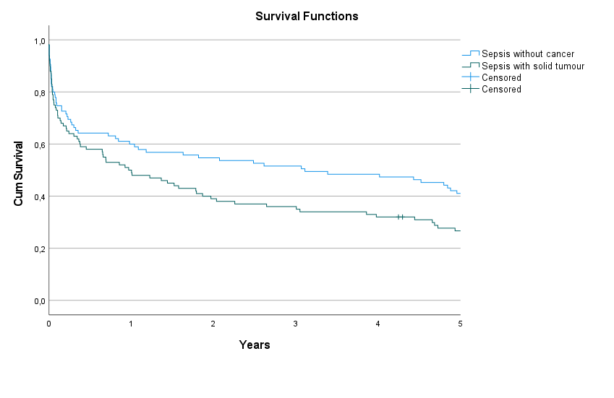 Figure S2: Long-term survival of propensity-score matched groups of sepsis patients without cancer (blue) and sepsis patients with solid-tumour (green) (p=0.009 (Log Rank test)).

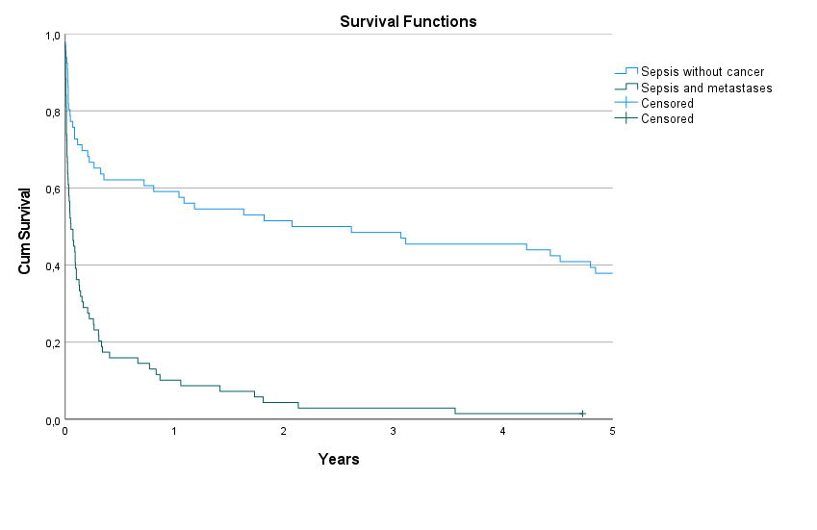 Figure S3: Long-term survival of propensity-score matched groups of sepsis patients without cancer (blue) and sepsis patients with metastatic malignancy (green) (p<0.001 (Log Rank test)).

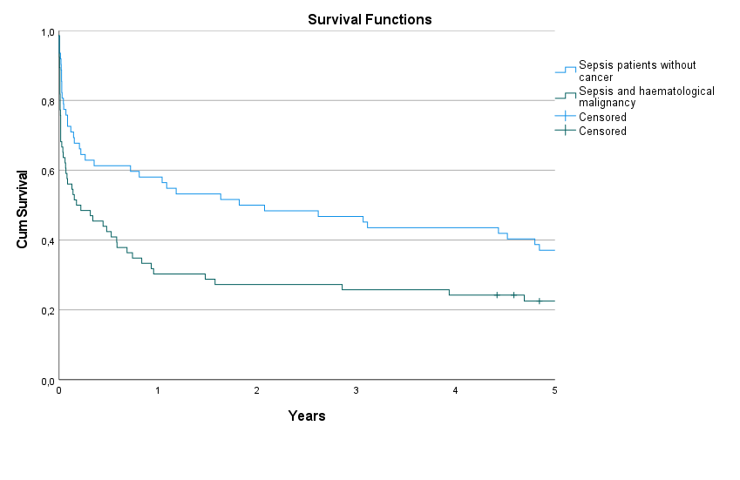
Figure S4: Long-term survival of propensity-score matched groups of sepsis patients without cancer (blue) and sepsis patients with haematological malignancy (green) (p=0.002 (Log Rank test)).

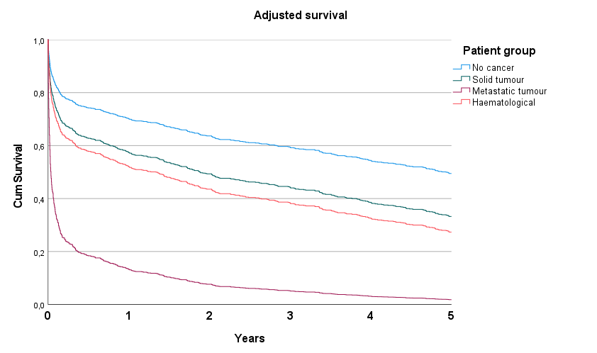
Figure S5: Adjusted survival curves for five-year survival of the four groups of sepsis patients after fitting a Cox proportional hazards model.

