Supplementary Material

Suppl. Mat A:
The patient-specific prostate CTV used for the ARPT plans (white contour) was created as the union between the prostate CTV from the first CT (red), second CT (green) and third CT (yellow) with the rectum (brown) subtracted. The original prostate CTV from the first CT (red) was used in the conventional robust PT plans and the prostate PTV was used in the VMAT plans (blue contour).

Suppl. Mat. B
In-house dose constraints for relevant organs at risk and PTVs in locally advanced prostate cancer.
Priority | Structure | Constraint
1 | Rectum | D_{1cc} < 74
1 |  | V_{70Gy} ≤ 10%
3 |  | 50 Gy isodose curve may not enclose the entire rectum
2 | Bowel loops |  | D_{2cc} < 70 Gy
2 |  |  | D_{0.1cm}³ < 74 Gy
3 | PTV 78 |  | D_{95%} ≥ 74.1 Gy
4 | PTV 56 |  | D_{95%} ≥ 53.2 Gy
5 | Femoral head |  | D_{max} < 52 Gy
5 | Bowel cavity |  | V_{35Gy} ≤ 40%
- | PTV 74 |  | D_{mean} = 100%
- | Body | D_{max} = 107%

Suppl. Mat. C
Lyman-Kutcher-Burman NTCP models and a DVH-based NTCP model for rectum and bladder. The rectum NTPC models are for late rectal bleeding (LRB)≥2 [20][21]. The bladder NTCP modes are for bladder urgency [22] and grade 3+ late urinary morbidity [23]. The risk of Grade 2+ acute diarrhoea have been estimated based on a correlation with the bowel cavity volume receiving 45 Gy or higher (Figure 2 in [24]).
Structure | Model | Endpoint | n | m | D50 [Gy]
Rectum | Emami et al. | LRB ≥ 2 | 0.12 | 0.15 | 80.0
Rectum | Quantec | LRB ≥ 2 | 0.09 | 0.13 | 76.9 Gy
Bladder | Mavroidis et al. | Urgency | 1 | 0.5 | 64.2
Bladder | Pedersen et al. | GR3+ | S = -4.22+(anticoagulant_use)*  0.27+(prostate_vol.)*0.008+  (bladder(D5))*0.006+  (bladder(V75)*0.015 |  | $$NTCP=\frac{1}{1+e^{-S}}$$

Suppl. Mat. D:
The mean dose in the first CT (red cross) and median and range (black dot and line) across the rCTs for the OARs across all patients and plans.

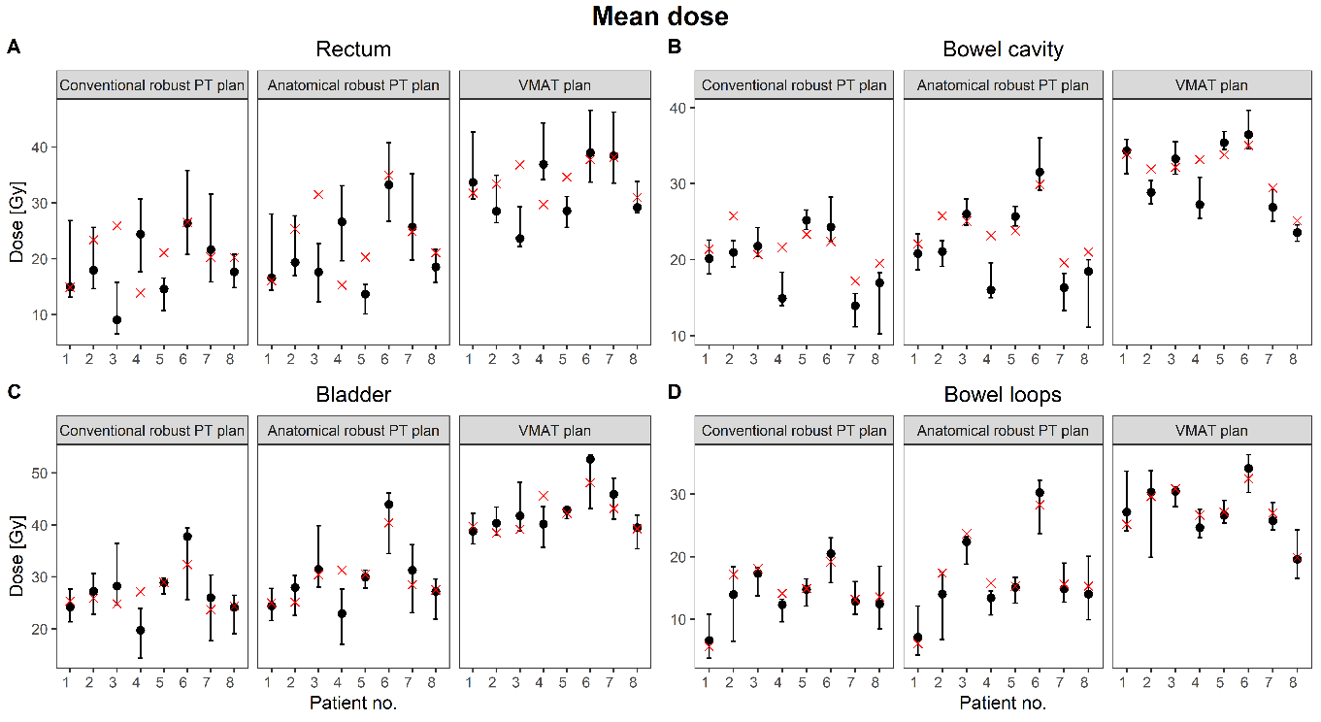

Suppl. Mat. E
The NTCP values in the first CT (red cross) and median and range (black dot and line) across the rCTs for the rectum, bladder and bowel cavity across all patients and plans.
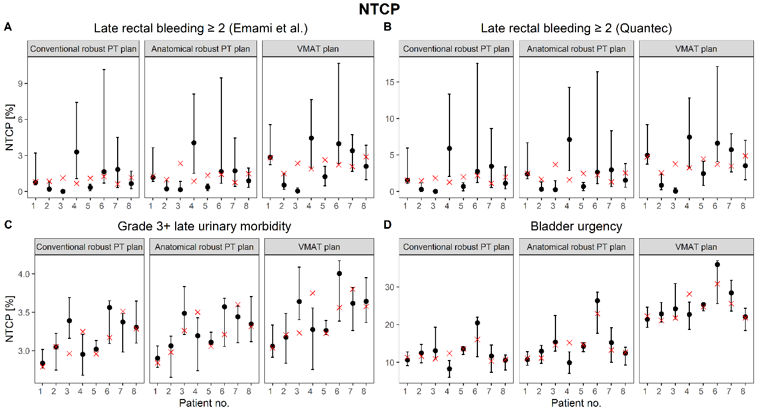

Suppl. Mat F:
NTCP values (median and range) in the rCTs for each patient, plan and NTCP model including statistical mean and 95% confidence interval across patients.
Late rectal bleeding ≥ 2 (Emami et al.)
Patient no. | Conventional robust PT plan | Anatomical robust PT plan | VMAT plan
1 | 0.8 (0.5-3.2) | 1.2 (0.8-3.6) | 2.8 (2.2-5.6)
2 | 0.2 (0.0-0.8) | 0.2 (0.1-0.9) | 0.5 (0.2-1.5)
3 | 0.0 (0.0-0.1) | 0.2 (0.0-0.8) | 0.0 (0.0-0.3)
4 | 3.3 (1.1-7.4) | 4.1 (1.5-8.1) | 4.5 (1.9-7.6)
5 | 0.3 (0.1-0.6) | 0.4 (0.1-0.6) | 1.2 (0.5-2.1)
6 | 1.7 (0.7-10.1) | 1.7 (0.7-9.5) | 4.0 (2.3-10.7)
7 | 1.8 (0.3-4.5) | 1.7 (0.4-4.5) | 3.4 (1.7-4.7)
8 | 0.7 (0.2-1.7) | 0.9 (0.3-2.0) | 2.1 (1.0-3.8)
Mean (95%CI) | 1.3 (0.3-2.4) | 1.5 (0.5-2.6) | 2.6 (1.5-3.6)

Late rectal bleeding ≥ 2 (Quantec)
Patient no. | Conventional robust PT plan | Anatomical robust PT plan | VMAT plan
1 | 1.5 (1.1-6.0) | 2.4 (1.7-6.7) | 5.0 (3.7-9.2)
2 | 0.3 (0.0-1.2) | 0.3 (0.1-1.3) | 0.9 (0.2-2.4)
3 | 0.0 (0.0-0.1) | 0.2 (0.0-1.5) | 0.0 (0.0-0.5)
4 | 5.9 (2.1-13.3) | 7.1 (2.9-14.2) | 7.5 (3.3-12.8)
5 | 0.7 (0.1-1.2) | 0.7 (0.1-1.2) | 2.5 (0.8-4.1)
6 | 2.8 (1.2-17.6) | 2.6 (1.1-16.4) | 6.6 (4.1-17.1)
7 | 3.5 (0.5-8.6) | 3.0 (0.7-8.3) | 5.7 (2.7-7.9)
8 | 1.1 (0.3-3.4) | 1.5 (0.6-3.8) | 3.5 (1.7-7.0)
Mean (95%CI) | 2.4 (0.6-4.2) | 2.7 (0.9-4.5) | 4.3 (2.5-6.1)

Grade 3+ late urinary morbidity
Patient no. | Conventional robust PT plan | Anatomical robust PT plan | VMAT plan
1 | 2.8 (2.8-3.0) | 2.9 (2.8-3.1) | 3.1 (2.9-3.3)
2 | 3.1 (2.8-3.2) | 3.1 (2.7-3.2) | 3.2 (2.8-3.5)
3 | 3.4 (3.2-3.7) | 3.5 (3.2-3.8) | 3.6 (3.4-4.1)
4 | 3.0 (2.7-3.2) | 3.2 (2.8-3.4) | 3.3 (2.8-3.6)
5 | 3.0 (3.0-3.1) | 3.1 (3.1-3.2) | 3.3 (3.2-3.4)
6 | 3.6 (3.1-3.7) | 3.6 (3.1-3.7) | 4.0 (3.4-4.2)
7 | 3.4 (3.0-3.5) | 3.4 (3.1-3.6) | 3.6 (3.3-3.8)
8 | 3.3 (3.1-3.7) | 3.4 (3.1-3.7) | 3.6 (3.4-4.0)
Mean (95%CI) | 3.2 (3.0-3.4) | 3.2 (3.1-3.4) | 3.5 (3.3-3.6)

Bladder urgency
Patient no. | Conventional robust PT plan | Anatomical robust PT plan | VMAT plan
1 | 10.7 (9.1-12.8) | 10.8 (9.2-12.8) | 21.4 (19.3-24.7)
2 | 12.5 (9.8-14.8) | 13.0 (9.7-14.5) | 22.9 (20.7-25.9)
3 | 13.1 (10.9-19.4) | 15.4 (13.0-22.4) | 24.2 (21.5-30.9)
4 | 8.3 (6.0-10.5) | 9.9 (7.1-12.8) | 22.7 (18.8-26.0)
5 | 13.6 (12.1-14.2) | 14.3 (12.9-15.3) | 25.4 (23.7-25.9)
6 | 20.5 (11.5-22.0) | 26.4 (17.7-28.6) | 36.0 (25.6-37.0)
7 | 11.7 (7.4-14.6) | 15.3 (10.0-19.2) | 28.4 (23.6-31.8)
8 | 10.6 (8.0-12.0) | 12.5 (9.4-14.0) | 22.1 (18.5-24.4)
Mean (95%CI) | 12.4 (9.5-15.3) | 14.5 (11.6-17.3) | 25.2 (22.4-28.1)

Grade 2+ acute diarrhoea
Patient no. | Conventional robust PT plan | Anatomical robust PT plan | VMAT plan
1 | 24.2 (23.0-24.9) | 24.6 (23.4-25.4) | 27.5 (26.0-28.9)
2 | 25.7 (24.2-29.1) | 25.7 (24.3-29.2) | 27.0 (25.7-30.2)
3 | 29.9 (29.7-37.3) | 32.1 (31.7-39.7) | 32.4 (31.7-40.4)
4 | 29.3 (28.7-32.1) | 30.2 (29.6-33.3) | 33.6 (31.8-37.2)
5 | 35.7 (34.6-37.7) | 36.0 (34.9-38.0) | 39.6 (37.8-41.2)
6 | 37.6 (33.0-39.1) | 45.5 (40.8-46.8) | 41.6 (37.3-42.6)
7 | 28.8 (24.7-30.1) | 29.7 (25.5-31.0) | 31.5 (28.8-36.3)
8 | 28.5 (27.3-30.9) | 29.9 (28.6-32.6) | 26.1 (25.4-28.1)
Mean (95%CI) | 30.1 (26.2-34.0) | 31.8 (27.9-35.7) | 32.7 (28.8-36.6)

Suppl. Mat G:
The field placement for the four field configurations investigated. In all cases, two lateral opposed fields were targeting the prostate and seminal vesicles target, while the field placement for the lymph node target varied.
 | 1. configuration | 2. configuration | 3. configuration | 4. configuration
Prostate & seminal vesicles | 90 & 270 degrees | 90 & 270 degrees | 90 & 270 degrees | 90 & 270 degrees
Lymph nodes | 90, 180 & 270 degrees | 35, 180 & 325 degrees | 150, 180 & 210 degrees | 35, 150, 180, 210 & 325 degrees

