Table S1: Target characteristics for cohorts A and B. The Welch's t-test was used to determine the p-value.
 | Cohort A | Cohort B | P-value
Patient Number | 1-26 | 27-43
CTV (cm³) on avg CT1  Median[range] | 289.35  [134.5, 695.2] | 104.4  [56.7, 579.4] | 0.0088
Target respiratory amplitude (cm) in CC  Median[range] | 0.40  [0.07, 0.94] | 0.37  [0.15, 0.79] | 0.70

Table S2. Details of target volume, location and respiratory amplitude in three directions.
Cohort | Patient Number | CTV Volume on CT1 (cm³) | Target location w.r.t diaphragm* | Target respiratory amplitude (cm)
 |  |  |  | x-direction (R-L) | Y-direction (AP/PA) | Z-direction (CC)
A | 1 | 327.7 | 2 | 0.05 | -0.58 | -0.86
A | 2 | 144.5 | 2 | 0.05 | -0.04 | -0.30
A | 3 | 269.4 | 2 | 0.03 | -0.08 | -0.22
A | 4 | 321.6 | 2 | -0.09 | -0.05 | -0.37
A | 5 | 413.8 | 2 | -0.01 | -0.08 | -0.31
A | 6 | 306.9 | 2 | -0.03 | -0.11 | -0.49
A | 7 | 218.4 | 2 | -0.04 | -0.17 | -0.33
A | 8 | 538.0 | 2 | 0.11 | -0.16 | -0.41
A | 9 | 255.8 | 2 | -0.08 | -0.11 | -0.67
A | 10 | 274.9 | 2 | -0.03 | -0.09 | -0.52
A | 11 | 641.3 | 2 | -0.07 | 0.03 | -0.07
A | 12 | 406.0 | 2 | -0.12 | 0.01 | -0.30
A | 13 | 249.9 | 2 | -0.06 | -0.04 | -0.44
A | 14 | 296.1 | 2 | -0.02 | 0.07 | -0.31
A | 15 | 134.5 | 1 | 0.09 | -0.06 | -0.33
A | 16 | 236.4 | 2 | 0.05 | -0.14 | -0.41
A | 17 | 298.9 | 2 | 0.08 | -0.04 | -0.26
A | 18 | 254.2 | 2 | 0.02 | -0.14 | -0.78
A | 19 | 229.2 | 2 | -0.06 | -0.17 | -0.80
A | 20 | 322.1 | 2 | -0.05 | -0.08 | -0.94
A | 21 | 695.2 | 2 | -0.12 | 0.02 | -0.38
A | 22 | 499.9 | 1 | -0.07 | -0.05 | -0.27
A | 23 | 213.1 | 2 | -0.06 | 0.08 | -0.29
A | 24 | 368.3 | 2 | -0.09 | 0.02 | -0.50
A | 25 | 271.6 | 3 | -0.16 | -0.25 | -0.93
A | 26 | 282.6 | 2 | -0.01 | -0.01 | -0.54
B | 27 | 99.7 | 2 | 0.00 | -0.34 | -0.56
B | 28 | 101.6 | 2 | -0.09 | -0.11 | -0.36
B | 29 | 104.4 | 2 | -0.16 | -0.14 | -0.50
B | 30 | 392.5 | 2 | -0.03 | -0.11 | -0.35
B | 31 | 454.7 | 2 | -0.04 | -0.08 | -0.40
B | 32 | 102.4 | 3 | 0.06 | -0.30 | -0.77
B | 33 | 327.6 | 2 | -0.04 | 0.01 | -0.48
B | 34 | 272.4 | 3 | -0.08 | -0.22 | -0.79
B | 35 | 162.2 | 2 | 0.00 | -0.03 | -0.27
B | 36 | 179.3 | 2 | -0.05 | -0.20 | -0.55
B | 37 | 103.7 | 2 | 0.03 | -0.25 | -0.77
B | 38 | 100.9 | 2 | -0.09 | -0.11 | -0.36
B | 39 | 79.6 | 2 | -0.03 | -0.11 | -0.23
B | 40 | 56.7 | 1 | -0.01 | -0.03 | -0.15
B | 41 | 92.4 | 2 | 0.01 | -0.05 | -0.32
B | 42 | 579.4 | 2 | -0.03 | -0.04 | -0.37
B | 43 | 154.2 | 3 | 0.03 | -0.01 | -0.02
* 1= CTV above diaphragm, 2 = CTV on diaphragm, 3= CTV below diaphragm

Table S3: Dose constraints for target coverage and OARs are given. These constraints were mandatory for all patient’s nominal plan and all robustness scenarios. These dose constraints are taken from PROTECT RTQA document.
Targets/  OARs | Target/OARs Dose Constraints for CT1 |  | Target/OARs Dose Constraints for CT2
Targets/  OARs | Dose  (Nominal plan) | Dose  (All scenarios)/ All phases | Dose  (Nominal plan) | Dose  (All scenarios)/ All phases
iCTV | V95%_{iCTV} >99%  98% < D_{mean} < 102% | V95%_{iCTV} >97% | V95%_{iCTV} >99%  98% < D_{mean} < 102% | V95%_{iCTV} >96%
Spinal cord | D_{0.05cm3} < 45Gy | D_{0.05cm3} < 50Gy | D_{0.05cm3} < 50Gy
Body | D_{0.05cm3} < 110%  D_{1cm3} < 107% | D_{1cm3} < 110%  D_{5cm3} < 107% | D_{1cm3} < 110%  D_{5cm3} < 107%
CTVtotal |  | *V95%_{CTVtotal} >97% |  | *V95%_{CTVtotal} >96%
Lungs | MLD < 20Gy  V20Gy < 35%  V5Gy < 70% | Not evaluated
Heart | MHD < 26Gy  V40Gy < 30%  V25Gy < 50% | Not evaluated
Kidney | MKD < 10 Gy  V20Gy < 32%  V6Gy < 30% for one functional kidney | Not evaluated
Stomach-iCTV | D_{0.5cm3} < 103%
Bowel Cavity | V30Gy < 600 cm3 V45Gy < 300 cm
Spleen | MSD < 20Gy | Not evaluated

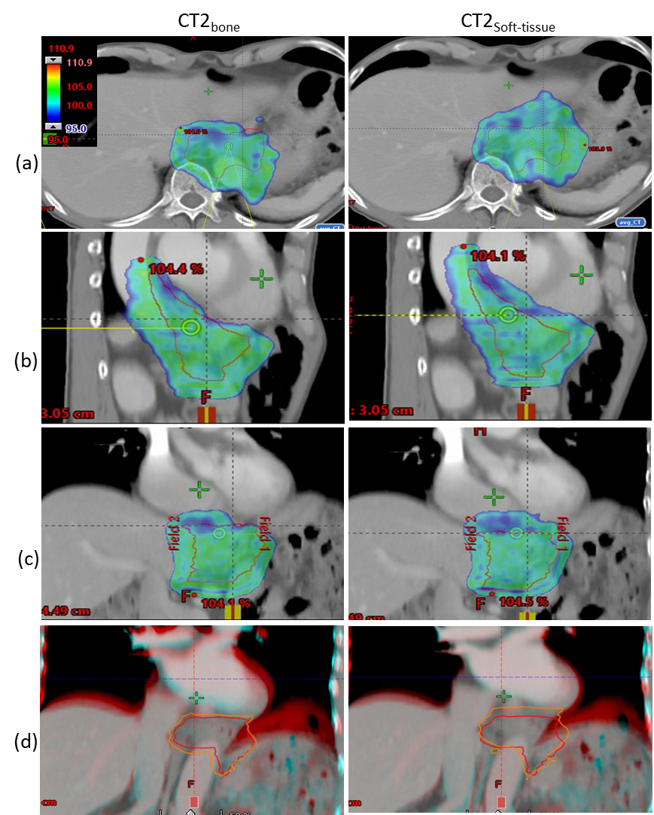
Figure S1. V95%iCTV coverage for patient No. 36(cohort B) shows that the large diaphragmatic shift did not cause any dose deterioration due to the location of the target being predominantly below the diaphragm with bone match (left column) as compared to the soft tissue match (right column) for the same slice in (a) transverse, (b)sagittal and (c) coronal view. Row (d) shows the registration difference between (left) CT1 and CT2 _{Bone} and (Right) CT1 and CT2_{Soft-tissue} in coronal view. Orange and red contours represent the iCTV delineated on CT1 and CT2 respectively.

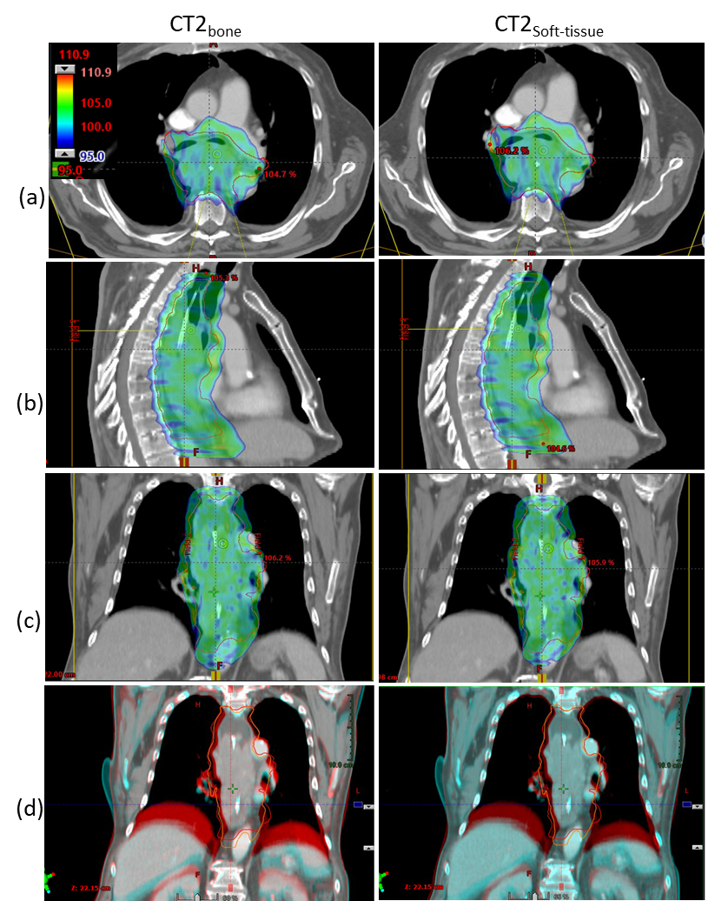
Figure S2. V95%iCTV coverage for patient No. 42(cohort B) shows that a large cranial diaphragmatic shift let the target dose nearly unaffected at the level of the diaphragm due to its position mostly cranial to the diaphragm. However, deformations of the target let to scattered under-dosage and as the target was very extended, dose deterioration below the limit was observed for CT2_{bone} as compared to the soft tissue match (right column) for the same slice in (a) transverse, (b)sagittal and (c) coronal view. Row (d) shows the registration difference between (left) CT1 and CT2 _{Bone} and (Right) CT1 and CT2_{Soft-tissue} in coronal view. Orange and red contours represent the iCTV delineated on CT1 and CT2 respectively.

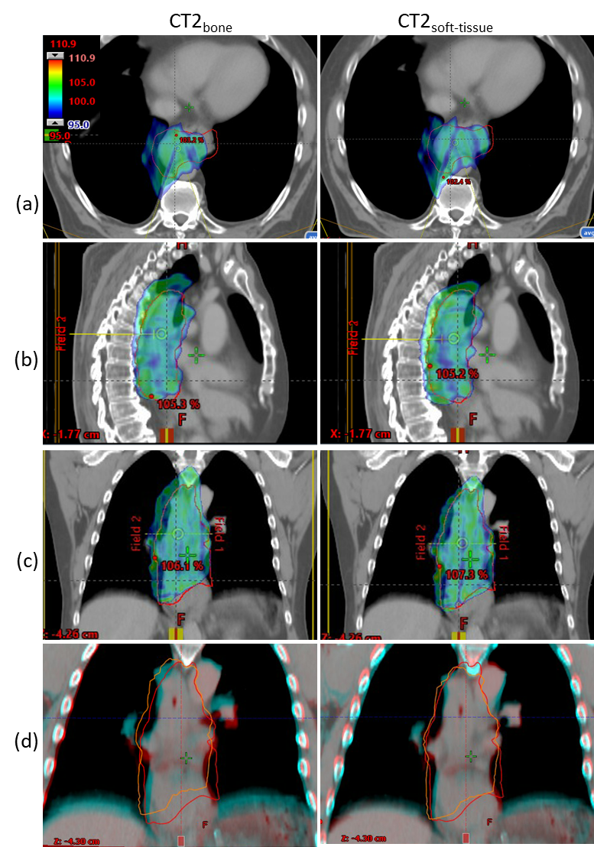
Figure S3. V95%iCTV coverage for patient No. 20 (cohort A) shows that a lateral shift and deformation of the target caused target depletion with bone match (left column) as compared to the soft tissue match (right column) for the same slice in (a) transverse, (b)sagittal and (c) coronal view. Row (d) shows the registration difference between (left) CT1 and CT2 _{Bone} and (Right) CT1 and CT2_{Soft-tissue} in coronal view. Orange and red contours represent the iCTV delineated on CT1 and CT2 respectively.

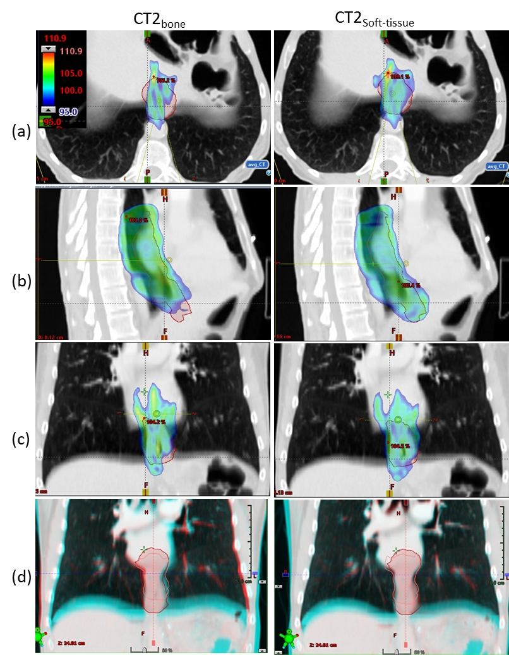
Figure S4. V95%iCTV coverage for patient No. 27(cohort B) shows lateral shift between CT1 and CT2 along with diaphragm shift in caudal direction. There was a minor effect of diaphragm shift between CT1 and CT2, however, caudal shift in the target caused dose depletion as the target moved into the region where there was no dose for the target with bone match (left column) as compared to the soft tissue match (right column) for the same slice in (a) transverse, (b)sagittal and (c) coronal view. Row (d) shows the registration difference between (left) CT1 and CT2 _{Bone} and (Right) CT1 and CT2_{Soft-tissue} in coronal view. Orange and red contours represent the iCTV delineated on CT1 and CT2 respectively.

Figure S5. Dosimetric comparison between the Superior-Inferior (S-I) posterior oblique beams versus posterior oblique beams used in this study. S-I posterior oblique beams generally reduce the mean lung dose due its entrance avoiding the lungs compared to R-L posterior oblique beams. Spinal cord doses are higher for the S-I beam arrangement, as both beams go through the spinal cord. For the mean heart dose, only one patient had lower dose for the S-I beam configuration compared to the R-L beam configuration. The gain in mean heart dose depends on the location of the heart with respect to the target when S-I posterior oblique beams are used. These five patients are those who required adaptation after the bone match.

Figure S6. Dosimetric comparison between the Superior-Inferior (S-I) posterior oblique beams versus posterior oblique beams (this study) for patient No.18 and 20. S-I posterior oblique beams reduce the lung dose due to less exposure to lung volume while it is higher for R-L posterior oblique beams. S-I posterior oblique beams reduces the heart dose when the target is slightly lower than the heart as shown in patient No.18, while there is no dosimetric benefit when the target is located both cranial and caudal to the heart as shown in patient 20.

Figure S7. Robustness evaluation of V95%_{iCTV} for CT1 and CT2 (with bone or soft tissue registration), respectively. Box plot: median (red vertical line), first and third interquartile ranges (box), and minimum/maximum (whiskers). Five patients which required adaptation with bone match were re-planned with the application of one S-I posterior oblique and one posterior beam (Gantry angle 155º, Gantry angle 185º) with couch angle 270º. Better robustness was found for the soft-tissue match compared to the bone match. However, still three patients required adaptation after soft tissue match for the S-I posterior beams.

