Supplementary table 1a. Results of the Cox regression analysis for the RC group for the endpoint of local recurrence within 2 years after start treatment.
Risk factor | Univariable
 | HR | 95% CI | p
Age ≥75 vs <75 | 1.73 | 0.71-4.26 | 0.23
Gender female vs male | 1.85 | 0.55-6.29 | 0.32
CCI ≥3 vs <3 | 0.70 | 0.30-1.63 | 0.41
Smoking at diagnosis yes vs no | 0.72 | 0.30-1.71 | 0.45
WHO PS ≥1 vs 0 | 0.67 | 0.20-2.29 | 0.53
Additional CIS yes vs no | 1.53 | 0.59-3.97 | 0.38
T-stage T3-4 vs T2 | 1.72 | 0.73-4.04 | 0.21

Abbreviations: WHO-PS = WHO Performance status, CCI = Charlson comorbidity index, CIS = carcinoma in situ, RT = Radiotherapy only group, CRT = Chemoradiation group, RC = Radical Cystectomy group.

Supplementary table 1b. Results of the Cox regression analysis for the combined RC+CRT group for the endpoint of local recurrence within 2 years after start treatment.
Risk factor | Univariable
 | HR | 95% CI | p
Age ≥75 vs <75 | 1.92 | 0.83-4.24 | 0.13
Gender female vs male | 1.85 | 0.55-6.29 | 0.32
CCI ≥3 vs <3 | 0.67 | 0.34-1.32 | 0.24
Smoking at diagnosis yes vs no | 0.94 | 0.47-1.86 | 0.85
WHO PS ≥1 vs 0 | 1.06 | 0.52-2.17 | 0.87
Additional CIS yes vs no | 1.17 | 0.55-2.53 | 0.68
T-stage T3-4 vs T2 | 2.39 | 1.21-4.75 | 0.013

Abbreviations: WHO-PS = WHO Performance status, CCI = Charlson comorbidity index, CIS = carcinoma in situ, RT = Radiotherapy only group, CRT = Chemoradiation group, RC = Radical Cystectomy group.

Supplementary table 2a. Results of the Cox regression analysis for the RC group for the endpoint of overall survival within 5 years after start treatment.
Risk factor | Univariable
 | HR | 95% CI | p
Age ≥75 vs <75 | 1.38 | 0.71-2.71 | 0.34
Gender female vs male | 0.88 | 0.27-2.85 | 0.83
CCI ≥3 vs <3 | 1.22 | 0.67-2.22 | 0.52
WHO PS ≥1 vs 0 | 1.45 | 0.70-2.98 | 0.31
Additional CIS yes vs no | 1.23 | 0.64-2.37 | 0.54
T-stage T3-4 vs T2 | 1.46 | 0.80-2.67 | 0.22

Abbreviations: WHO-PS = WHO Performance status, CCI = Charlson comorbidity index, CIS = carcinoma in situ, RT = Radiotherapy only group, CRT = Chemoradiation group, RC = Radical Cystectomy group.

Supplementary table 2b. Results of the Cox regression analysis for the combined RC+CRT group for the endpoint of overall survival within 5 years after start treatment.
Risk factor | Univariable
 | HR | 95% CI | p
Age ≥75 vs <75 | 1.38 | 0.71-2.71 | 0.34
Gender female vs male | 0.88 | 0.27-2.85 | 0.83
CCI ≥3 vs <3 | 1.22 | 0.67-2.22 | 0.52
WHO PS ≥1 vs 0 | 1.13 | 0.70-2.98 | 0.31
Additional CIS yes vs no | 1.01 | 0.62-1.66 | 0.96
T-stage T3-4 vs T2 | 1.82 | 1.17-2.83 | 0.008

Abbreviations: WHO-PS = WHO Performance status, CCI = Charlson comorbidity index, CIS = carcinoma in situ, RT = Radiotherapy only group, CRT = Chemoradiation group, RC = Radical Cystectomy group.

Suppl Figure A. Local Control (Kaplan Meier estimates) for treatment groups CRT (chemoradiotherapy), RC (radical cystectomy), and RT (radiotherapy only).
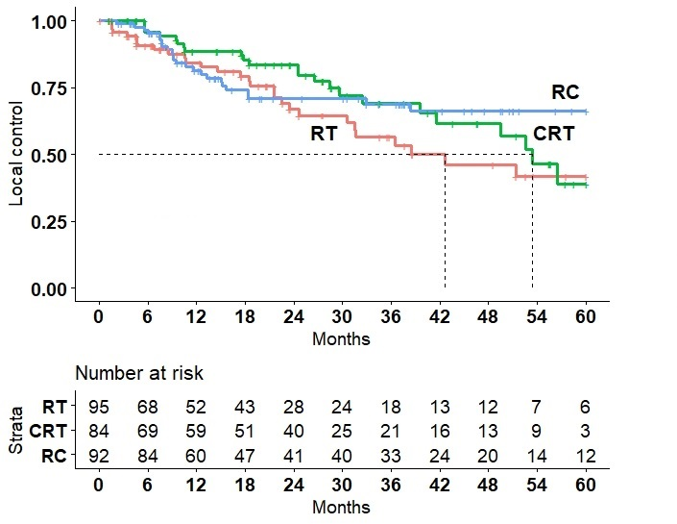

Supl File: Applied STROBE Checklist.
Manuscript | Item | No
Title/Abstract | Indicate the study’s design with a commonly used term in the title or the abstract | 1
Introduction | Explain the scientific background and rationale | 2
Introduction | State specific objectives, including any prespecified hypotheses | 3
METHODS
Design | Present key elements of study design early in the paper | 4
Setting | Describe the setting, locations, and relevant dates, including periods of recruitment, exposure, follow-up, and data collection | 5
Participants | Give the eligibility criteria, and the sources and methods of selection of participants. Describe methods of follow-up. | 6
Variables | Clearly define all outcomes, exposures, predictors, potential confounders, and effect modifiers. Give diagnostic criteria, if applicable | 7
Data sources / measurements | For each variable of interest, give sources of data and details of methods of assessment (measurement). Describe comparability of assessment methods if there is more than one group | 8
Bias | Describe any efforts to address potential sources of bias | 9
Sample Size | Explain how the study size was arrived at | 10
 | Explain how quantitative variables were handled in the analyses. If applicable, describe which groupings were chosen and why | 11
Statistical Methods | (a) Describe all statistical methods, including those used to control for confounding  (b) Describe any methods used to examine subgroups and interactions  (c) Explain how missing data were addressed  (d) Cohort study—If applicable, explain how loss to follow-up was addressed  e) Describe any sensitivity analyses | 12
RESULTS
Participants | (a) Report numbers of individuals at each stage of study—eg numbers potentially eligible, examined for eligibility, confirmed eligible, included in the study, completing follow-up, and analysed, (b) Give reasons for non-participation at each stage,  (c) Consider use of a flow diagram | 13
Descriptive data | (a)Give characteristics of study participants (eg demographic, clinical, social) and information on exposures and potential confounders  (b) Indicate number of participants with missing data for each var of interest  (c) Cohort study—Summarise follow-up time (eg average and total amount) | 14
Outcome data | Report numbers of outcome events or summary measures over time | 15
Main results | (a) Report the numbers of individuals at each stage of the study—eg numbers potentially eligible, examined for eligibility, confirmed eligible, included in the study, completing follow-up, and analysed, (b) Give reasons for non-participation at each stage, (c) Consider use of a flow diagram | 16
Other analyses | Report other analyses done—eg subgroups, interactions, sensitivity analyses | 17
DISCUSSION/OTHER
Key results | Summarise key results with reference to study objectives | 18
Limitations | Discuss limitations of the study, taking into account sources of potential bias or imprecision. Discuss both direction and magnitude of any potential bias | 19
Interpretation | Give a cautious overall interpretation of results considering objectives, limitations, multiplicity of analyses, results from similar studies, and other relevant evidence | 20
Generalisability | Discuss the generalisability (external validity) of the study results | 21
Funding | Give the source of funding and the role of the funders for the present study and, if applicable, for the original study on which the present article is based | 22

