Supplementary Table 1. Primers, probes, and methods for ctDNA analysis

Targeted sequences | Modification | Forward primer (5’>3’) | Probe sequence (5’>3’) | Reverse primer (5’>3’) | Formulation
WIF1 | FAM-MGB | GAGGGAGTTGTAGCGTAGTAGAGTATTTG | CGGCGTTAGGTTGC | AAAACTCCTCGTACCGCACCTA | 20x
NPY | FAM-MGB | CGCGGCGAGGAAGTTTTATA | CGCGATTCGTTTTTTGTA | ATACTATCGAACGAACGTCTCCG | 20x
Albumin | VIC-MGB | GGGATGGAAAGAATTTTATGTT | AGGGTTTTTATAATTTA | AAACAAACTAACCCCAAATTCT | 20x

All primers and probes were manifactured by Applied Biosystems (Thermo Fisher Scientific, Waltham, USA)
PCR conditions for WIF1: Step 1: 2’ at 50°C. Step 2: 10’ at 95°C. Step 3: 44 cycles at 95°C for 15’’ and 57.7°C for 1’ 2°C/second ramp rate. Step 4: 10’ at 98°C.
PCR conditions for NPY: Step 1: 2’ at 50°C. Step 2: 10’ at 95°C. Step 3: 44 cycles at 95°C for 15’’ and 55.5°C for 1’ 1.5°C/second ramp rate. Step 4: 10’ at 98°C.
The maximum number of false positive droplets in negative controls were 4 for WIF1 (N=10) and 1 for NPY (N=18). Mean false positive droplets were 0.17 (SD 0.37) for NPY and 1.89 (SD 0.99) for WIF1. The calculated limit of blank for NPY and WIF1 were 1.64 and 4.95, respectively. Samples with ≥2 positive droplets for NPY and ≥5 positive droplets for WIF1 were considered positive.
Samples with <10000 droplets were not considered assessable

Supplementary Table 2. Patients’ characteristics
 | N (%)
Sex  Male  Female | 49 (61.3)  31 (38.2)
Median age (SD) | 62.9 (9.9)
ECOG PS  0  1  Unknown | 55 (68.8)  24 (30)  1 (1.2)
Primary tumor sidedness  Right  Left | 35 (43.7)  44 (56.3)
Median CEA (IQR) | 2.85 (4.55)
Grade of differentiation  Well differentiated  Moderately/Poor differentiated  Unknown | 31 (38.8)  36 (45)  13 (16.2)
Pathological stage  I/II  III | 44 (55)  36 (45)
Number of adjuvant chemotherapy cycles received  0  4  6  8  11 | 44 (55)  2 (2.4)  1 (1.3)  1 (1.3)  32 (40)

Abbreviations: ECOG PS – Eastern Cooperative Oncology Group Performance Status; IQR – interquartile range; SD – standard deviation.

Supplementary Figure 1. Disease-free survival (A) and overall survival (B) in the whole study cohort

A) B)
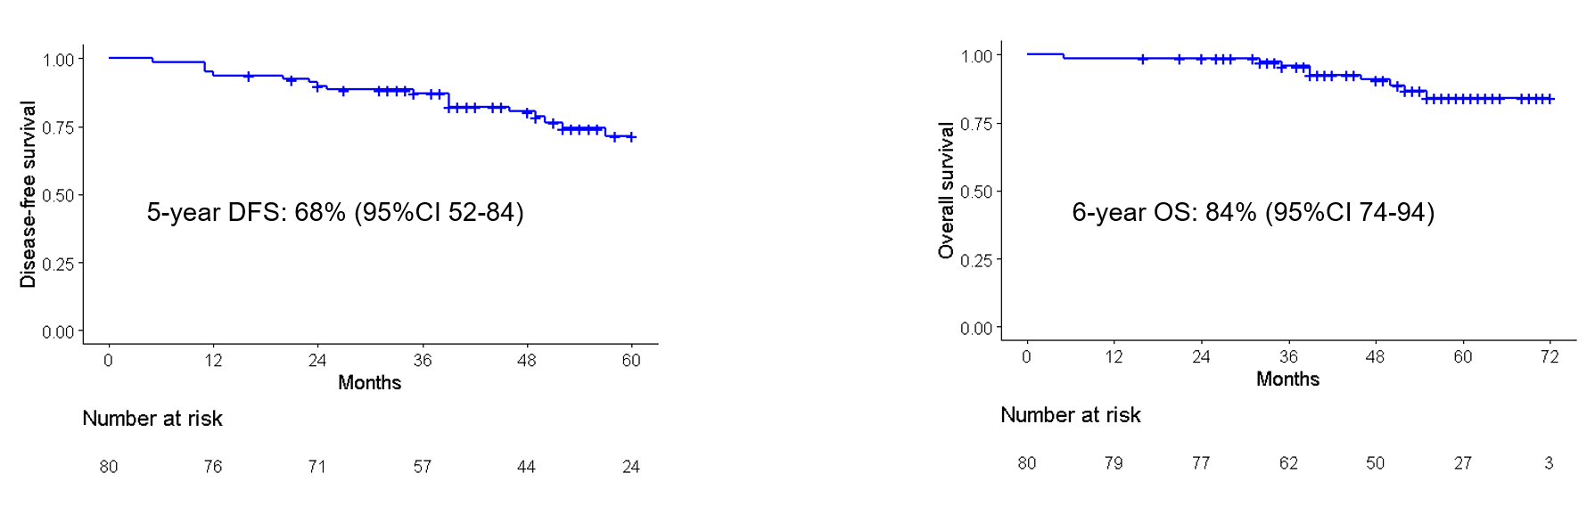

Supplementary Figure 2. Overall survival by cfDNA (A) and ctDNA (B) relative changes from baseline to surgery

A) B)

