Supplement Figure 1 Attention maps obtained at different iterations
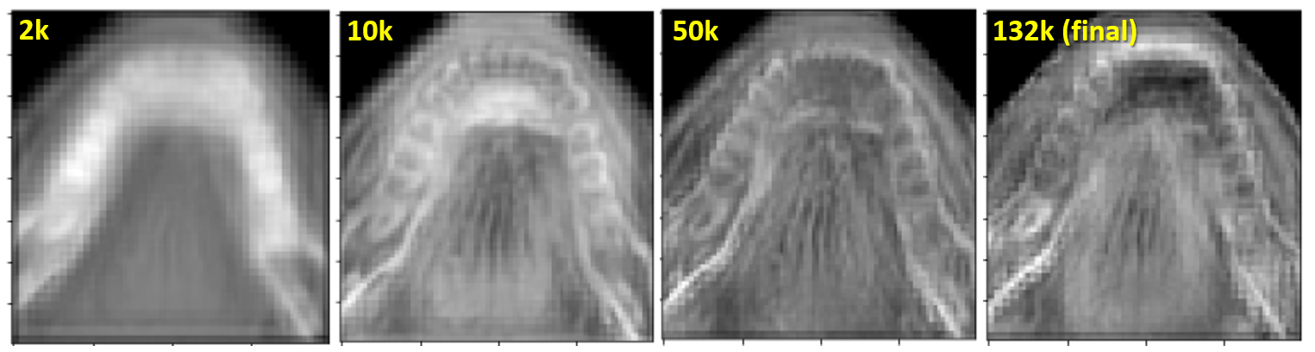

Supplement Figure 2 3D-Unet with residual blocks and attentions
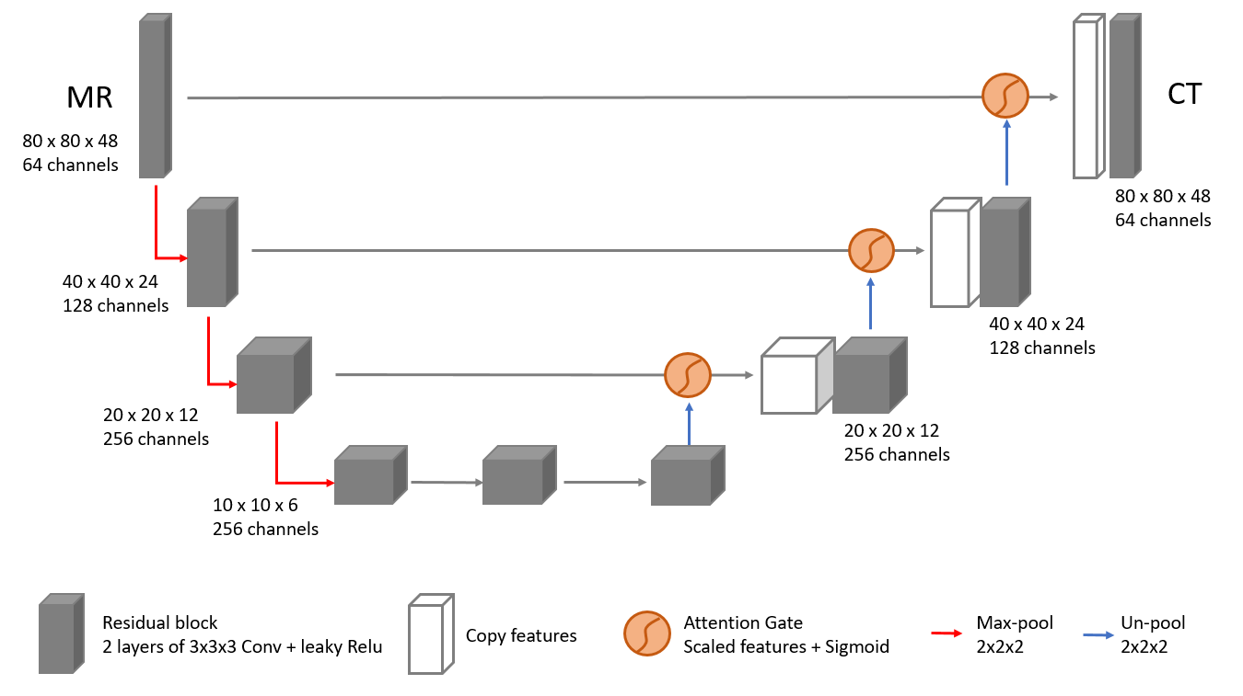

Supplement Figure 3 The DVH-parameter differences between the dose calculated on the PCT image and the dose calculated on the SCT images
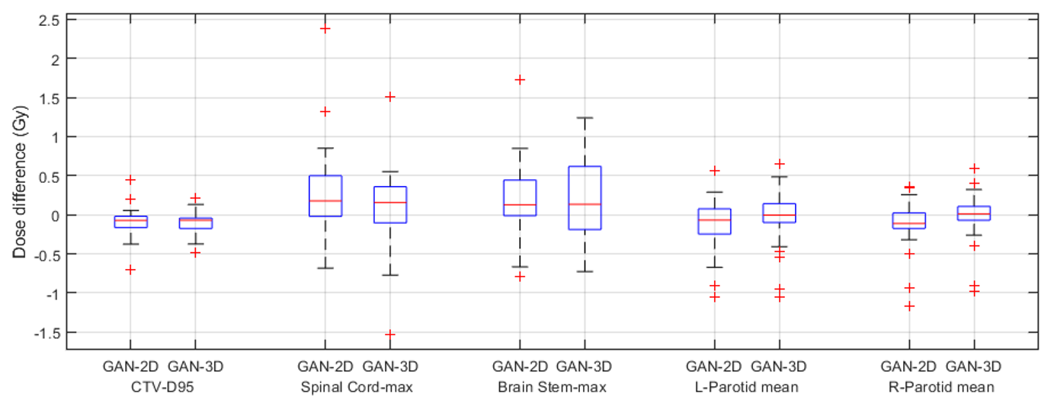

Models | Number of layers | Filter number | Filter size | Stride
2D | 6 | 64-128-256-512-512-1 | 4x4 for 1-5 layers 1x1 for the last layer | 2-2-2-2-2-1
3D | 6 | 64-128-128-256-512-1 | 4x4x4 for 1-5 layers 1x1x1 for the last layer | 2-2-2-2-2-1
Supplement table 1 Discriminator hyperparameter settings

