Online-Only Supplements
This document include the following online-only materials:
eTable 1
eFigure 1
eFigure 2
eFigure 3
eFigure 4
eFigure 5
eFigure 6
eFigure 7
eFigure 8
eFigure 9
eFigure 10
eFigure 11
eFigure 12
eFigure 13
eFigure 14
eFigure 15
eTable 1: International Classification of Disease 10 codes for included cancer diagnoses (online only)
ICD 10 codes | Code text
C16* | Malignant neoplasm of stomach
C17* | Malignant neoplasm of small intestine
C18* | Malignant neoplasm of colon
C19* | Malignant neoplasm of rectosigmoid junction
C20* | Malignant neoplasm of rectum
C21* | Malignant neoplasm of anus and anal canal
C25* | Malignant neoplasm of pancreas
C33* | Malignant neoplasm of trachea
C34* | Malignant neoplasm of bronchus and lung
C37* | Malignant neoplasm of thymus
C38* | Malignant neoplasm of heart, mediastinum and pleura
C43* | Malignant melanoma of skin
C45* | Mesothelioma
C46* | Kaposi sarcoma
C47* | Malignant neoplasm of peripheral nerves and autonomic nervous system
C48* | Malignant neoplasm of retroperitoneum and peritoneum
C50* | C50 Malignant neoplasm of breast
C51* | Malignant neoplasm of vulva
C52* | Malignant neoplasm of vagina
C53* | Malignant neoplasm of cervix uteri
C54* | Malignant neoplasm of corpus uteri
C55* | Malignant neoplasm of uterus, part unspecified
C56* | Malignant neoplasm of ovary
C57* | Malignant neoplasm of other and unspecified female genital organs
C58* | Malignant neoplasm of placenta
C61* | Malignant neoplasm of prostate
C64* | Malignant neoplasm of kidney, except renal pelvis
C65* | Malignant neoplasm of renal pelvis
C66* | Malignant neoplasm of ureter
C67* | Malignant neoplasm of bladder
C68* | Malignant neoplasm of other and unspecified urinary organs
C70* | Malignant neoplasm of meninges
C71* | Malignant neoplasm of brain
C72* | Malignant neoplasm of spinal cord, cranial nerves and other parts of central nervous system
C73* | Malignant neoplasm of thyroid gland
C74* | Malignant neoplasm of adrenal gland
C75* | Malignant neoplasm of other endocrine glands and related structures
C88* | Malignant immunoproliferative diseases
D09* | Carcinoma in situ of other and unspecified sites
D30* | Benign neoplasm of urinary organs
D32* | Benign neoplasm of meninges
D33* | Benign neoplasm of brain and other parts of central nervous system
D35* | Benign neoplasm of other and unspecified endocrine glands
D41* | Neoplasm of uncertain or unknown behaviour of urinary organs
D42* | Neoplasm of uncertain or unknown behaviour of meninges
D43* | Neoplasm of uncertain or unknown behaviour of brain and central nervous system
D44* | Neoplasm of uncertain or unknown behaviour of endocrine glands
D46* | Myelodysplastic syndromes

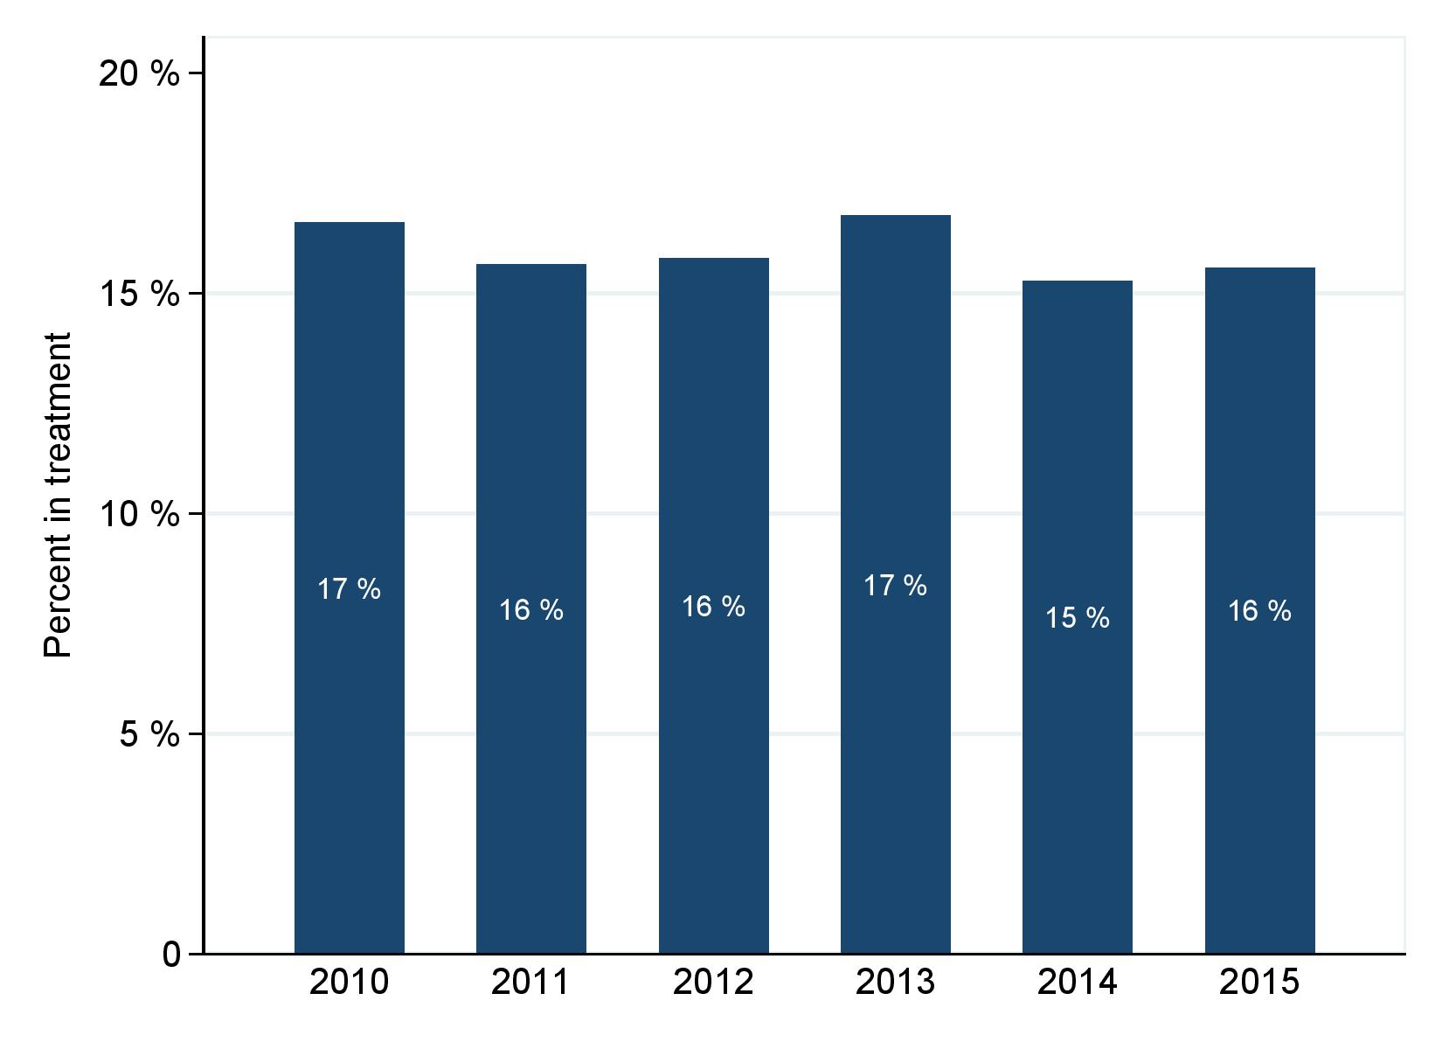
eFigure 1. Percentage of patients receiving end-of-life anticancer treatment in Denmark by year, 2010-2015 (online only).

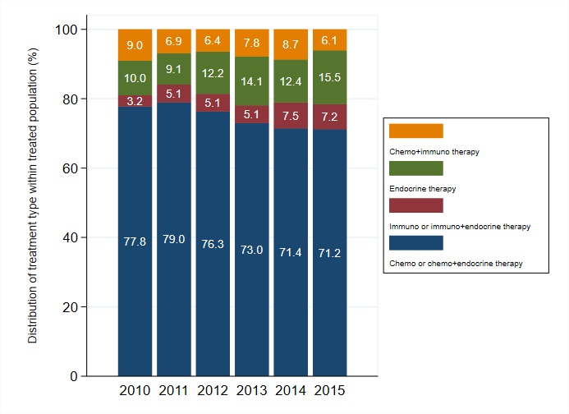
eFigure 2. Distribution of type of end-of-life anticancer treatment within all treated patients by year in the Danish cancer population dying of cancer 2010-2015 (n=42,377) (online only).

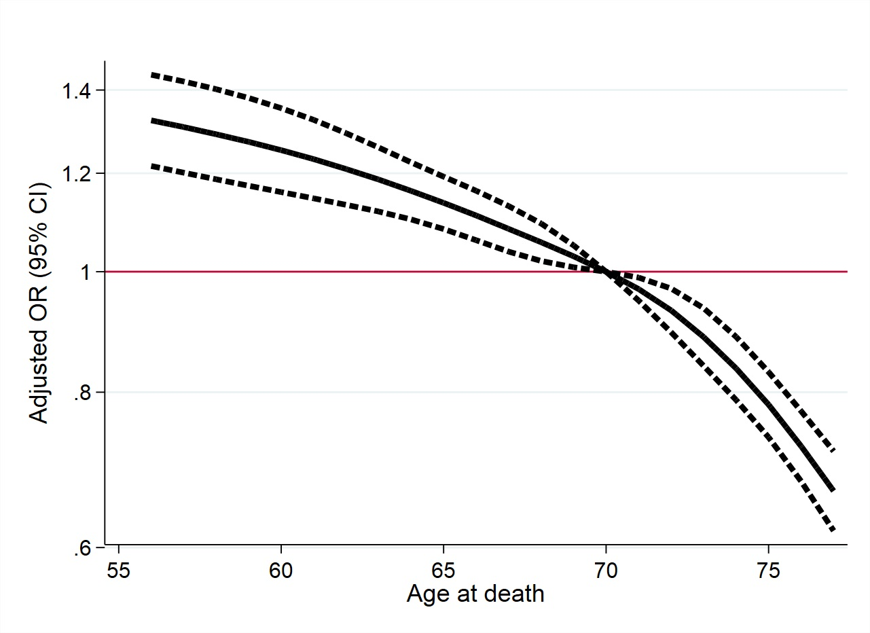
eFigure 3. Spline for age at death and being treated within 30 days prior to death. Spline indicating adjusted estimates (OR, 95 % CI) of treatment within 30 days prior to death according to age of death adjusted for sex, cancer group, Charlson Comorbidity index, time-between diagnosis and death, and year of death (only online).

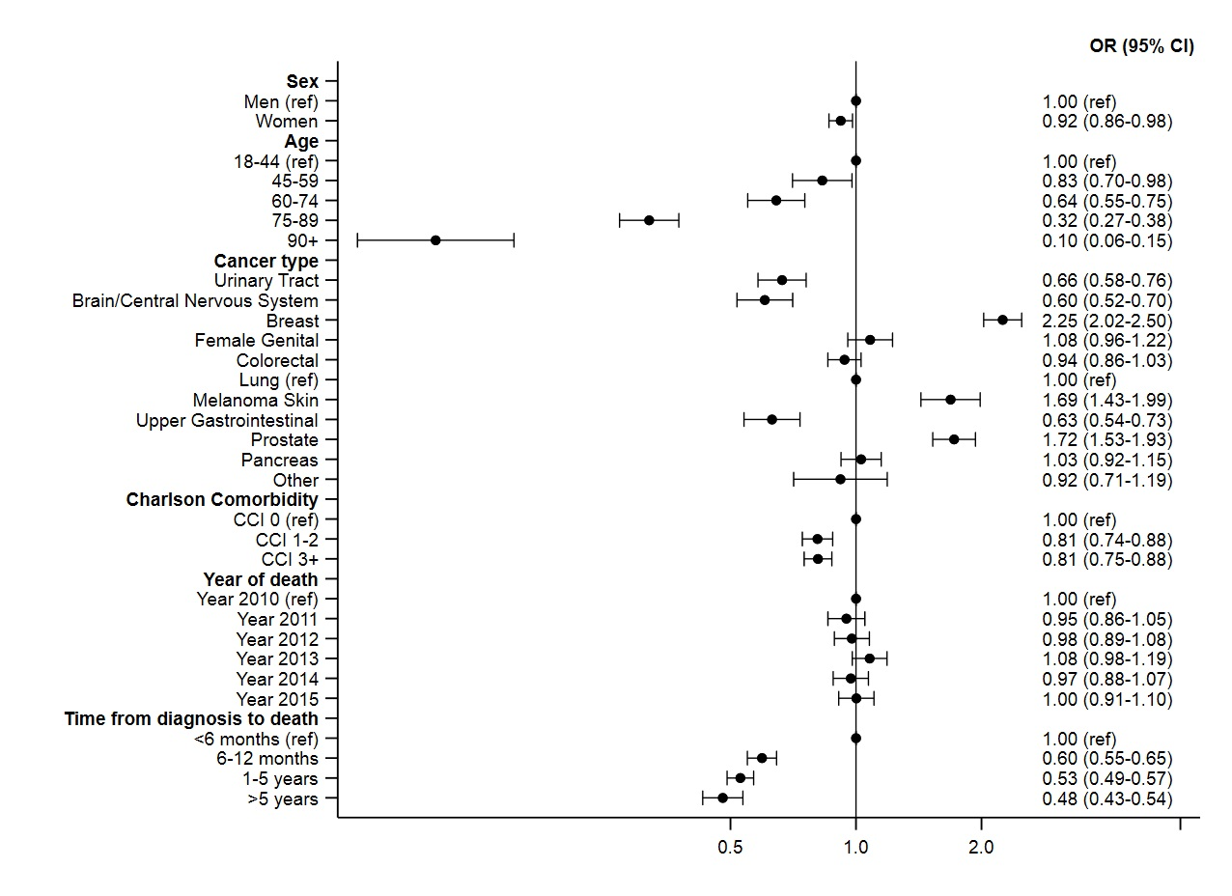
eFigure 4. Forest plot of odds ratios (OR) with 95% confidence intervals (95% CI) for risk of receiving end of life treatment according to sex, cancer type, age, Charlson Comorbidity Index, year of death, and time to death from diagnosis, mutually adjusted – and age standardized according to 2010 (online only).

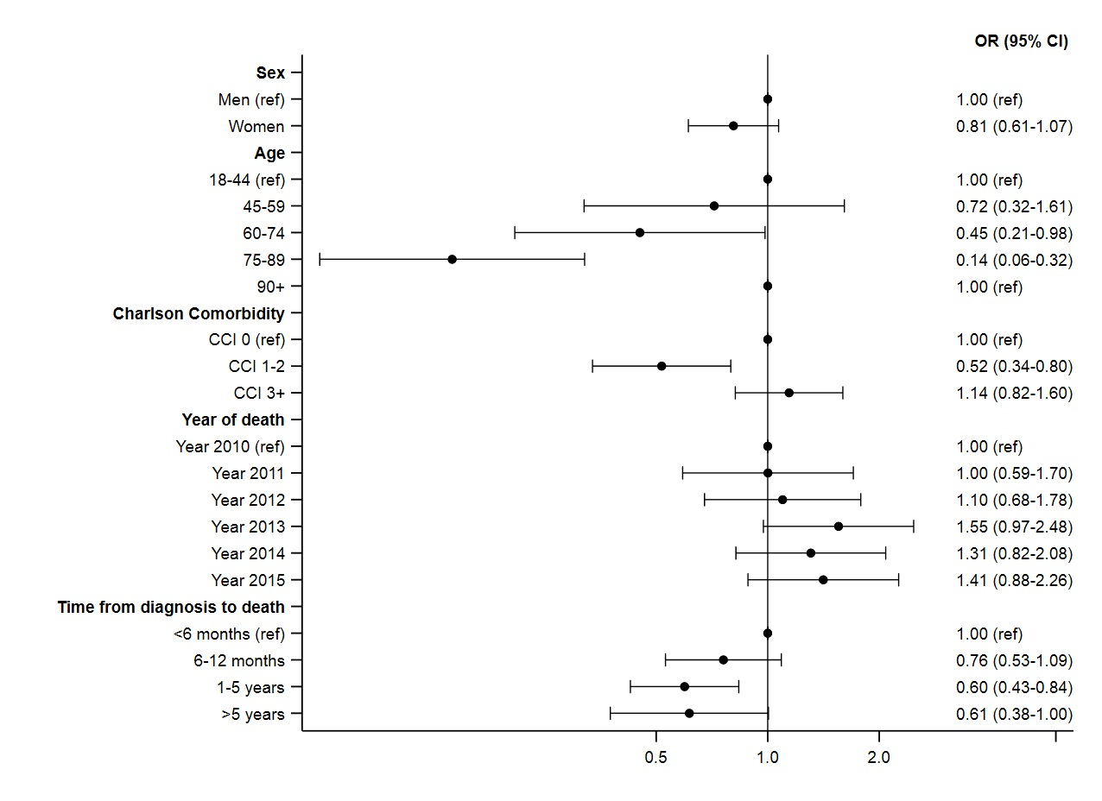
eFigure 5. Forest plot of odds ratios (OR) with 95% confidence intervals (95% CI) for risk of receiving end of life treatment according to sex, age, Charlson Comorbidity Index, year of death, and time to death from diagnosis, mutually adjusted – Urinary tract cancer patients. Plotted on a logarithmic scale (online only).
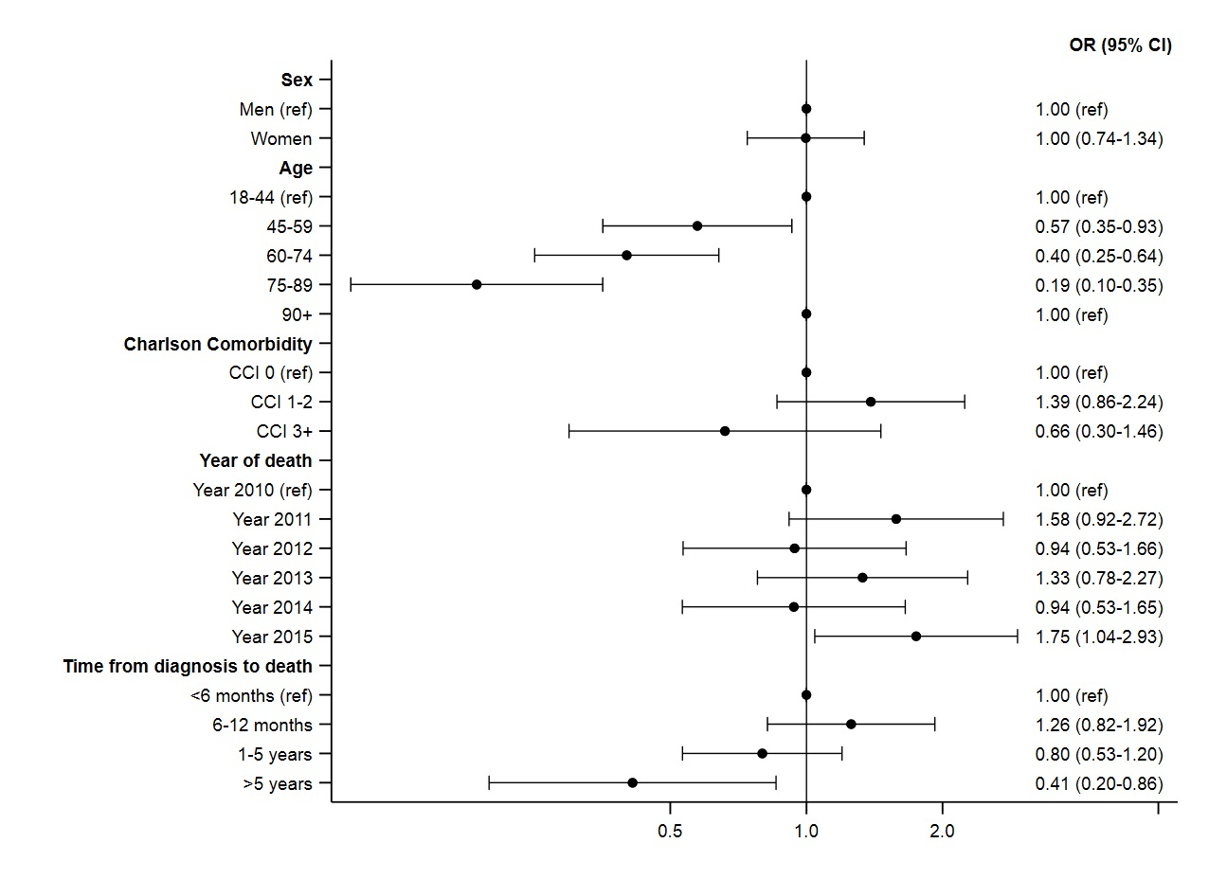
eFigure 6. Forest plot of odds ratios (OR) with 95% confidence intervals (95% CI) for risk of receiving end of life treatment according to sex, age, Charlson Comorbidity Index, year of death, and time to death from diagnosis, mutually adjusted – Brain/Central nervous system cancer patients. Plotted on a logarithmic scale (online only).

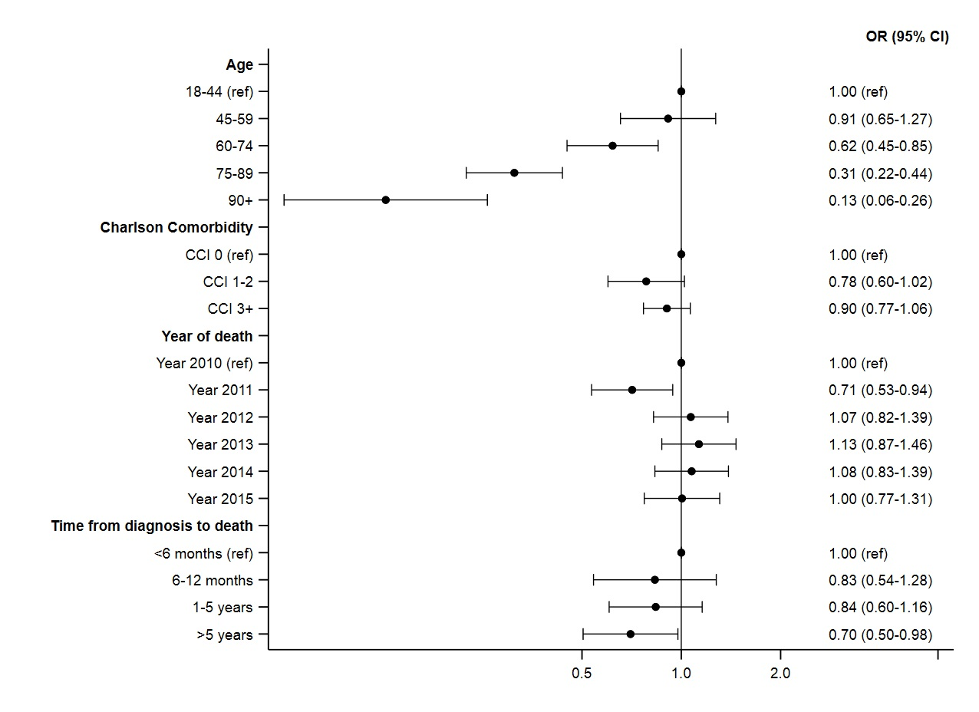eFigure 7. Forest plot of odds ratios (OR) with 95% confidence intervals (95% CI) for risk of receiving end of life treatment according to sex, age, Charlson Comorbidity Index, year of death, and time to death from diagnosis, mutually adjusted – Breast cancer patients (Women only). Plotted on a logarithmic scale (online only).
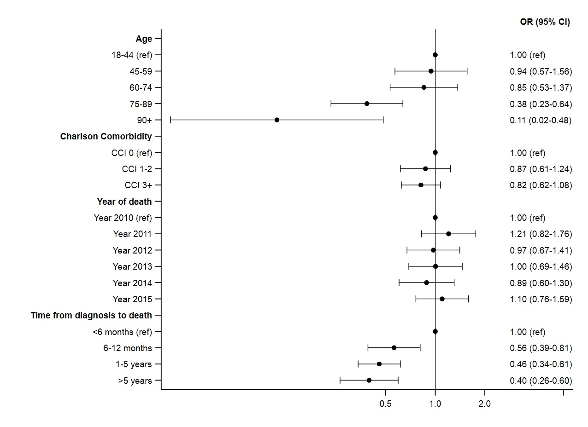
eFigure 8. Forest plot of odds ratios (OR) with 95% confidence intervals (95% CI) for risk of receiving end of life treatment according to sex, age, Charlson Comorbidity Index, year of death, and time to death from diagnosis, mutually adjusted – Female genital cancer patients. Plotted on a logarithmic scale (online only).

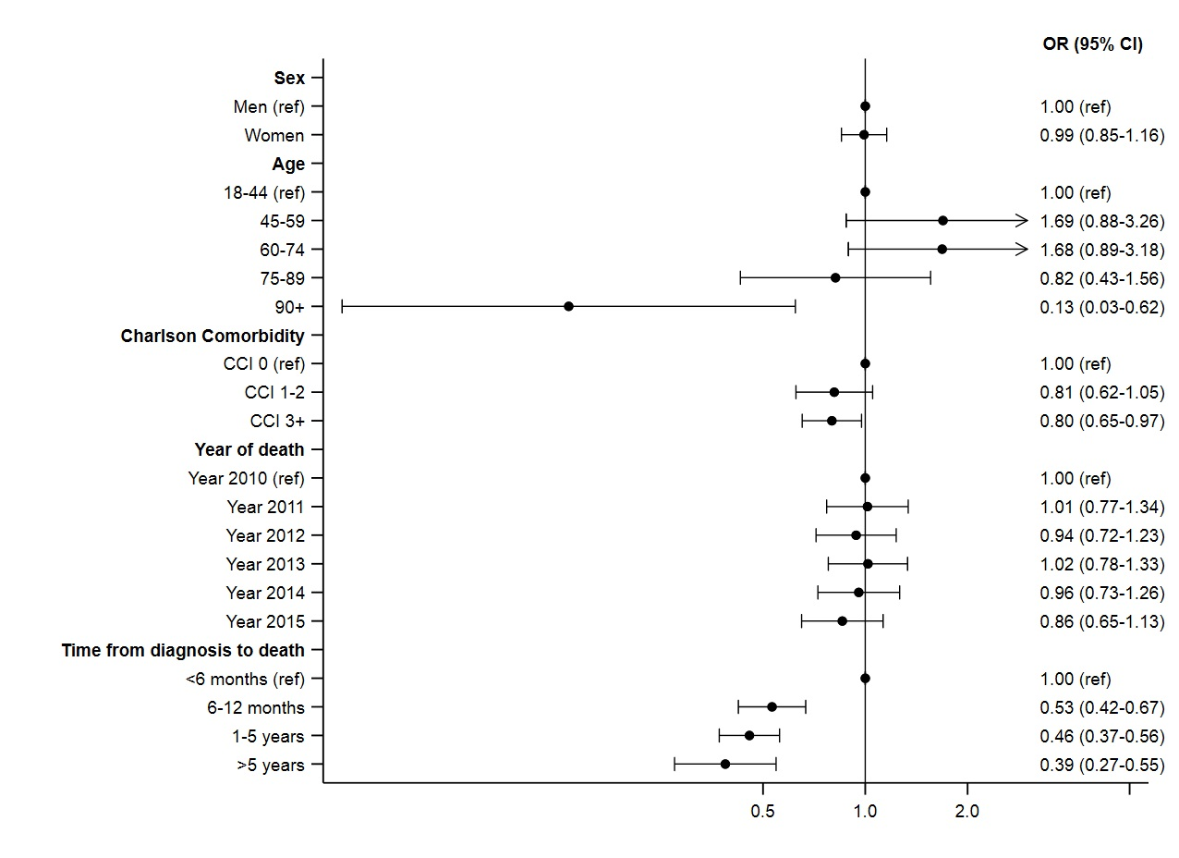
eFigure 9. Forest plot of odds ratios (OR) with 95% confidence intervals (95% CI) for risk of receiving end of life treatment according to sex, age, Charlson Comorbidity Index, year of death, and time to death from diagnosis, mutually adjusted – Colorectal cancer patients. Plotted on a logarithmic scale (online only).

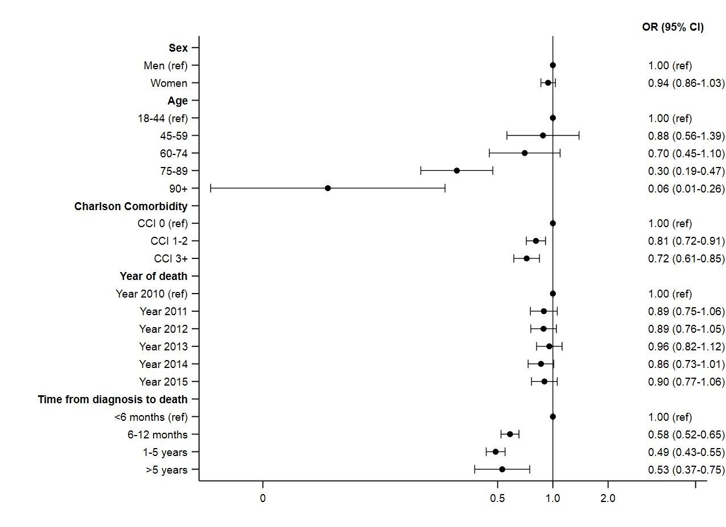
eFigure 10. Forest plot of odds ratios (OR) with 95% confidence intervals (95% CI) for risk of receiving end of life treatment according to sex, age, Charlson Comorbidity Index, year of death, and time to death from diagnosis, mutually adjusted – Lung cancer patients. Plotted on a logarithmic scale (online only).

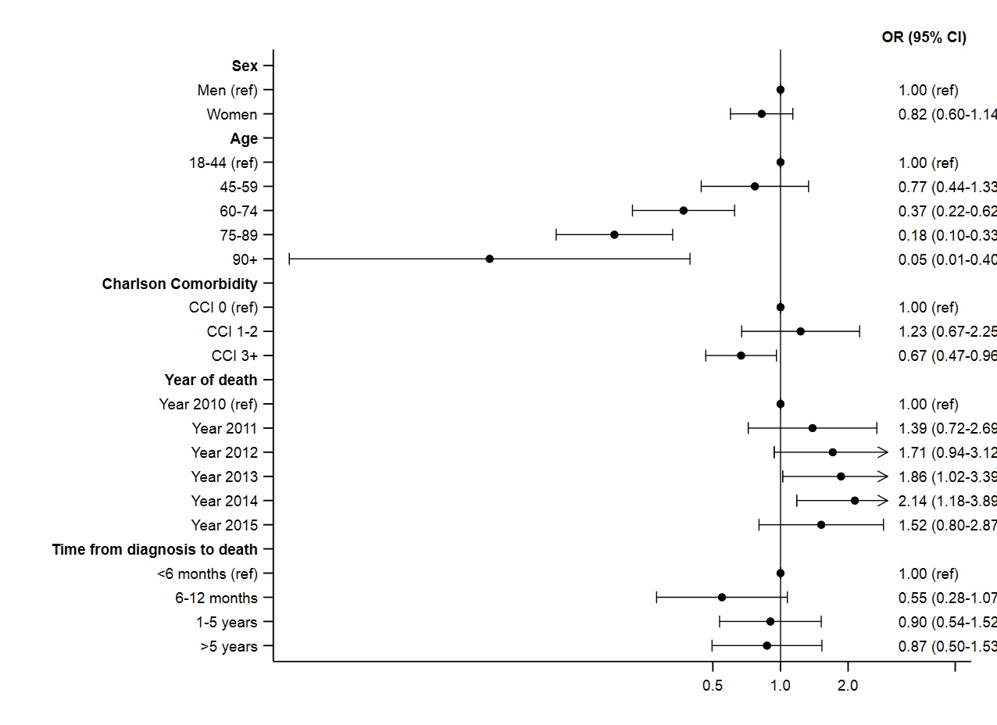
eFigure 11. Forest plot of odds ratios (OR) with 95% confidence intervals (95% CI) for risk of receiving end of life treatment according to sex, age, Charlson Comorbidity Index, year of death, and time to death from diagnosis, mutually adjusted – Melanoma of the skin cancer patients. Plotted on a logarithmic scale (online only).

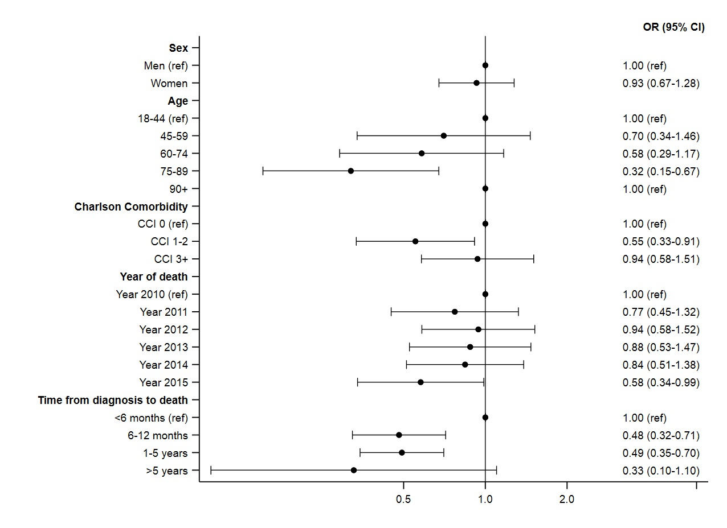
eFigure 12. Forest plot of odds ratios (OR) with 95% confidence intervals (95% CI) for risk of receiving end of life treatment according to sex, age, Charlson Comorbidity Index, year of death, and time to death from diagnosis, mutually adjusted – Upper gastrointestinal cancer patients. Plotted on a logarithmic scale (online only).
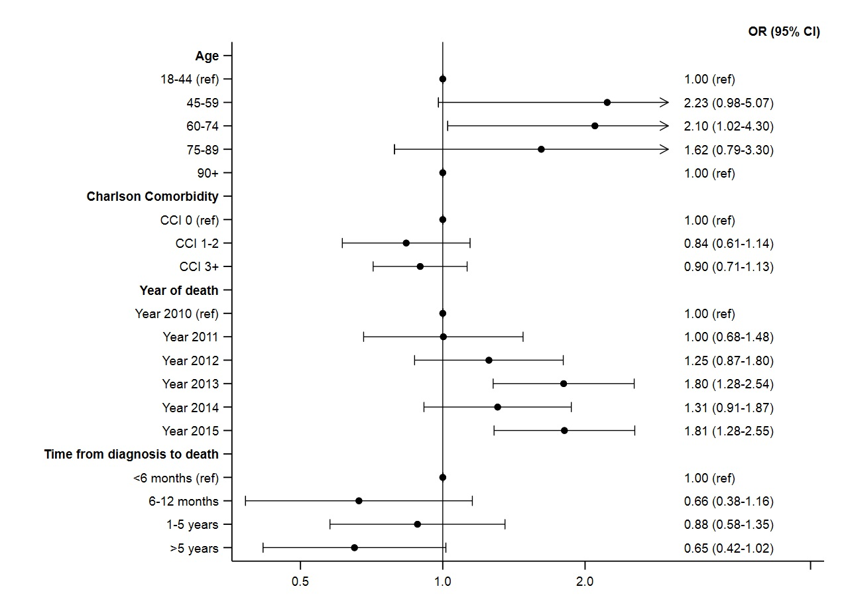
eFigure 13. Forest plot of odds ratios (OR) with 95% confidence intervals (95% CI) for risk of receiving end of life treatment according to sex, age, Charlson Comorbidity Index, year of death, and time to death from diagnosis, mutually adjusted – Prostate cancer patients. Plotted on a logarithmic scale (online only).

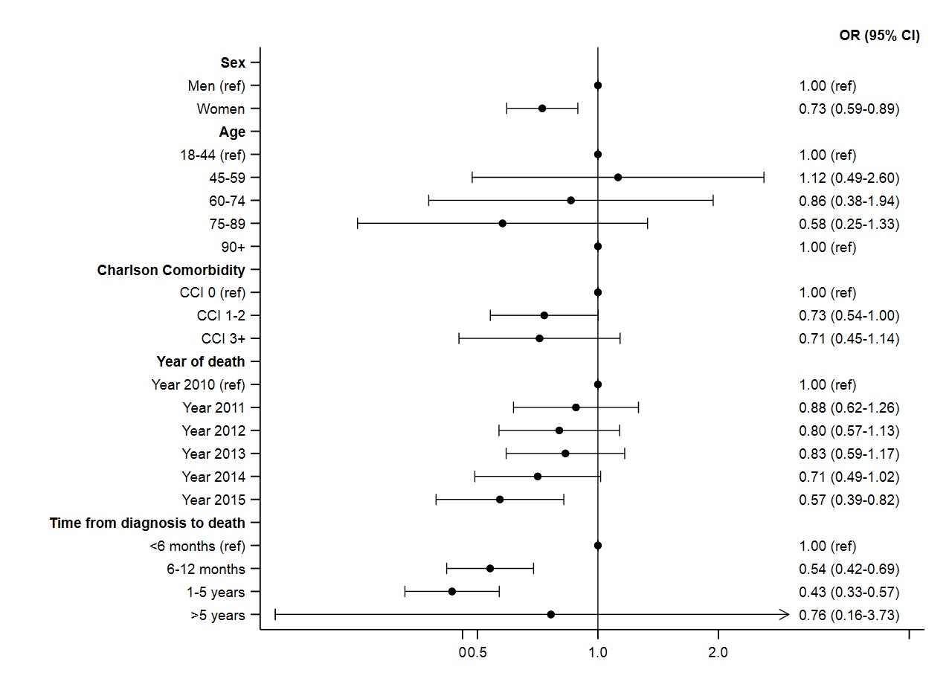
eFigure 14. Forest plot of odds ratios (OR) with 95% confidence intervals (95% CI) for risk of receiving end of life treatment according to sex, age, Charlson Comorbidity Index, year of death, and time to death from diagnosis, mutually adjusted – Pancreas cancer patients. Plotted on a logarithmic scale (online only).

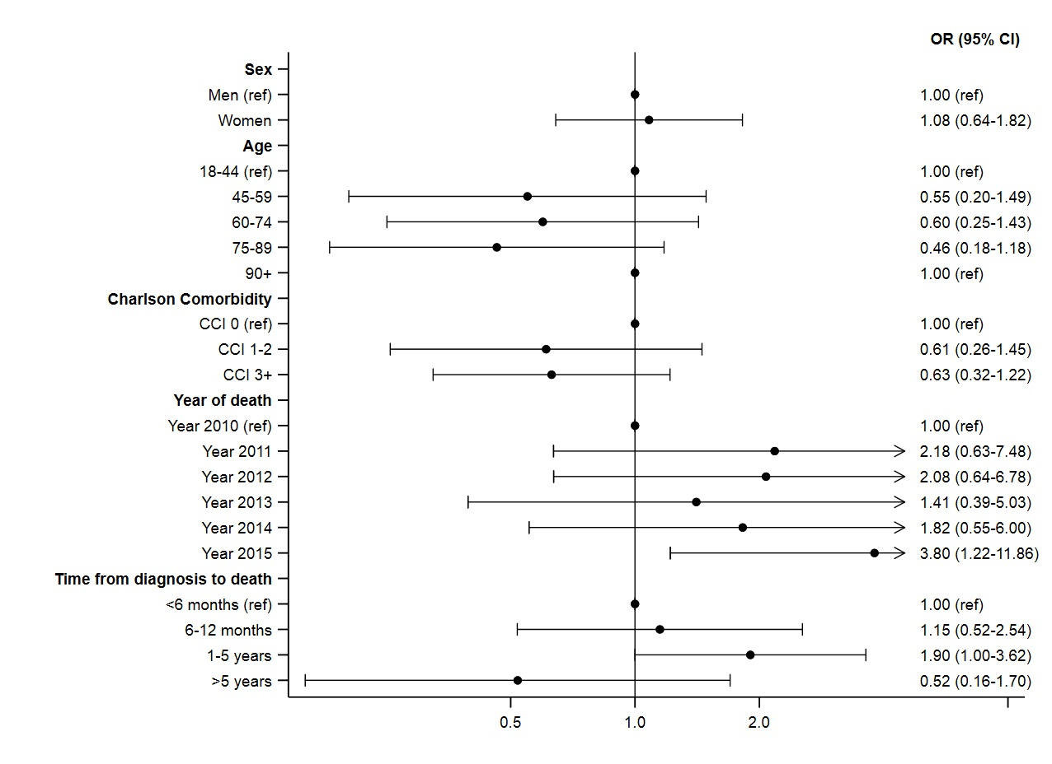
eFigure 15. Forest plot of odds ratios (OR) with 95% confidence intervals (95% CI) for risk of receiving end of life treatment according to sex, age, Charlson Comorbidity Index, year of death, and time to death from diagnosis, mutually adjusted – Other cancer patients. Plotted on a logarithmic scale (online only).

