eFigure 1 - Schoenfeld residuals for influenza vaccination as a time-dependent variable.
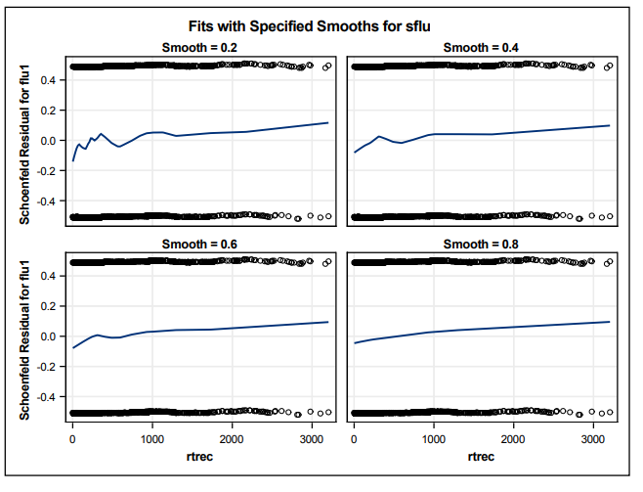

eFigure 2 – Flow chart of study cohort
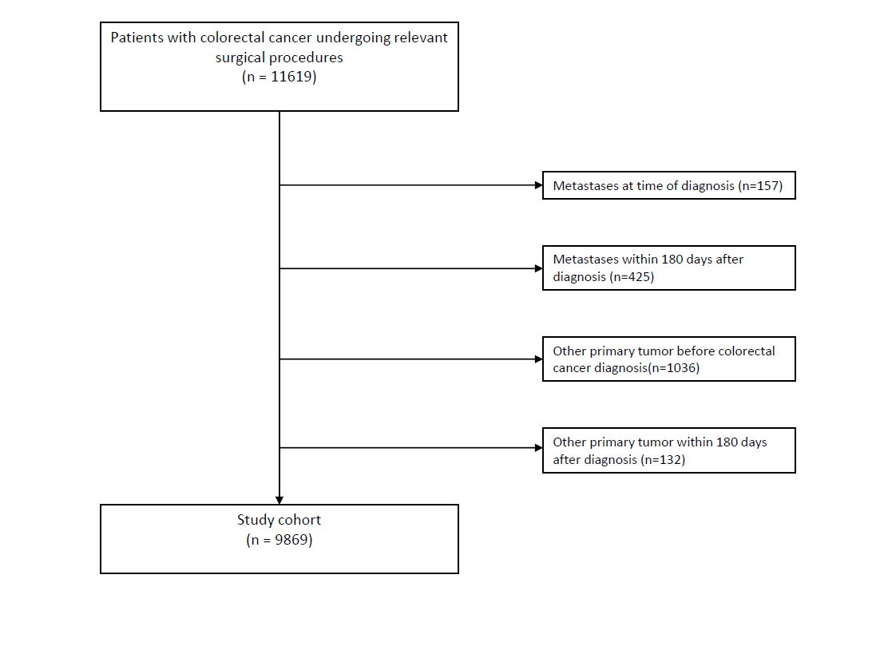

eFigure 3 - Cumulative incidence plot of risk of recurrence in Fine and Gray model.
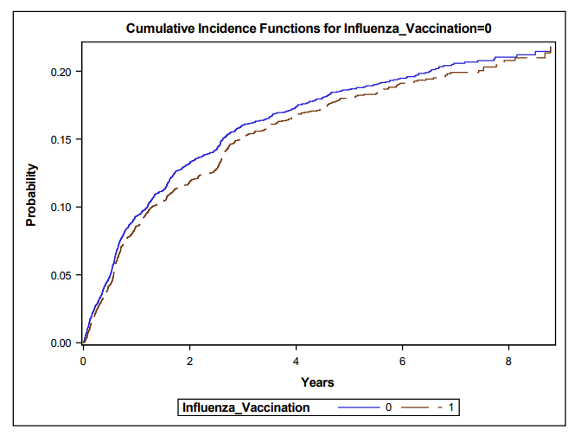

eTable 1 – Subgroup analysis – Risk of recurrence
Influenza Vaccination | Events | Person-years | IR | HR (adjusted1) | Competing risk model
Patients under 65 years of age
No | 395 | 10043 | 393 | 1 (ref) | 1 (ref)
Yes | 134 | 2379 | 563 | 1.31 (1.06-1.61) | 1.29 (1.05-1.58)
Timing of vaccination
6m-12m preop | 27 | 529 | 510 | 0.97 (0.64-1.48) | 0.91 (0.60-1.38)
1m-6m preop | 28 | 470 | 596 | 1.53 (1.03-2.27) | 1.50 (1.02-2.21)
0-30d preop | Less than 5 events
0-30d postop | 14 | 296 | 473 | 0.87 (0.51-1.50) | 0.88 (0.51-1.52)
1m-6m postop | 83 | 1446 | 574 | 1.27 (0.99-1.64) | 1.29 (1.00-1.67)
Patients over 65 years of age
No | 438 | 9341 | 469 | 1 (ref) | 1 (ref)
Yes | 722 | 17970 | 402 | 0.84 (0.75-0.95) | 0.85 (0.75-0.96)
Timing of vaccination
6m-12m preop | 304 | 8227 | 370 | 0.76 (0.65-0.90) | 0.74 (0.63-0.87)
1m-6m preop | 263 | 6733 | 391 | 0.86 (0.74-1.00) | 0.86 (0.74-1.00)
0-30d preop | 36 | 896 | 402 | 0.83 (0.59-1.17) | 0.83 (0.59-1.16)
0-30d postop | 61 | 1278 | 477 | 1.06 (0.81-1.38) | 1.10 (0.85-1.44)
1m-6m postop | 318 | 7716 | 412 | 1.06 (0.90-1.25) | 1.09 (0.93-1.28)
Patients with UICC III
No | 505 | 8783 | 575 | 1 (ref) | 1 (ref)
Yes | 462 | 8183 | 565 | 0.93 (0.80-1.07) | 0.95 (0.82-1.09)
Timing of vaccination
6m-12m preop | 160 | 3155 | 507 | 0.73 (0.60-0.90) | 0.71 (0.58-0.88)
1m-6m preop | 157 | 2541 | 618 | 0.98 (0.81-1.18) | 1.00 (0.82-1.20)
0-30d preop | 16 | 357 | 448 | 0.67 (0.41-1.11) | 0.67 (0.40-1.12)
0-30d postop | 41 | 785 | 522 | 0.96 (0.70-1.32) | 1.01 (0.73-1.39)
1m-6m postop | 220 | 3871 | 568 | 1.12 (0.94-1.34) | 1.16 (0.96-1.39)
Patients with UICC I-II
No | 328 | 13148 | 249 | 1 (ref) | 1 (ref)
Yes | 394 | 14972 | 263 | 0.94 (0.80-1.11) | 0.94 (0.80-1.11)
Timing of vaccination
6m-12m preop | 171 | 6700 | 255 | 0.80 (0.64-1.00) | 0.79 (0.64-0.99)
1m-6m preop | 134 | 5576 | 240 | 0.85 (0.70-1.05) | 0.85 (0.69-1.04)
0-30d preop | 24 | 766 | 300 | 1.09 (0.72-1.66) | 1.11 (0.73-1.68)
0-30d postop | 34 | 1029 | 330 | 1.18 (0.83-1.68) | 1.18 (0.84-1.67)
1m-6m postop | 181 | 6658 | 272 | 1.12 (0.91-1.39) | 1.13 (0.91-1.40)
eTable 1, Analysis of risk of recurrence. IR: Incidence-rate per 10.000 years. HR1: adjusted for age, sex, CCI, UICC stage, year of surgery, education level, and income level. Preop: Preoperative, postop: Postoperative, CCI: Charlson Comorbidity Index, UICC: Union of International Cancer Control

eTable 2 – subgroup analysis – Overall mortality

Influenza Vaccination | Events | Person-years | IR | HR (adjusted1)
Patients under 65 years of age
No | 283 | 11406 | 248 | 1 (ref)
Yes | 126 | 2869 | 439 | 1.41 (1.13-1.76)
Timing of vaccination
6m-12m preop | 40 | 637 | 628 | 1.62 (1.12-2.35)
1m-6m preop | 32 | 547 | 585 | 1.99 (1.37-2.90)
0-30d preop | Less than 5 events
0-30d postop | 11 | 351 | 313 | 0.86 (0.47-1.58)
1m-6m postop | 71 | 1780 | 399 | 1.08 (0.81-1.44)
Patients over 65 years of age
No | 661 | 10526 | 628 | 1 (ref)
Yes | 1471 | 20286 | 725 | 1.02 (0.93-1.12)
Timing of vaccination
6m-12m preop | 697 | 9218 | 756 | 1.18 (1.05-1.32)
1m-6m preop | 567 | 7570 | 749 | 1.07 (0.96-1.19)
0-30d preop | 82 | 1016 | 807 | 1.11 (0.89-1.40)
0-30d postop | 103 | 1463 | 704 | 0.88 (0.72-1.08)
1m-6m postop | 605 | 8749 | 692 | 0.87 (0.77-0.98)
Patients with UICC III
No | 537 | 8783 | 611 | 1 (ref)
Yes | 689 | 8183 | 842 | 0.85 (0.75-0.96)
Timing of vaccination
6m-12m preop | 305 | 3155 | 967 | 0.99 (0.84-1.16)
1m-6m preop | 241 | 2541 | 948 | 0.91 (0.77-1.06)
0-30d preop | 31 | 357 | 868 | 0.85 (0.59-1.22)
0-30d postop | 48 | 785 | 611 | 0.74 (0.55-1.00)
1m-6m postop | 306 | 3871 | 790 | 0.88 (0.75-1.04)
Patients with UICC I-II
No | 407 | 13148 | 310 | 1 (ref)
Yes | 908 | 14972 | 606 | 1.05 (0.92-1.19)
Timing of vaccination
6m-12m preop | 432 | 6700 | 645 | 1.08 (0.93-1.26)
1m-6m preop | 358 | 5576 | 642 | 1.07 (0.93-1.26)
0-30d preop | 53 | 766 | 692 | 1.01 (0.76-1.34)
0-30d postop | 66 | 1029 | 641 | 1.03 (0.79-1.33)
1m-6m postop | 370 | 6658 | 556 | 0.91 (0.78-1.06)
eTable 2, Analysis of overall mortality. IR: Incidence-rate per 10.000 years. HR1: adjusted for age, sex, CCI, UICC stage, year of surgery, education level, and income level. Preop: Preoperative, postop: Postoperative, CCI: Charlson Comorbidity Index, UICC: Union of International Cancer Control
eTable 3 – Subgroup analysis – Disease-free survival
Influenza Vaccination | Events | Person-years | IR | HR (adjusted2)
Patients under 65 years of age
No | 553 | 10043 | 551 | 1 (ref)
Yes | 209 | 2379 | 879 | 1.39 (1.18-1.65)
Timing of vaccination
6m-12m preop | 59 | 529 | 1115 | 1.38 (1.03-1.86)
1m-6m preop | 45 | 470 | 957 | 1.57 (1.15-2.14)
0-30d preop | 6 | 81 | 741 | 1.38 (0.61-3.10)
0-30d postop | 22 | 296 | 743 | 0.97 (0.63-1.50)
1m-6m postop | 125 | 1446 | 864 | 1.23 (0.99-1.51)
Patients over 65 years of age
No | 891 | 9341 | 954 | 1 (ref)
Yes | 1910 | 17970 | 1063 | 1.03 (0.95-1.11)
Timing of vaccination
6m-12m preop | 872 | 8227 | 1060 | 1.03 (0.93-1.14)
1m-6m preop | 722 | 6733 | 1072 | 1.04 (0.95-1.14)
0-30d preop | 108 | 896 | 1205 | 1.12 (0.92-1.37)
0-30d postop | 139 | 1278 | 1088 | 0.99 (0.83-1.18)
1m-6m postop | 805 | 7716 | 1043 | 0.98 (0.89-1.09)
Patients with UICC III
No | 785 | 8783 | 894 | 1 (ref)
Yes | 897 | 8183 | 1096 | 0.93 (0.83-1.03)
Timing of vaccination
6m-12m preop | 368 | 3155 | 1166 | 0.91 (0.79-1.05)
1m-6m preop | 302 | 2541 | 1189 | 0.95 (0.82-1.09)
0-30d preop | 39 | 357 | 1092 | 0.83 (0.60-1.15)
0-30d postop | 69 | 785 | 879 | 0.85 (0.67-1.09)
1m-6m postop | 411 | 3871 | 1062 | 1.00 (0.87-1.15)
Patients with UICC I-II
No | 659 | 13148 | 501 | 1 (ref)
Yes | 1222 | 14972 | 816 | 1.12 (1.01-1.24)
Timing of vaccination
6m-12m preop | 563 | 6700 | 840 | 1.01 (0.89-1.16)
1m-6m preop | 465 | 5576 | 834 | 1.10 (0.98-1.24)
0-30d preop | 75 | 766 | 979 | 1.22 (0.96-1.54)
0-30d postop | 92 | 1029 | 894 | 1.16 (0.94-1.44)
1m-6m postop | 519 | 6658 | 780 | 1.05 (0.92-1.20)
eTable 3, Analysis of disease-free survival. IR_ Incidence-rate per 10.000 years. HR1: adjusted for age, sex, CCI, UICC stage, year of surgery, education level, and income level. Preop: Preoperative, postop: Postoperative, CCI: Charlson Comorbidity Index, UICC: Union of International Cancer Control

eTable 4 – sensitivity analysis – risk of recurrence
We measured if comorbidities, health-seeking bias or number of vaccinations had an influence on risk of recurrence.
Influenza Vaccination | Events | Person-years |  | IR | HR (adjusted1) | Competing risk model
A sensitivity analysis of only included patients with a CCI of 0 or 1.
No | 904 | 19162 | 472 |  | 1 (ref) | 1 (ref)
Yes | 1422 | 19375 | 734 |  | 0.93 (0.83-1.03) | 0.93 (0.83-1.04)
Timing of vaccination
6m-12m preop | 648 | 8316 | 779 |  | 0.75 (0.64-0.87) | 0.73 (0.62-0.86)
1m-6m preop | 530 | 6805 | 779 |  | 0.93 (0.81-1.07) | 0.93 (0.81-1.08)
0-30d preop | 75 | 924 | 812 |  | 0.86 (0.62-1.21) | 0.86 (0.61-1.21)
0-30d postop | 95 | 1495 | 635 |  | 1.02 (0.79-1.30) | 1.05 (0.82-1.34)
1m-6m postop | 598 | 8759 | 683 |  | 1.10 (0.96-1.27) | 1.13 (0.98-1.30)
Tracer analysis – We only patients receiving the influenza vaccine in the influenza season, to control for any health-seeking bias.
No | 833 | 19384 | 430 |  | 1 (ref) | 1 (ref)
Yes | 847 | 20163 | 420 |  | 0.93 (0.83-1.03) | 0.94 (0.84-1.05)
Timing of vaccination
6m-12m preop | 328 | 8707 | 377 |  | 0.77 (0.66-0.89) | 0.76 (0.65-0.88)
1m-6m preop | 290 | 7162 | 405 |  | 0.92 (0.80-1.05) | 0.93 (0.81-1.07)
0-30d preop | 40 | 965 | 415 |  | 0.90 (0.65-1.23) | 0.90 (0.65-1.24)
0-30d postop | 73 | 1504 | 485 |  | 1.06 (0.84-1.35) | 1.10 (0.86-1.39)
1m-6m postop | 392 | 9029 | 434 |  | 1.11 (0.96-1.27) | 1.13 (0.98-1.30)
A sensitivity analysis of only patients with one vaccination

No | 841 | 19309 | 436 |  | 1 (ref) | 1 (ref)
Yes | 560 | 12736 | 440 |  | 0.95 (0.84-1.07) | 0.95 (0.85-1.07)
Timing of vaccination
6m-12m preop | 70 | 1901 | 368 |  | 0.75 (0.58-0.96) | 0.74 (0.57-0.95)
1m-6m preop | 272 | 6521 | 417 |  | 0.92 (0.80-1.07) | 0.92 (0.79-1.07)
0-30d preop | 28 | 756 | 370 |  | 0.78 (0.54-1.15) | 0.79 (0.53-1.15)
0-30d postop | 35 | 744 | 470 |  | 0.93 (0.68-1.35) | 0.98 (0.70-1.38)
1m-6m postop | 155 | 2814 | 551 |  | 1.13 (0.95-1.35) | 1.16 (0.97-1.39)
eTable 4, Analysis of risk of recurrence. IR: Incidence-rate per 10.000 years. HR1: adjusted for age, sex, CCI, UICC stage, year of surgery, education level, and income level. Preop: Preoperative, postop: Postoperative, CCI: Charlson Comorbidity Index, UICC: Union of International Cancer Control
eTable 5 – Sensitivity analysis – Overall mortality
We measured if comorbidities, health-seeking bias or number of vaccinations had an influence on overall mortality.
Influenza Vaccination | Events | Person-years | IR | HR (adjusted1)
A sensitivity analysis of only included patients with a CCI of 0 or 1.
No | 904 | 21686 | 417 | 1 (ref)
Yes | 1422 | 22025 | 646 | 1.00 (0.91-1.09)
Timing of vaccination
6m-12m preop | 648 | 9328 | 695 | 1.07 (0.95-1.21)
1m-6m preop | 530 | 7680 | 690 | 1.04 (0.93-1.16)
0-30d preop | 75 | 1056 | 710 | 1.01 (0.80-1.28)
0-30d postop | 95 | 1711 | 555 | 0.91 (0.74-1.12)
1m-6m postop | 598 | 10043 | 595 | 0.91 (0.80-1.02)
Tracer analysis – We only patients receiving the influenza vaccine in the influenza season, to control for any health-seeking bias.
No | 944 | 21932 | 430 | 1 (ref)
Yes | 1583 | 22940 | 690 | 0.94 (0.86-1.03)
Timing of vaccination
6m-12m preop | 734 | 9799 | 749 | 1.04 (0.93-1.16)
1m-6m preop | 591 | 8075 | 732 | 0.98 (0.88-1.09)
0-30d preop | 84 | 1112 | 755 | 0.97 (0.77-1.21)
0-30d postop | 110 | 1742 | 631 | 0.88 (0.73-1.08)
1m-6m postop | 666 | 10369 | 642 | 0.89 (0.80-1.00)
A sensitivity analysis of only patients with one vaccination

No | 1157 | 21873 | 529 | 1 (ref)
Yes | 1268 | 14541 | 872 | 0.94 (0.86-1.04)
Timing of vaccination
6m-12m preop | 318 | 2136 | 1489 | 1.02 (0.87-1.21)
1m-6m preop | 669 | 7344 | 911 | 0.98 (0.88-1.10)
0-30d preop | 74 | 862 | 858 | 0.89 (0.69-1.16)
0-30d postop | 40 | 851 | 470 | 0.68 (0.49-0.95)
1m-6m postop | 167 | 3348 | 499 | 0.88 (0.74-1.04)
eTable 5, Analysis of overall mortality. IR_ Incidence-rate per 10.000 years. HR1: adjusted for age, sex, CCI, UICC stage, year of surgery, education level, and income level. Preop: Preoperative, postop: Postoperative, CCI: Charlson Comorbidity Index, UICC: Union of International Cancer Control

eTable 6 – Sensitivity analysis – Disease-free survival
We measured if comorbidities, health-seeking bias or number of vaccinations had an influence on disease-free survival.
Influenza Vaccination | Events | Person-years | IR | HR (adjusted1)
A sensitivity analysis of only included patients with a CCI of 0 or 1.
No | 1402 | 19162 | 732 | 1 (ref)
Yes | 1972 | 19375 | 1018 | 1.05 (0.98-1.14)
Timing of vaccination
6m-12m preop | 834 | 8316 | 1003 | 0.99 (0.89-1.09)
1m-6m preop | 695 | 6805 | 1021 | 1.07 (0.97-1.17)
0-30d preop | 102 | 924 | 1104 | 1.09 (0.89-1.33)
0-30d postop | 140 | 1495 | 936 | 1.00 (0.84-1.18)
1m-6m postop | 842 | 8759 | 961 | 1.03 (0.93-1.13)
Tracer analysis – We only patients receiving the influenza vaccine in the influenza season, to control for any health-seeking bias.
No | 1444 | 19384 | 745 | 1 (ref)
Yes | 2100 | 20163 | 1042 | 1.01 (0.94-1.09)
Timing of vaccination
6m-12m preop | 927 | 8707 | 1065 | 0.97 (0.88-1.07)
1m-6m preop | 759 | 7162 | 1060 | 1.02 (0.93-1.12)
0-30d preop | 114 | 965 | 1181 | 1.07 (0.89-1.30)
0-30d postop | 156 | 1504 | 1037 | 1.01 (0.86-1.20)
1m-6m postop | 915 | 9029 | 1013 | 1.02 (0.93-1.12)
A sensitivity analysis of only patients with one vaccination

No | 1660 | 19309 | 860 | 1 (ref)
Yes | 1612 | 12736 | 1266 | 1.03 (0.95-1.12)
Timing of vaccination
6m-12m preop | 354 | 1901 | 1862 | 1.01 (0.87-1.18)
1m-6m preop | 825 | 6521 | 1265 | 1.04 (0.94-1.14)
0-30d preop | 94 | 756 | 1243 | 0.97 (0.77-1.23)
0-30d postop | 63 | 744 | 847 | 0.85 (0.66-1.10)
1m-6m postop | 276 | 2814 | 981 | 1.08 (0.94-1.23)

eTable 6, Analysis of disease-free survival. IR: Incidence-rate per 10.000 years. HR1: adjusted for age, sex, CCI, UICC stage, year of surgery, education level, and income level. Preop: Preoperative, postop: Postoperative, CCI: Charlson Comorbidity Index, UICC: Union of International Cancer Control

