Supplemental material: The relative effectiveness of eribulin versus different chemotherapy for advanced breast cancer treatment using treatment line matching: a study of the Southeast Netherlands Advanced Breast Cancer (SONABRE) Registry
Pouwels XGLV1,2,3 ORCID: 0000-0003-3563-0013, Geurts SME3,4, Ramaekers BLT1, Erdkamp F5, Vriens BEPJ6, Aaldering KNA7, van de Wouw YAJ8, Dercksen MW9, Smilde TJ10, Peters NAJB11, van Riel12, Pepels MJ13, Heijnen-Mommers J3,4, Joore MA1,2, Tjan-Heijnen VCG3,4, de Boer M3,4
1 Department of Clinical Epidemiology and Medical Technology Assessment (KEMTA), Maastricht University Medical Centre+, Maastricht, The Netherlands.
2 Care and Public Health Research Institute (CAPHRI), Maastricht University, Maastricht, The Netherlands.
3 School of Oncology and Developmental Biology (GROW), Maastricht University, Maastricht, The Netherlands.
4 Division Medical Oncology, Maastricht University Medical Centre+, Maastricht, The Netherlands.
5 Department of Internal Medicine, Zuyderland Medical Centre, Sittard-Geleen, The Netherlands.
6 Department of Internal Medicine, Catharina hospital, Eindhoven, The Netherlands.
7 Department of Internal Medicine, Laurentius Hospital, Roermond, The Netherlands.
8 Department of Internal Medicine, VieCuri Medical Center, Venlo, The Netherlands.
9 Department of Internal Medicine, Máxima Medical Centre, Veldhoven/Eindhoven, The Netherlands.
10 Department of Internal Medicine, Jeroen Bosch Hospital, ’s Hertogenbosch, The Netherlands.
11 Department of Internal Medicine, Sint Jans Gasthuis, Weert, The Netherlands.
12 Department of Internal Medicine, Elisabeth-TweeSteden Hospital, Tilburg, The Netherlands.
13 Department of Internal Medicine, Elkerliek Hospital, Helmond, The Netherlands.

Overlap in patient characteristics before matching
In the following two figures, one can observe how baseline characteristics of the eribulin and unmatched non-eribulin (patient level and treatment lines separately) overlap before matching has been performed. For matching to be successful, baseline characteristics have to overlap, otherwise matching will not resolve the disbalance in baseline characteristics. In Figures 1 and 2, one can see that baseline characteristics overlap between eribulin en both non-eribulin groups, hence, matching is a suitable method to adjust the comparison of eribulin versus non-eribulin.
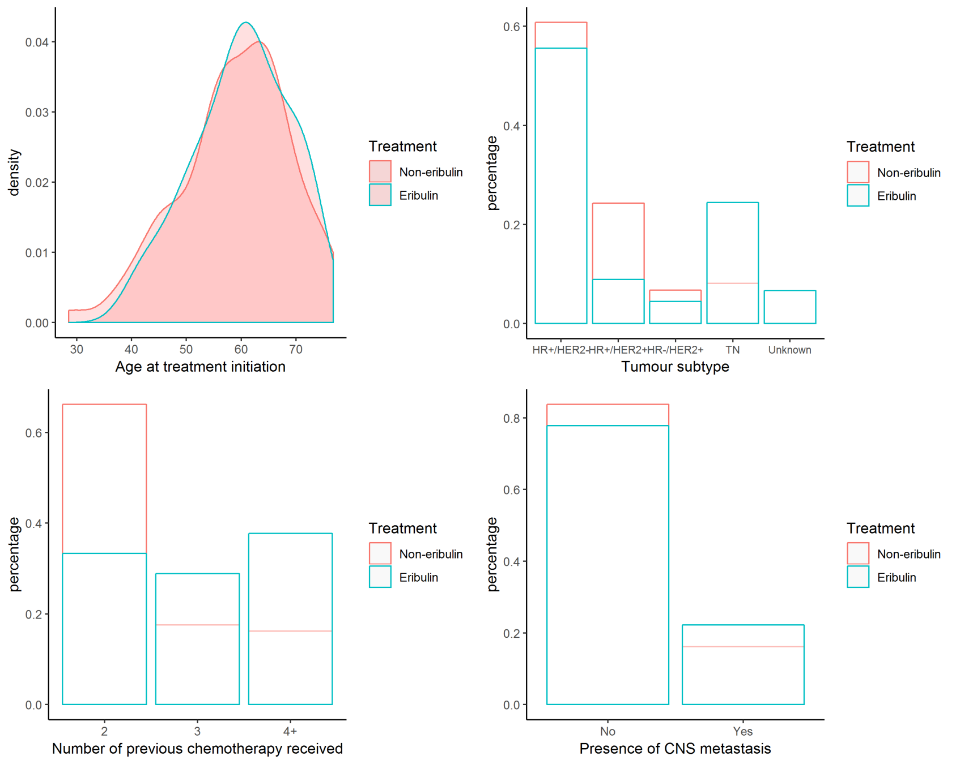
Figure 1: Overlap in baseline characteristics between the eribulin group and the unmatched non-eribulin group (patient level)
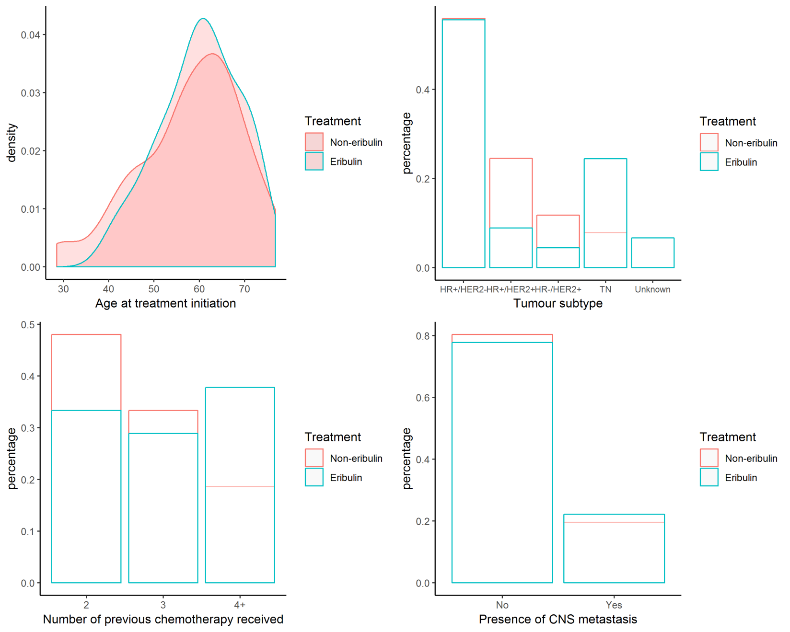
Figure 2: Overlap in baseline characteristics between the eribulin group and the unmatched non-eribulin treatment lines

Covariate balance comparison between the different non-eribulin groups

Covariates balance was improved for tumour subtype, and the number of previous chemotherapy received, but not for the age at treatment initiation and the proportion of patients having CNS metastasis in the treatment line matched non-eribulin group compared to patient level matched non-eribulin group. The variance ratio of all covariates covariates (except for the presence of CNS metastasis) was the most similar between the eribulin group and the treatment line matched non-eribulin group compared to the other non-eribulin groups.
Compared to the unmatched non-eribulin group, both the treatment line matched and the patient level matched non-eribulin groups had better covariate balance overall, expect for the age at treatment initiation.
The variance ratio should be as close as possible to 1 while the bootstrapped Kolmorogov Smirnov p-value should be maximized.

Table 1: Balance statistics for each non eribulin group
Variable names | Variance ratio unmatched non-eribulin | Variance ratio after treatment line matching | Variance ratio after patient level matching | Bootstrapped Kolmorogov Smirnov p-value unmatched non-eribulin | Bootstrapped Kolmorogov Smirnov p-value after treatment line matching | Bootstrapped Kolmorogov Smirnov p value after patient level matching
Tumor subtype (continuous) | 2.906 | 1.694 | 2.043 | 0.011 | 0.835 | 0.505
Number of previous chemotherapy (continuous) | 1.238 | 0.939 | 1.171 | 0.044 | 0.92 | 0.172
Age at treatment initiation | 0.597 | 0.837 | 0.543 | 0.617 | 0.22 | 0.297
Presence of CNS metastasis | 1.11 | 1.316 | 1.316 | NA | NA | NA
Abbreviations: CNS, central nervous system; NA, not applicable

QQ plots patient characteristics before and after matching
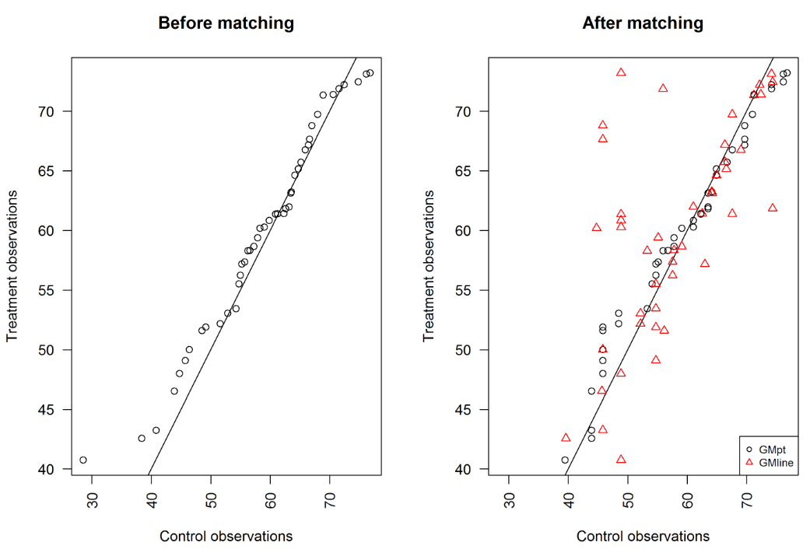
Figure 3: QQplot of the age at treatment initiation of eribulin (treatment observation) versus non-eribulin (control observations).
Abbreviations: GMline, treatment line matched non-eribulin group; GMpt, patient level matched non-eribulin group; QQ, quantile-quantile

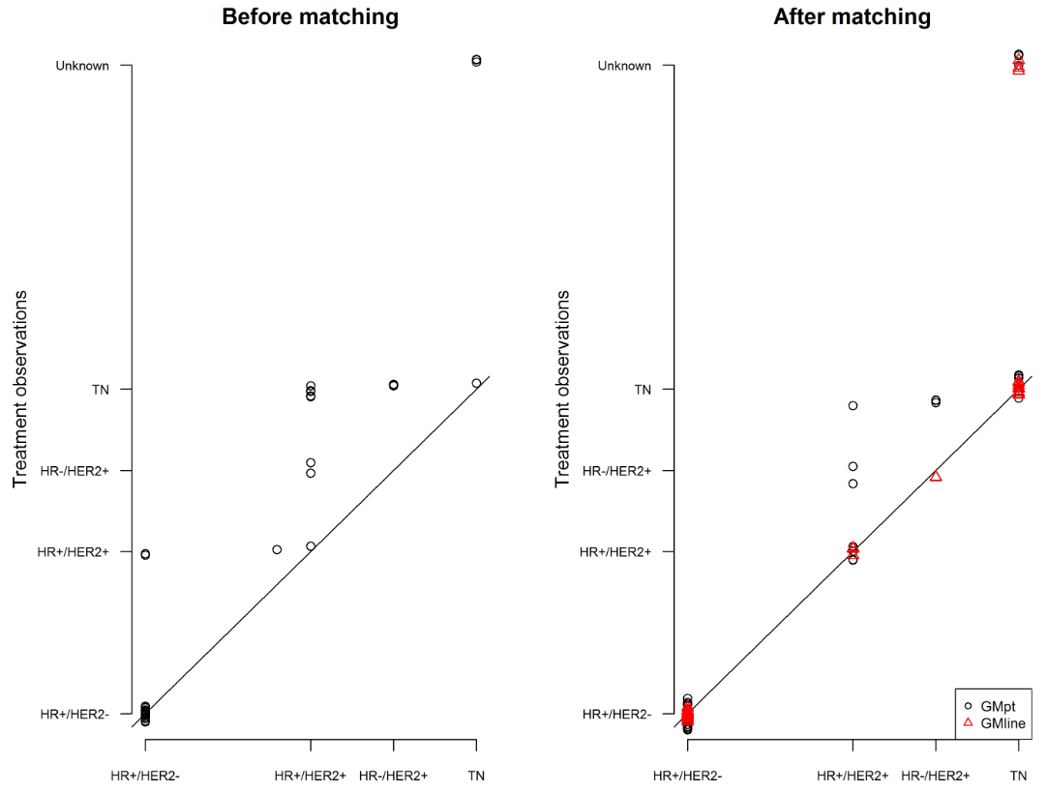
Figure 4: QQplot of the tumour subtype of eribulin (treatment observation) versus non-eribulin (control observations)
Abbreviation: HR, hormonal status; HER2, human epidermal growth factor receptor 2; GMline, treatment line matched non-eribulin group; GMpt, patient level matched non-eribulin group; TN, triple negative; QQ, quantile-quantile

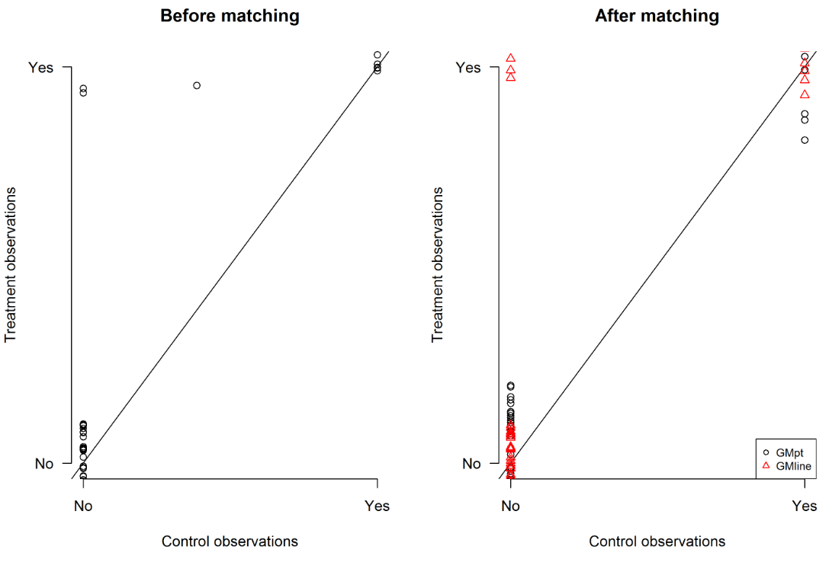
Figure 5: QQplot of the presence of CNS metastasis in the eribulin (treatment observation) versus non-eribulin (control observations) group.
Abbreviation: CNS, central nervous metastasis; GMline, treatment line matched non-eribulin group; GMpt, patient level matched non-eribulin group; QQ, quantile-quantile

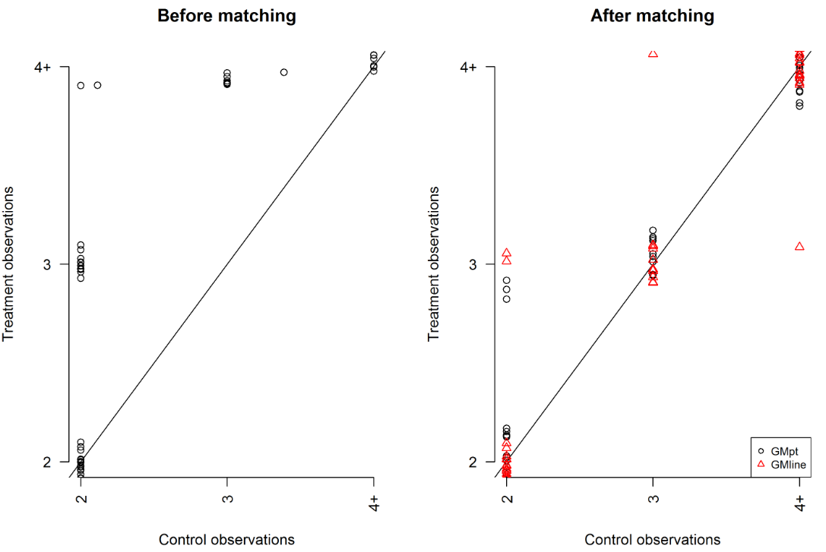
Figure 6: QQplot of the number of previous chemotherapy received in the eribulin (treatment observation) versus non-eribulin (control observations) group.
Abbreviation: GMline, treatment line matched non-eribulin group; GMpt, patient level matched non-eribulin group; QQ, quantile-quantile

Results of the sensitivity analysis: eribulin versus patient-level matched non-eribulin
Table 2: Patient characteristics in each group
Treatment group |  | Eribulin (N) | % | Patient level matched non-eribulin | %
Number of patient |  | 45 |  | 45
Median age |  | 61 |  | 61
Minimum age |  | 41 |  | 39
Maximum age |  | 73 |  | 77
Tumour status | HR+/HER2- | 25 | 56 % | 25 | 56 %
Tumour status | HR+/HER2+ | 4 | 9 % | 7 | 16 %
Tumour status | HR-/HER2+ | 2 | 4 % | 3 | 7 %
Tumour status | Triple Negative | 11 | 24 % | 10 | 22 %
Tumour status | Unknown | 3 | 7 % | 0 | 0
Dominant metastatic site | CNS | 10 | 22 % | 10 | 22 %
Dominant metastatic site | Visceral | 31 | 69 % | 29 | 64 %
Dominant metastatic site | Non-visceral | 4 | 9 % | 6 | 13 %
Dominant metastatic site | Bone only* | 2 | 4 % | 6 | 13 %
Dominant metastatic site | Unknown | 0 | 0 % | 0 | 0 %
Number of metastatic sites | 1 | 2 | 4 % | 3 | 7 %
Number of metastatic sites | 2 | 12 | 27 % | 10 | 22 %
Number of metastatic sites | 3 | 15 | 33 % | 9 | 20 %
Number of metastatic sites | 4 | 8 | 18 % | 12 | 27 %
Number of metastatic sites | 5+ | 8 | 17 % | 11 | 25 %
Number of previous endocrine therapy in the ABC setting | 0 | 16 | 36 % | 16 | 36 %
Number of previous endocrine therapy in the ABC setting | 1 | 7 | 16 % | 6 | 13 %
Number of previous endocrine therapy in the ABC setting | 2 | 7 | 16 % | 9 | 20 %
Number of previous endocrine therapy in the ABC setting | 3 | 5 | 11 % | 7 | 16 %
Number of previous endocrine therapy in the ABC setting | 4+ | 10 | 22 % | 7 | 15 %
Number of previous chemotherapy in the ABC setting | 2 | 15 | 33 % | 18 | 40 %
Number of previous chemotherapy in the ABC setting | 3 | 13 | 29 % | 10 | 22 %
Number of previous chemotherapy in the ABC setting | 4+ | 17 | 37 % | 17 | 38 %
* Subgroup of non-visceral metastasis
Abbreviations: ABC, advanced breast cancer; GM, genetic matched; HER2, human epidermal growth factor 2 receptor; HR, hormonal status
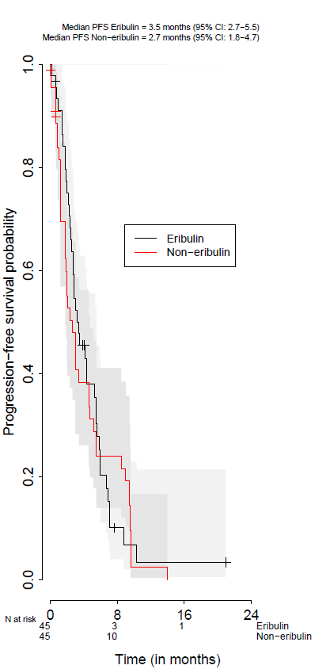
Figure 9: KM curves, log cumulative hazard plots and Scaled Schoenfeld residual plots of PFS for eribulin and the patient level matched non-eribulin group,
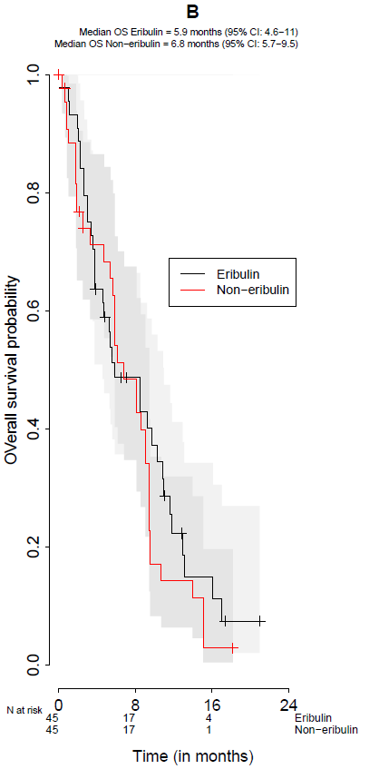
Figure 10: KM curves, log cumulative hazard plots, and Scaled Schoenfeld residual plots of OS for eribulin and the patient level matched non-eribulin group,

Results of the sensitivity analysis: eribulin versus unmatched non-eribulin
Table 3: Patient characteristics in each group
Treatment group |  | Eribulin (N) | % | Unmatched non-eribulin | %
Number of patient |  | 45 |  | 74
Median age |  | 61 |  | 60
Minimum age |  | 41 |  | 29
Maximum age |  | 73 |  | 77
Tumour status | HR+/HER2- | 25 | 56 % | 45 | 61 %
Tumour status | HR+/HER2+ | 4 | 9 % | 18 | 24 %
Tumour status | HR-/HER2+ | 2 | 4 % | 5 | 7 %
Tumour status | Triple Negative | 11 | 24 % | 6 | 8 %
Tumour status | Unknown | 3 | 7 % | 0 | 0
Dominant metastatic site | CNS | 10 | 22 % | 12 | 16 %
Dominant metastatic site | Visceral | 31 | 69 % | 52 | 70 %
Dominant metastatic site | Non-visceral | 4 | 9 % | 10 | 14 %
Dominant metastatic site | Bone only* | 2 | 4 % | 9 | 12 %
Dominant metastatic site | Unknown | 0 | 0 % | 0 | 0 %
Number of metastatic sites | 1 | 2 | 4 % | 12 | 16 %
Number of metastatic sites | 2 | 12 | 27 % | 17 | 23 %
Number of metastatic sites | 3 | 15 | 33 % | 18 | 24 %
Number of metastatic sites | 4 | 8 | 18 % | 14 | 19 %
Number of metastatic sites | 5+ | 8 | 17 % | 13 | 17 %
Number of previous endocrine therapy in the ABC setting | 0 | 16 | 36 % | 20 | 27 %
Number of previous endocrine therapy in the ABC setting | 1 | 7 | 16 % | 13 | 18 %
Number of previous endocrine therapy in the ABC setting | 2 | 7 | 16 % | 13 | 18 %
Number of previous endocrine therapy in the ABC setting | 3 | 5 | 11 % | 16 | 22 %
Number of previous endocrine therapy in the ABC setting | 4+ | 10 | 22 % | 12 | 16 %
Number of previous chemotherapy in the ABC setting | 2 | 15 | 33 % | 49 | 66 %
Number of previous chemotherapy in the ABC setting | 3 | 13 | 29 % | 13 | 18 %
Number of previous chemotherapy in the ABC setting | 4+ | 17 | 37 % | 12 | 16 %
* Subgroup of non-visceral metastasis
Abbreviations: ABC, advanced breast cancer; GM, genetic matched; HER2, human epidermal growth factor 2 receptor; HR, hormonal status

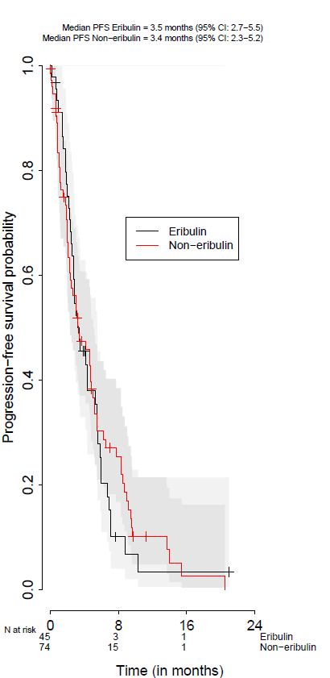
Figure 11: KM curves, log cumulative hazard plots and Scaled Schoenfeld residual plots of PFS for eribulin and the unmatched non-eribulin group,

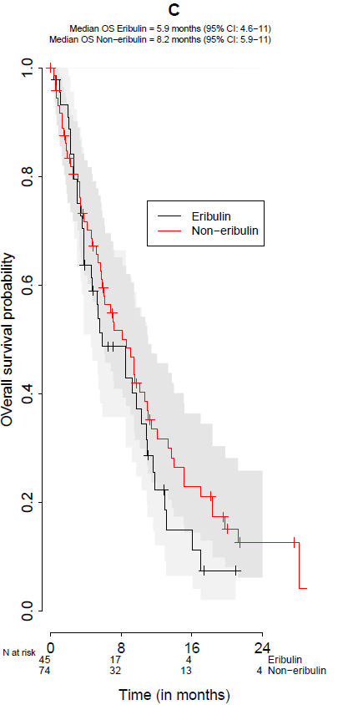
Figure 12: KM curves, log cumulative hazard plots and Scaled Schoenfeld residual plots of PFS for eribulin and the unmatched non-eribulin group,

Multivariate Cox proportional hazard models (sensitivity analyses)
Table 4: Results of the Cox proportional hazard models performed during the sensitivity analyses
 |  |  | PFS |  |  | OS
Comparison | Covariates |  | Coefficient (SE) | Hazard ratio | Significance | Coefficient (SE) | Hazard ratio | Significance
Comparison |  |  | Coefficient (SE) | (95% CI) | Significance | Coefficient (SE) | (95% CI) | Significance
Patient level matched non-eribulin | Treatment | Non-eribulin | Reference | 1 | - | - | 1 | -
Patient level matched non-eribulin | Treatment | Eribulin | -0.096 (0.24) | 0.909 (0.568-1.454) | 0.69 | -0.478 (0.265) | 0.62 (0.369-1.042) | 0.071
Patient level matched non-eribulin | Tumour status | HR+/HER2- | Reference | 1 | - | - | 1 | -
Patient level matched non-eribulin | Tumour status | HR+/HER2+ | -0.983 (0.47) | 0.374 (0.149-0.94) | 0.037 | -1.017 (0.415) | 0.362 (0.16-0.816) | 0.014
Patient level matched non-eribulin | Tumour status | HR-/HER2+ | -0.925 (0.595) | 0.397 (0.123-1.274) | 0.12 | -0.887 (0.618) | 0.412 (0.123-1.384) | 0.151
Patient level matched non-eribulin | Tumour status | Triple Negative tumour | 0.071 (0.325) | 1.073 (0.568-2.028) | 0.827 | 0.157 (0.346) | 1.169 (0.593-2.306) | 0.651
Patient level matched non-eribulin | Tumour status | Tumour subtype unknown | -1.321 (0.748) | 0.267 (0.062-1.157) | 0.078 | -0.331 (0.742) | 0.718 (0.168-3.075) | 0.655
Patient level matched non-eribulin | Age at treatment start |  | 0 (0.014) | 1 (0.972-1.028) | 0.973 | 0.016 (0.015) | 1.016 (0.986-1.047) | 0.3
Patient level matched non-eribulin | Number of previous chemotherapy | 2 previous chemotherapy received | Reference | 1 | - | - | 1 | -
Patient level matched non-eribulin | Number of previous chemotherapy | 3 previous chemotherapy received | -0.126 (0.302) | 0.882 (0.488-1.594) | 0.678 | 0.528 (0.328) | 1.696 (0.892-3.223) | 0.107
Patient level matched non-eribulin | Number of previous chemotherapy | 4+ previous chemotherapy received | -0.726 (0.336) | 0.484 (0.25-0.935) | 0.031 | 0.13 (0.345) | 1.139 (0.579-2.241) | 0.707
Patient level matched non-eribulin | Presence of CNS metastasis | No CNS metastasis | Reference | 1 | - | - | 1 | -
Patient level matched non-eribulin | Presence of CNS metastasis | CNS metastasis | 1.823 (0.36) | 6.191 (3.058-12.534) | <0.01 | 1.532 (0.396) | 4.626 (2.13-10.051) | <0.01
Unmatched non-eribulin | Treatment | Non-eribulin | Reference | 1 | - | - | 1 | -
Unmatched non-eribulin | Treatment | Eribulin | -0.012 (0.253) | 0.989 (0.602-1.622) | 0.964 | -0.312 (0.268) | 0.732 (0.433-1.236) | 0.243
Unmatched non-eribulin | Tumour status | HR+/HER2- | Reference | 1 | - | - | 1 | -
Unmatched non-eribulin | Tumour status | HR+/HER2+ | -0.378 (0.271) | 0.685 (0.403-1.165) | 0.163 | -0.542 (0.286) | 0.582 (0.332-1.019) | 0.058
Unmatched non-eribulin | Tumour status | HR-/HER2+ | -1.34 (0.492) | 0.262 (0.1-0.687) | 0.006 | -1.789 (0.558) | 0.167 (0.056-0.499) | 0.001
Unmatched non-eribulin | Tumour status | Triple Negative tumour | 0.176 (0.314) | 1.192 (0.644-2.206) | 0.576 | 0.611 (0.33) | 1.842 (0.966-3.514) | 0.064
Unmatched non-eribulin | Tumour status | Tumour subtype unknown | -0.786 (0.696) | 0.456 (0.116-1.785) | 0.259 | 0.083 (0.693) | 1.087 (0.28-4.227) | 0.904
Unmatched non-eribulin | Age at treatment start |  | -0.01 (0.012) | 0.99 (0.968-1.013) | 0.387 | -0.007 (0.012) | 0.993 (0.969-1.017) | 0.559
Unmatched non-eribulin | Number of previous chemotherapy | 2 previous chemotherapy received | Reference | 1 | - | - | 1 | -
Unmatched non-eribulin | Number of previous chemotherapy | 3 previous chemotherapy received | 0.456 (0.274) | 1.579 (0.922-2.703) | 0.096 | 1.004 (0.296) | 2.73 (1.527-4.882) | 0.001
Unmatched non-eribulin | Number of previous chemotherapy | 4+ previous chemotherapy received | -0.107 (0.28) | 0.898 (0.518-1.556) | 0.702 | 0.661 (0.303) | 1.936 (1.068-3.509) | 0.029
Unmatched non-eribulin | Presence of CNS metastasis | No CNS metastasis | Reference | 1 | - | - | 1 | -
Unmatched non-eribulin | Presence of CNS metastasis | CNS metastasis | 1.181 (0.31) | 3.256 (1.772-5.985) | <0.01 | 1.084 (0.293) | 2.955 (1.664-5.25) | <0.01
Abbreviations: CI, confidence interval; CNS, central nervous system; HER2, human epidermal growth factor 2 receptor; HR, hormonal status; SE, standard error

Univariate Cox proportional hazard models
Table 5: Cox proportional hazard model results PFS - eribulin versus treatment line matched non-eribulin
Covariate | Coefficient (SE) | Hazard ratio (95% CI) | Significance
Eribulin | 0.07 (0.232) | 1.073 (0.681-1.692) | 0.762
Abbreviations: CI, confidence interval; SE, standard error

Table 6: Cox proportional hazard model results OS - eribulin versus treatment line matched non-eribulin
Covariate | Coefficient (SE) | Hazard ratio (95% CI) | Significance
Eribulin | -0.28 (0.254) | 0.755 (0.459-1.243) | 0.27
Abbreviations: CI, confidence interval; SE, standard error

Table 7: Cox proportional hazard model results PFS - eribulin versus patient level matched non-eribulin
Covariate | Coefficient (SE) | Hazard ratio (95% CI) | Significance
Eribulin | -0.096 (0.225) | 0.908 (0.584-1.413) | 0.67
Abbreviations: CI, confidence interval; SE, standard error

Table 8: Cox proportional hazard model results OS - eribulin versus patient level matched non-eribulin
Covariate | Coefficient (SE) | Hazard ratio (95% CI) | Significance
Eribulin | -0.251 (0.24) | 0.778 (0.486-1.245) | 0.295
Abbreviations: CI, confidence interval; SE, standard error

Table 9: Cox proportional hazard model results PFS - eribulin versus unmatched non-eribulin
Covariate | Coefficient (SE) | Hazard ratio (95% CI) | Significance
Eribulin | 0.092 (0.204) | 1.097 (0.735-1.636) | 0.651
Abbreviations: CI, confidence interval; SE, standard error

Table 10: Cox proportional hazard model results OS - eribulin versus unmatched non-eribulin
Covariate | Coefficient (SE) | Hazard ratio (95% CI) | Significance
Eribulin | 0.259 (0.22) | 1.295 (0.842-1.993) | 0.239
Abbreviations: CI, confidence interval; SE, standard error

