Supplemental Digital Content
17β-hydroxysteroid dehydrogenase 1:2 and breast cancer recurrence: a Danish population-based study

Author List: Lindsay J Collin,ª Sinna P Ulrichsen,^{b} Thomas P Ahern,^{c} Michael Goodman,ª Lauren E McCullough,ª Lance A Waller,^{d} Kristina B Christensen,^{e} Per Damkier,^{f,g} Stephen Hamilton-Dutoit,^{e} Kristina L Lauridsen,^{e} Rami Yacoub,ª Peer M Christiansen,^{h} Bent Ejlertsen,^{i,j} Henrik Toft Sørensen,^{b,k} Deirdre P Cronin-Fenton,^{b} Timothy L Lash^{a,b}

Methods
Data Collection from Danish Registries
Each Danish resident is assigned a unique 10-digit Civil Personal Registration (CPR) number at birth or upon immigration, allowing for accurate linkage across Danish registries. CPR numbers of the patients selected for this study permitted data collection from the DBCG registry, including information on demographics (age, menopausal status, and hospital of diagnosis), tumour (UICC stage, histological grade, and ER expression), and treatment characteristics (primary surgical tumour management, receipt of radiation therapy, receipt of chemotherapy, and receipt of tamoxifen therapy).
In Denmark, all paraffin blocks from pathological specimens are routinely archived after diagnosis. Patient CPR numbers were used to link patients in the study population to the Danish Pathology Data Bank, enabling us to locate and retrieve tumour blocks for 90% of study subjects. For each case and control, formalin-fixed, paraffin-embedded (FFPE) primary tumour tissue blocks were retrieved from the pathology archives of treating hospitals. Laboratory personnel were blinded to all clinical information including case or control status, ER status, and receipt of tamoxifen therapy.
Tissue microarrays (TMAs) were constructed using standard techniques. A fresh section was cut from each study participant’s paraffin block and stained with hematoxylin and eosin. The diagnosis was confirmed by a study pathologist. Areas containing invasive breast carcinoma were identified and marked up. Then core samples (1 mm diameter) were subsequently removed from each tumour donor block and re-embedded in a new recipient paraffin TMA block using a TMA Master Arrayer (3DHISTECH, Budapest, Hungary). If sufficient material was available, representative tumour (n=3) and marginal tissue (n=1) cores were sampled. Liver and placental cores were included in each TMA to facilitate orientation within the TMA during microscopy.
Immunohistochemistry (IHC) stains were performed on 3 µm TMA tissue sections according to standard protocols. The TMA slides were deparaffinized in xylene, hydrated in graded alcohols, and blocked for endogenous peroxidase for 5 min in an UltraVision hydrogen peroxidase block (Thermo Fisher Scientific, Waltham, MA; ref. TA-125H2O2Q). Heat-induced epitope retrieval was performed in a decloaking chamber (PT Link, Agilent, Santa Clara, CA 95051) in a pH 6.0 citrate buffer (Thermo Fisher Scientific; ref. TA-250-PM1X). The slides were rinsed in distilled water and immersed in wash buffer with tween 20 (Cell Marque. Rocklin, CA; ref. 935B-09) for 5 min to eliminate surface tension. Immunostaining was carried out at room temperature in an automated instrument; Dako AutostainerPlus, and the slides were rinsed with a buffer between all steps. The slides were incubated with UltraV block (Thermo Fisher Scientific; ref. TA-125-UB) for 5 min, followed by primary antibody for 30 min. Expression of HSD17B1 was assessed using a rabbit monoclonal antibody at a concentration of 1:150 (Abcam, Cambridge, UK; catalog no. EP1682Y). Expression of HSD17B2 was also assessed using a rabbit polyclonal antibody at a concentration of 1:300 (Proteintech, Rosemont, IL; catalog no. 10978-1-AP). For each biomarker, sections were incubated with the primary antibody for 30 minutes. Visualization was achieved via serial incubation with UltraVision Goat Polyvalent Secondary (Thermo Fisher Scientific; ref. TL-125-BN) for 15 minutes withUltraVision Streptavidin Horseradish Peroxidase (Thermo Fisher Scientific; ref. TL-125-HR) for 15 minutes, and with diaminobenzidine (DAB; Thermo Fisher Scientific, ref. TA-125-HDX) for 5 minutes. The slides were counterstained with haematoxylin (Thermo Fisher Scientific; ref. 7211), dehydrated, and coverslipped using Cytoseal XYL (Thermo Fisher Scientific; ref. 8312-4) in Leica AutoStainer XL and Leica CV5030 (Leica, Wtzlar, Germany) instruments. Slides were dried for at least 24 hours before being digitalized using a whole slide image scanner (Panoranmic SCAN 150; 3DHISTECH). Staining was titrated to uniform staining intensity as illustrated in eFigure 1, and results differences in the concentrations of the antibodies used in the project likely reflect differences in the affinity of the antibody to the protein rather than differences in the resulting stains.

TMA Core Scoring
Expression of HSD17B1 and HSD17B2 were quantified with an H-score that incorporated staining intensity and percentage of positively stained tumour cells (eFigure 2). Staining intensity was a weighted scale ranging from 0 for no intensity to 3 for high staining intensity. Percent positivity ranged from 0 to 100% based on percentage of positively stained tumour cells. The H-score therefore has a plausible range from 0 to 300 (observed range = 0–294). There were 1–3 tumour cores available for each specimen and we used the average score of the viable cores.
Two observers (LJC and SHD) developed a rubric for intensity levels and scoring schematic, which were developed using multiple TMAs with approximately 200 cores, however data are unavailable. Subsequently, all study cores were rated by one evaluator (LJC), and these scores were used in the analysis. Cases that were difficult to interpret were reviewed by two observers (LJC and SHD) who agreed upon a consensus score. FFPE tumour blocks available for TMA construction generated 4351 TMA cores, of which 3770 (87%) were scored for HSD17B1 and 3645 (84%) were scored for HSD17B2. Cores that could not be scored were excluded, either because the core section on the TMA was absent or inadequately represented, or because of poor staining of the core, and this exclusion was addressed in the analysis.

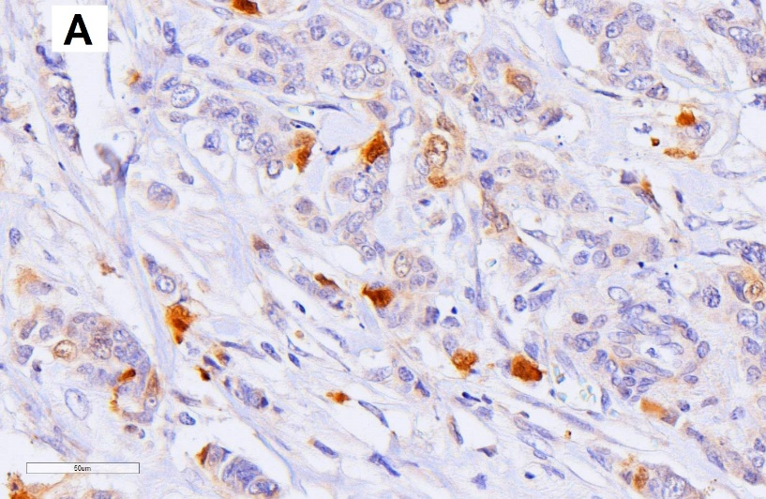
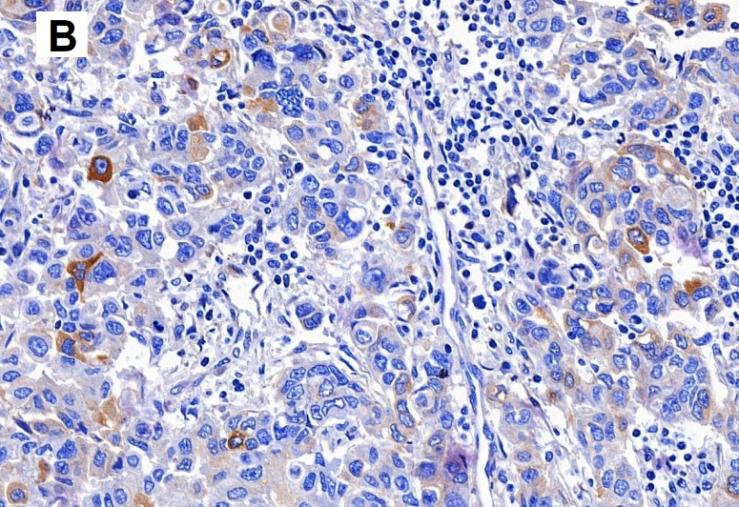
eFigure 1: Immunohistochemical analysis of cytoplasmic 17β-hydroxysteroid dehydrogenase 1 and 2 expression. (A) IHC x10 17β-hydroxysteroid dehydrogenase 1 cytoplasmic staining intensity, (B) IHC x10 17β-hydroxysteroid dehydrogenase 2 cytoplasmic staining intensity,

eFigure 2: Correlation between the staining intensity and percent of positively stained cells by H-score quartile for each of the cytoplasmic (A) 17β-hydroxysteroid dehydrogenase 1 and (B) 17β-hydroxysteroid dehydrogenase 2 expression.
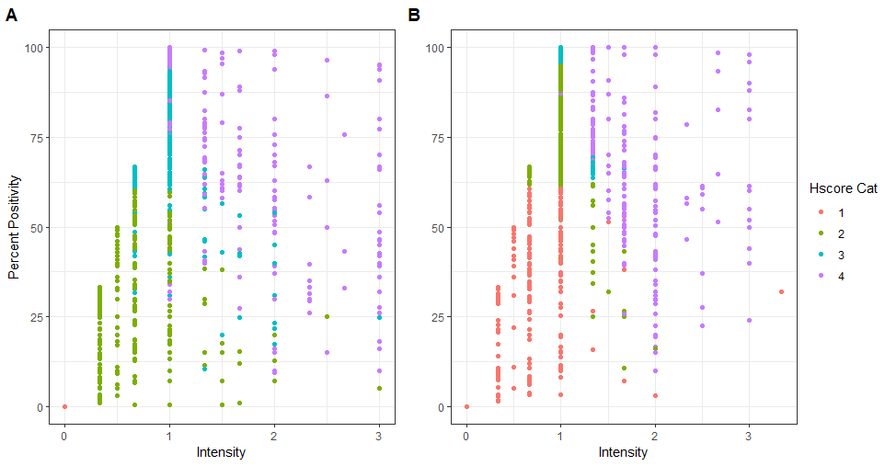

eTable 1: Distribution of tumor and patient characteristics among breast cancer recurrence cases and controls by ER/TAM strata among subjects from a Danish population-based case-control study.
Patient Characteristic | ER+/TAM+, N (%) |  |  |  | ER−/TAM−, N (%)
 | Case |  | Control |  | Case |  | Control
Cytoplasmic HSD17B1 Expression
≥75th %tile | 121 | (27) | 121 | (27) | 66 | (25) | 54 | (22)
50th– <75th %tile | 106 | (24) | 93 | (21) | 68 | (26) | 77 | (31)
25th– <50th %tile | 115 | (26) | 110 | (25) | 67 | (26) | 58 | (23)
<25th %tile | 104 | (23) | 124 | (28) | 61 | (23) | 60 | (24)
Missing | 95 |  | 93 |  | 38 |  | 51
Cytoplasmic HSD17B2 Expression
≥75th %tile | 73 | (17) | 58 | (13) | 64 | (24) | 59 | (23)
50th– <75th %tile | 142 | (32) | 154 | (35) | 84 | (32) | 82 | (32)
25th– <50th %tile | 124 | (28) | 115 | (26) | 59 | (22) | 54 | (21)
<25th %tile | 102 | (23) | 115 | (26) | 57 | (22) | 60 | (24)
Missing | 100 |  | 99 |  | 36 |  | 45
HSD17B1:HSD17B2 Expression
> 1 | 131 | (31) | 128 | (31) | 75 | (30) | 60 | (25)
≤ 1 | 296 | (69) | 291 | (69) | 177 | (70) | 179 | (75)
Missing | 114 |  | 122 |  | 48 |  | 61
Diagnosis year
1985–1993 | 235 | (43) | 234 | (43) | 107 | (36) | 100 | (33)
1994–1996 | 113 | (21) | 112 | (30) | 81 | (27) | 83 | (28)
1997–2001 | 193 | (36) | 195 | (36) | 112 | (37) | 117 | (39)
Age category at diagnosis (years)
35–44 | 16 | (3.1) | 13 | (2.4) | 68 | (23) | 58 | (19)
45–54 | 116 | (21) | 111 | (21) | 120 | (40) | 113 | (38)
55–64 | 286 | (53) | 281 | (52) | 82 | (27) | 86 | (29)
65–69 | 123 | (23) | 136 | (25) | 30 | (10) | 43 | (14)
Menopausal status at diagnosis
Premenopausal | 34 | (6.3) | 34 | (6.3) | 121 | (40) | 121 | (40)
Postmenopausal | 507 | (94) | 507 | (94) | 179 | (60) | 176 | (60)
UICC tumour stage at diagnosis
I | 9 | (2) | 9 | (1.7) | 25 | (8.3) | 25 | (8.3)
II | 250 | (46) | 250 | (46) | 153 | (51) | 153 | (51)
III | 282 | (52) | 282 | (52) | 122 | (41) | 122 | (41)
Histological grade
I | 108 | (25) | 144 | (35) | 27 | (11) | 23 | (10)
II | 234 | (54) | 215 | (52) | 125 | (49) | 98 | (43)
III | 92 | (21) | 57 | (14) | 103 | (40) | 106 | (47)
Missing | 107 |  | 125 |  | 45 |  | 73
Surgery Type
Breast-conserving surgery | 58 | (11) | 71 | (13) | 47 | (16) | 56 | (19)
Mastectomy | 483 | (89) | 470 | (87) | 252 | (84) | 244 | (81)
Missing |  |  |  |  | 1 |  | 0
Radiation therapy
Yes | 183 | (34) | 191 | (35) | 128 | (44) | 123 | (47)
No | 358 | (66) | 350 | (65) | 166 | (56) | 137 | (53)
Missing |  |  |  |  | 6 |  | 40
Systemic adjuvant chemotherapy
Yes | 70 | (13) | 65 | (12) | 248 | (83) | 188 | (63)
No | 471 | (87) | 476 | (88) | 52 | (17) | 112 | (37)
Tamoxifen protocol, years
1 | 257 | (48) | 261 | (48)
2 | 98 | (18) | 92 | (17)
5 | 186 | (34) | 188 | (34)

eTable 2: Distribution of tumour and patient characteristics among breast cancer recurrence cases and controls by missing tumour core and ER/TAM stratum
Table 2: Distribution of tumor and patient characteristics among breast cancer recurrence cases and controls by ER/TAM group and availability of tumour cores for the analysis among women from the Danish population-based case control study.
Patient Characteristic | ER+/TAM+, N (%)* |  |  |  |  |  |  |  | ER−/TAM−, N (%)*
 | Case |  |  |  | Control |  |  |  | Case |  |  |  | Control
 | Tumour Core |  | No Tumour Core |  | Tumour Core |  | No Tumour Core |  | Tumour Core |  | No Tumour Core |  | Tumour Core |  | No Tumour Core
 | N | (%) | N | (%) | N | (%) | N | (%) | N | (%) | N | (%) | N | (%) | N | (%)
Diagnosis year
1985–1993 | 195 | (83) | 40 | (17) | 190 | (81) | 44 | (19) | 95 | (89) | 12 | (11) | 86 | (86) | 14 | (14)
1994–1996 | 93 | (82) | 20 | (18) | 98 | (88) | 14 | (13) | 72 | (89) | 9 | (11) | 75 | (90) | 8 | (9.6)
1997–2001 | 169 | (88) | 24 | (12) | 174 | (89) | 21 | (11) | 102 | (91) | 10 | (8.9) | 98 | (84) | 19 | (16)
Menopausal status at diagnosis
Premenopausal | 29 |  |  |  | 31 |  |  |  | 108 | (89) | 13 | (11) | 105 | (87) | 16 | (13)
Postmenopausal | 428 | (84) | 79 | (16) | 431 | (85) | 76 | (15) | 161 | (90) | 18 | (10) | 154 | (86) | 25 | (14)
Age category at diagnosis
35–44 | 15 |  |  |  | 13 | (100) |  |  | 59 | (87) | 9 | (13) | 51 | (88) | 7 | (12)
45–54 | 96 | (83) | 20 | (17) | 96 | (86) | 15 | (14) | 107 | (89) | 13 | (11) | 96 | (85) | 17 | (15)
55–64 | 235 | (82) | 51 | (18) | 235 | (84) | 46 | (16) | 75 | (92) | 7 | (8.5) | 77 | (90) | 9 | (11)
65–69 | 111 | (90) | 12 | (10) | 118 | (87) | 18 | (13) | 28 |  |  |  | 35 | (81) | 8 | (19)
UICC tumour stage at diagnosis
I | 9 | (100) |  |  |  |  |  |  | 19 | (76) | 6 | (24) | 20
II | 210 | (84) | 40 | (16) | 213 | (85) | 37 | (15) | 139 | (91) | 14 | (9.2) | 131 | (86) | 22 | (14)
III | 238 | (84) | 44 | (16) | 244 | (87) | 38 | (13) | 111 | (91) | 11 | (9) | 108 | (88) | 14 | (12)
Histological grade
I | 88 | (81) | 20 | (19) | 125 | (87) | 19 | (13) | 21 | (78) | 6 | (22) | 19
II | 200 | (85) | 34 | (15) | 183 | (85) | 32 | (15) | 116 | (93) | 9 | (7.2) | 88 | (90) | 10 | (10)
III | 79 | (86) | 13 | (14) | 50 | (88) | 7 | (12) | 94 | (91) | 9 | (8.7) | 93 | (88) | 13 | (12)
Missing | 90 | (84) | 17 | (16) | 104 | (83) | 21 | (17) | 38 | (84) | 7 | (16) | 59 | (81) | 14 | (19)
Surgery Type
Breast-conserving surgery | 46 | (79) | 12 | (21) | 63 | (89) | 8 | (11) | 37 | (79) | 10 | (21) | 48 | (86) | 8 | (14)
Mastectomy | 411 | (85) | 72 | (15) | 399 | (85) | 71 | (15) | 231 | (92) | 21 | (8.3) | 211 | (86) | 33 | (14)
Missing
Radiation therapy
Yes | 157 | (86) | 26 | (14) | 165 | (86) | 26 | (14) | 112 | (87) | 16 | (13) | 104 | (85) | 19 | (15)
No | 300 | (84) | 58 | (16) | 297 | (85) | 53 | (15) | 152 | (92) | 14 | (8.4) | 120 | (88) | 17 | (12)
Missing |  |  |  |  |  |  |  |  |  |  |  |  | 35
Systemic adjuvant chemotherapy
Yes | 59 | (84) | 11 | (16) | 50 | (77) | 15 | (23) | 229 | (92) | 19 | (7.7) | 162 | (86) | 26 | (14)
No | 398 | (85) | 73 | (15) | 412 | (87) | 64 | (13) | 40 | (77) | 12 | (23) | 97 | (87) | 15 | (14)
Tamoxifen protocol, years
1 | 216 | (84) | 41 | (16) | 214 | (82) | 47 | (18)
2 | 78 | (80) | 20 | (20) | 79 | (86) | 13 | (14)
5 | 163 | (88) | 23 | (12) | 169 | (90) | 19 | (10)

