Supplementary Material
- Impact of noise in Saito’s and Hünemohr’s method
Saito’s and Hünemohr’s methodologies were used to convert the DECT images into $ρ_{e}$. Both methods combine the 80 and 140 kVp CT datasets according to Equation 1 and Equation 2 in the manuscript. To reduce noise influences after combining the 80 kVp and the 140 kVp CT datasets, an edge preserving denoising algorithm was applied to the calculated ${ ρ}_{e}$ images, which consisted of an edge-preserving curvature flow image filter implemented in the Insight Segmentation and Registration Toolkit (ITK). The influence of the iteration number on the ${ ρ}_{e}$ accuracy was investigated for 3 different iteration numbers: 5, 10, and 15 iterations.
After applying the edge-preserving denoising algorithm as a post-processing step, the relative differences were computed between the ${ ρ}_{e}$ from the reference and the ones obtained by the two methods (Figure S1). For the 062M tissue mimicking inserts, the mean value remained the same after the post-processing step, while the standard deviations reduced by 50% between Saito-0it and Saito-15it or Hünemohr-0it and Hünemohr-15it.
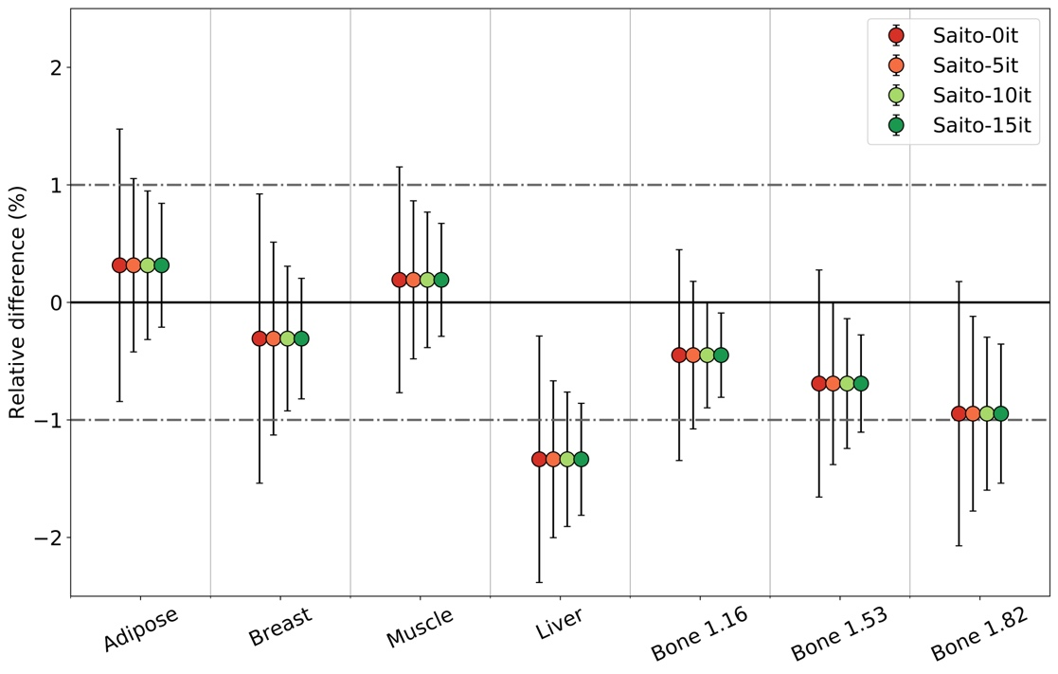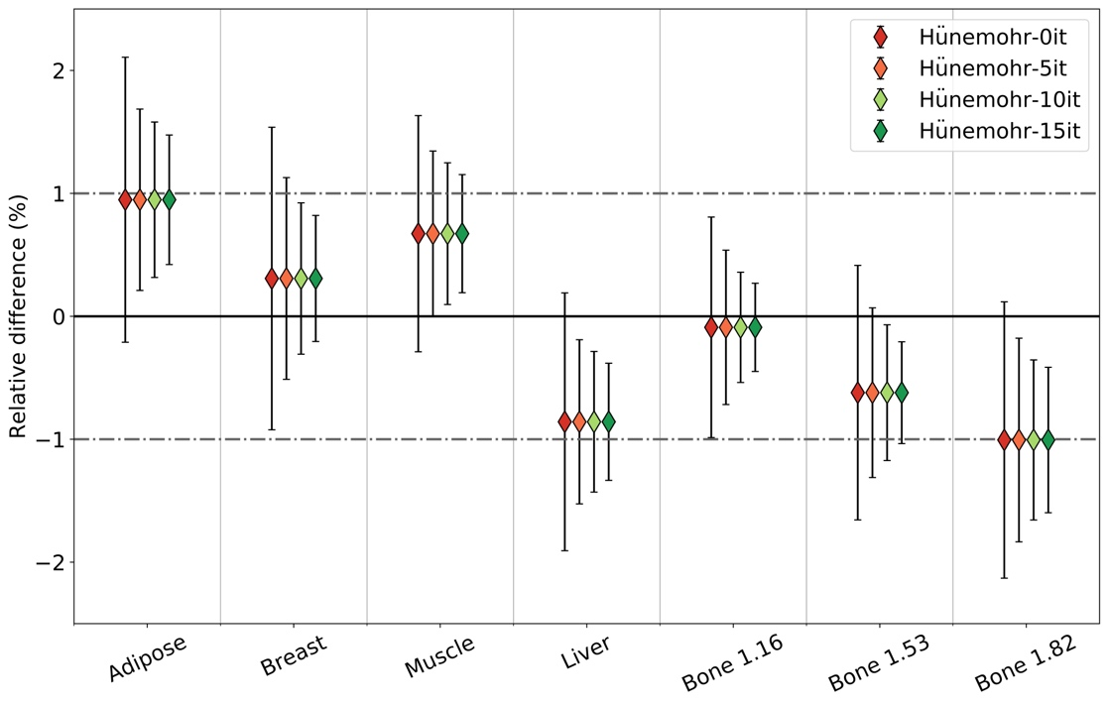
Figure S1. Relative difference (%) ± 1 standard deviation (measured-reference) in $ρ_{e}$ for two methodologies and for different iteration values of the edge-preserving curvature flow image filter in the post-processing step (0, 5, 10 and 15). Zero iterations correspond to no denoising.

- CT2ED and PMI2ED conversion curves

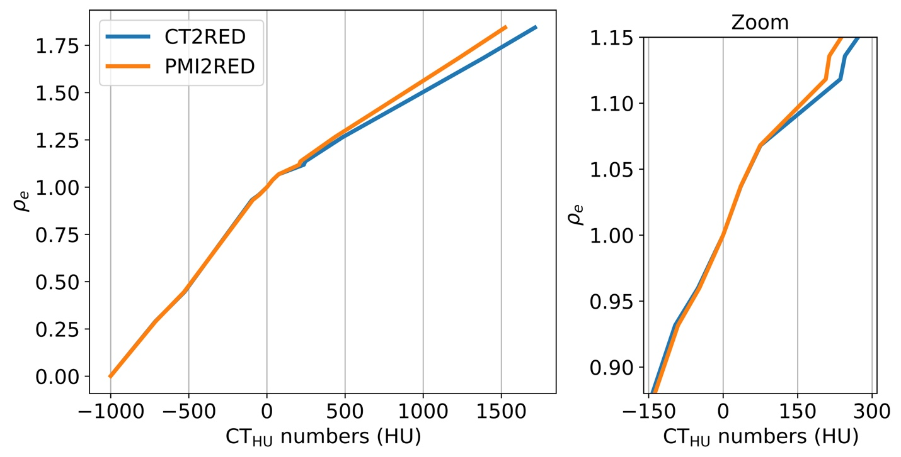
Figure S2. Relative electron density conversion curves used to convert 120 kVp CT and 79 keV PMI images in Hounsfield Units to relative electron densities (RED)

- Study workflow
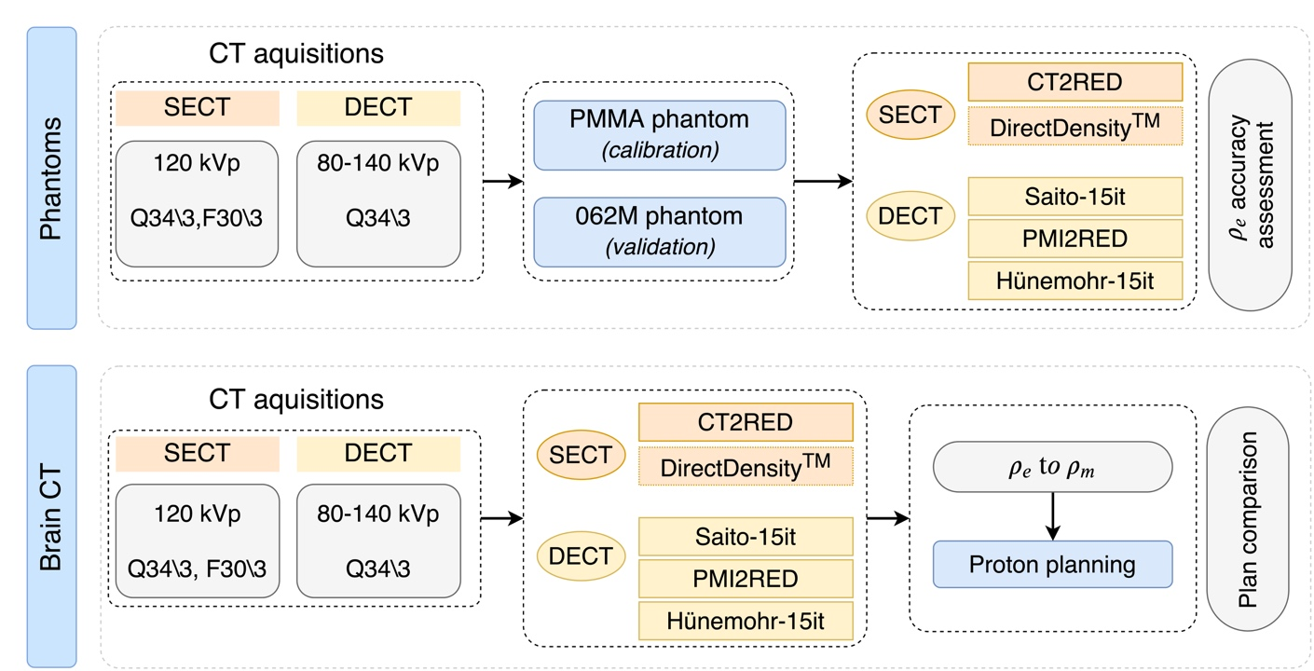

Figure S3. Workflow of the phantom and the patient brain CT acquisitions. The phantom study aims to assess relative electron density differences between five CT to density conversion methods. The patient study investigates density and proton dose differences between all conversion methods in one patient treatment plan.

- Impact of the presence of contrast medium in the patient scans

In clinical practice, when a contrast-enhanced CT is desired for tumor and organ-at-risk delineation, a second scan without contrast is acquired for proton treatment planning. However, this study was part of a clinical trial where multiple CT scans were acquired from one patient; a DECT scan prior to contrast injection, a SECT scan after contrast injection and a DECT scan after contract injection. For the proton dose calculations presented in the paper, only the contrast enhanced SECT and contrast-enhanced DECT scans were used. The individual non-contrast DECT images of 80 kVp and 140 kVp were only used for the comparison with the contrast-enhanced 80 kVp and 140 kVp CT images. The mean Hounsfield Unit (HU) differences between the contrast-enhanced images and the non-contrast images are shown in Figure S4, highlighting the slices through which the beams crossed. In these slices of interest, the maximum mean CT number difference was 7 HU for the 80 kVp CT scans and 5 HU for the 140 kVp CT scans.

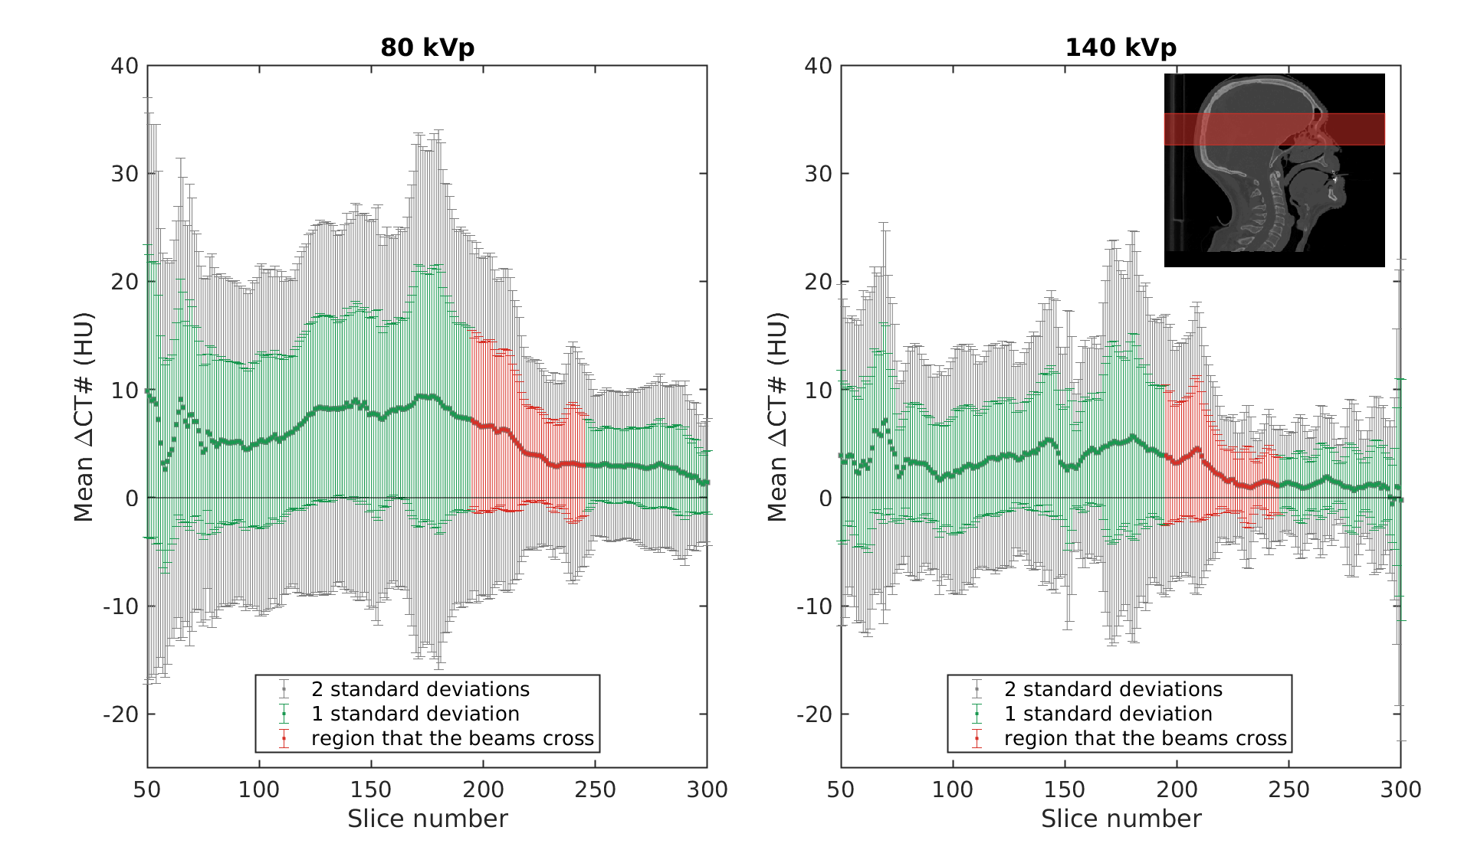
Figure S4. Mean difference in CT numbers (1 and 2 standard deviations) between the contrast-enhanced and the non-contrast CT images, for 80 kVp (left) and 140 kVp (right). The top right panel: sagittal CT plane of the patient illustrating with a red box the slices crossed by the three proton beams shown in Figure 1. The same slices are highlighted in both plots.

An additional phantom study, supported by patient data, was performed to evaluate the performance of the CT conversion methods on iodine inserts. The dose differences reported in this study were evaluated on a patient treatment plan with a virtual non-contrast-enhanced tumor. However, the patient had a real brain tumor close to the cranium of which the mean 80kVp HUs of brain tissue and the tumor were determined as extreme scenario. The 80 kVp CT reconstruction was picked because the photo-electric absorption of X-rays is sensitive to changes in material composition, especially in high-Z materials (iodine) and at lower energies (80 kVp). Then, the iodine insert with the highest similarity in measured HUs (84±7 HU), the 2 mg/ml Gammex insert, was chosen for further analysis. The atomic weight fractions of the 2 mg/ml iodine insert are listed in Table S1.
Table S1
 | $$ρ_{m}$$ | $$ρ_{e}$$ | H | O | C | N | Cl | Ca | Mg | I
Iodine insert | 1.03 | 1.00 | 8.64 | 17.51 | 69.53 | 2.15 | 0.13 | 1.81 | 0.03 | 0.20

The iodine insert was placed in the middle of the central bulk of the 062M phantom (Figure S5(a) and S5(b)). 120 kVp SECT imaging was performed to evaluate the accuracy of the CT2RED conversion method and the DirectDensity algorithm. 80/140 kVp dual-spiral DECT acquisitions were acquired and processed to evaluate the PMI2RED, the Saito-15it, and the Hünemohr-15it conversion methods. The accuracy of the different relative electron density conversion methods are listed in Table S3 (measurement – reference)/ref.
Table S2
Conversion method | (Measurement-Ref)/Ref * 100%
CT2RED | 4.8%
DirectDensity | 4.1%
PMI2RED | 4.3%
Hünemohr-15it | 0.2%
Saito-15it | 1.0%

The HU difference between the 2.0 mg/ml iodine insert and the phantom bulk was approximately 80HU, as extreme example. Differences found in the patient example between contrast-enhanced and non-contrast 80 kVp images showed HU differences of maximum 7HU. Converted to RED, this only introduces a small and negligible RED error.
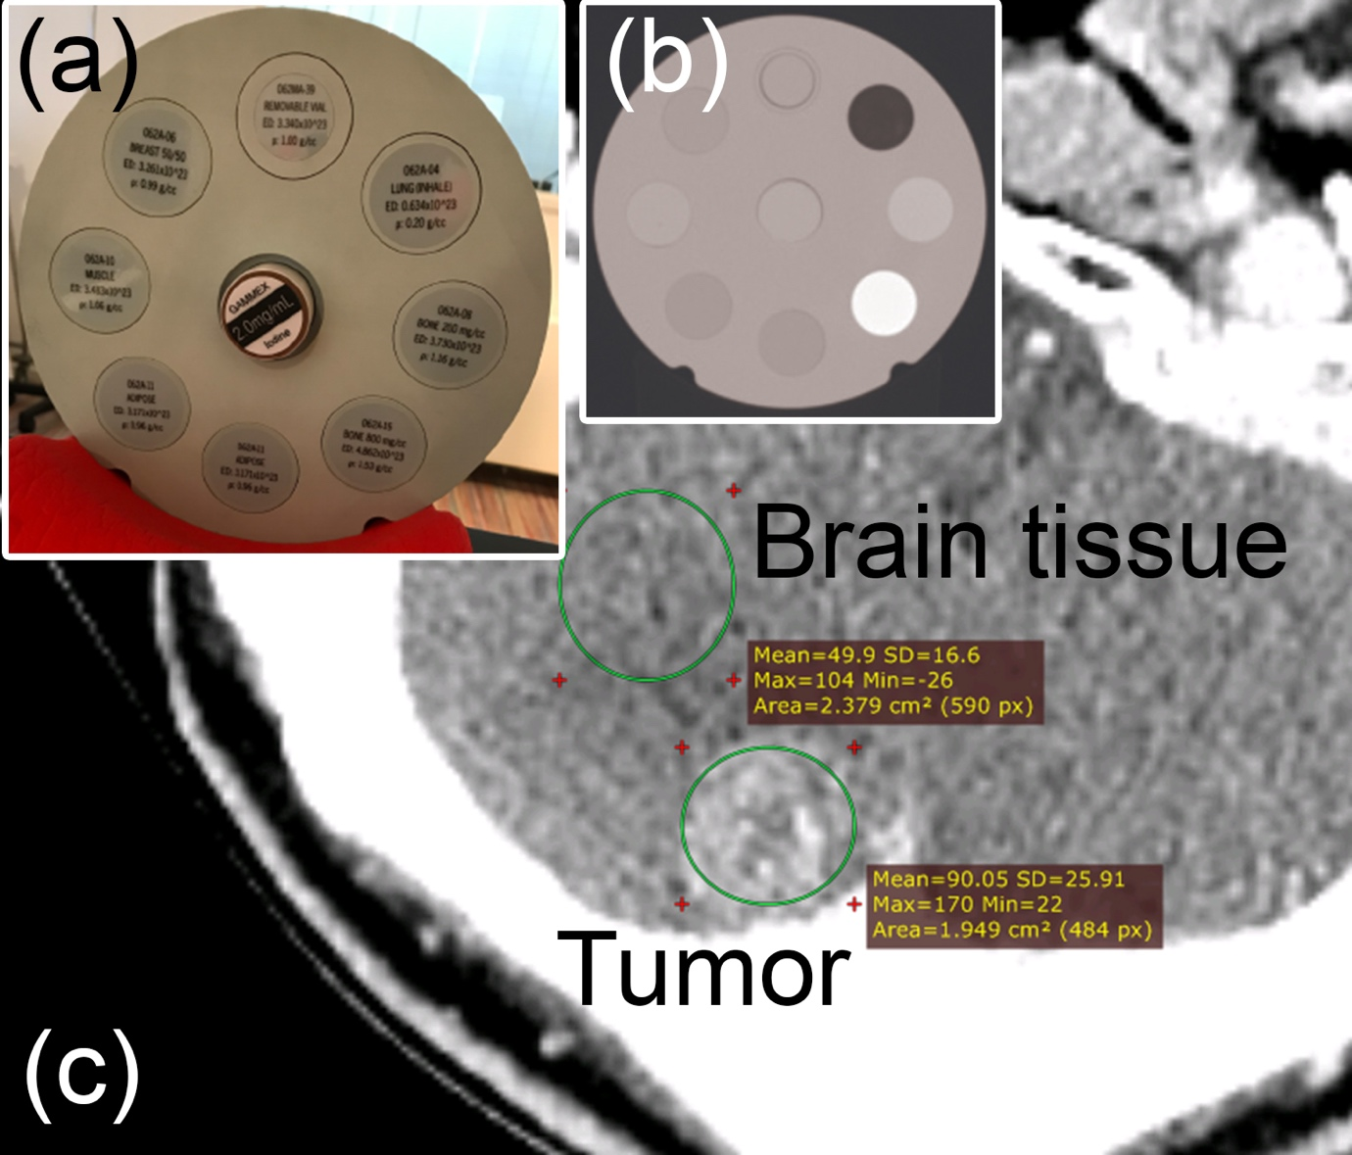

Figure S5. (a) imaging setup of the 062M phantom (CIRS) with the iodine insert 2.0 mg/ml in the middle, (b) depicts the SECT scan of the imaging setup acquired at 80 kVp, (c) shows the real patient tumor (not the virtual tumor used for dose calculations in this study) in a 80 kVp CT reconstruction where two regions-of-interest were drawn to investigate the mean absolute Hounsfield Units for brain tissue (50±17 HU) and the tumor (90±26 HU).

- DirectDensityTM results for patient #1

The CT acquisitions for patient #1 were reconstructed using DirectDensityTM. The resulting $ρ_{e}$-images were converted to $ρ_{m}$ as explained in subsection “CT protocol and post-processing”. The average $ρ_{m}$ difference (± 1 standard deviation) over the whole CT scan between the DirectDensityTM image and the CT2RED image was 0.00±0.02 g/cm³. The dose differences for the plan calculated in the CT2RED set and recalculated with DirectDensityTM were within 1%. Figure S6 summarizes the results for DirectDensityTM: absolute $ρ_{m}$ differences with respect to the CT2RED image for a representative slice, the frequency distribution calculated over all slices (excl. air cavities and dental filling artifacts) and the resulting dose difference for the proton treatment plan with three beams.

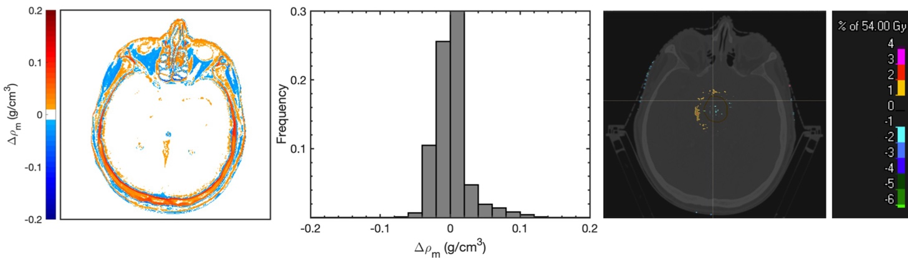

Figure S6. Left panel: Absolute mass-density differences ($Δρ_{m}$) between DirectDensityTM and the conventional CT2RED conversion method. Middle panel: Probability histogram calculated over the entire CT (excl. air cavities and dental filling artifacts). Right panel: dose differences between the plan calculated on the CT2RED images and the same plan evaluated on the DirectDensityTM set.

