Supplementary Figures, Tables and Appendices
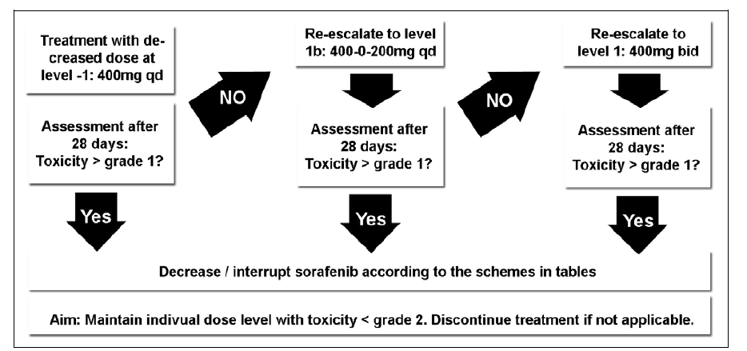
Supplementary Figure 1. General scheme for sorafenib dose re-escalation.

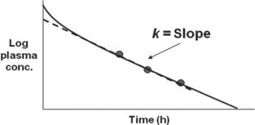
Supplementary Figure 2A. First order rate constant. Adapted from Di, Li, and Edward H. Kerns. Drug-like properties: concepts, structure design and methods from ADME to toxicity optimization.

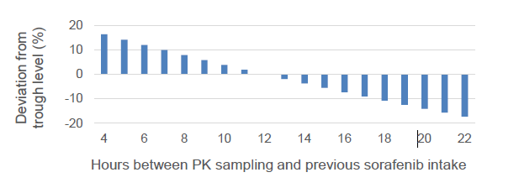
Supplementary Figure 2B. Dose adjustments according to time interval to last sorafenib intake.

Supplementary Figure 3. Overall survival (OS) according to received treatment. The median OS of the SIRT plus sorafenib subgroup was 19.6 months (95% CI 12.5-26.7) vs a median OS of 20.7 months (95% CI 13.5-27.9) in the sorafenib monotherapy subgroup.

Supplementary Table 1. Incidence of sorafenib-related adverse events*
Adverse event – no. of patients (%) | All patients for PK analysis (n=74)
Adverse event – no. of patients (%) | Grade 1 | Grade 2 | Grade 3 | Grade 4 | Any grade
Overall incidence | 9 (12) | 21 (28) | 23 (31) | 4 (5) | 57 (77)
Constitutional symptoms
Fatigue/Asthenia | 6 (8) | 10 (14) | 5 (7) | 0 (0) | 21 (28)
Night sweats | 2 (3) | 0 (0) | 0 (0) | 0 (0) | 2 (3)
Dermatologic events
Alopecia | 9 (12) | 3 (4) | 0 (0) | 0 (0) | 12 (16)
Dry skin | 1 (1) | 1 (1) | 0 (0) | 0 (0) | 2 (3)
Hand-foot syndrome / Rash | 12 (16) | 10 (14) | 10 (14) | 0 (0) | 32 (43)
Pruritus | 3 (4) | 1 (1) | 0 (0) | 0 (0) | 4 (5)
Psoriasis | 0 (0) | 0 (0) | 1 (1) | 0 (0) | 1 (1)
Gastrointestinal events
Anorexia | 6 (8) | 6 (8) | 1 (1) | 0 (0) | 13 (18)
Diarrhea | 10 (14) | 11 (15) | 7 (9) | 0 (0) | 28 (38)
Dry mouth | 2 (3) | 1 (1) | 0 (0) | 0 (0) | 3 (4)
Nausea | 7 (9) | 1 (1) | 0 (0) | 0 (0) | 8 (11)
Stomatitis | 5 (7) | 4 (5) | 1 (1) | 0 (0) | 10 (14)
Vomiting | 3 (4) | 1 (1) | 0 (0) | 0 (0) | 4 (5)
Other
Abdominal pain | 1 (1) | 3 (4) | 0 (0) | 0 (0) | 4 (5)
Arthralgia | 2 (3) | 0 (0) | 0 (0) | 0 (0) | 2 (3)
GGT increased | 0 (0) | 0 (0) | 0 (0) | 1 (1) | 1 (1)
Hepatic encephalopathy | 0 (0) | 0 (0) | 0 (0) | 1 (1) | 1 (1)
Hyperbilirubinaemia | 0 (0) | 0 (0) | 1 (1) | 0 (0) | 1 (1)
Hypertension | 2 (3) | 3 (4) | 1 (1) | 1 (1) | 7 (9)
Hypocalcaemia | 0 (0) | 0 (0) | 1 (1) | 1 (1) | 2 (3)
Hypomagnesaemia | 0 (0) | 0 (0) | 1 (1) | 0 (0) | 1 (1)
Hypophosphatemia | 0 (0) | 2 (3) | 1 (1) | 0 (0) | 3 (4)
Muscle spasms | 1 (1) | 2 (3) | 1 (1) | 0 (0) | 4 (5)
Voice changes | 4 (5) | 1 (1) | 0 (0) | 0 (0) | 5 (7)
*The incidence of adverse events (maximum grade) that were considered to be probably or definitely related to sorafenib, as assessed by the treating physician. Adverse events that occurred in >1 patient or were grade 3 or 4 are shown.

Supplementary Table 2. Comparison of patients with and without grade 3-4 adverse events.
Variable | Grade 0-2 toxicity  (n=47) | Grade 3-4 toxicity  (n=27) | p-value
Demographics
Age, years – mean (SD) | 64 (9.3) | 68 (6.9) | 0.066
Male sex – no. (%) | 40 (85) | 26 (96) | 0.245
BMI – mean (SD) | 29 (5.4) | 28 (4.9) | 0.507
BSA – mean (SD) | 2.0 (0.2) | 1.9 (0.2) | 0.252
Liver disease
Cirrhosis – no. (%) | 38 (81) | 23 (85) | 0.757
Child-Pugh class – no. (%) |  |  | 0.530
A | 45 (96) | 27 (100)
B | 2 (4) | 0 (0)
Tumor parameters
ECOG PS – no. (%) |  |  | 0.155
0 | 29 (62) | 21 (78)
1 | 18 (38) | 6 (22)
BCLC stage – no. (%) |  |  | 0.900
A | 0 (0) | 0 (0)
B | 15 (32) | 9 (33)
C | 32 (68) | 18 (67)
Serum tests (median, IQR)
AFP, ng/ml – median (IQR) | 109 (6-2681) | 20 (6-109) | 0.126
Albumin, g/l – mean (SD) | 40 (4.7) | 40 (4.7) | 0.892
Total bilirubin, µmol/L – median (IQR) | 12 (9-17) | 11 (8-14) | 0.184
Treatment details
SORAMIC treatment arm – no. (%) |  |  | 0.483
SIRT plus sorafenib (palliative) | 17 (36) | 12 (44)
Sorafenib monotherapy | 30 (64) | 15 (56)
Duration sorafenib treatment, weeks – median (IQR) | 51 (30-59) | 42 (23-77) | 0.862
Mean daily sorafenib dose, mg – median (IQR) | 730 (593-788) | 551 (409-716) | 0.003
PK parameters
Sorafenib trough levels, ng/ml
Mean – median (IQR) | 3298 (1999-4687) | 2915 (2177-3848) | 0.442
Highest – median (IQR) | 3780 (2311-6435) | 3264 (2320-5128) | 0.384
M2 metabolite trough levels, ng/mk
Mean – median (IQR) | 428 (185-734) | 283 (191-522) | 0.159
Highest – median (IQR) | 534 (232-932) | 317 (202-609) | 0.117
Ratio M2 / sorafenib trough level, ng/ml
Mean – median (IQR) | 0.12 (0.09-0.17) | 0.09 (0.07-0.15) | 0.128
Highest – median (IQR) | 0.12 (0.09-0.19) | 0.10 (0.07-0.15) | 0.102
Abbreviations: AFP, Alpha-fetoprotein; BCLC, Barcelona Clinic Liver Cancer; BMI, body-mass index; BSA, body-surface area; ECOG PS, Eastern Cooperative Oncology Group performance status; IQR, interquartile range; M2, N-oxide sorafenib metabolite; no, number; SD, standard deviation; SIRT, selective internal radiation therapy.

Appendix A: Full list of eligibility criteria of the SORAMIC trial
Patients of either sex were eligible for this trial provided they met all in- and exclusion criteria.

Inclusion Criteria
- Age: 18-85 years
- Diagnosis of hepatocellular carcinoma
- If primary diagnosis of HCC: diagnosis based on the following criteria:
a. cyto-histological criteria, OR
b. radiological criteria: Focal lesion >1 cm with arterial hypervascularization in 2
coincident imaging techniques (CT, MRI, or US), OR
c. combined criteria: one imaging technique showing a focal lesion 1-2 cm with
arterial hypervascularization AND AFP levels >400 ng/mL, OR
d. combined criteria: one imaging technique showing a focal lesion >2 cm with
arterial hypervascularization AND AFP levels >200 ng/mL
- If extrahepatic metastases: liver-dominant disease
- Stage BCLC A, B, or C
- Child-Pugh A, Child-Pugh B up to 7 points (in patients receiving anticoagulant therapy: Child-Pugh score up to 5 points; INR category not regarded for calculation of the Child-Pugh score)
- Willing to comply with all study procedures
- Has voluntarily given written informed consent

Exclusion Criteria
- If female, pregnant or breast feeding (females of child-bearing potential must use adequate contraception and must have a negative pregnancy test performed within 7
days prior to inclusion into this study)
- If male, not using adequate birth control measures
- One or more of the following:
- Hemoglobin <10g/dL,
- WBC <2,500 cells/mm3,
- ANC <1,500 cells/mm3,
- platelets <50,000/mm3,
- ECOG performance status >2
- Life expectancy <16 weeks or medically unstable
- Extrahepatic metastases (except metastases to bone, lymph nodes, and adrenal glands which do not constitute an exclusion criterion), but, see Section 4.2, Additional Criteria for the Local Ablation Group, below
- Patients with known GFR <30 mL/min/1.73m2
- PT-INR/PTT >1.5 times the upper limit of normal (patients on anticoagulation therapy will be allowed to participate provided that no prior evidence exists of an underlying abnormality in anticoagulation)
- uncontrolled infections at the time of microtherapy
- Child-Pugh score >7 points; in patients receiving anticoagulant therapy: Child-Pugh score >5 points (INR category not regarded for calculation of the Child-Pugh score)
- Uncontrolled ascites
- Tumor load of the whole liver >70%
- Contraindications for study medications according to product labeling or procedures (sorafenib, Primovist®, x-ray contrast agents, SIR-Spheres®, RFA, MRI, CT) incl. any contraindication to the trans-arterial interventional procedure (e.g., allergy against xray contrast agents, uncontrolled hyperthyroidism)
- Prior resection of the papilla of Vater (e.g., Whipple procedure) or bile duct stent across the papilla
- Significant cardiovascular disease; e.g., myocardial infarction within 6 months of inclusion, chronic heart failure (New York Heart Association class III or IV), unstable coronary artery disease
- Uncontrolled hypertension
- Thrombotic or embolic events including transient ischemic attacks within the past 6 months (tumor-related portal vein thrombosis allowed in the palliative part of the trial)
- History of GI bleeding within 30 days before inclusion into this study
- History of esophageal varices bleeding which has not been controlled by effective therapy and/or therapy to prevent bleeding recurrence
- Previous malignancy other than carcinoma in situ of the skin or the cervix uteri within 5 years prior to inclusion
- History of organ transplant (including prior liver transplantation)
- HIV, congenital immune defect, any immunosuppressive therapy for autoimmune disease (rheumatoid arthritis) or inflammatory bowel disease
- Mental conditions rendering the subject incapable to understand the nature, scope, and consequences of the trial
- Close affiliation with the investigational site; e.g. first-degree relative of the Investigator
- Participating in another therapeutic clinical trial or has completed study participation in another therapeutic clinical trial within 30 days of enrolment into this trial
- Having been previously enrolled in this clinical trial

Additional Criteria for the Palliative Treatment Group
Inclusion criteria
- Not eligible for TACE (at the discretion of the investigator; i.e. diffuse tumors, tumors
larger than 5 cm)
- Patients who have undergone prior hepatic treatments for HCC (including resection,
PEI, RFA, TAE and TACE) are eligible for inclusion in the study under the following
conditions:
o Resection (segmentectomy, lobectomy) prior RFA and vascular interventions
must leave sufficient liver tissue to maintain hepatic functional reserve as
indicated by the general inclusion/exclusion criteria
o The last session of prior TAE and TACE must have been conducted a
minimum of 12 weeks prior to randomization for the current study, with
sufficient hepatic vascular flow to permit infusion of yttrium-90 microspheres
o For prior TAE/TACE procedures, there is sufficient hepatic vasculature to
access either pre-existing lesion(s) that have re-vascularized, or there is
sufficient collateral flow to new lesions to permit the infusion of yttrium-90
microspheres

Exclusion criteria
- Bilirubin above 1.5 times the upper limit of the normal range (NOTE: good clinical
practice suggests that bilirubin be [re]assessed within 1 or 2 days of the planned SIRT
to assure that hepatic function has not deteriorated since the screening values.)
- Hepato-pulmonary shunt leading to a lung dose >30 Gy
- Any previous external beam radiation therapy to the liver
- Previous therapy with monoclonal antibodies

Appendix B: Sorafenib pharmacokinetic analysis
Sorafenib and sorafenib N-oxide were analyzed using LC-MS/MS in the positive ionisation mode on a Shimadzu LC-20 (Nishinokyo-Kuwabaracho, Japan) system coupled to an ABSciex (Framingham, MA, USA) API3200 Qtrap lc-MS. To 100 µl of patient plasma, 750 µl methanol/acetonitrile (1:1 v/v), containing the internal standard Sorafenib-d3, was added to precipitate proteins. Samples were vortexed, stored at -20°C for 10 minutes, vortexed again and centrifuged for 5 minutes at 2750 x g . For the determination of sorafenib and sorafenib N-oxide, 5 µl was injected onto a Thermo Scientific Hypurity C18 (50 x 2.1 mm, 3µm) column. A chromatographic gradient was applied using acetonitrile and water with a constant 5% addition of 1% ammonium acetate / 3,5% glacial acetic acid in water. The flow was 500 µl/min, column-oven temperature was set at 30°C. Sorafenib was measured as [M+H]⁺, using the mass transition 465.1/252.0, Sorafenib N-oxide with mass transition 481.0/286.0 and Sorafenib-d3 with mass transition 468.0/255.0. The method was validated over a range of 0.0500 – 100 mg/L (including dilution) for Sorafenib and over a range of 0.0200 – 50.0 mg/L (including dilution) for Sorafenib N-oxide. The accuracy ranged from 90.7% to 109% for Sorafenib and from 90.7% to 112 % fo Sorafenib N-oxide across the validated range, the intra-day precision was ≤ 5.8% for Sorafenib and 5.7% for Sorafenib N-oxide. The inter-day precisions was ≤ 5.6% for Sorafenib and ≤ 6.9% for Sorafenib N-oxide. With a sample volume of 100 µL, the sensitivity of LC-MS/MS is sufficient to determine sorafenib and sorafenib N-oxide levels far below the therapeutic level with a lower limit of quantification of 20 ng/mL .

