**Supplementary Material**

1. **Supplementary Methods.**
2. **Supplementary References.**
3. **Supplementary Figure 1: Internal calibration plot of predicted versus observed median overall survival.**
4. **Supplementary Figure 2: External calibration plot of predicted versus observed median overall survival.**
5. **Supplementary Figure 3: Formula for absolute treatment effect of upfront combination chemotherapy versus sequential chemotherapy in patients with metastatic colorectal cancer.**
6. **Supplementary Figure 4: Histogram illustrating the distribution of predicted effect for combination chemotherapy versus sequential chemotherapy in CAIRO patients.**
7. **Supplementary Figure 5: Histogram illustrating the distribution of predicted effect for combination chemotherapy versus sequential chemotherapy in FOCUS patients.**
8. **Supplementary Table 1: Clinical implications according to different treatment-thresholds (CAIRO data).**
9. **Supplementary Figure 6: Nomogram predicting the probability of receiving second-line treatment after first-line monochemotherapy.**
10. **Supplementary Figure 7: Actual calibration and interval calibration plot of predicted and observed probabilities for receiving second-line treatment in CAIRO patients.**
11. **Supplementary Figure 8: External calibration plot of predicted and observed probabilities for receiving second-line treatment in FOCUS patients.**
12. **Supplementary Figure 9: Formula for the prediction of the probability of receiving second-line treatment of first-line monochemotherapy in metastatic colorectal cancer patients.**

**Supplementary Methods**

**Patients**

Data from the CAIRO trial were used for the development of the model. In the CAIRO trial, 803 patients with mCRC not amenable for curative surgery were randomised to receive either A) first-line treatment with capecitabine monotherapy, second-line treatment with irinotecan and third-line treatment with capecitabine plus oxaliplatin (CAPOX), or B) first-line treatment with capecitabine plus irinotecan (CAPIRI) and second-line treatment with CAPOX. The trial showed a median overall survival (OS) of 16.3 months in the sequential arm and 17.4 months in the combination arm (hazard ratio [HR] for combination treatment 0.92, 95% confidence interval [CI] 0.79 to1.08; *P*=.33).1 Both arms were used for the model predicting survival times. For the development of the model predicting the probability of receiving second-line treatment after first-line monochemotherapy, only patients in arm A with a complete follow-up – i.e. until death or exposure to second-line treatment – were included.

Data of the FOCUS trial were used for the external validation of the models. In FOCUS, 2135 patients were randomised between A) first-line treatment 5-fluorouracil (5-FU) and second-line irinotecan, B) first-line treatment 5-FU and second-line 5-FU plus irinotecan (FOLFIRI) or 5-FU plus oxaliplatin (FOLFOX), or C) upfront combination chemotherapy with FOLFIRI or FOLFOX. Median OS was 13.9 months in arm A, 15.3 and 14.3 months in arm B, respectively, and 16.5 and 15.0 months in arm C, respectively. The only statistically significant difference was observed between arm A and treatment with FOLFIRI in arm C (HR 0.84, 95% CI 0.73 to 0.96; *P*=.01), and arm B was considered non-inferior to Arm C (HR 1.06, 90% CI 0.97 to 1.17).2 For the model predicting survival times, arm A (sequential chemotherapy) and arm C (combination chemotherapy) were included. For the model predicting the probability of receiving second-line treatment arm A and B were used. OS was defined as the interval between randomization and death, and patients alive at last follow-up were censored. For the original trials ethics committee approval was obtained and all patients provided written informed consent.

**Development of model estimating overall survival times**

The CAIRO data were used to build an accelerated failure time model with a Weibull distribution for prediction of gain in median OS for individual patients (i.e. point in time from which onwards it is more likely that the patient is dead than alive). Prespecified predictors of survival included sex, WHO performance status (0, 1, or 2), body mass index (BMI), number of metastatic sites (0, 1, 2, or ≥3), presentation of metastatic disease (synchronous or metachronous), resection of the primary tumour (yes or no), sidedness of the primary tumour (right colon until splenic flexure, or left colon/rectum from splenic flexure on), alkaline phosphatase (ALP), and white blood cell count (WBC).3-6 Treatment arm was added to the model as a predictor for survival. To prevent a loss of statistical power, missing values were imputed with single imputation using additive regression and predictive mean matching (aregImpute-algorithm, Hmisc package), assuming that these values were missing at random. We were unable to include *BRAFV600E*- and *KRAS*-mutation status in the model because of missing data in more than 50% of patients. Serum lactate dehydrogenase (LDH) could not be added to the model because this parameter was not obtained in the FOCUS trial. Next, continuous predictors were truncated at the 1st and 99th percentile to limit the effect of outliers. Exploratory analysis with continuous predictors truncated at percentiles 0.5%-99.5% and 2%-98% did not substantially affect model outcomes compared to 1%-99%. Continuous predictors were assessed for linearity with OS. When not linearly associated, multiple transformations were subjected to Akaike’s Information Criterion (AIC) to identify the optimal transformation (rms package). WHO performance score was added to the model as treatment interaction since previous data indicated that patients with poor performance may benefit from intensified upfront therapy. 2,7 To evaluate the presence of additional treatment interactions, interactions terms of all included variables were added and subjected to backward selection based on AIC (rms package).8 An estimate of the optimism in the calibration slope and the corresponding shrinkage factor were determined by repeating the full modelling process in 1000 bootstrap repetitions.

Data from the FOCUS trial were used for external validation. Again, missing values of predictors were imputed and continuous predictors were truncated. Model coefficients were penalized by using a uniform shrinkage factor of 0.91 prior to obtaining predictions. Model performance was measured using the C-index,9 and a calibration plot was constructed to evaluate how close the predictions were to the observed survival times.

**Development of model estimating the probability of receiving second-line treatment**

A step-by-step protocol10 was followed for the development of this model: 1) Potential prognostic variables were identified, including age, sex, WHO performance status (0, 1, or 2), BMI, number of metastatic sites (0, 1, 2, or ≥3), presentation of metastatic disease (synchronous or metachronous), resection of the primary tumour (yes or no), sidedness of the primary tumour (left or right), ALP, and WBC. Missing data were imputed using the methods described above and continuous variables were truncated at the 1st and 99th percentile. Continuous variables were transformed when not linearly association with the endpoint. 2) Predictors were selected using logistic regression analysis with backward stepwise selection based on AIC (rms package), with assessment of any potential interaction effects; 3) The model was subjected to 1000 bootstrap resamples for internal validation and appraised with Harrell’s C-index11; 4) Model coefficients were shrunk using penalized maximum likelihood (optimal penalty factor of 12; pentrace package), after which FOCUS data were used for external validation and a nomogram was constructed (rms package).

**Model outcomes**

The first model was used to predict median OS in months with sequential treatment and with upfront combination treatment for every individual patient in the CAIRO trial. The predicted gain in median OS of combination versus sequential treatment was subsequently calculated as the difference between these two survival estimates. The second model was used to predict the probability of receiving second-line treatment after first-line monochemotherapy. Since exposure to all available drugs is associated with improved survival12, this model would be particularly helpful for patients who do not have a clear predicted survival benefit for combination or sequential chemotherapy.

For the model predicting gain in median OS, decision curve analysis was used to determine whether treatment-decisions based on the model predictions of treatment effect would result in better clinical outcomes than treating patients based on group level results (treating all or none with combination therapy).13 This method includes calculation of net benefit, which was defined as the predicted gain in median OS minus the treatment threshold multiplied by the associated treatment rate (i.e. proportion of patients treated with combination therapy according to a certain strategy at a certain threshold). The treatment threshold is the smallest gain in OS at which a patient and doctor would opt for upfront combination treatment. For example, a threshold of three months gain in OS implies that at that point the benefits (gain in OS) and harms (e.g. toxicity) of combination treatment are considered equal. Thus, the more harms are associated with a treatment, the higher the treatment threshold. At each threshold, data from patients who were actually treated according to the strategy at hand was used. For example, when 50% of patients have a predicted gain of more than a hypothetical threshold of three months for combination treatment, and the median OS benefit observed in patients with a congruent actual and recommended treatment is two months, the net benefit will be 2.0 – 0.5 x 3 = 0.5. Positive net benefit indicates that combination treatment is superior to treating all patients with sequential chemotherapy, which is the reference (net benefit equals zero), whereas negative net benefit indicates worse clinical outcome. In CAIRO as well as FOCUS data, the net benefit in OS of the following treatment strategies was compared: treat all patients with sequential chemotherapy, treat all patients with upfront combination chemotherapy, prediction-based treatment, and prediction-based treatment treating only those with a significant predicted treatment effect (*P*<.05). Since the selection of a threshold is highly subjective, we calculated the net benefit for thresholds ranging from zero to five months gain in median OS and presented the results graphically as decision curves. Analyses were performed using SPSS, version 24, and R (with packages as described above, and own algorithms), version 3.3.3.

**Supplementary References**

1. Koopman M, Antonini NF, Douma J et al. Sequential versus combination chemotherapy with capecitabine, irinotecan, and oxaliplatin in advanced colorectal cancer (CAIRO): a phase III randomised controlled trial. Lancet 2007; 370: 135-142.
2. Seymour MT, Maughan TS, Ledermann JA et al. Different strategies of sequential and combination chemotherapy for patients with poor prognosis advanced colorectal cancer (MRC FOCUS): a randomised controlled trial. Lancet 2007; 370: 143-152.
3. Köhne CH, Cunningham D, Di Costanzo F et al. Clinical determinants of survival in patients with 5-fluorouracil-based treatment for metastatic colorectal cancer: results of a multivariate analysis of 3825 patients. Ann Oncol 2002; 13: 308-317.
4. Renfro LA, Loupakis F, Adams RA et al. Body Mass Index Is Prognostic in Metastatic Colorectal Cancer: Pooled Analysis of Patients From First-Line Clinical Trials in the ARCAD Database. J Clin Oncol 2016; 34: 144-150.
5. Holch JW, Ricard I, Stintzing S, Modest DP, Heinemann V. The relevance of primary tumour location in patients with metastatic colorectal cancer: A meta-analysis of first-line clinical trials. Eur J Cancer 2017; 70: 87–98.
6. Venderbosch S, de Wilt JH, Teerenstra S et al. Prognostic value of resection of primary tumor in patients with stage IV colorectal cancer: retrospective analysis of two randomized studies and a review of the literature. Ann Surg Oncol 2011; 18: 3252-3260.
7. Cremolini C, Loupakis F, Antoniotti C et al. FOLFOXIRI plus bevacizumab versus FOLFIRI plus bevacizumab as first-line treatment of patients with metastatic colorectal cancer: updated overall survival and molecular subgroup analyses of the open-label, phase 3 TRIBE study. Lancet Oncol 2015; 16: 1306-1315.
8. Steyerberg EW. Clinical Prediction Models: A Practical Approach to Development, Validation, and Updating. New York: Springer, 2009.
9. Gerds TA, Kattan MW, Schumacher M, Yu C. Estimating a time-dependent concordance index for survival prediction models with covariate dependent censoring. Stat Med 2013; 32: 2173-2184.
10. Iasonos A, Schrag D, Raj GV, Panageas KS. How to build and interpret a nomogram for cancer prognosis. J Clin Oncol 2008; 26: 1364-1370.
11. Harrell FE. Regression Modeling Strategies with Applications to Linear Models, Logistic Regression, and Survival Analysis. New York: Springer; 2001.
12. Grothey A, Sargent D, Goldberg RM, Schmoll HJ. Survival of patients with advanced colorectal cancer improves with the availability of fluorouracil-leucovorin, irinotecan, and oxaliplatin in the course of treatment. J Clin Oncol 2004; 22: 1209-1214.
13. Vickers AJ, Kattan MW, Daniel S. Method for evaluating prediction models that apply the results of randomized trials to individual patients. Trials 2007; 8: 14.

Supplementary Figure 1. Internal calibration plot of predicted versus observed median overall survival.

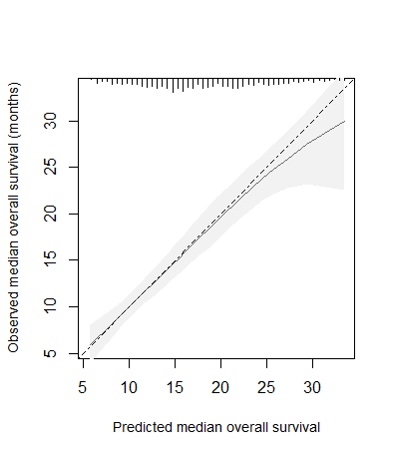

The tick marks at the top axis represent the distribution of the predicted median overall survival as present in the CAIRO dataset.

Supplementary Figure 2. External calibration plot of predicted versus observed median overall survival.

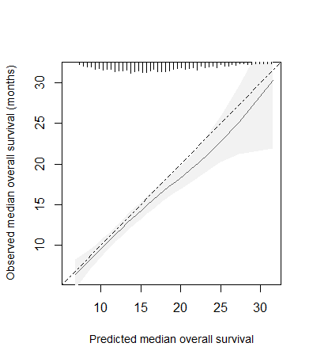

The tick marks at the top axis represent the distribution of the predicted median overall survival as present in the FOCUS dataset.

Supplementary Figure 3. Formula for absolute treatment effect of upfront combination chemotherapy versus sequential chemotherapy in patients with metastatic colorectal cancer.

LP linear predictor; WHO World Health Organization. SI conversion factor: To convert alkaline phosphatase to μkat per liter, multiply by 0.0167.

Supplementary Figure 4. Histogram illustrating the distribution of predicted effect for combination chemotherapy versus sequential chemotherapy in CAIRO patients.

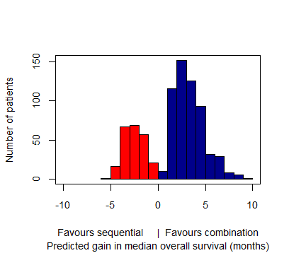

Supplementary Figure 5. Histogram illustrating the distribution of predicted effect for combination chemotherapy versus sequential chemotherapy in FOCUS patients.

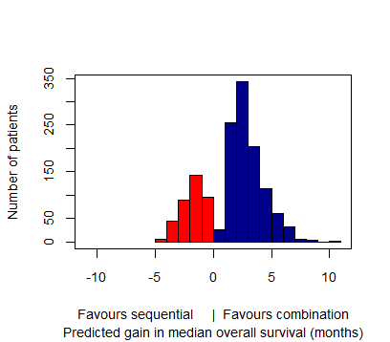

**Supplementary Table 1. Clinical implications according to different treatment-thresholds (CAIRO data).**

|  |  |  |  |
| --- | --- | --- | --- |
| **Treatment-threshold (gain in median OS in months)** | **Strategy associated with the highest net benefit** | **Combination chemotherapy treatment ratea** | **Average gain in median OS (months)b** |
| 0 | Prediction-based treatment | 71.2% | 3.1 |
| 1 | Prediction-based treatment | 70.0% | 3.1 |
| 2 | Prediction-based treatment with statistical significance | 33.5% | 4.1 |
| ≥3 | Treat all patients with sequential chemotherapy | 0% | NA |

OS overall survival; NA not applicable. aPercentage of patients who would be treated with combination chemotherapy instead of sequential chemotherapy according to the strategy with highest net benefit. bMedian gain for patients treated with combination chemotherapy (according to strategy with highest net benefit) as compared to sequential chemotherapy.

Supplementary Figure 6. Nomogram predicting the probability of receiving second-line treatment after first-line monochemotherapy.

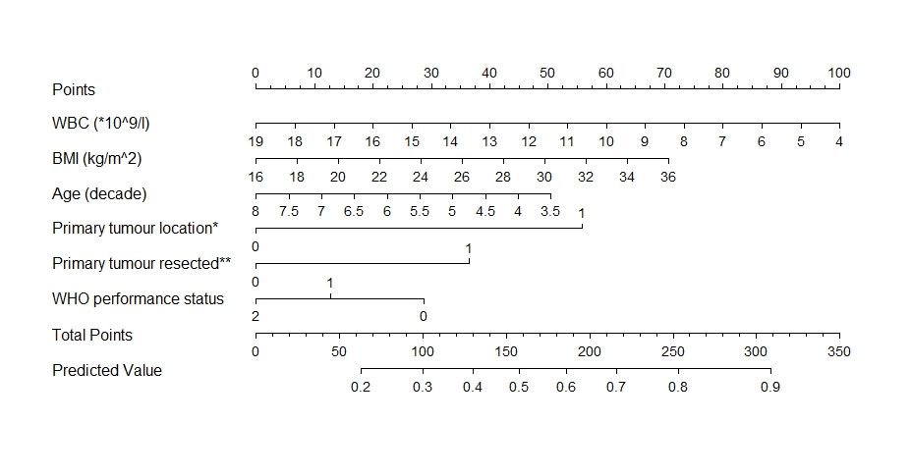

WHO World Health Organization; WBC white blood cell count; BMI Body Mass Index. *0=right-sided colon, 1=left-sided colon/rectum. **0=no, 1=yes.

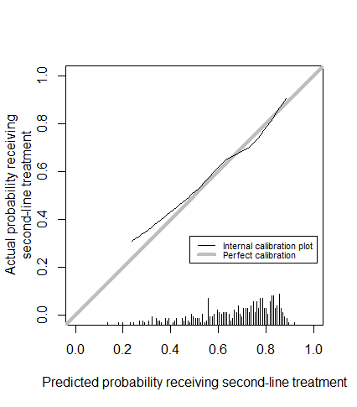

Supplementary Figure 7. Interval calibration plot of predicted and observed probabilities for receiving second-line treatment in CAIRO patients.

The tick marks at the bottom axis represent the distribution of the predicted probabilities.

Supplementary Figure 8. External calibration plot of predicted and observed probabilities for receiving second-line treatment in FOCUS patients.

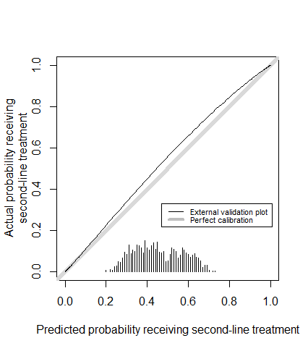

The tick marks at the bottom axis represent the distribution of the predicted probabilities.

Supplementary Figure 9. Formula for the prediction of the probability of receiving second-line treatment of first-line monochemotherapy in metastatic colorectal cancer patients.

**Probability (%)** = 1/(1+ $e^{-LP}$), where LP = 0.44721 – 0.16342 * Age (per decade) – 0.09706 * white blood cell count (*109/l) + 0.05148 * Body Mass Index (kg/m2) + 0.81330 [if primary tumour is located in left side of colon or rectum] + 0.53192 [if primary tumour resected] – 0.23328 [if WHO performance status 1] – 0.41800 [if WHO performance status 2].

LP linear predictor; WHO World Health Organization.