**Appendix 1 - Supplementary material**

The exercise intervention is described following the Consensus on Exercise Reporting Template (CERT) (20)

*Type of exercise equipment used:*

Exercise training consisted of 40 min (including 5 min warm-up and 5 min cool-down) of interval training on an electromagnetically braked cycle ergometer (Optibike Ergoline GmbH, Germany). The training programme was preloaded on a chip-and-pin card which executed the interval intensities automatically.

*Qualifications, teaching/supervising expertise, and/or training undertaken by the exercise instructor:*

Exercise intervention was supervised by hospital staff with a minimal qualification of Basic Life Support. These included physiotherapists, sports medicine practitioners and research nurses, trained by the bicycle ergometer suppliers.

*Describe whether the exercises are performed individually or in a group:*

Wherever possible, dependent on availability, trial participants were exercised in pairs, in order to provide camaraderie.

*Exercise supervision and delivery:*

Upon randomisation to exercise intervention, participant details were passed to the hospital-based exercise supervisors. Professional background varied between hospital sites, either band 4 physiotherapy assistants or band 4 research exercise physiologists. They contacted the participants in order to arrange sessions, at a time convenient to both parties.

On arrival, in the hospital prehabilitation department, the participants underwent questioning regarding desire to continue with the trial and medical consultations subsequent to previous exercise visits. In addition, basic observations are taken, heart rate, blood pressure and oxygen saturations.

The participants are reminded to inform the supervisor in the case of chest pain, sudden onset shortness of breath and dizziness, according the Perioperative Exercise testing and Training Society guideline (19).

*How fidelity/ adherence to exercise is measured and reported:*

Patient adherence is defined as a percentage of prescribed exercise sessions that were attended, with more than half of the 40 minute session completed. The session intensities were recorded on a pin and chip card which is inserted into the training ergometer. This chip and pin system records live patient data (heart rate, and cadence) during the session, which is download to provide post hoc analysis of adherence.

*Description of motivation strategies:*

All exercise sessions were supervised throughout as described above. No specific motivational strategies were adopted, although presence of the supervisor and pairing of trial participants was reported to increase motivation and adherence by our patient ambassadors.

*Exercise progression:*

Exercise intensity is prescribed onto a chip and pin card, using the participant’s physiological variables determined by CPET. To ensure that progressive overload was maintained throughout the trial, participants underwent CPET after 3 weeks and the training programme was modified for each individual's ramped CPET protocol results ensuring consistent, progressive and individualized intensities for all subjects.

*Detailed description of the structured, tailored and responsive exercise training sessions:*

Exercise training consisted of 40 min (including 5 min warm-up and 5 min cool-down) of interval, aerobic training on an electromagnetically braked cycle ergometer (Optibike Ergoline GmbH, Germany).

Patients randomised to the exercise group attended an in-hopsital, 6 week, structured, responsive exercise training programme. (Three sessions per week) Participants wore a heart rate monitor throughout the session which reported pulse rate onto the ergometer screen.

Training intensities were prescribed onto a chip and pin card, based on individual’s physiological variables, (anaerobic threshold (AT) and peak) determined at CPET. This card was inserted into the cycle ergometer and participants instructed to pedal at a cadence of 60-65 revolution per minute, according to a visible reading. Sessions lasted for 40 minutes, starting with a 5 minute warm-up at 0-5 watts.

After 5 minutes warm-up, the interval components began with 3 minutes, moderate intensity, at a work rate equal to 80% of that achieved at anaerobic threshold (AT). This was followed by high intensity exercise, for 2 minutes at a work rate equal to 50% of the difference in work rate between AT and peak.

This 5 minute interval was repeated 6 times, followed by a 5 minute recovery period at 0-5 watts. In total, exercise sessions lasted for 40 minutes.

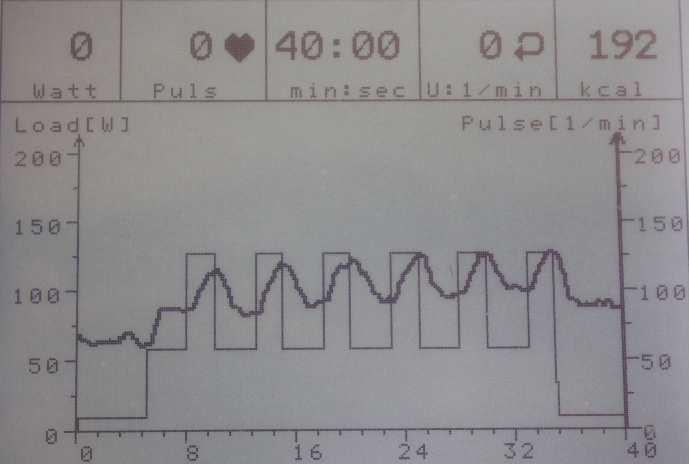

*Photo of visual output from the training ergometer showing the end screen of the interval training programme. The first 5 minutes of exercise are a warm-up phase with the ergometer on freewheel. The next 30 minutes are split into 3 minute (moderate intensity) and 2 minute (high intensity) exercise intervals. The final 5 minutes is the cool-down phase with the ergometer on freewheel. Total exercise time is 40 minutes.*

*Home programme component:*

All trial exercise participation took place in-hospital.

*Non-exercise components:*

We did not perform non-exercise components to this trial.

*Type and number of adverse events:*

Trial participants were assessed prior to commencement of exercise sessions and CPET. This consisted of questioning the patient, blood pressure, heart rate, lung and heart auscultation, observation of calf and palpation of posterior calf and popliteal space.

Adverse events would be deemed attributable if occurring within 30 minutes of exercise or CPET. No adverse events were reported.

*Setting in which the exercise was performed:*

The protocol stipulates that exercise sessions should be performed in-hospital. Sessions took place in a purpose built prehabilitation department or designated research physiology laboratory. This was determined according to facility available at participating sites.

*Extent of adherence:*

During these two trials, a total of 98% of the sessions were completed by participants, according to the prescription. There were no missed neoadjuvant chemo- or radiotherapy sessions due to the exercise and no attributable adverse events.