S1. Patient demographics and tumour characteristics

Variable |  | Value | Percentage | Range
Median Age |  | 66 |  | (54 – 72)
Median Tumour Volume ª (cm³) |  | 4.3 |  | (1.0 – 30.1)
Median PSA (ng/mL) |  | 6.7 |  | (2.2 – 42.0)
Number of foci | Total | 137
 | Per patient | 4.6
EPE | Patient-based | 19 | (63%)
 | Focus-based | 13 | (~12%)
Area (mm²)
 | Low grade | 94 |  | (20 –447)
 | High grade | 327 |  | (22 – 906)
Gleason Score
(patient-based,
dominant focus)
 | 3+3=6 | 1 | (3%)
 | 3+4=7 | 12 | (40%)
 | 4+3=7 | 14 | (47%)
 | 5+4=9 | 3 | (10%)
Gleason Score (focus-based)
 | 3+2=5 | 3 | (2%)
 | 3+3=6 | 13 | (9%)
 | 3+4=7 | 72 | (53%)
 | 4+3=7 | 28 | (21%)
 | 4+4=8 | 1 | (1%)
 | 4+5=9 | 3 | (2%)
 | 5+4=9 | 17 | (12%)
Pathological T Stage
 | pT2b | 1 | (3%)
 | pT2c | 9 | (30%)
 | pT3a | 14 | (46%)
 | pT3b | 6 | (20%)
ª Using Chen’s method; PSA: prostate specific antigen; EPE: extraprostatic extension.

S2. Image acquisition parameters

Parameters | In vivo |  |  |  | Ex vivo
Parameters | T2w (2D) | T2w (3D) | DWI ª | DCE-MRI ^{b} | T2w (2D) | T2w (3D)
Sequence type | TSE | TSE | EPI-SE | T1 twist | TSE | TSE
Coil | Torso surface coil |  |  |  | 8-channel knee coil / head coil
TR (ms) | 3500-4380 | 750 | 3400-5500 | 5.8-6.3 | 3670-5880 | 500 – 750
TE (ms) | 89-96 | 104 – 114 | 89-98 | 2.2-2.4 | 76 | 109 – 120
Field of view (mm²) | 160 × 160 | 205 × 205 –  240 × 240 | 250 × 250 | 200 × 200 | 100 × 69.6 | 172.5 × 200 –  205 × 205
Acquisition matrix | 320 × 320 | 256 × 256 –  384 × 384 | 192 × 192 | 128 x 128 – 256 × 256 | 448 × 312 | 256 × 256 –  552 × 640
Slice thickness (mm) | 3 | 0.6 - 0.8 | 4 | 4 | 2.5 | 0.6 - 0.8
In-plane resolution (mm²) | 0.5 × 0.5 | 0.6 × 0.6 –  0.8 × 0.8 | 1.3 × 1.3 | 0.78 × 0.78 –  1.56 × 1.56 | 0.22 × 0.22 | 0.31 × 0.31 –  0.8 × 0.8
Parametric maps |  |  | ADC | K^{trans}, k_{ep}, V_{e}, IAUC

ª b-values: 50, 400, 800, 1200 s/mm²; ^{b} Temporal resolution: 7.2 s or 3.62 s; TSE: Turbo spin echo; EPI-SE: echo planar imaging spin echo.

S3. Image registration for in vivo and ex vivo data.

Registration is represented as solid arrows. Parametric maps from DWI and DCE-MRI were co-registered to in vivo 2D T2w images and histology was co-registered to ex vivo 2D T2w images using rigid registration methods. To account for in-plane and out-of-plane rotation, shrinkage and deformation, a combination of rigid and deformable registration techniques was used, including 3D deformable registration methods for co-registering in vivo 3D T2w images with ex vivo 3D T2w images.

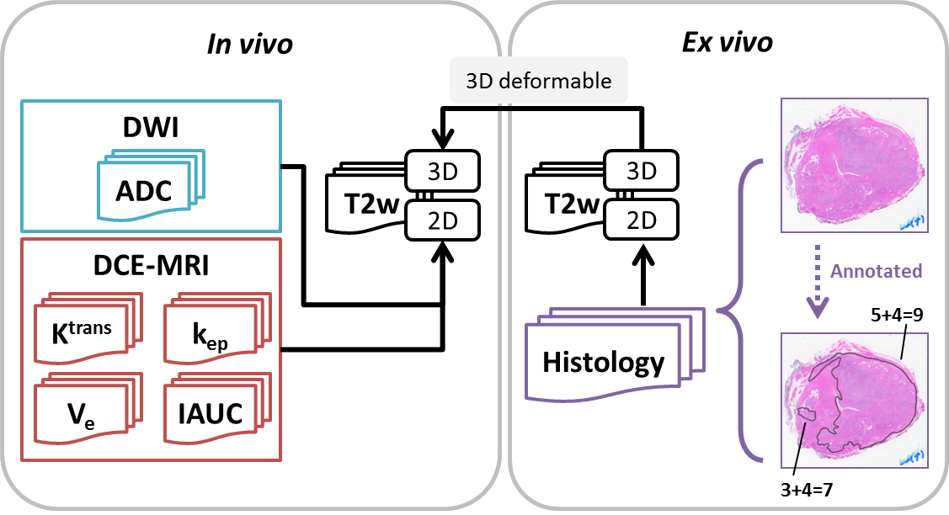

(DWI: diffusion-weighted imaging; ADC: apparent diffusion coefficient; DCE: dynamic contrast enhanced; K^{trans}: volume transfer constant; k_{ep}: interstitium-to-plasma rate constant; V_{e}: extracellular extravascular volume fraction; IAUC: initial area under the uptake curve; T2w: T2-weighted.)

S4. Examples of imaging and histology data from one patient

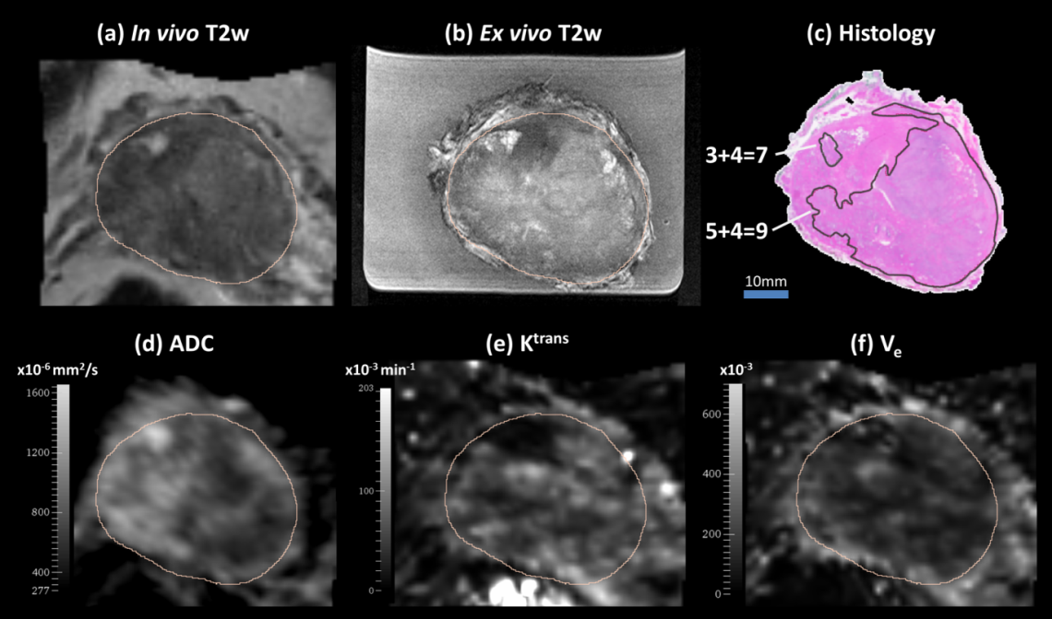

(a) in vivo T2w image, (b) ex vivo T2w image, (c) histology with pathologist’s annotation, (d) ADC map, (e) K^{trans} map and (f) V_{e}, with the prostate contour shown in dark yellow.
(T2w: T2-weighted; ADC: apparent diffusion coefficient; K^{trans}: volume transfer constant; k_{ep}: interstitium-to-plasma rate constant; V_{e}: extracellular extravascular volume fraction.)

S5. Computation of texture features

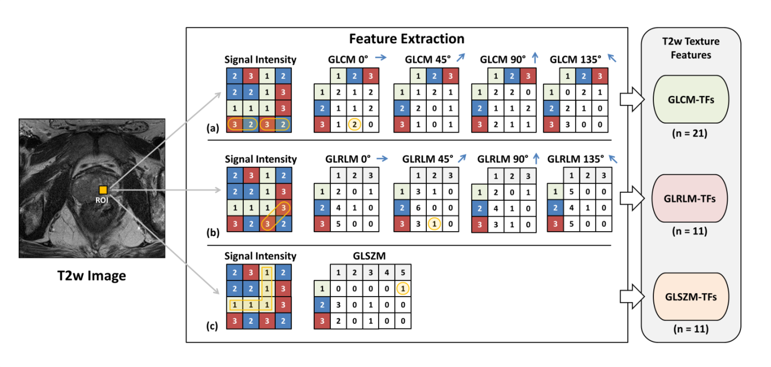
Feature extraction diagram showing examples of (a) a GLCM, where there are two occurrences of adjacent voxels with signal intensity of 3 and 2 in the 0° direction (circled); (b) GLRLM, where there is one occurrence that the longest segment with signal intensity 3 in 45° direction is 2 (circled); (c) GLSZM, where the area of the largest connected region with signal intensity 1 is 5; (GLCM: gray-level co-occurrence matrix; GLRLM: gray-level run length matrix; GLSZM: gray-level size zone matrix; T2w: T2-weighted;)

S6. A list of texture features from three statistical families

Category | Feature | Abbreviation | Category | Feature | Abbreviation
GLCM  (n=21) | Mean | mean | GLRLM  (n=11) | Gray-level non-uniformity | GLN
GLCM  (n=21) | Variance | variance | GLRLM  (n=11) | High gray-level run emphasis | HGLRE
GLCM  (n=21) | Autocorrelation | autoCorrelation | GLRLM  (n=11) | Long run emphasis | LRE
GLCM  (n=21) | Cluster Prominence | cPromince | GLRLM  (n=11) | Long run high gray-level emphasis | LRHGLE
GLCM  (n=21) | Cluster Shade | cShade | GLRLM  (n=11) | Long run low gray-level emphasis | LRLGLE
GLCM  (n=21) | Cluster Tendency | cTendency | GLRLM  (n=11) | Low gray-level run emphasis | LGLRE
GLCM  (n=21) | Contrast | contrast | GLRLM  (n=11) | Run length non-uniformity | RLN
GLCM  (n=21) | Correlation | correlation | GLRLM  (n=11) | Run percentage | RP
GLCM  (n=21) | Difference Entropy | differenceEntropy | GLRLM  (n=11) | Short run emphasis | SRE
GLCM  (n=21) | Dissimilarity | dissimilarity | GLRLM  (n=11) | Short run high gray-level emphasis | SRHGLE
GLCM  (n=21) | Energy | energy | GLRLM  (n=11) | Short run low gray-level emphasis | SRLGLE
GLCM  (n=21) | Entropy | entropy | GLSZM  (n=11) | Small area emphasis | SAE
GLCM  (n=21) | Homogeneity | homogeneity1 | GLSZM  (n=11) | Large area emphasis | LAE
GLCM  (n=21) | Homogeneity 2 | homogeneity2 | GLSZM  (n=11) | Intensity variability | IV
GLCM  (n=21) | Inverse Difference Moment Normalized | IDMN | GLSZM  (n=11) | Size zone variability | SZV
GLCM  (n=21) | Inverse Difference Normalized | IDN | GLSZM  (n=11) | Zone percentage | ZP
GLCM  (n=21) | Inverse Variance | inverseVaraince | GLSZM  (n=11) | Low intensity emphasis | LIE
GLCM  (n=21) | Maximum Probability | maxPro | GLSZM  (n=11) | High intensity emphasis | HIE
GLCM  (n=21) | Sum Average | sumAverage | GLSZM  (n=11) | Low intensity small area emphasis | LISAE
GLCM  (n=21) | Sum Entropy | sumEntropy | GLSZM  (n=11) | High intensity small area emphasis | HISAE
GLCM  (n=21) | Sum Variance | sumVariance | GLSZM  (n=11) | Low intensity large area emphasis | LILAE
 |  |  | GLSZM  (n=11) | High intensity large area emphasis | HILAE

GLCM: gray-level co-occurrence matrix; GLRLM: gray-level run length matrix; GLSZM: gray-level size zone matrix; TF: texture feature.

S7. The machine learning pipeline

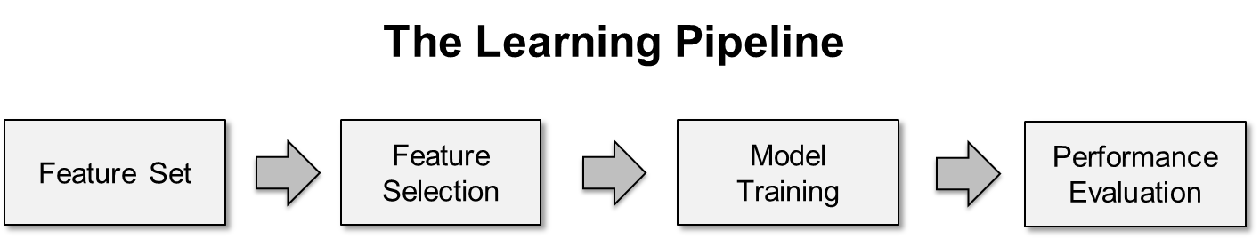

The learning pipeline to compare four feature sets. The pipeline was applied independently on each feature set: 1) mpMRI alone with no TFs, 2) mpMRI with GLCM-TFs 3) mpMRI with GLRLM-TFs and 4) mpMRI with GLSZM-TFs.

S8. Results of feature selection for four feature sets

 | mpMRI | mpMRI  + GLCM-TFs | mpMRI  + GLRLM-TFs | mpMRI  + GLSZM-TFs
Selected Features | ADC  V_{e}  IAUC | T2w  ADC  V_{e}  homogeneity2  differenceEntropy  cTendency  mean  homogeneity1  energy  entropy  sumAverage | k_{ep}  V_{e}  SRHGLE  LGLRE  SRE  SRLGLE  LRHGLE | ADC  SZV  HILAE  ZP  LISAE  HIE
Number of Features | 3 | 11 | 7 | 6

mpMRI: multiparametric MRI; T2w: T2-weighted; ADC: apparent diffusion coefficient; k_{ep}: interstitium-to-plasma rate constant; V_{e}: extracellular extravascular volume fraction; IAUC: initial area under the uptake curve; GLCM: gray-level co-occurrence matrix; GLRLM: gray-level run length matrix; GLSZM: gray-level size zone matrix; TF: texture feature; Acronyms of texture features referred to S4.

S9. Examination of collinearity for feature group [mpMRI + GLCM-TFs]

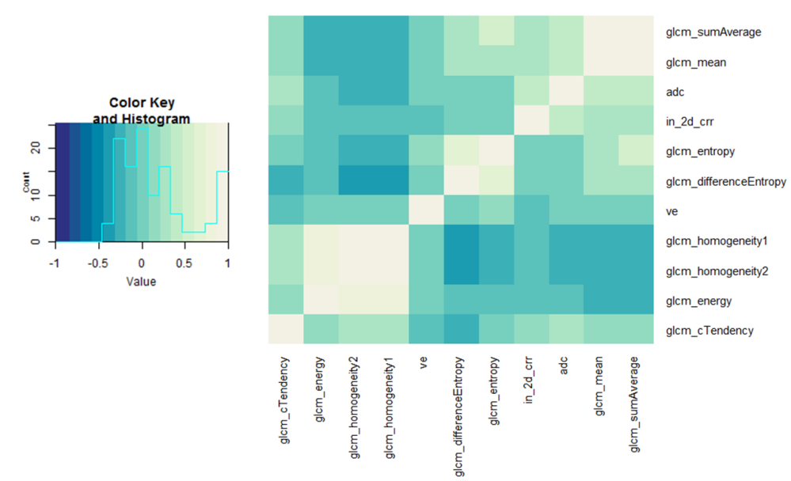

Eleven features (n=11) were selected in this feature group. Based on the histogram, most correlation coefficients were between -0.5 and 0.5. A small number of high correlation occurred (1) between energy and homogeneity1 and homogeneity2 and (2) between difference entropy and entropy and between mean and sum average. Correlation coefficients are shown in S7.
(in_2d_crr: in vivo 2D T2w imaging; adc: apparent diffusion coefficient; ve: extracellular extravascular volume fraction Acronyms of texture features referred to S4)

S10. Correlation coefficients for feature group [mpMRI + GLCM-TFs] (95% confidence intervals)
 | t2w | adc | ve | energy | cTendency
t2w | 1.0 (1.0, 1.0) | - | - | - | -
Adc | 0.41 (0.22, 0.57) | 1.0 (1.0, 1.0) | - | - | -
Ve | -0.1 (-0.3, 0.11) | -0.03 (-0.24, 0.18) | 1.0 (1.0, 1.0) | - | -
Energy | -0.1 (-0.3, 0.12) | -0.15 (-0.34, 0.06) | 0.06 (-0.15, 0.26) | 1.0 (1.0, 1.0) | -
cTendency | 0.13 (-0.08, 0.33) | 0.24 (0.03, 0.43) | -0.16 (-0.36, 0.05) | 0.15 (-0.06, 0.35) | 1.0 (1.0, 1.0)
Entropy | 0.02 (-0.19, 0.23) | 0.01 (-0.2, 0.22) | 0.12 (-0.09, 0.32) | -0.11 (-0.31, 0.1) | 0.01 (-0.2, 0.22)
Mean | 0.3 (0.1, 0.48) | 0.37 (0.17, 0.54) | -0.03 (-0.23, 0.18) | -0.21 (-0.4, -0.01) | 0.19 (-0.02, 0.38)
sumAverage | 0.33 (0.13, 0.5) | 0.33 (0.13, 0.51) | -0.02 (-0.23, 0.19) | -0.21 (-0.4, 0) | 0.13 (-0.08, 0.33)
homogeneity1 | -0.14 (-0.34, 0.07) | -0.23 (-0.42, -0.02) | 0 (-0.21, 0.21) | 0.77 (0.67, 0.84) | 0.29 (0.08, 0.47)
homogeneity2 | -0.15 (-0.34, 0.07) | -0.2 (-0.39, 0.01) | -0.01 (-0.21, 0.2) | 0.74 (0.63, 0.82) | 0.29 (0.08, 0.47)
differenceEntropy | -0.02 (-0.23, 0.19) | -0.04 (-0.24, 0.17) | 0.05 (-0.16, 0.25) | -0.08 (-0.29, 0.13) | -0.2 (-0.39, 0.01)

(Continued table)
 | entropy | mean | sumAverage | homogeneity1 | homogeneity2 | differenceEntropy
t2w | - | - | - | - | - | -
Adc | - | - | - | - | - | -
Ve | - | - | - | - | - | -
Energy | - | - | - | - | - | -
cTendency | - | - | - | - | - | -
Entropy | 1.0 (1.0, 1.0) | - | - | - | - | -
Mean | 0.28 (0.08, 0.46) | 1.0 (1.0, 1.0) | - | - | - | -
sumAverage | 0.48 (0.3, 0.62) | 0.91 (0.87, 0.94) | 1.0 (1.0, 1.0) |  | - | -
homogeneity1 | -0.24 (-0.42, -0.03) | -0.27 (-0.45, -0.06) | -0.29 (-0.47, -0.09) | 1.0 (1.0, 1.0) | - | -
homogeneity2 | -0.31 (-0.49, -0.11) | -0.26 (-0.44, -0.05) | -0.31 (-0.48, -0.11) | 0.99 (0.99, 0.99) | 1.0 (1.0, 1.0) | -
differenceEntropy | 0.69 (0.56, 0.78) | 0.21 (0.01, 0.4) | 0.33 (0.13, 0.51) | -0.41 (-0.57, -0.22) | -0.45 (-0.6, -0.26) | 1.0 (1.0, 1.0)

(mpMRI: multiparametric MRI; t2w: T2-weighted; adc: apparent diffusion coefficient; ve: extracellular extravascular volume fraction; GLCM: gray-level co-occurrence matrix; TF: texture feature; Acronyms of texture features referred to S4.

S11. Comparison with pre-surgical clinical information

 | Biopsy |  | Model Prediction | Histology | Number of cases
1 | LG |  | LG | LG | 9
2 | HG |  | HG | HG | 9
3 | LG |  | LG | HG | 2
4 | HG |  | LG | HG | 2
5 | LG |  | HG | HG | 1
6 | HG |  | LG | LG | 1
7 | HG |  | HG | LG | 0
8 | LG |  | HG | LG | 0

Pre-surgical information based on biopsy Gleason Score was retrieved to compare with model prediction (the final combining model) and ground truth histology at the patient-wise level. In total, 24 out of 30 patients have complete data for all three fields.
- In 18 patients (rows 1 & 2), the model prediction and histology are consistent in reporting LG or HG.
- In 2 patients (row 3), the biopsy and model predicted LG, but the histology predicted HG. In this case, if this information was used in treatment selection, the model performed no worse than the biopsy information. However, the patient could have benefited from a more aggressive treatment than the biopsy and model indicated.
- In 2 patients (row 4), the model predicted LG in contrast to the biopsy and histology which reported HG. In this case, the model was incorrect. However, if the treatment decision was made on the worst grade of the model or biopsy, then treatment selection would not have been affected.
- In 1 patient (row 5), the biopsy predicted LG in contrast to the model and histology. In this case, if the model result could have (correctly) influenced treatment selection.
- In one patient, (row 6), the histology reported LG in contrast to the biopsy. This result requires further investigation.
- No cases showed a model overestimate compared with histology (rows 7 & 8).

