Supplementary Tables
Table S1: Characteristics of glioma patients with morphological image changes in T1-weighted contrast-enhanced (T1w-CE) MR images after adjuvant radio-(chemo)therapy.
Patient | Diagnosis | V_{CTV} | $$\hat{D}$$ | Age at first proton therapy fraction | Time to earliest available image change in T1w-CE MR | pMRI |  | fuMRI
 | WHO Grade | in cm³ | in Gy (RBE) | in years | in months after treatment | Field strength [T] | Orientation, Resolution [mm³] | Field strength [T] | Orientation, Resolution [mm³]
P_{I} | Astrocytoma III | 158.0 | 60 | 41 | 15 | 1.5 | Sag, 1.09×1.09×1 | 1.5 | Sag, 1×1×1
P_{II} | Astrocytoma III | 196.5 | 60 | 46 | 14 | 1.5 | Sag, 1.09×1.09×1 | 1.5 | Ax, 0.5×0.5×1
P_{III} | Astrocytoma III | 248.4 | 60 | 41 | 15 | 1.5 | Sag, 1.09×1.09×1 | 1.5 | Sag, 1×1×2
P_{IV} | Oligoastrocytoma III | 117.0 | 60 | 51 | 20 | 1.5 | Sag, 1.09×1.09×1 | 3 | Sag, 1×1×1
P_{V} | Astrocytoma II | 167.0 | 54 | 31 | 24 | 3 | Sag, 1×1×1 | 1.5 | Sag, 1×1×1
P_{VI} | Oligodendroglioma III | 165.7 | 60 | 38 | 6 | 3 | Sag, 1×1×1 | 3 | Sag, 1×1×1
Abbreviations: MR, magnetic resonance; V_{CTV}, volume of the clinical target volume; $\hat{D}$, prescribed dose; WHO, World Health Organization; RBE, relative biological effectiveness; Sag, sagittal; Ax, axial; pMRI, planning MR image; fuMRI, follow-up MR image.

Table S2: Plan information for the six glioma patients treated with passive scattering proton therapy.
Patient | Prescription dose (Gy/fx) | Number of fractions | R / cm | M / cm | Snout position / cm | Beam angles (gantry, couch)
P_{I} | 2 | 30 | 11.0 | 8.0 | 18.5 | (85°, 0°)
P_{I} | 2 | 30 | 15.2 | 11.5 | 23.4 | (175°, 0°)
P_{II} | 2 | 30 | 9.4 | 7.7 | 17.2 | (280°, 0°)
P_{II} | 2 | 30 | 12.9 | 11.0 | 19.1 | (310°,80°)
P_{II} | 2 | 30 | 11.0 | 9.5 | 20.9 | (245°, 0°)
P_{III} | 2 | 30 | 9.2 | 7.7 | 15.3 | (300°,80°)
P_{III} | 2 | 30 | 10.8 | 9.5 | 16.0 | (245°, 0°)
P_{IV} | 2 | 30 | 8.8 | 7.4 | 13.0 | (70°, 300°)
P_{IV} | 2 | 30 | 10.0 | 8.6 | 13.5 | (70°, 0°)
P_{V} | 2 | 27 | 9.2 | 7.7 | 12.4 | (290°, 0°)
P_{V} | 2 | 27 | 10.8 | 8.6 | 14.4 | (285°,80°)
P_{VI} | 2 | 30 | 10.3 | 8.6 | 12.0 | (290°,85°)
P_{VI} | 2 | 30 | 12.8 | 10.7 | 15.1 | (95°,0°)
Abbreviations: P, patient; fx, fraction; R, range; M, modulation

Table S3: Results of the k-fold cross validation with dose, LET and PVR for six glioma patients using 30 models each with 29 k-folds for model training and the remaining left-out k-fold for model testing. The mean and range of the 30 test AUC values are reported for every modelling approach.
Model |  | Predictor 1 |  |  | Predictor 2 |  |  | Predictor 3 |  |  |  | AUC
 |  |  |  |  |  |  |  |  |  |  |  | Mean | Range
$$M_{I}$$ | D |  |  | - |  |  | - |  |  |  |  | 0.60 | 0.57-0.62
$$M_{II}$$ | LET |  |  | - |  |  | - |  |  |  |  | 0.68 | 0.66-0.69
$$M_{III}$$ | PVR |  |  | - |  |  | - |  |  |  |  | 0.76 | 0.74-0.78
$$M_{IV}$$ | D x PVR |  |  | - |  |  | - |  |  |  |  | 0.76 | 0.74-0.78
$$M_{V}$$ | D |  |  | PVR |  |  | - |  |  |  |  | 0.79 | 0.77-0.82
$$M_{VI}$$ | D x LET |  |  | - |  |  | - |  |  |  |  | 0.87 | 0.85-0.88
$$M_{VII}$$ | D |  |  | LET |  |  | - |  |  |  |  | 0.85 | 0.84-0.87
$$M_{VIII}$$ | D x LET |  |  | PVR |  |  | - |  |  |  |  | 0.92 | 0.90-0.93
$$M_{IX}$$ | D x LET |  |  | D x PVR |  |  | - |  |  |  |  | 0.91 | 0.89-0.93
$$M_{X}$$ | D |  |  | LET |  |  | PVR |  |  |  |  | 0.91 | 0.89-0.92
Abbreviations: $M_{I-X}$, logistic regression models; AUC, area under the curve; PVR, periventricular region

Table S4: Mean and standard deviation of the model coefficients of the ten logit models built on the full voxel dataset. For each model and fold all coefficients were significantly different from 0 (p<0.05).
 |  | $$β_{0}$$ |  |  | $$β_{1}$$ |  |  | $$β_{2}$$ |  |  | $$β_{3}$$
 | $$μ± σ$$ |  |  | $$μ± σ$$ |  |  | $$μ± σ$$ |  |  | $$μ± σ$$
$$M_{I}$$ | $$-6.1716±0.032$$ |  |  | $$\left(0.0304±0.001\right)\frac{\text{1}}{\text{Gy}}$$ |  |  | - |  |  | -
$$M_{II}$$ | $$-5.2286±0.018$$ |  |  | $$\left(0.1911±0.006\right) \frac{\text{μm}}{\text{keV}}$$ |  |  | - |  |  | -
$$M_{III}$$ | $$-5.5904±0.014$$ |  |  | $$3.0263±0.019$$ |  |  | - |  |  | -
$$M_{IV}$$ | $$-5.4993±0.013$$ |  |  | $$\left(0.0555±0.000\right) \frac{\text{1}}{\text{Gy }}$$ |  |  | - |  |  | -
$$M_{V}$$ | $$-6.6508±0.033$$ |  |  | $$\left(0.0239±0.001\right) \frac{\text{1}}{\text{Gy}}$$ |  |  | $$2.9260±0.019$$ |  |  | -
$$M_{VI}$$ | $$-8.3180±0.033$$ |  |  | $\left(0.0378±0.000\right)$ $\frac{\text{μm}}{\text{Gy keV}}$ |  |  | - |  |  | -
$$M_{VII}$$ | $$-15.9855±0.111$$ |  |  | $$\left(0.1506±0.002\right) \frac{\text{1}}{\text{Gy}}$$ |  |  | $$\left(1.7533±0.015\right) \frac{\text{μm}}{\text{ keV}}$$ |  |  | -
$$M_{VIII}$$ | $$-8.1269±0.033$$ |  |  | $$\left(0.0295±0.000\right) \frac{\text{μm}}{\text{Gy keV}}$$ |  |  | $$2.3467±0.020$$ |  |  | -
$$M_{IX}$$ | $$-13.9090±0.106$$ |  |  | ($0.1126±0.001)$ $\frac{1}{Gy}$ |  |  | ($1.3727±0.016)$ $\frac{\text{μm}}{\text{keV}}$ |  |  | $$2.4276±0.020$$
$$M_{X}$$ | $$-8.2568±0.049$$ |  |  | ($0.0031±0.001)$ $\frac{1}{Gy}$ |  |  | ($0.0293±0.000)$ $\frac{\text{μm}}{\text{Gy keV}}$ |  |  | $$2.3458±0.020$$
Abbreviations: $β_{0-3}$, logistic regression coefficients; PVR, periventricular region

Supplementary Figures
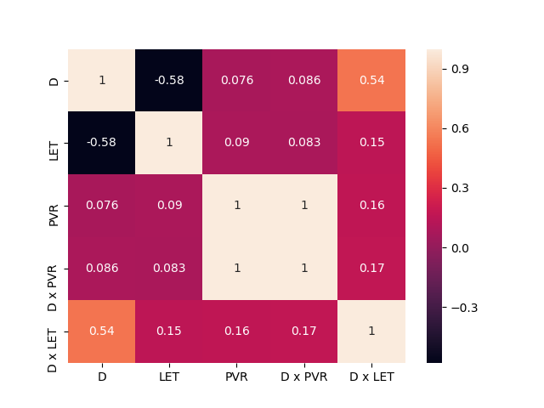
Figure S1: Spearman’s rank coefficient for the five different metrics used as variables in logistic regression analysis.
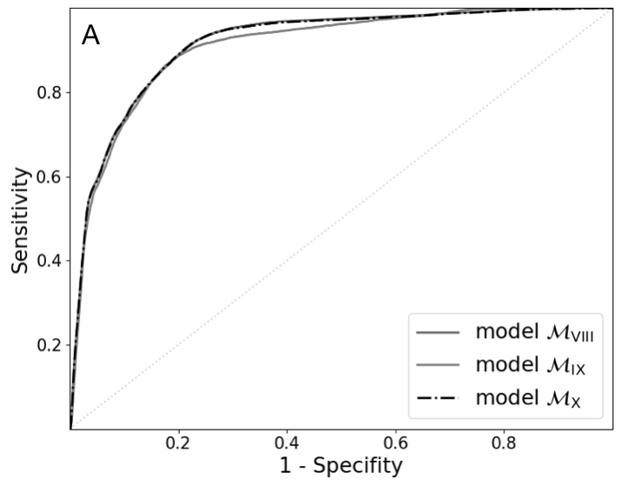
Figure S2: The receiver-operating-characteristic curves of the multivariable models $M_{VIII}$, $M_{IX}$ and $M_{X}$ derived from logistic regression analysis with dose, LET and the periventricular region are presented (A).

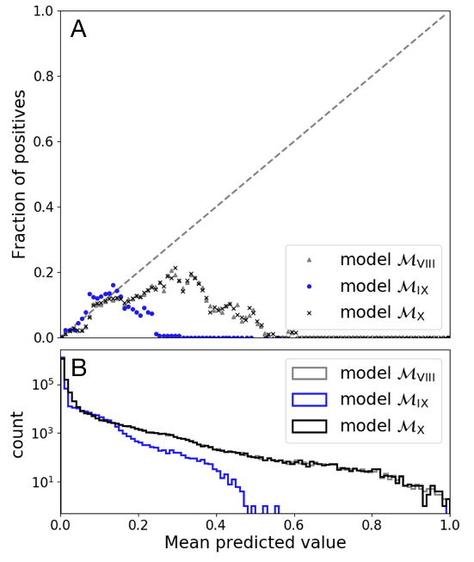
Figure S3: Calibration curve of the models $M_{VIII}$,$M_{IX}$ and $M_{X}$ with fraction of positives (A) and counts (B) visualized over mean predicted value.

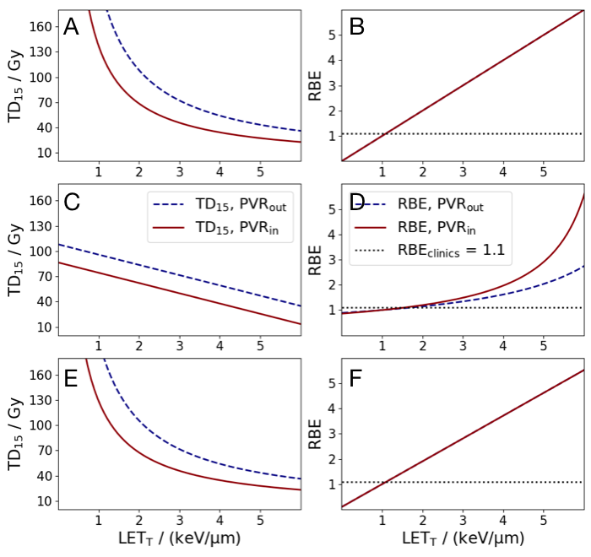
Figure S4: Illustration of the TD₁₅ (A, C, E) and the RBE (B, D, F) over the track-averaged linear energy transfer (LET_{T}) that has been interpolated from the logistic regression models $M_{VIII}$(A, B),$M_{IX}$(C, D) and $M_{X}$(E, F), respectively. The curves were calculated for voxels within and outside the periventricular region (PVR). For RBE estimation, the dose TD₁₅ (LET_{T} = 1 ${keV}/{μm}$) was used as a reference radiation.

