Appendix 1
General approach to treatment planning
Clinical RapidArc plans for lung SBRT treatments are created using either a 6-MV flattening filter (FF) beam, or a 10-MV flattening filter-free (FFF) beam, depending on the treatment machine. We previously found no significant differences in dosimetry when using a 6-MV FF or 10-MV FFF beam [1]. A comprehensive description of the planning process was given previously [2]. Tissue inhomogeneity and low density regions in the lung cause inaccuracies in predicting lateral electron scatter during the initial optimization [2]. A continue previous optimization (CPO) is therefore applied to all TPs after the final dose calculation, to account for differences between the simplified dose calculation algorithm used during initial optimization and final dose calculation [3]. Due to differing densities of PTVinOAR and PTVoutOAR, the higher density PTVinOAR structure typically receives a higher dose in the dose calculation after the first optimization than that specified by the optimization objectives. This can be resolved by the CPO.
Appendix 2
Minimization of monitor units (MUs) in Photon Optimizer v13.6.15 (PO13)
We found that the CPO in PO13 stopped prematurely and seemed to inherently minimize MUs more than that of PRO v10.0.28 (PRO10), especially for plans with MU>~4000. To investigate this further, the CPs of 3 patients (8, 18, 20) in whom the PTVinOAR dose increased the most using CP_{PO} compared with CP, were re-optimized in PO, with a lower fraction dose (9 fractions of 6 Gy, or 11 fractions of 5 Gy) and a prolonged CPO to allow the cost function to converge. In the resulting plans, re-scaled to their original dose per fraction, PTVinOAR doses approached that of the CP (Figure S2), and the number of MUs increased compared to the original CP_{PO}. This suggested that a restriction on MUs, and CPO running time, prevented more optimal plan quality from being achieved. This has been communicated to the manufacturer. Increasing the priority for the PTVinOAR structure also reduced D_{max}.
1. Ong CL, Verbakel WFAR, Dahele M, et al. Fast Arc Delivery for Stereotactic Body Radiotherapy of Vertebral and Lung Tumors. Int J Radiat Oncol Biol Phys. 2012;83:e137–43.
2. Ong CL, Verbakel WFAR, Cuijpers JP, et al. Stereotactic radiotherapy for peripheral lung tumors: A comparison of volumetric modulated arc therapy with 3 other delivery techniques. Radiother Oncol. 2010;97:437–42.
3. Tol JP, Dahele M, Doornaert P, et al. Toward optimal organ at risk sparing in complex volumetric modulated arc therapy: an exponential trade-off with target volume dose homogeneity. Med Phys. 2014;41:021722.

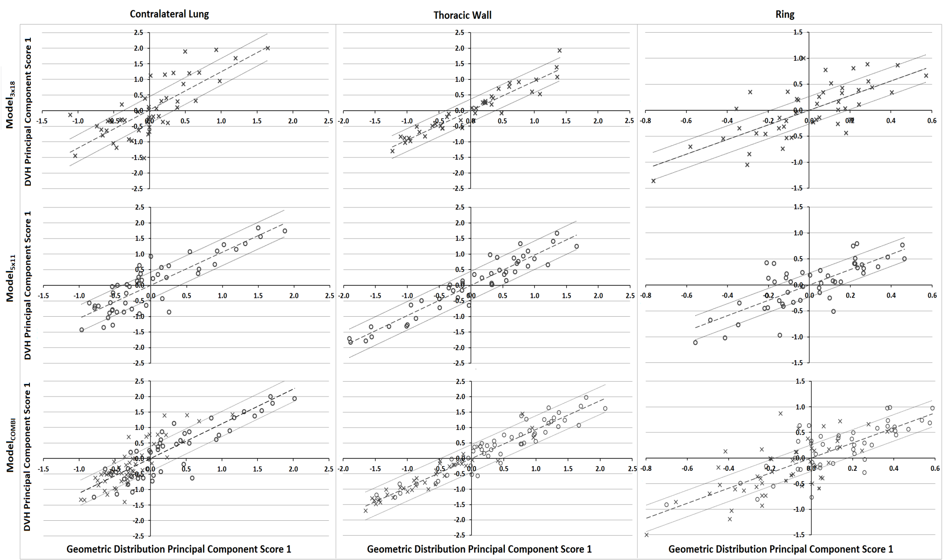
Figure S1. Regression plots generated using Model Analytics. DVH principal component score 1 (PCS1) is plotted against geometric distribution PCS1, which can correspond to a number of geometric features depending on the contribution of a feature to the variance.
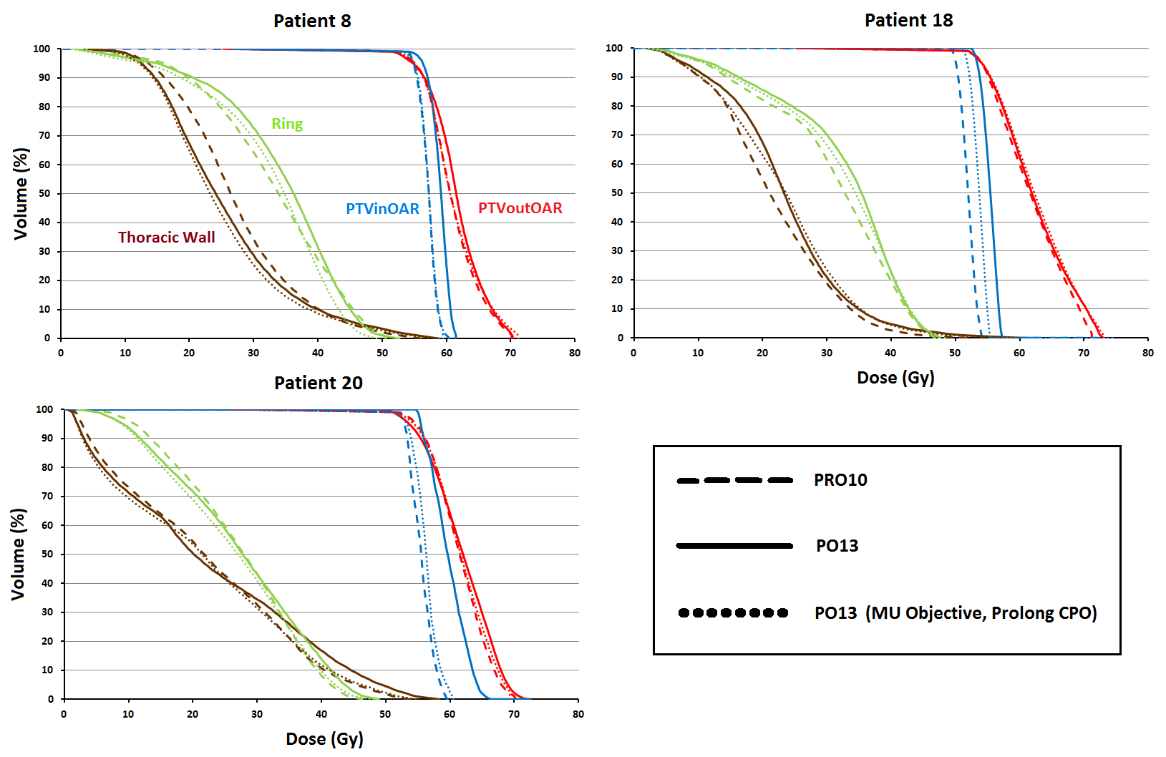
Figure S2. DVHs for clinical plans of 3 patients, optimized in PRO10, PO13 and PO13, with extended CPO and MU objective.

Structure |  | Volume (%) | Dose | Priority
 |  |  | 5x11 Gy | 3x18 Gy
PTVinOAR
Upper |  | 0 | 58 | 56 Gy | 120
Lower |  | 100 | 55 | 54 Gy | 120
PTVoutOAR
Upper |  | 0 | 74 | 73 Gy | 110
Lower |  | 100 | 59 | 58 Gy | 120
Contralateral Lung
Upper |  | 0 | 4.5 Gy | 110
Spinal Cord
Upper |  | 0 | 21 | 16 Gy | 130
Spinal Cord +3mm
Upper |  | 0 | 22.5 | 18 Gy | 130
Esophagus
Upper |  | 0 | 30.5 | 25 Gy | 80
Esophagus +5mm
Upper |  | 0 | 32.5 | 27 Gy | 80
Thoracic Wall
Upper |  | 0 | 28 | NS | 110 | NS
Upper |  | 5 | 40 | 40 Gy | 120 | 110
Upper |  | 40 | 30 | NS | 80 | NS
Ring
Upper |  | 0 | 49.5 | 48.6 Gy | 95 | 110
Upper |  | 2 | 46.8 | 45.9 Gy | 100 | 105
Upper |  | 35 | 35.8 | 35.1 Gy | 80 | 90
Trachea
Upper |  | 0 | 35.5 | 28 Gy | 80
Trachea +5mm
Upper |  | 0 | 37.5 | 30 Gy | 80

Table S1. Typical clinical dose-volume optimization objectives and their respective priorities for 5x11 Gy and 3x18 Gy plans. These are representative of the starting values which are then interactively optimized. This means that end-optimization values may differ from what is presented here. NS=Not Standard, only used in 2/10 CPs at discretion of planner
 | Model_{3x18} |  | Model_{5x11} |  | Model_{COMBI} |  | EG
Plans | 50 |  | 50 |  | 100 |  | 20
Plan Information
Prescription Dose | 54 Gy |  | 55 Gy |  | 54 Gy, 55 Gy |  | 54 Gy (10), 55 Gy (10)
Fractionation | 3x18 Gy |  | 5x11 Gy |  | 3x18 Gy, 5x11Gy |  | 3x18 Gy (10), 5x11 Gy (10)
Beam Energy
6 MV | 12 |  | 25 |  | 37 |  | 4
10 MV FFF | 38 |  | 25 |  | 63 |  | 16
Calculation model
AAA 10. 0.28 | 22 |  | 25 |  | 47
ACUROS 11.0.31 | 28 |  | 25 |  | 53 |  | 20
Field set-up
Partial Arc | 33 |  | 35 |  | 68 |  | 15
Avoidance Sector | 17 |  | 15 |  | 32 |  | 5
Volumes (cm³)
PTV
Mean | 11.4 ± 7.1 |  | 32.3 ± 19.7 |  | 21.8 ± 18.1 |  | 23.4 ± 16.0
Range | 0.6 - 31.8 |  | 6.3 - 93.3 |  | 0.6 - 93.3 |  | 7.3 - 64.5
PTV in OAR | (n=9) |  | (n=35) |  | (n=43) |  | (n=13)
Mean | 1.3 ± 0.7 |  | 4.6 ± 4.6 |  | 4.0 ± 4.4 |  | 2.5 ± 2.2
Range | 0.5 - 2.5 |  | 0.4 - 16.3 |  | 0.4 - 16.3 |  | 0.0 - 7.8
PTV out OAR | (n=49) |  | (n=50) |  | (n=99) |  | (n=20)
Mean | 11.4 ± 7.1 |  | 29.1 ± 17.5 |  | 20.3 ± 16.0 |  | 24.9 ± 18.7
Range | 2.0 - 31.8 |  | 5.3 - 77.0 |  | 2.0 - 77.0 |  | 6.7 - 62.5
Thoracic wall | (n=44) |  | (n=47) |  | (n=92) |  | (n=19)
Mean | 88 ± 59 |  | 118 ± 70 |  | 102 ± 66 |  | 80 ± 37
Range | 27 - 333 |  | 33 - 359 |  | 27 - 359 |  | 24 - 141
Contralateral Lung | (n=50) |  | (n=49) |  | (n=99) |  | (n=20)
Mean | 1630 ± 620 |  | 1746 ± 624 |  | 1687 ± 621 |  | 1866 ± 626
Range | 698 - 3018 |  | 766 - 3550 |  | 698 - 3550 |  | 518 - 3268
Ipsilateral Lung | (n=50) |  | (n=50) |  | (n=100) |  | (n=20)
Mean | 1787 ± 665 |  | 1992 ± 607 |  | 1889 ± 642 |  | 2008 ± 792
Range | 814 - 3549 |  | 1039 - 3302 |  | 814 - 3549 |  | 384 - 3753
Ring | (n=49) |  | (n=49) |  | (n=97) |  | (n=20)
Mean | 31.3 ± 8.3 |  | 53.4 ± 21.6 |  | 42.2 ± 19.8 |  | 43.3 ± 13.7
Range | 15.7 - 53.0 |  | 24.6 - 145.7 |  | 15.7 - 145.7 |  | 25.9 - 75.1
Trachea | (n=43) |  | (n=44) |  | (n=87) |  | (n=14)
Mean | 29.7 ± 14.4 |  | 29.6 ± 15.7 |  | 29.5 ± 15.0 |  | 30.4 ± 14.8
Range | 6.8 - 64.1 |  | 5.2 - 70.7 |  | 5.2 - 70.7 |  | 11.2 - 59.7
Esophagus | (n=44) |  | (n=38) |  | (n=82) |  | (n=15)
Mean | 14.7 ± 14.6 |  | 20.0 ± 11.8 |  | 17.0 ± 13.5 |  | 15.8 ± 14.8
Range | 1.0 - 48.5 |  | 5.7 - 63.2 |  | 1.0 - 63.2 |  | 2.8 - 57.6
Spinal Cord | (n=50) |  | (n=48) |  | (n=100) |  | (n=20)
Mean | 28.0 ± 23.2 |  | 35.8 ± 26.4 |  | 31.6 ± 24.8 |  | 20.7 ± 18.9
Range | 5.4 - 88.5 |  | 5.5 - 99.5 |  | 5.4 - 99.5 |  | 5.8 - 74.7
Spinal Cord +5mm | (n=47) |  | (n=49) |  | (n=97) |  | (n=20)
Mean | 69 ± 51 |  | 87 ± 60 |  | 77 ± 56 |  | 62 ± 52
Range | 15 - 219 |  | 14 - 222 |  | 14 - 222 |  | 23 - 209

Table S2. Clinical plans populating Model_{3x18}, Model_{5x11} and Model_{COMBI} and the 20 patient evaluation group, EG.

Structure |  | Volume (%) | Dose | Priority
PTVinOAR
Upper |  | 0 | 103.7 % | 110
Lower |  | 100 | 100.0 % | 120
PTVoutOAR
Upper |  | 0 | 134.8 % | 110
Lower |  | 100 | 107.4 % | 120
Contralateral Lung
Upper |  | 0 | 4.25 Gy | 110
Line |  | Generated | Generated | 110
Ipsilateral Lung*
Line |  | Generated | Generated | 100
Spinal Cord
Upper |  | 0 | Generated | 130
Line |  | Generated | Generated | 130
Spinal Cord +3mm
Upper |  | 0 | Generated | 130
Line |  | Generated | Generated | 130
Esophagus
Upper |  | 0 | Generated | 80
Line |  | Generated | Generated | 80
Thoracic Wall
Upper |  | 0 | Generated | 110
Line |  | Generated | Generated | 100
Ring
Upper |  | 0 | Generated | 110
Upper |  | 2 | Generated | 105
Upper |  | 35 | Generated | 90
Line |  | Generated | Generated | 90
Trachea
Upper |  | 0 | Generated | 80
Line |  | Generated | Generated | 80

Table S3. Dose-volume optimization objectives and their respective priorities for all models. % indicates percentage of prescribed dose.
Abbreviations:
*: Ipsilateral lung did not have optimization objectives in clinical plan

