SUPPLEMENTARY MATERIALS

Intensity Modulated Radiation Therapy (IMRT) technique description
All photon plans were developed using the Pinnacle treatment planning system (Philips version 9.10). Two open tangential 6 MV beams were created according to PTV geometry and included a ~ 2 cm beyond the patient surface. The direct machine parameter optimization (DMPO) technique was used to generate IMRT plans as described by van Asselen et al [16]. In DMPO-IMRT the delivery parameters (number of segments, shapes and weights) are directly considered during the optimization process. A maximum of 12 segments, minimal segment size of 9 cm² and minimal monitor units of 5 were specified. A minimum (49 Gy) maximum (52 Gy) and uniform (50 Gy) dose objective were assigned to the PTV. All IMRT plans were optimized during 40 iterations with dose calculation iterations set to 10. Dose calculation was performed using Collapsed Cone Convolution algorithm.
When constraint criteria reported in Supplementary Table S1 were not satisfied by two tangential IMRT technique, a 4 field technique was applied [17]. The 4 field technique consist of two tangential fields and two additional anterior-oblique IMRT beams at a 30° angle respect to the standard tangential beams. Typically ∼20% of the dose was delivered with the anterior-oblique beams.
…..

Supplementary Figure S1: derived skin-structure
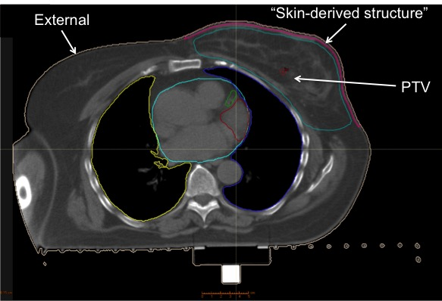
Supplementary Table 1. Optimization criteria according to RTOG 1005 guidelines for left-side breast cancer (prescription dose: 50 Gy in 25 fractions)

 | Objective/Constraint
 | Goal | Volume | Dose
PTV receiving whole prescription dose | Per protocol | At least 95% of PTV receives | At least 95% of whole breast dose | 47.5 Gy
PTV receiving whole prescription dose | Variation Acceptable | At least 90% of PTV receives | At least 90% of whole breast dose | 45 Gy
PTV receiving above the whole-breast dose | Per Protocol | No more than 50% of the PTV | Exceeds 108% of whole breast dose | 54 Gy
PTV receiving above the whole-breast dose | Variation Acceptable | No more than 50% of the PTV | Exceeds 112% of whole breast dose | 56 Gy
PTV maximum dose | Per Protocol | - | Does not exceed 115% of prescription whole breast dose | 57.5 Gy
PTV maximum dose | Variation Acceptable | - | Does not exceed 120% of prescription whole breast dose | 60 Gy
Heart dose constraint | Per protocol | No more than 5% of the heart | Receives | 20 Gy
Heart dose constraint | Variation Acceptable | No more than 5% of the heart | Receives | 25 Gy
Heart dose constraint | Per protocol | Mean dose | Does not exceed | 4 Gy
Heart dose constraint | Variation Acceptable | Mean dose | Does not exceed | 5 Gy
Ipsilateral lung dose | Per protocol | No more than 15% of the ipsilateral lung | Exceeds | 20 Gy
Ipsilateral lung dose | Variation Acceptable | No more than 20% of the ipsilateral lung | Exceeds | 20 Gy
Contralateral lung | Per protocol | No more than 10% of the ipsilateral lung | Exceeds | 5 Gy
Contralateral lung | Variation Acceptable | No more than 15% of the ipsilateral lung | Exceeds | 5 Gy

