Supplementary material for Petersson et al., Evaluation of dual-arc VMAT radiotherapy treatment plans automatically generated via dose-mimicking, Acta Oncologica, 2015

### **Details about the dose-mimicking algorithm**

The composite objective function during generation of a dose-mimicking plan is a weighted sum of reference dose-volume histogram (DVH) functions that impose a one-sided quadratic penalty on DVH curve error. Functions associated with OARs are given unit weight while functions associated with targets are given a weight equal to a user-defined target priority. Reference DVH functions associated with OARs penalize overdo­sage with respect to the fallback DVH over the entire volume in­terval. Whereas, reference DVH functions associated with targets penalize overdosage for relative volumes in the interval [0, 0.5] and underdosage in the interval [0.5, 1.0]. All reference DVH functions are based on creating sets of DVH points for the reference dose and the present dose. These divide the volume interval into subintervals in which the dose levels of both curves are constant, e.g. for the subinterval [*Vlow,Vhigh*] with corresponding dose levels *d* and *dref* the contribution to the objective function value from the given subinterval will be:

Penalizing overdosage: $\left(V_{high}-V_{low}\right)∙H{\left(d-d_{ref}\right)}^{2}$ (1)

Penalizing underdosage: $\left(V_{high}-V_{low}\right)∙H{\left(d_{ref}-d\right)}^{2}$ (2)

where *H* is the Heaviside function.

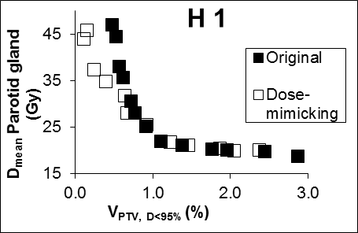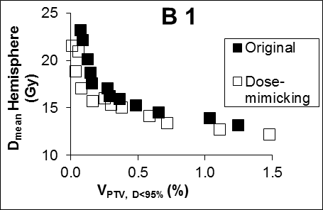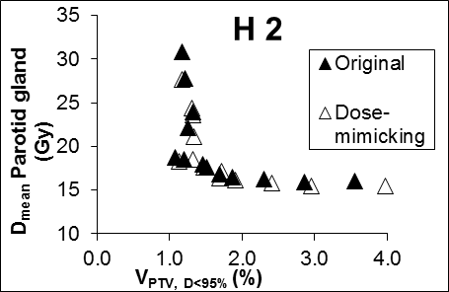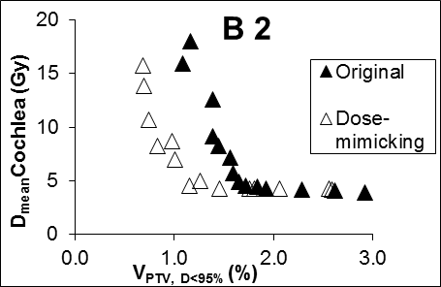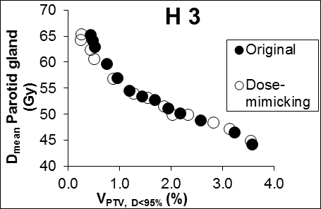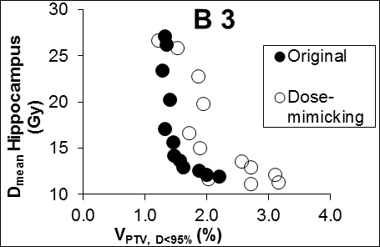

Supplementary Figure 1.Fronts consisting of system-specific optimal original plans and dose-mimicking treatment plans for three cases of head & neck tumors (H1-3) and three cases of brain tumors (B1-3).

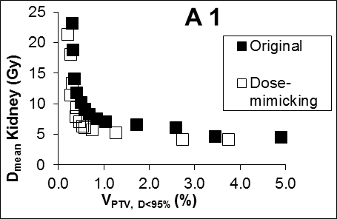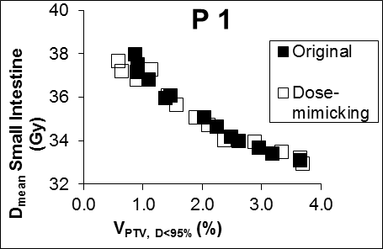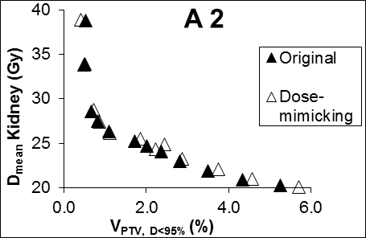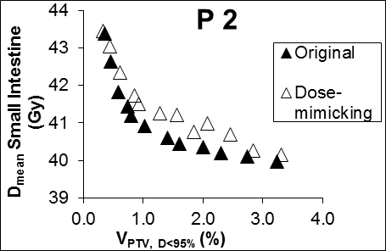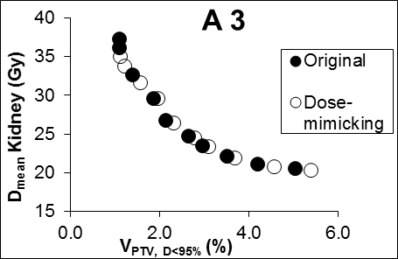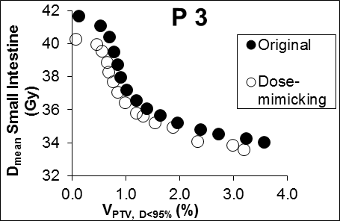

Supplementary Figure 2. Fronts consisting of system-specific optimal original plans and dose-mimicking treatment plans for three cases of tumors in the abdominal region (A1-3) and three cases of tumors in the pelvic region (P1-3).

Supplementary Figure 3.Results from the 3%/2 mm γ-analysis for original plans as well as dose-mimicking treatment plans that illustrates how the results correlate (correlation line) with the total number of MUs in a plan. Our clinical quality control (QC) criterion of 95% approved data points for a plan is included in the figure as a dotted line. Also, ellipses are shown which encompasses plans for case H2 and A2.