Supplementary Material
Failure pattern and salvage treatment after radical treatment of head and neck cancer
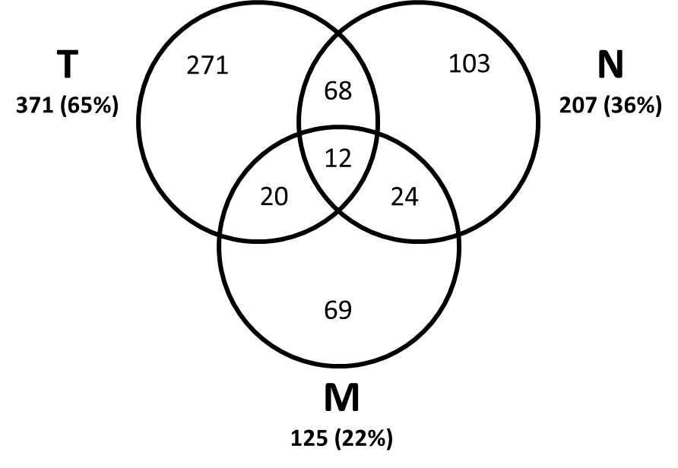

Figure I
Pattern of failure of first recurrence.

Figure II

Flow chart illustrating the outcome of the treatment evaluation.
Abbreviations: CR: complete response, PR: partial response, NO: No further treatment (supportive care), U-SS: unsuccessful salvage, SS: successful salvage, Pal: palliative treatment.

Figure III
The outcome after first recurrence
Abbreviations: NO: No further treatment (supportive care), U-SS: unsuccessful salvage, SS: successful salvage, Pal: palliative treatment.

Figure IV.
The outcome after second recurrence
Abbreviations: NO: No further treatment (supportive care), U-SS: unsuccessful salvage, SS: successful salvage, Pal: palliative treatment.

Figure V
The outcome after third recurrence
Abbreviations: NO: No further treatment (supportive care), U-SS: unsuccessful salvage, SS: successful salvage, Pal: palliative treatment.

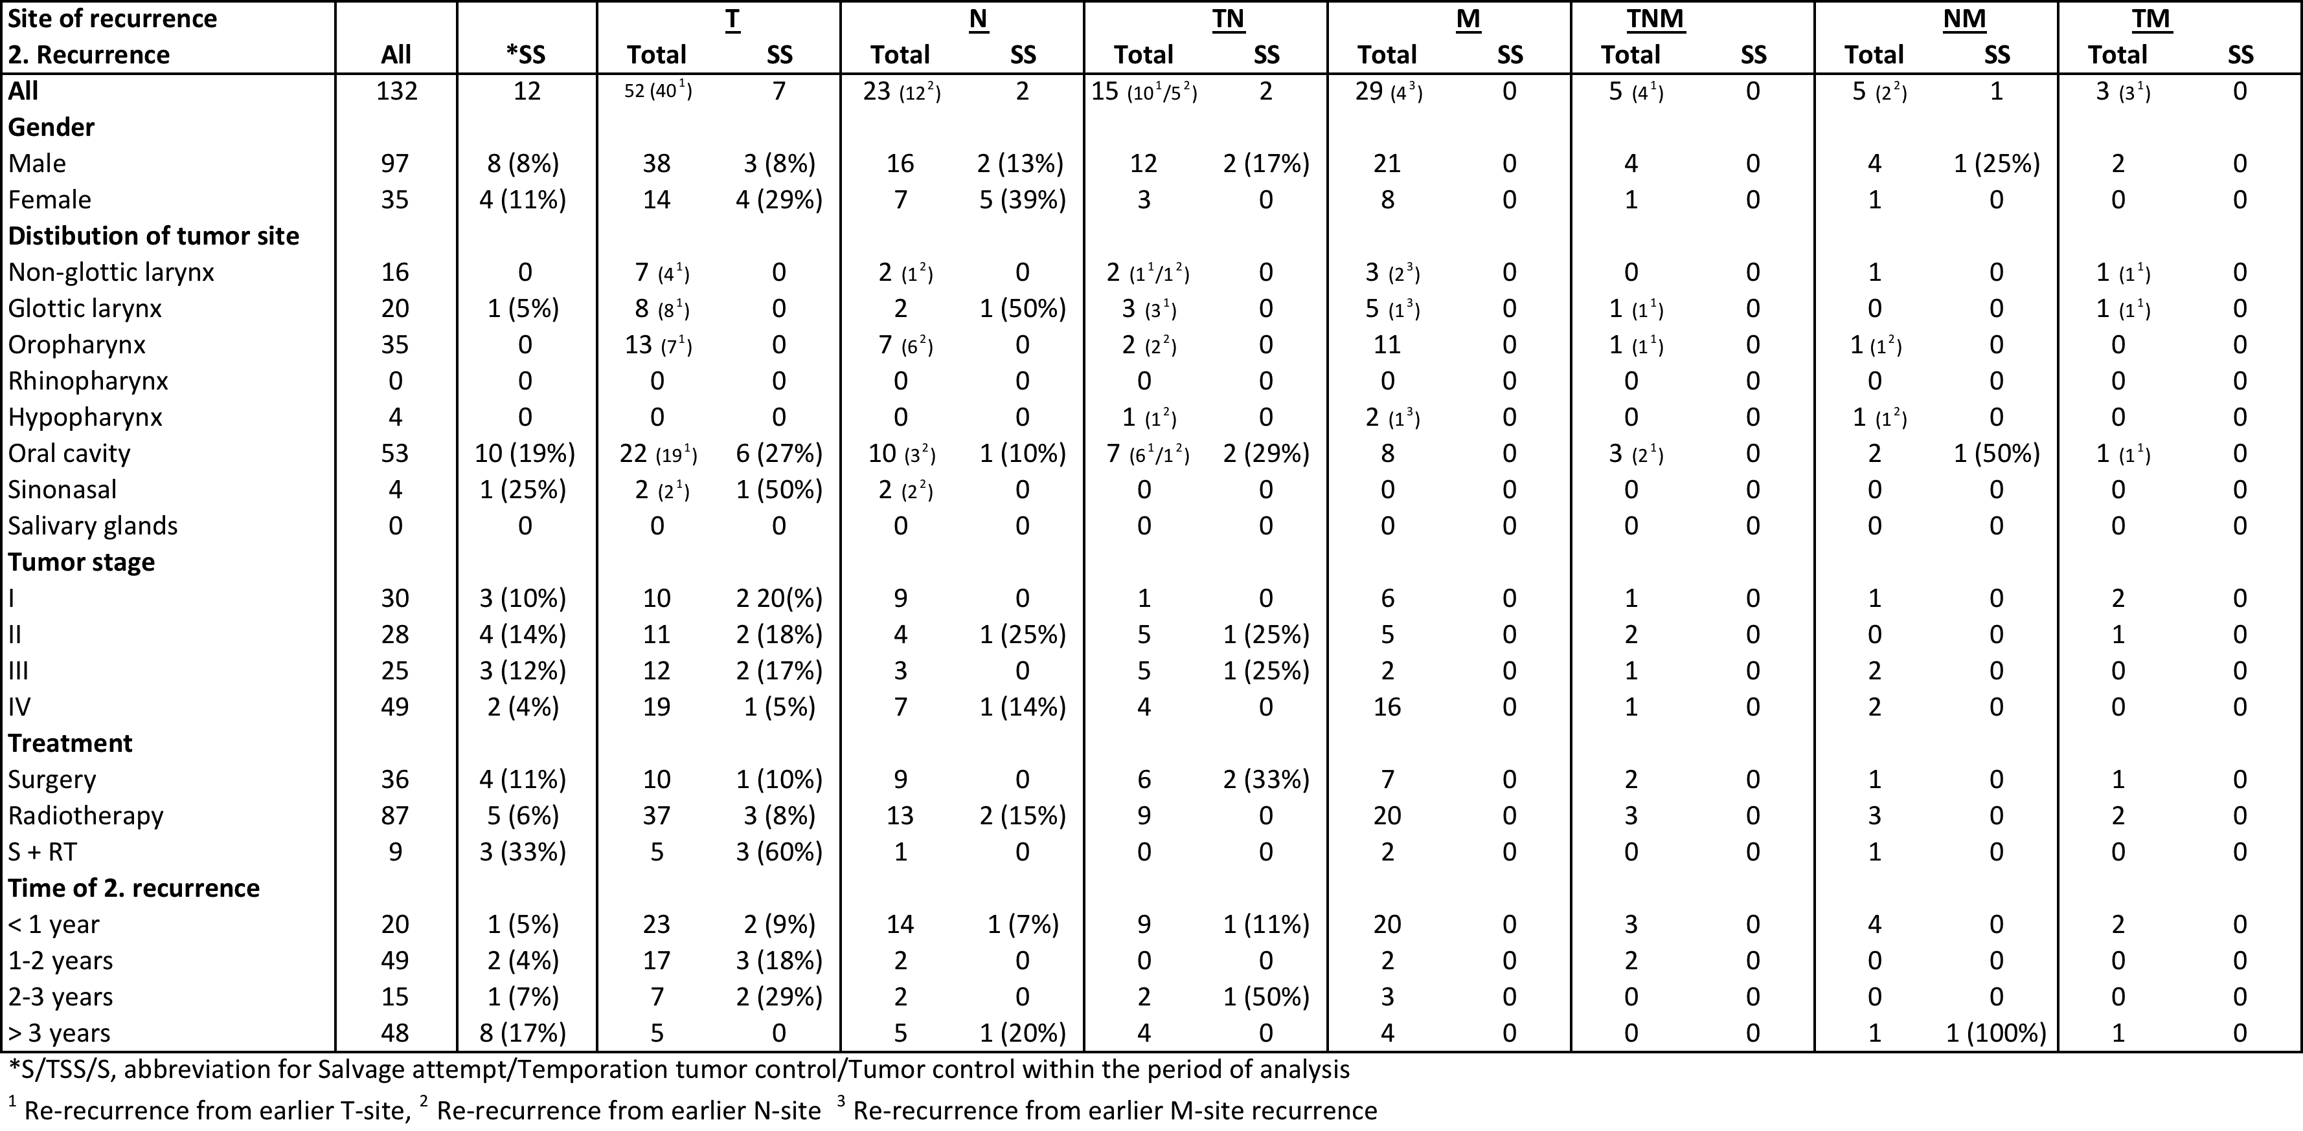

Table I
Second recurrences: Relationship between salvaged recurrences versus the total amount of all the first time recurrences in relation to sites of failure and chosen patient and tumor characteristics. All percentages are summarized vertically in the first column and within each group of characteristics. The rest is presented horizontally with column 2 (recurrences) as percentages of column 1 (total) and percentages in column 3 to 9 represents horizontal percentages of column 2 (recurrences).
Abbreviations: S/TSS/SS: Feasible salvage/Temporary successful salvage/Successful salvage.
Marks: ¹ Re-recurrence from earlier T-site failure, ² Re-recurrence from earlier N-site recurrence and ³ Re-recurrence from earlier M-site recurrence.

Table II
Number of recordings of treatment procedures performed at first, second and third recurrence

