Supplementary material for Grønborg et al., Intra-fractional bladder motion and margins in adaptive radiotherapy for urinary bladder cancer, Acta Oncol, 2015

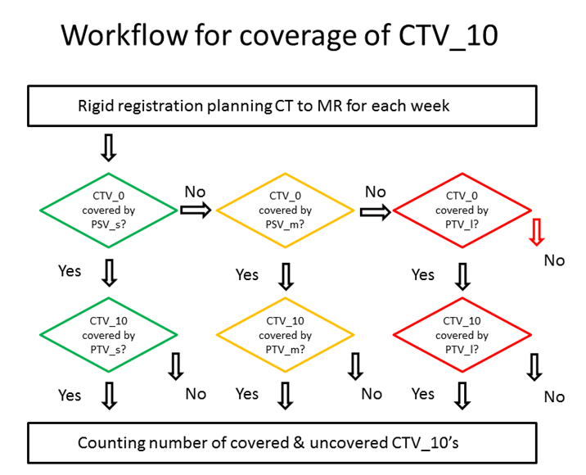
Figure S1: Workflow for plan selection procedure and coverage evaluation.

Figure S2: Overview of the nine bladder patients; showing the 0, 2, 4, 6, 8 and 10 minute bladder on the 0 minute scan.

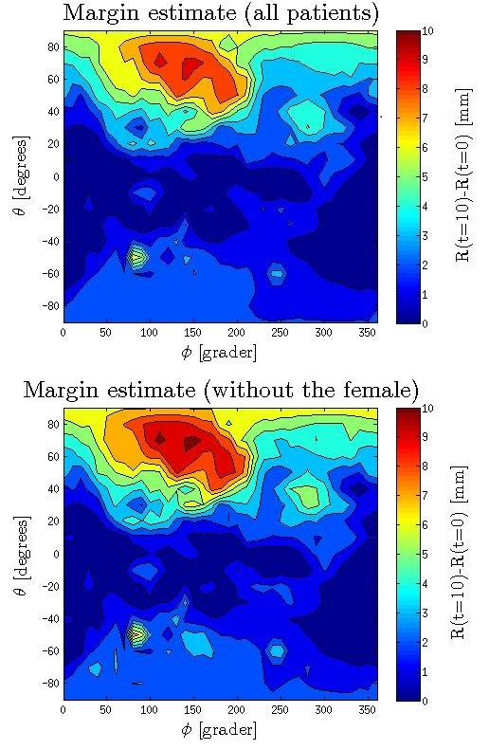
Figure S3: 2D-maps of the population-based margins calculations based on CBCT-scans. The figure shows both the margins for all nine patients (upper) and the margins when the one female patient was excluded due to anatomically unexpected motion (lower).

