SUPPLEMENTARY TABLE 1 Distribution of single and synchronous (defined as diagnoses where the first and the last occurrence were diagnosed within a six month period) diagnosis dates among the total 77,567 CRC diagnoses which are registered in CRCBaSe. For this table specifically, patients contributed with all their diagnoses, if they fulfilled the definition of a synchronous cancer.
 |  | Number of CRC diagnoses
Location |  | One  n (column %) | Two  n (column %) | Three or more  n (column %)
Colon only |  | 38,317 (50.4) | 952 (66.3) | 89 (71.2)
Rectum only |  | 37,690 (49.6) | 83 (5.8) | 1 (0.1)
Colon and rectum |  | - | 400 (27.9) | 35 (28.0)
Total number of diagnoses, (row %) |  | 76,007 (98.0) | 1,435 (1.9) | 125 (0.2)
Due to rounding, all percentages do not add up to 100%.
Abbreviations: CRC; colorectal cancer, n; number.

SUPPLEMENTARY TABLE 2 Overview of comparators included in one or more than one matching stratum.
Number of unique individuals |  | Number of records
402,431 | Appears in 1 strata | 402,431
26,856 | Appears in 2 strata | 26,856×2 = 53,712
1,522 | Appears in 3 strata | 1,522×3 = 4,566
63 | Appears in 4 strata | 63×4 = 252
3 | Appears in 5 strata | 3×5 = 15
Total: 430,875 |  | Total: 460,976

SUPPLEMENTARY FIGURE 1 Overview of the CRCBaSe study population, including all exclusions. Comparators were matched (1:6) with replacement, resulting in a total number of comparators less than six times the number of patients (as the same individual may act as comparator for more than one patient). Datasets were not necessarily mutually exclusive, meaning that (in theory) the same individual could be included in the database as CRC patient, comparator (to another patient diagnosed earlier), and any/all of parent/child/sibling to a patient or comparator.
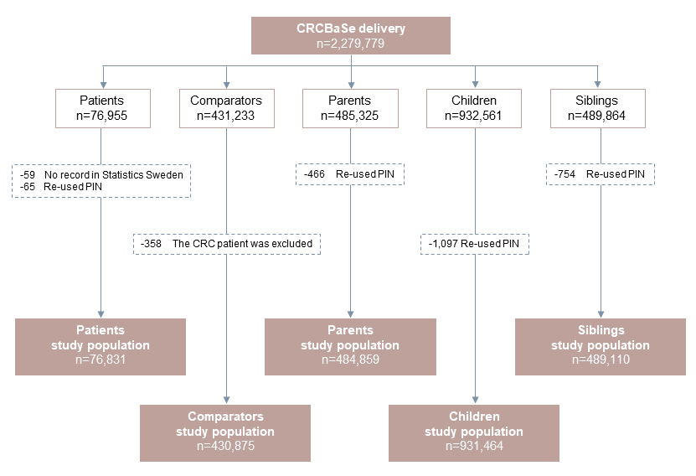
Abbreviations: CRCBaSe; Colorectal Cancer Database Sweden, PIN; Personal Identification Number, n; Number.

SUPPLEMENTARY FIGURE 2 Overall survival among comparators and CRC patients (by stage) in the Colorectal Cancer Database Sweden (CRCBaSe), estimated using the Kaplan-Meier method. Follow-up was restricted to the first ten years after index date (diagnosis date for patients and matching date for the comparators).

