Supplementary Figure 1. Sample beam’s eye view configuration of (A) a standard two-arc plan and (B) an institutional three-arc plan. For each plan, the representation beam’s eye-view image represents the initial arc position prior to delivery.

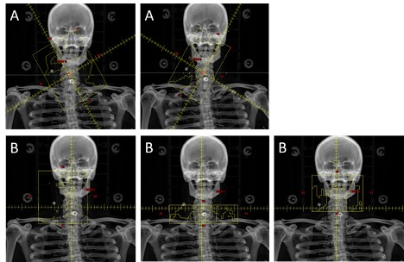

Supplementary Figure 2. Mean DVH comparison for ipsilateral and contralateral parotid glands with standard (group 1) and institutional (group 2) techniques.

Supplementary Table 1. Institutional planning constraints.

Structure | Volume | Dose | Acceptable Alternative | Mandatory | Guideline
Brain stem (Whole) | 0.03cc | 54 Gy | 60 Gy | ☒ | ☐
Spinal cord | 0.03cc | 45 Gy |  | ☒ | ☐
Spinal cord + 0.5cm | 0.03cc | 48 Gy |  | ☐ | ☒
Optic nerve/chiasm | 0.03 cc | <54 Gy |  | ☒ | ☐
Brachial Plexus | Max | <66 Gy |  | ☐ | ☒
Parotid, each side | Mean | <26 Gy | Contralateral Only | ☒ | ☐
Parotid, each side | 50% | <30 Gy | Contralateral Only | ☒ | ☐
Parotid, combined | MVS > 20 cc | <20 Gy | Contralateral Only | ☒ | ☐
Mandible | 0.03 cc | <70 Gy |  | ☒ | ☐
Mandible | D30% | <35 Gy |  | ☐ | ☒
Submandibular, each side | Mean | <39 Gy |  | ☐ | ☒
Larynx | Mean | <30 Gy | <45 Gy | ☐ | ☒
Larynx - PTV | Mean | <20 Gy |  | ☐ | ☒
Constrictors | Mean | <50 Gy |  | ☐ | ☒
Cricopharyngeus | Mean | <44 Gy |  | ☐ | ☒
Esophagus | Mean | <34 Gy |  | ☐ | ☒
Cochlea (each) | Mean | ≤45 Gy |  | ☐ | ☒
Cochlea (each) | <5% | 55 Gy |  | ☐ | ☒
Eyes | Max | <45 Gy |  | ☐ | ☒
Lens | Max | <7 Gy |  | ☐ | ☒
Pituitary | Mean | <30 Gy |  | ☐ | ☒
Oral Cavity | Mean | <30 Gy | <45 Gy | ☐ | ☒

