Robustness of multifield pseudo-arc proton therapy for sinonasal cancer
Supplementary materials
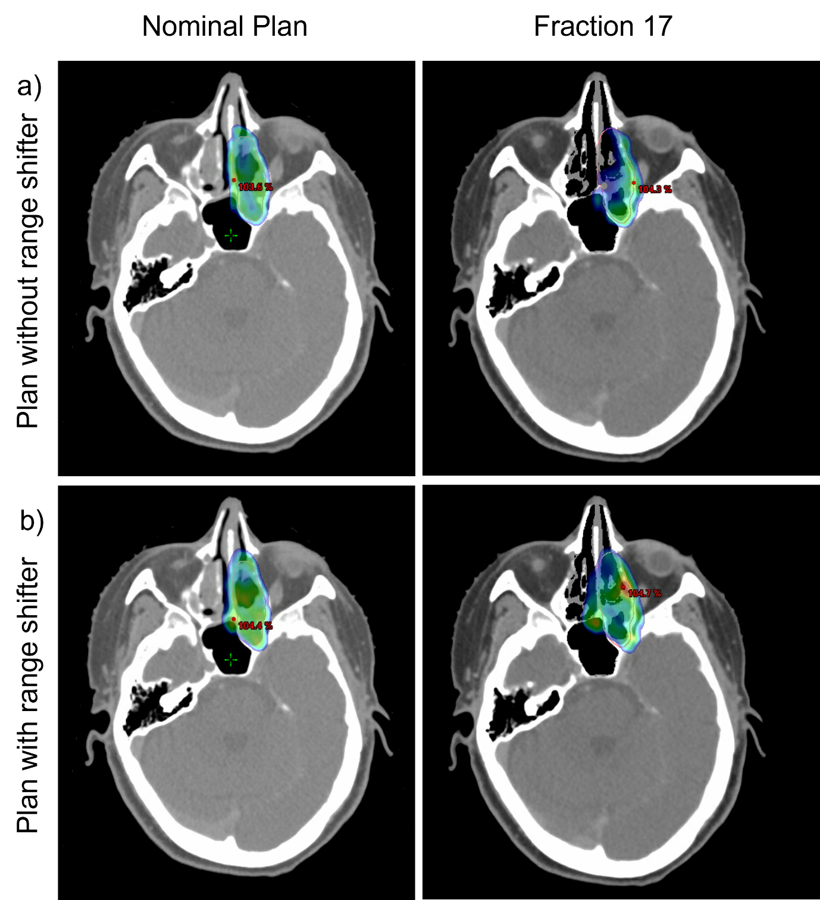Supplementary Figure S1. CTV coverage (V95%) for Patient 11 for plan: a) S2 and b) S3. S2: Pseudo-arc configuration without range shifter, S3: Pseudo-arc configuration with range shifter.

