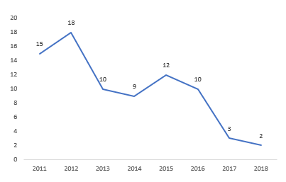
Supplementary data 1: Number of patients with PCNSL treated with radiotherapy as part of first line treatment per year of the studied period
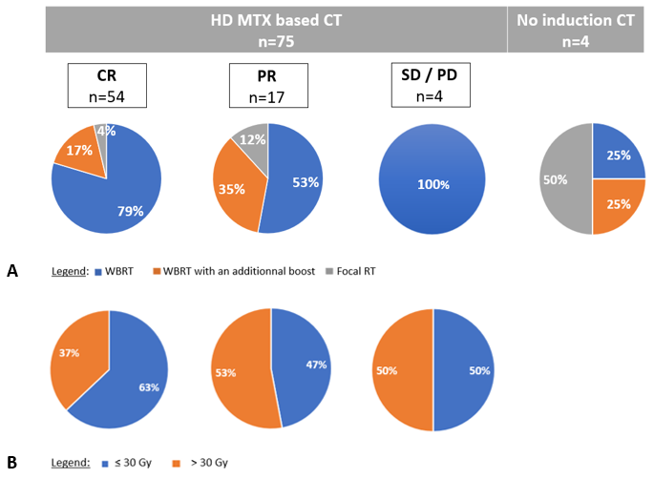
Abbreviations: HD-MTX = high-dose methotrexate; CT = chemotherapy; CR = complete response; PR = partial response; SD = stable disease; PD = progressive disease; WBRT = whole-brain radiotherapy; PBRT = partial brain radiotherapy
Supplementary data 2: Irradiation volume (A) and dose delivered to the whole brain (B) according to the response to induction CT

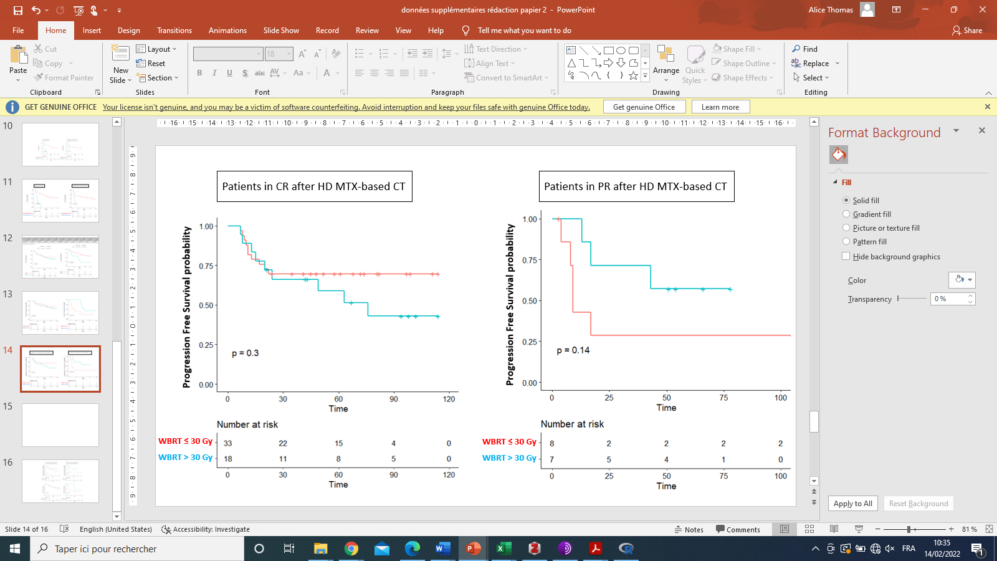
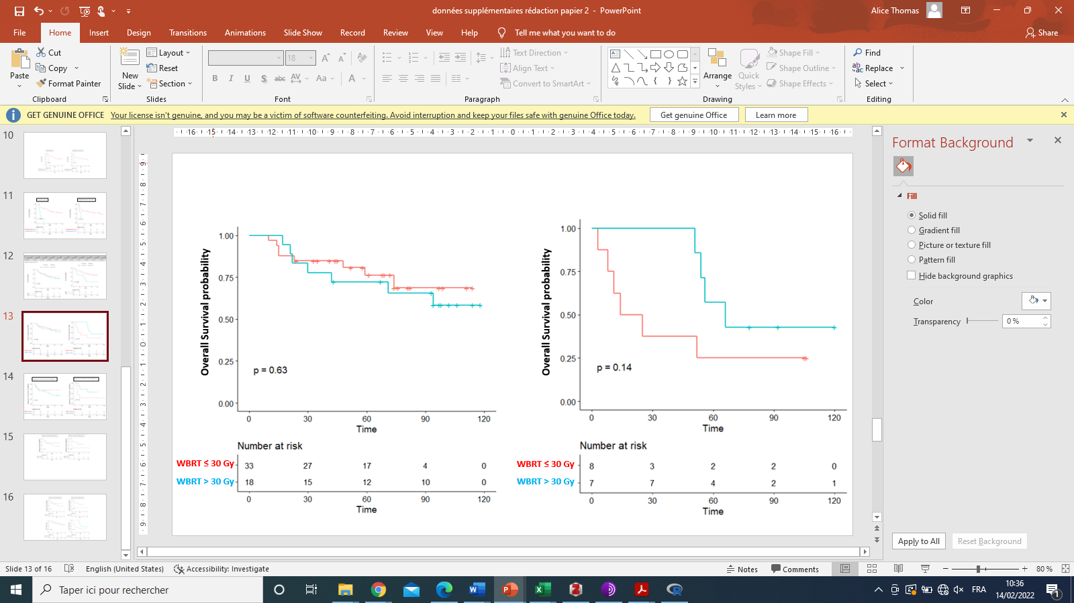
Abbreviations: CR = complete response; PR = partial response; WBRT = whole-brain radiotherapy
Supplementary data 3: Evaluation of the influence of dose on the WBRT (≤ 30 Gy vs. > 30 Gy) on PFS and OS, according to the response to induction CT

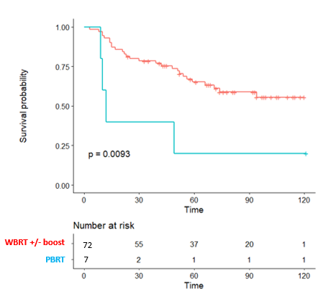
Abbreviations: WBRT = whole-brain radiotherapy; PBRT = partial brain radiotherapy
Supplementary data 4: Evaluation of the influence of irradiation volume (WBRT +/- boost vs. PBRT) on OS

 |  | Posterior third of the eyes included  in the WBRT volume  n=6 | Full eyes included in the WBRT volume  n=5 | Eyes totally excluded from the WBRT volume  n=61
Presence of intraocular lymphomatous involvement at diagnosis | Yes  n=9 | 1 | 3 | 5
 | No  n=42 | 4 | 0 | 38
 | Absence of ophthalmologic evaluation  n=21 | 1 | 2 | 18
Abbreviations: WBRT = whole-brain radiotherapy
Supplementary data 5: Irradiation of the eyes according to intraocular lymphomatous status at diagnosis

 | Guidelines for the delineation of the boost
Guidelines for the diagnosis and management of PCNSL, 2019 (14) | Residual contrast-enhancing lesion(s) after induction CT + 1 to 2 cm margins
NCCN guidelines CNS Cancers, v3.2020 (23) | Unspecified
Nelson et al, 1992 (36) | Initial contrast-enhancing lesion(s) + 2 cm margin
Reni et al, 1997 (40) | Unspecified

Abbreviations: RT = radiotherapy
Supplementary data 6: Review of the recommendations from the different guidelines and studies with patients treated for newly diagnosed PCNSL with an irradiation boost

