Supplementary

- Supplement (Annex 1). Items from the Life Situation Questionnaire used in the study.
- Supplement (Annex 2). Definition of binary outcomes.
- Supplement (Annex 3). Characteristics of students by education interruption status.
- Supplement (Annex 4). Characteristics of workers by work interruption status.
- Supplement (Annex 5). Unadjusted estimates of the associations between survivors’ characteristics and education and work interruption and resumption.
- Supplement (Annex 6). Forest plot (education and work interruption by treatment year and country).
- Supplement (Annex 7). Estimated probabilities of resumption of education across a period of five years following the interruption.
- Supplement (Annex 8). Estimated probabilities of resumption of work across a period of five years following the interruption.

Supplement (Annex 1). Items from the Life Situation Questionnaire used in the study.

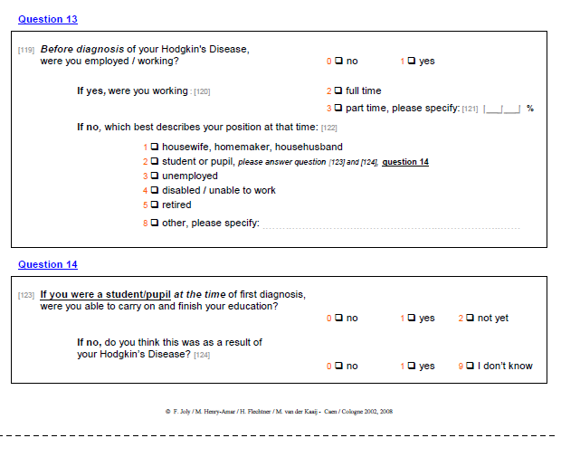
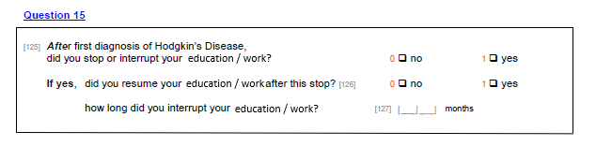

Supplement (Annex 2). Definition of binary outcomes.

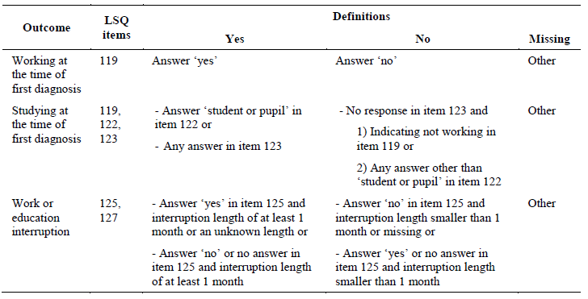

Supplement (Annex 3).

Characteristics of students by education interruption status
 |  | No education interruption (N=156) |  | Education interruption (N=167)
 |  | N | (row %) | N | (row %)
Sex
 | Male | 65 | (48.5) | 69 | (51.5)
 | Female | 91 | (48.1) | 98 | (51.9)
Age
 | Less than 18 years | 46 | (50.5) | 45 | (49.5)
 | 18 years or older | 110 | (47.4) | 122 | (52.6)
Treatment year
 | 1965-1974 | 3 | (33.3) | 6 | (66.7)
 | 1975-1984 | 7 | (24.1) | 22 | (75.9)
 | 1985-1994 | 50 | (49.0) | 52 | (51.0)
 | 1995-2004 | 96 | (52.5) | 87 | (47.5)
Country
 | The Netherlands | 62 | (40.8) | 90 | (59.2)
 | France | 65 | (58.0) | 47 | (42.0)
 | Belgium | 15 | (48.4) | 16 | (51.6)
 | Other | 14 | (50.0) | 14 | (50.0)
Stage
 | I | 26 | (42.6) | 35 | (57.4)
 | II | 112 | (51.4) | 106 | (48.6)
 | III or IV | 18 | (40.9) | 26 | (59.1)
Chemotherapy
 | No | 33 | (47.1) | 37 | (52.9)
 | Yes | 123 | (48.6) | 130 | (51.4)
Chemotherapy duration
 | No chemotherapy | 33 | (47.1) | 37 | (52.9)
 | 8 to 12 weeks | 19 | (54.3) | 16 | (45.7)
 | 16 to 18 weeks | 67 | (54.5) | 56 | (45.5)
 | 24 weeks or longer | 37 | (38.9) | 58 | (61.1)
Radiotherapy
 | No | 21 | (53.8) | 18 | (46.2)
 | Yes | 135 | (47.5) | 149 | (52.5)
(Any) relapse within 6
months from treatment start
 | No | 153 | (48.4) | 163 | (51.6)
 | Yes | 3 | (42.9) | 4 | (57.1)

Supplement (Annex 4).

Characteristics of workers by work interruption status
 |  | No work interruption (N=306) |  | Work interruption (N=1017)
 |  | N | (row %) | N | (row %)
Sex
 | Male | 202 | (28.3) | 511 | (71.7)
 | Female | 104 | (17.0) | 506 | (83.0)
Age
 | 18-29 | 119 | (21.8) | 427 | (78.2)
 | 30-39 | 96 | (22.1) | 339 | (77.9)
 | 40-49 | 58 | (23.5) | 189 | (76.5)
 | ≥50 | 33 | (34.7) | 62 | (65.3)
Treatment year
 | 1965-1974 | 7 | (20.0) | 28 | (80.0)
 | 1975-1984 | 23 | (18.4) | 102 | (81.6)
 | 1985-1994 | 93 | (22.6) | 319 | (77.4)
 | 1995-2004 | 183 | (24.4) | 568 | (75.6)
Country
 | The Netherlands | 120 | (20.1) | 478 | (79.9)
 | France | 124 | (23.9) | 394 | (76.1)
 | Belgium | 22 | (21.6) | 80 | (78.4)
 | Other | 40 | (38.1) | 65 | (61.9)
Stage
 | I | 80 | (24.2) | 250 | (75.8)
 | II | 184 | (22.8) | 623 | (77.2)
 | III or IV | 42 | (22.7) | 143 | (77.3)
 | Missing | 0 | (0.0) | 1 | (100.0)
Chemotherapy
 | No | 61 | (24.9) | 184 | (75.1)
 | Yes | 245 | (22.7) | 833 | (77.3)
Chemotherapy duration
 | No chemotherapy | 61 | (24.9) | 184 | (75.1)
 | 8 to 12 weeks | 28 | (20.1) | 111 | (79.9)
 | 16 to 18 weeks | 105 | (23.6) | 340 | (76.4)
 | 24 weeks or longer | 110 | (22.4) | 381 | (77.6)
 | Missing | 2 | (66.7) | 1 | (33.3)
Radiotherapy
 | No | 41 | (25.6) | 119 | (74.4)
 | Yes | 265 | (22.8) | 898 | (77.2)
(Any) relapse within 6
months from treatment start
 | No | 304 | (23.2) | 1005 | (76.8)
 | Yes | 2 | (14.3) | 12 | (85.7)
Educational level
 | No high school | 92 | (21.6) | 333 | (78.4)
 | High school diploma | 101 | (21.9) | 361 | (78.1)
 | University degree | 109 | (26.1) | 309 | (73.9)
 | Missing | 4 | (22.2) | 14 | (77.8)

Supplement (Annex 5).

Table. Unadjusted estimates of the associations between survivors’ characteristics and education and work interruption and resumption.
 | Education interruption |  | Work interruption |  | Education resumption |  | Work resumption
Covariate | OR (95% CI) | p-value | OR (95% CI) | p-value | HR (95% CI) | p-value | HR (95% CI) | p-value
Sex |  | 0.949 |  | <0.001 |  | 0.153 |  | <0.001
Male | Ref |  | Ref |  | Ref |  | Ref
Female | 1.01 (0.65-1.58) |  | 1.92 (1.47-2.51) |  | 0.79 (0.57-1.09) |  | 0.73 (0.64-0.84)
Age |  | 0.612 |  | 0.050 |  | 0.295 |  | 0.024
18-29 |  |  | Ref |  |  |  | Ref
30-39 |  |  | 0.98 (0.66-1.47) |  |  |  | 0.89 (0.73-1.09)
40-49 |  |  | 0.91 (0.57-1.45) |  |  |  | 0.87 (0.68-1.11)
≥50 |  |  | 0.52 (0.28-0.97) |  |  |  | 0.64 (0.43-0.96)
Less than 18 years | Ref |  |  |  | Ref
18 years or older | 1.13 (0.70-1.84) |  |  |  | 1.21 (0.85-1.73)
Treatment year |  | 0.017 |  | 0.166 |  | 0.565 |  | 0.814
+ 10 years | 0.68 (0.50-0.94) |  | 0.88 (0.74-1.05) |  | 0.94 (0.78-1.15) |  | 1.01 (0.92-1.11)
Country |  | 0.054 |  | 0.001 |  |  |  | 0.024
The Netherlands | Ref |  | Ref |  | Non-proportional hazards |  | Ref
France | 0.50 (0.26-0.95) |  | 0.80 (0.55-1.16) |  |  |  | 1.16 (0.96-1.40)
Belgium | 0.73 (0.27-2.03) |  | 0.91 (0.47-1.79) |  |  |  | 0.84 (0.59-1.19)
Other | 0.69 (0.24-1.99) |  | 0.41 (0.23-0.73) |  |  |  | 0.86 (0.59-1.26)
Stage |  | 0.277 |  | 0.862 |  | 0.160
I | Ref |  | Ref |  | Ref |  | Non-proportional hazards
II | 0.70 (0.35-1.39) |  | 1.08 (0.76-1.55) |  | 1.05 (0.64-1.71)
III or IV | 1.07 (0.42-2.75) |  | 1.09 (0.65-1.81) |  | 0.67 (0.35-1.29)
Chemotherapy |  | 0.827 |  | 0.467 |  | 0.470
No | Ref |  | Ref |  | Ref |  | Non-proportional hazards
Yes | 0.94 (0.55-1.60) |  | 1.13 (0.82-1.56) |  | 0.87 (0.59-1.28)
Radiotherapy |  | 0.460 |  | 0.425 |  | 0.012 |  | 0.016
No | Ref |  | Ref |  | Ref |  | Ref
Yes | 1.29 (0.66-2.52) |  | 1.17 (0.80-1.71) |  | 2.15 (1.18-3.92) |  | 1.29 (1.05-1.59)
Educational level |  |  |  | 0.226 |  |  |  | <0.001
No high school |  |  | Ref |  |  |  | Ref
High school diploma |  |  | 0.99 (0.67-1.45) |  |  |  | 1.21 (1.00-1.48)
University degree |  |  | 0.78 (0.54-1.15) |  |  |  | 1.54 (1.26-1.89)
CI: confidence interval
HR: hazards ratio
OR: odds ratio

Supplement (Annex 6). Forest plot (education and work interruption by treatment year and country).

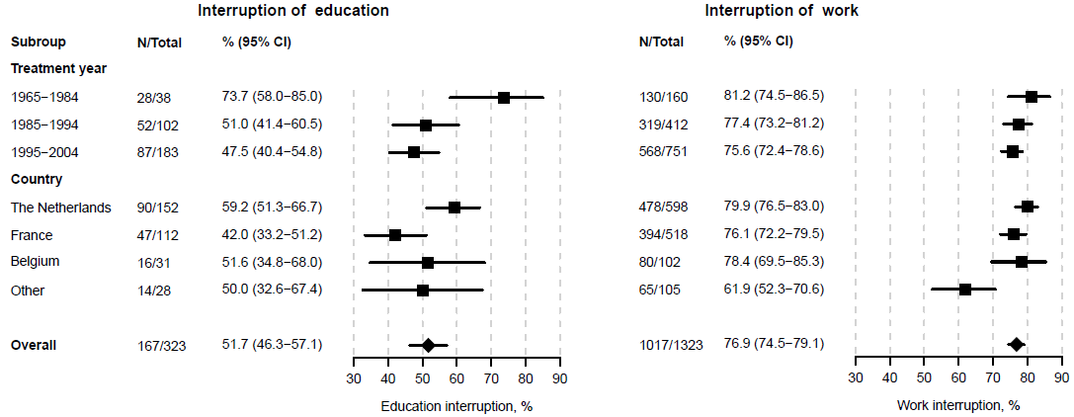

Supplement (Annex 7). Estimated probabilities of resumption of education across a period of five years following the interruption.

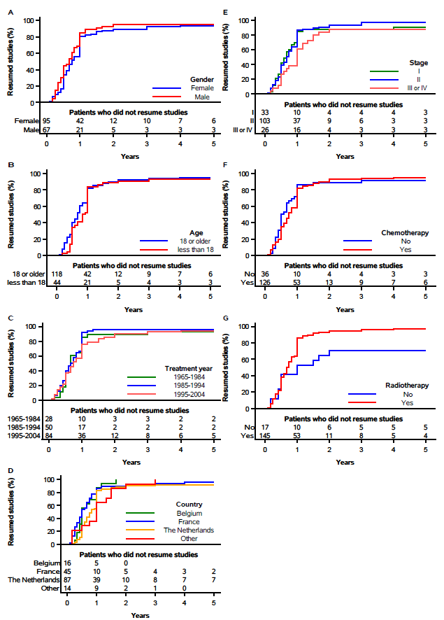

Supplement (Annex 8). Estimated probabilities of resumption of work across a period of five years following the interruption.

