Supplementary Materials

- Supplementary Acute Toxicity Tables
Table S1.1 Maximum Acute Toxicity by Treatment Arm
 |  |  | 3D | IMRT | TOTAL
 | Grade 1 | Count | 13 | 15 | 28
 | Grade 1 | % within Arm | 32% | 34% | 33%
 | Grade 2 | Count | 17 | 19 | 36
 | Grade 2 | % within Arm | 42% | 43% | 43%
 | Grade 3 | Count | 10 | 10 | 20
 | Grade 3 | % within Arm | 25% | 23% | 24%
Total |  | Count | 40 | 44 | 84
 |  | % within Arm | 100% | 100% | 100%
P= .969
Table S1.2a: Maximum Acute GI Toxicity by Treatment Arm
 |  |  | 3D | IMRT | TOTAL
 | Grade 0 | Count | 0 | 1 | 1
 | Grade 0 | % within Arm | 0% | 2% | 1%
 | Grade 1 | Count | 26 | 28 | 54
 | Grade 1 | % within Arm | 65% | 64% | 64%
 | Grade 2 | Count | 9 | 11 | 20
 | Grade 2 | % within Arm | 22% | 25% | 24%
 | Grade 3 | Count | 5 | 4 | 9
 | Grade 3 | % within Arm | 12% | 9% | 11%
Total |  | Count | 40 | 44 | 84
 |  | % within Arm | 100% | 100% | 100%
P= .754
Table S1.2b: Grade ≥2 Acute GI Toxicity by Treatment Arm
 |  |  | 3D | IMRT | TOTAL
 | No | Count | 26 | 29 | 55
 | No | % within Arm | 65% | 66% | 65%
 | Yes | Count | 14 | 15 | 29
 | Yes | % within Arm | 35 % | 34% | 35%
Total |  | Count | 40 | 44 | 84
 |  | % within Arm | 100% | 1.0% | 1.0%
Fisher’s exact test p= 1.000

Table S1.2c Acute GI Grade 3 Toxicity by Treatment Arm
 |  |  | Arm |  | Total
 |  |  | 3D | IMRT | Total
Grade 3 | No | Count | 35 | 40 | 75
Grade 3 | No | % within Arm | 87.5% | 90.9% | 89.3%
Grade 3 | Yes | Count | 5 | 4 | 9
Grade 3 | Yes | % within Arm | 12.5% | 9.1% | 10.7%
Total |  | Count | 40 | 44 | 84
 |  | % within Arm | 100.0% | 100.0% | 100.0%
Fisher’s exact test p= .730
Table S1.3a: Maximum Acute GU Toxicity by Treatment Arm
 |  |  | 3D | IMRT | TOTAL
Grade | 0 | Count | 4 | 3 | 7
Grade | 0 | % within Arm | 10% | 7% | 8%
Grade | 1 | Count | 24 | 24 | 48
Grade | 1 | % within Arm | 60% | 54% | 57%
Grade | 2 | Count | 8 | 13 | 21
Grade | 2 | % within Arm | 20% | 29% | 25%
Grade | 3 | Count | 4 | 4 | 8
Grade | 3 | % within Arm | 10% | 9% | 9%
Total |  | Count | 40 | 44 | 84
 |  | % within Arm | 100% | 100% | 100%
P= .766
Table S1.3b: Grade ≥2 Acute GU Toxicity by Treatment Arm
 |  |  | 3D | IMRT | TOTAL
 | No | Count | 28 | 27 | 55
 | No | % within Arm | 70% | 61% | 65%
 | Yes | Count | 12 | 17 | 29
 | Yes | % within Arm | 30% | 39% | 35%
Total |  | Count | 40 | 44 | 84
 |  | % within Arm | 100% | 100% | 100%
Fisher’s exact test p= .493
Table S1.3c: Acute GU Grade ≥3 by Treatment Arm
 |  |  |  |  | Total
 |  |  | 3D | IMRT | Total
Acute Toxicity GU_≥3 | No | Count | 36 | 40 | 76
Acute Toxicity GU_≥3 | No | % within Arm | 90.0% | 90.9% | 90.5%
Acute Toxicity GU_≥3 | Yes | Count | 4 | 4 | 8
Acute Toxicity GU_≥3 | Yes | % within Arm | 10.0% | 9.1% | 9.5%
Total |  | Count | 40 | 44 | 84
 |  | % within Arm | 100.0% | 100.0% | 100.0%
Fisher’s exact test p= 1.000
Table S1.4: New diet* by Acute GI ≥2 toxicity
 |  |  | Acute GI Grade ≥2 toxicity |  | Total
 |  |  | No | Yes | Total
New diet | No | Count | 39 | 10 | 49
New diet | No | % within New_diet | 79.6% | 20.4% | 100.0%
New diet | No | % within Acute GI G≥2 | 70.9% | 34.5% | 58.3%
New diet | Yes | Count | 16 | 19 | 35
New diet | Yes | % within New_diet | 45.7% | 54.3% | 100.0%
New diet | Yes | % within Acute GI G≥2 | 29.1% | 65.5% | 41.7%
Total |  | Count | 55 | 29 | 84
 |  | % within New_diet | 65.5% | 34.5% | 100.0%
 |  | % within Acute GI G≥2 | 100.0% | 100.0% | 100.0%
P= .003
Table S1.5: New diet* by Acute GI or GU ≥2 toxicity
 |  |  | Acute GI or GU ≥2 |  | Total
 |  |  | No | Yes | Total
New diet | No | Count | 30 | 19 | 49
New diet | No | % within Acute GI or GU ≥2 | 76.9% | 42.2% | 58.3%
New diet | Yes | Count | 9 | 26 | 35
New diet | Yes | % within Acute GI or GU ≥2 | 23.1% | 57.8% | 41.7%
Total |  | Count | 39 | 45 | 84
 |  | % within Acute GI or GU ≥2 | 100.0% | 100.0% | 100.0%
P= .003
*Beginning in December 2014 (after 51 patients had been enrolled), patients were advised to follow a low residue diet, to ensure rectal volume consistency and to decrease rectal gas, for one week prior to their planning CT, one week prior to commencing their radiotherapy treatment and for the duration of their radiotherapy treatment.
Table S1.6 Adenocarcinoma by Acute GU ≥2 toxicity
 |  |  | Acute GU 2+ |  | Total
 |  |  | No | Yes | Total
Adeno | No | Count | 7 | 10 | 17
Adeno | No | % within Acute GU ≥2 | 12.7% | 34.5% | 20.2%
Adeno | Yes | Count | 48 | 19 | 67
Adeno | Yes | % within Acute GU ≥2 | 87.3% | 65.5% | 79.8%
Total |  | Count | 55 | 29 | 84
 |  | % within Acute GU ≥2 | 100.0% | 100.0% | 100.0%
P= .038
Table S1.7: Stage IIIB by Acute GU Grade ≥2 toxicity
 |  |  | Acute GU Grade ≥2 |  | Total
 |  |  | No | Yes | Total
Stage IIIB | No | Count | 54 | 24 | 78
Stage IIIB | No | % within A_GU_≥2 | 98.2% | 82.8% | 92.9%
Stage IIIB | Yes | Count | 1 | 5 | 6
Stage IIIB | Yes | % within A_GU_≥2 | 1.8% | 17.2% | 7.1%
Total |  | Count | 55 | 29 | 84
 |  | % within A_GU_≥2 | 100.0% | 100.0% | 100.0%
Fisher’s exact test p= .017

Table S1.8: Late ≥2 GI Toxicity
 |  |  | 3D | IMRT | Total
Late GI toxicity ≥2 | No | Count | 31 | 32 | 63
Late GI toxicity ≥2 | No | % within Arm A is 3D | 75.6% | 69.6% | 72.4%
Late GI toxicity ≥2 | Yes | Count | 10 | 14 | 24
Late GI toxicity ≥2 | Yes | % within Arm A is 3D | 24.4% | 30.4% | 27.6%
Total |  | Count | 41 | 46 | 87
 |  | % within Arm A is 3D | 100.0% | 100.0% | 100.0%
Fisher’s exact test p= .633

Table S1.9: Late GI Toxicity by each Grade

 |  |  | 3D | IMRT | Total
Late GI Grade | 0 | Count | 2 | 4 | 6
Late GI Grade | 0 | % within Arm A is 3D | 4.9% | 8.7% | 6.9%
Late GI Grade | 1 | Count | 29 | 28 | 57
Late GI Grade | 1 | % within Arm A is 3D | 70.7% | 60.9% | 65.5%
Late GI Grade | 2 | Count | 9 | 11 | 20
Late GI Grade | 2 | % within Arm A is 3D | 22.0% | 23.9% | 23.0%
Late GI Grade | 3 | Count | 1 | 2 | 3
Late GI Grade | 3 | % within Arm A is 3D | 2.4% | 4.3% | 3.4%
Late GI Grade | 4 | Count | 0 | 1 | 1
Late GI Grade | 4 | % within Arm | 0.0% | 2.2% | 1.1%
Total |  | Count | 41 | 46 | 87
 |  | % within Arm | 100.0% | 100.0% | 100.0%

Table S1.10: Late ≥2 GU Toxicity
 |  |  | 3D | IMRT | Total
Late GU ≥2 | No | Count | 28 | 28 | 56
Late GU ≥2 | No | % within Arm | 68.3% | 60.9% | 64.4%
Late GU ≥2 | Yes | Count | 13 | 18 | 31
Late GU ≥2 | Yes | % within Arm | 31.7% | 39.1% | 35.6%
Total |  | Count | 41 | 46 | 84
 |  | % within Arm | 100.0% | 100.0% | 100.0%
Fisher’s exact test p= .508
Table S1.11: Late GU Toxicity by each grade
 |  |  | 3D | IMRT | Total
Late GU grade | 0 | Count | 4 | 7 | 11
Late GU grade | 0 | % within Arm | 9.8% | 15.2% | 12.6%
Late GU grade | 1 | Count | 24 | 21 | 45
Late GU grade | 1 | % within Arm | 58.5% | 45.7% | 51.7%
Late GU grade | 2 | Count | 11 | 12 | 23
Late GU grade | 2 | % within Arm | 26.8% | 26.1% | 26.4%
Late GU grade | 3 | Count | 2 | 6 | 8
Late GU grade | 3 | % within Arm | 4.9% | 13.0% | 9.2%
Total |  | Count | 41 | 46 | 87
 |  | % within Arm | 100.0% | 100.0% | 100.0%

Table S1.12: Late GI/GU ≥2 toxicity
 |  |  | 3D | IMRT | Total
Late GI/ GU ≥2 | No | Count | 25 | 22 | 47
Late GI/ GU ≥2 | No | % within Arm | 61.0% | 47.8% | 54.0%
Late GI/ GU ≥2 | Yes | Count | 16 | 24 | 40
Late GI/ GU ≥2 | Yes | % within Arm | 39.0% | 52.2% | 46.0%
Total |  | Count | 41 | 46 | 87
 |  | % within Arm | 100.0% | 100.0% | 100.0%
Fisher’s exact test p= .282

Table S1.13: Max Late Grade Toxicity |  |  |  |  | Total
 |  |  | 3D | IMRT | Total
Max Late Grade | 0 | Count | 0 | 1 | 1
Max Late Grade | 0 | % within Arm | 0.0% | 2.2% | 1.1%
Max Late Grade | 1 | Count | 14 | 17 | 31
Max Late Grade | 1 | % within Arm | 34.1% | 37.0% | 35.6%
Max Late Grade | 2 | Count | 18 | 15 | 33
Max Late Grade | 2 | % within Arm | 43.9% | 32.6% | 37.9%
Max Late Grade | 3 | Count | 9 | 12 | 21
Max Late Grade | 3 | % within Arm | 22.0% | 26.1% | 24.1%
Max Late Grade | 4 | Count | 0 | 1 | 1
Max Late Grade | 4 | % within Arm | 0.0% | 2.2% | 1.1%
Total |  | Count | 41 | 46 | 87
 |  | % within Arm | 100.0% | 100.0% | 100.0%

Table S1.14: Max Late Grade ≥2 Toxicity by Treatment Arm
 |  |  |  |  | Total
 |  |  | 3D | IMRT | Total
Max Late ≥2 | No | Count | 14 | 18 | 32
Max Late ≥2 | No | % within Arm A is 3D | 34.1% | 39.1% | 36.8%
Max Late ≥2 | Yes | Count | 27 | 28 | 55
Max Late ≥2 | Yes | % within Arm A is 3D | 65.9% | 60.9% | 63.2%
Total |  | Count | 41 | 46 | 87
 |  | % within Arm A is 3D | 100.0% | 100.0% | 100.0%
Fisher’s exact test p= .662

Table S1.15: Late Fatigue Grade ≥2 by Treatment Arm
 |  |  | 3D | IMRT | Total
Late Fatigue ≥2 | Grade 0-1 | Count | 38 | 35 | 73
Late Fatigue ≥2 | Grade 0-1 | % within Arm | 92.7% | 76.1% | 83.9%
Late Fatigue ≥2 | Grade ≥2 | Count | 3 | 11 | 14
Late Fatigue ≥2 | Grade ≥2 | % within Arm | 7.3% | 23.9% | 16.1%
Total |  | Count | 41 | 46 | 87
 |  | % within Arm | 100.0% | 100.0% | 100.0%
Fisher’s exact test p= .044

Table S1.16: Pain Musculoskeletal Grade ≥2 by Treatment Arm

 |  |  | 3D | IMRT | Total
Pain Musculoskeletal ≥2 | No | Count | 41 | 39 | 80
Pain Musculoskeletal ≥2 | No | % within Arm A is 3D | 100.0% | 84.8% | 92.0%
Pain Musculoskeletal ≥2 | Yes | Count | 0 | 7 | 7
Pain Musculoskeletal ≥2 | Yes | % within Arm A is 3D | 0.0% | 15.2% | 8.0%
Total |  | Count | 41 | 46 | 87
 |  | % within Arm A is 3D | 100.0% | 100.0% | 100.0%
Fisher’s exact test p= .013

- Supplementary Multivariate Analyses Tables

Table S2.1 Multivariate analysis of Grade ≥2 GU toxicity
 |  | p | Odds Ratio | 95% CI for Odds Ratio
 |  | p | Odds Ratio | Lower | Upper
 | Dose delivered to 99% of the PTV | .030 | .249 | .071 | .874
 | New diet (Yes vs. No) | .110 | 2.979 | .782 | 11.343
 | Adenocarcinoma (No vs. Yes) | .014 | 6.806 | 1.467 | 31.583
 | Stage 3B (Yes vs. No) | .045 | 15.524 | 1.061 | 227.081
 | Left Femoral Head Absolute Vol cc | .020 | 1.025 | 1.004 | 1.047
 | Arm | .647 | .709 | .163 | 3.084
 | Constant | .043 | 3.9E+24
Abbreviations: CI = confidence interval; GU = genitourinary; PTV = planning target volume.

Table S2.2 Multivariate analysis of Grade ≥2 GI toxicity
 |  | P | Odds Ratio | 95% CI for Odds Ratio
 |  | P | Odds Ratio | Lower | Upper
 | Age | .023 | 1.089 | 1.012 | 1.171
 | New diet (Yes vs. No) | .204 | 2.347 | .630 | 8.751
 | Haemoglobin | .485 | 1.193 | .727 | 1.959
 | Percentage of Bowel volume exceeding 45Gy | .371 | .958 | .872 | 1.052
 | Left Femoral Heads Absolute Vol cc | .175 | 1.016 | .993 | 1.039
 | Left Femoral Heads V40% | .123 | .935 | .859 | 1.018
 | Arm | .107 | .274 | .056 | 1.326
 | Constant | .083 | .001
Abbreviations: CI = confidence interval; GI = gastrointestinal.

- Supplementary Figures
Figure S3.1: Kaplan Meier overall survival Cure

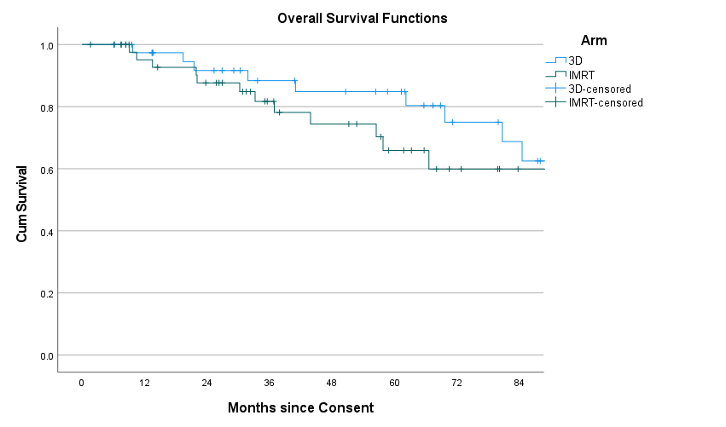

Arm | Censored | Died | Total | Number at risk of death at each time point
 |  |  |  | 12 mths | 24 mths | 36 mths | 48 mths | 60 mths | 72 mths | 84 mths
3D | 32 | 9 | 41 | 37 | 32 | 26 | 24 | 21 | 13 | 11
IMRT | 35 | 12 | 47 | 39 | 34 | 24 | 20 | 14 | 8 | 4
Total | 67 | 21 | 88 | 76 | 66 | 50 | 44 | 35 | 21 | 15

Figure S3.2 Kaplan Meier disease-free survival curve
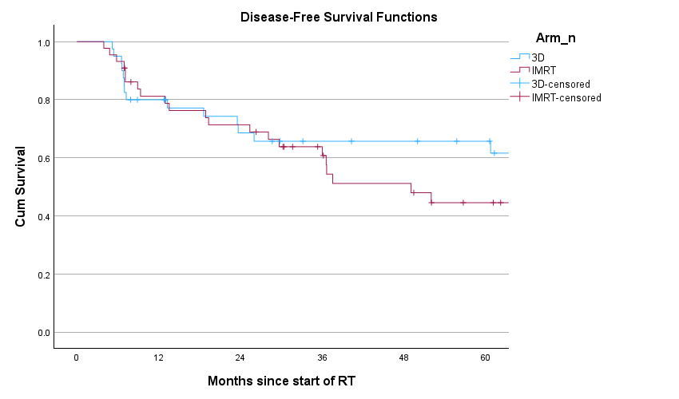

Arm | Censored | No. who had local or distant recurrence, second primary, or died | Total | Number at risk at each time point
 |  |  |  | 12 mths | 24 mths | 36 mths | 48 mths | 60 mths
3D | 26 | 14 | 40 | 30 | 24 | 20 | 19 | 17
IMRT | 23 | 21 | 44 | 33 | 29 | 21 | 16 | 11
Total | 49 | 35 | 84 | 63 | 55 | 41 | 35 | 28

Figure S3.3 Kaplan Meier local recurrence free survival curve
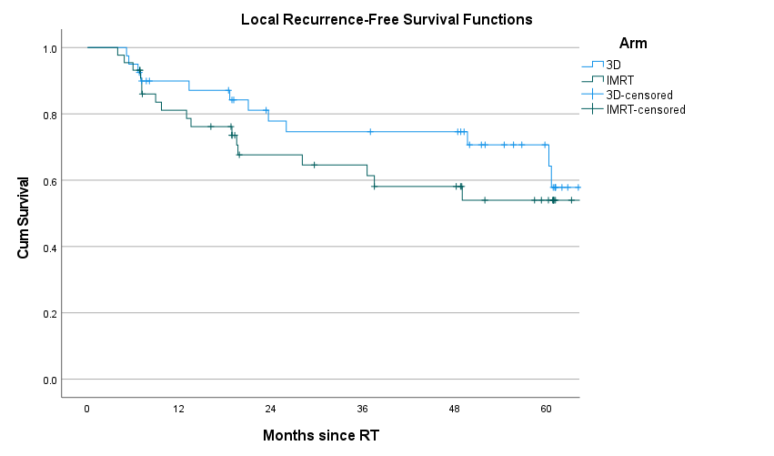

Arm | Censored | No. who had local recurrence or died | Total | Number at risk at each time point
 |  |  |  | 12 mths | 24 mths | 36 mths | 48 mths | 60 mths
3D | 28 | 12 | 40 | 32 | 24 | 23 | 22 | 11
IMRT | 27 | 17 | 44 | 33 | 22 | 20 | 17 | 10
Total | 55 | 29 | 84 | 65 | 46 | 43 | 39 | 21

S4.1 Radiotherapy target volume delineation/planning and treatment delivery
The clinical target volume (CTV) included the external, and internal iliac lymph node regions (7 mm expansion of contoured vessels were used as a guide for contouring at risk pelvic lymph node regions[1]) with the upper 3 cm of vagina and paravaginal soft tissue lateral to the vagina also included. For patients who had cervical stromal invasion, the CTV also included the presacral lymph node-region. For the 3D technique 4 pelvic fields were defined according to standard RT guidelines. IMRT prescription was to 95% of the planning target volume (PTV) target mean. Radiotherapy fractions was to be administered once per day Monday-Friday, with a break at the weekends. Inter-fractionation interval: ≥ 6 hours between fractions was required. Missed scheduled fractions (due to bank holidays, toxicity etc.) could be compensated by scheduled twice daily fractions (must be ≥ 6 hours apart). Patients were to be positioned supine and suitably immobilised, preferably with two-point immobilisation, e.g., Lung-board and footfix. Linear Accelerator with ≥ 6 MV energy with Image Guided Radiation Therapy (IGRT) capacity. A consistent bladder filling protocol was required prior to planning CT and before each EBRT fraction. Beginning in December 2014 (after 51 patients had been enrolled), patients were advised to follow a low residue diet, to ensure rectal volume consistency and to decrease rectal gas, for one week prior to their planning CT, one week prior to commencing their radiotherapy treatment and for the duration of their radiotherapy treatment.

Supplementary Material References
[1] Taylor A, Rockall AG, Reznek RH, Powell MEB. Mapping pelvic lymph nodes: guidelines for delineation in intensity-modulated radiotherapy. Int J Radiat Oncol Biol Phys 2005;63:1604–12. https://doi.org/10.1016/j.ijrobp.2005.05.062.

