Supplementary materials

Hybrid planning techniques for early stage left-sided breast cancer: dose distribution analysis and estimation of projected secondary cancer relative risk.
Iga Rackaª*, Karolina Majewskaª, Janusz Winiecki^{a,b}, Karolina Kiluk^{c}
ª Medical Physics Department, Prof. Franciszek Łukaszczyk Memorial Oncology Center, Bydgoszcz, Poland;
^{b} Clinic of Oncology and Brachytherapy, Collegium Medicum in Bydgoszcz, Nicholas Copernicus University, Torun, Poland;
^{c}Toruńska 45D/60, Bydgoszcz, Poland;
⁎ corresponding author; email: rackai@co.bydgoszcz.pl

ORCID:
Iga Racka: https://orcid.org/0000-0002-8885-4187
Janusz Winiecki: https://orcid.org/0000-0001-9330-1547

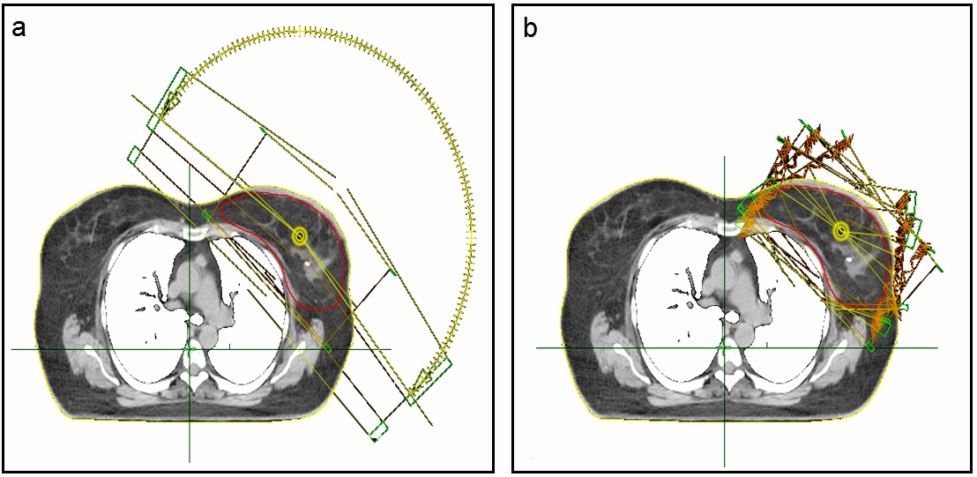
Figure S1. Beam arrangements for hybrid Volumetric Modulated Arc Therapy (a) and hybrid Intensity Modulated Radiotherapy (b) plans.

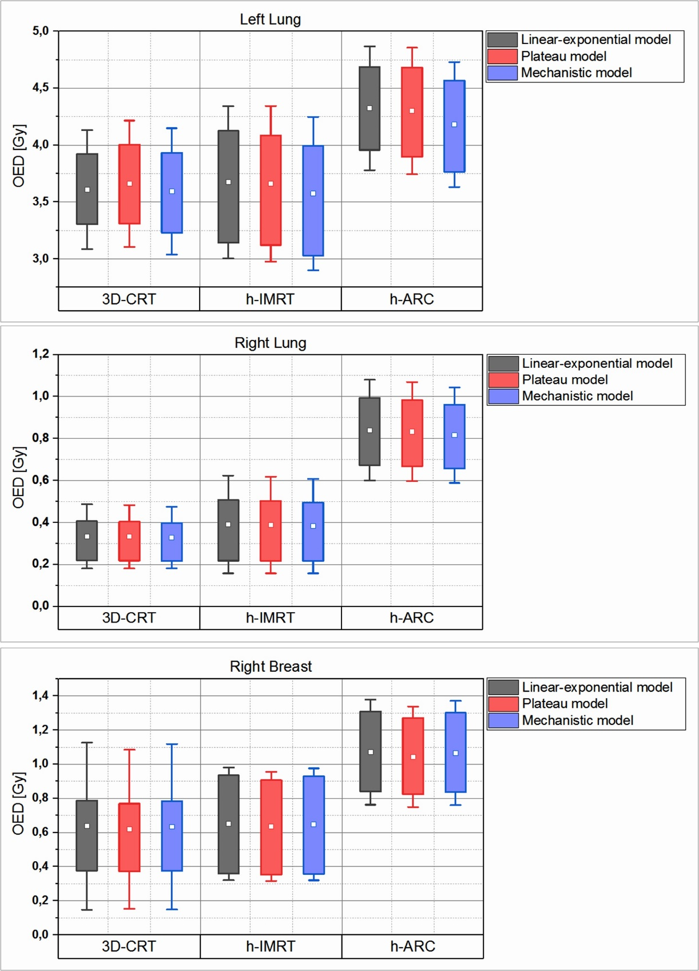
Figure S2. Comparison of OED value for left lung, right lung and right breast. Data are expressed as mean (square), standard deviation (bars) and interquartile range (box). 3D-CRT three-dimensional conformal radiotherapy plans, h-IMRT hybrid Intensity Modulated Radiotherapy plans, h-ARC hybrid Volumetric Modulated Arc Therapy plans.

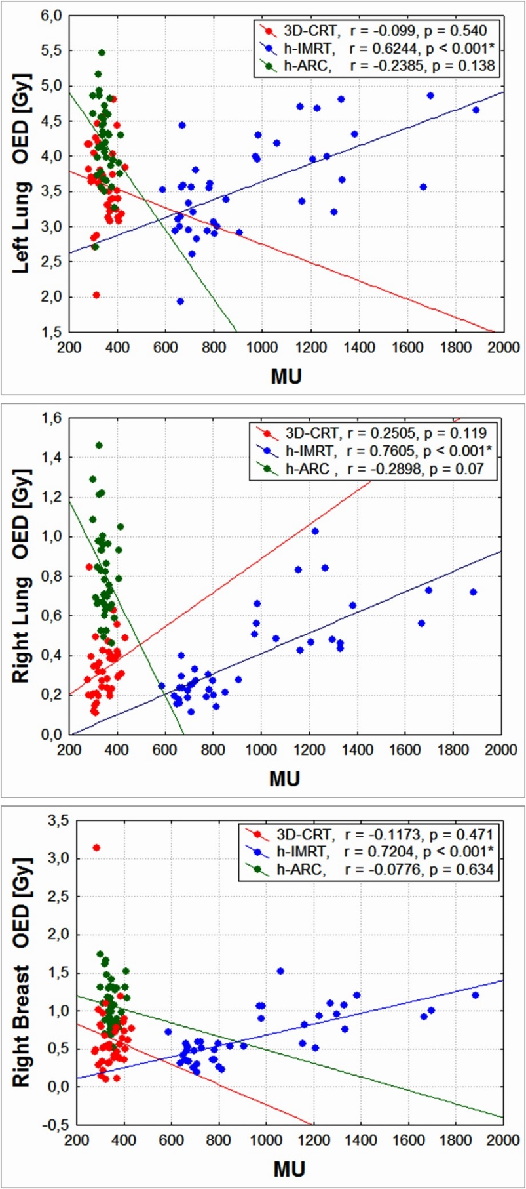
Figure S3. The correlation between total monitor units (MU) in a plan and estimated organ equivalent doses (OED) based on the full mechanistic dose-response model, for all plans and analyzed organs (left lung, right lung and right breast). The solid lines represents linear regression fits for all 40 patients.

