Supplementary materials

NTCP calculations

Radiation pneumonitis (RP)
The NTCP for RP grade ≥2 was calculated using a QUANTEC model refined by Appelt et al. [1,2]:
$NTCP=\frac{1}{1+e^{-S}}$ with $S=-4.12+0.138∙MLD-0.3711∙\left(Former smoker\right)-0.478∙\left(Current smoker\right)+0.8198∙\left(Co-morbidity\right)+0.6259∙\left(Tumor location\right)+0.5068∙\left(Old age\right)+0.47∙\left(Sequential chemo\right),$
where MLD is the mean lung dose in Gy and the other parameters are assigned value 1 or 0 according to Table S1.

Table S1. Variables in the NTCP model for radiation pneumonitis.
Variable | Value = 1 | Value = 0
Former smoker | Yes | Never smoked/active smoker
Current smoker | Yes | Never smoked/stopped smoking
Co-morbidity ¹ | Yes | No
Tumor location | Middle/lower lobe | Upper lobe
Old age | ≥63 years | <63 years
Sequential chemo | Yes | No
¹ Chronic obstructive pulmonary disease or other pre-existing lung disease.

2-year mortality
The NTCP for 2-year mortality based on heart dose was calculated using a model developed by Defraene et al. and revised after external validation in several patient cohorts [2,3]:
$NTCP=\frac{1}{1+e^{-S}}$ with $S=-1.3409+0.0590∙\sqrt{GTV}+0.2635∙\sqrt{MHD},$
where GTV is the combined GTV volume of the primary tumor and nodes in cm³ and MHD is the mean heart dose in Gy.

Acute esophageal toxicity (AET)
The NTCP for AET grade ≥2 was calculated using a model developed by Wijsman et al. and revised after external validation in several patient cohorts [2,4]:
$NTCP=\frac{1}{1+e^{-S}}$ with $S=-3.634+1.496∙\ln\left(MED\right)-0.0297∙OTT,$
where MED is the mean esophagus dose in Gy and OTT is the overall radiotherapy treatment time in days.

Results

Goodness of fit statistics
The goodness of fit statistics describe how well the RapidPlan model represents the data in the training set. The coefficient of determination, R², describes how well the regression model represents the training plan data. R² has values between 0.0 and 1.0, and larger values indicate a better fit. The χ² measures the residuals between the original and estimated data, and values closer to 1.0 indicate a better regression model.
Table S2. Training statistics for the RapidPlan models.
OAR | RP_CLIN |  | RP_MCO
 | R² | χ² | R² | χ²
Lungs | 0.85 | 1.18 | 0.84 | 1.11
Heart | 0.79 | 1.12 | 0.80 | 1.05
Esophagus | 0.73 | 1.06 | 0.74 | 1.06
Spinal canal | 0.77 | 1.00 | 0.89 | 1.14

Comparison of RP_MCO and CLIN plans
Dose metric | CLIN |  |  | RP_MCO
 | Avg | Median | 10th-90th percentile | Avg | Median | 10th-90th percentile | p-value
PTV V_{95%} [%] | 99.0 | 99.1 | 97.8-99.8 | 98.9 | 99.3 | 97.1-99.8 | 0.4
Lungs D_{mean} [Gy] | 13.2 | 13.8 | 9.7-16.1 | 13.5 | 13.9 | 10.2-16.5 | 0.2
Lungs V_{5Gy} [%] | 52.4 | 53.6 | 38.0-62.0 | 53.9 | 55.1 | 39.0-66.5 | 0.1
Lungs V_{20Gy} [%] | 22.4 | 21.8 | 16.6-29.0 | 23.4 | 21.7 | 15.6-32.0 | 0.05
Heart D_{mean} [Gy] | 8.5 | 7.9 | 2.7-17.0 | 8.3 | 7.7 | 2.4-18.3 | 0.06
Heart V_{5Gy} [%] | 39.0 | 30.1 | 10.3-92.2 | 38.3 | 29.7 | 9.9-87.2 | 0.4
Heart V_{30Gy} [%] | 11.7 | 5.9 | 1.0-39.1 | 7.6 | 4.9 | 0.7-19.9 | <0.001
Esophagus D_{mean} [Gy] | 19.5 | 18.4 | 7.0-32.3 | 18.3 | 17.6 | 6.0-30.5 | 0.003
Esophagus V_{20Gy} [%] | 34.8 | 32.1 | 16.7-56.6 | 31.2 | 27.6 | 7.5-55.8 | 0.005
Esophagus V_{60Gy} [%] | 9.6 | 7.5 | 0.0-24.5 | 9.2 | 4.9 | 0.0-23.7 | 0.1
Spinal canal D_{max} [Gy] | 42.7 | 45.7 | 24.2-50.3 | 44.8 | 48.7 | 29.9-50.8 | 0.05
NTCP RP [%] | 21.2 | 22.4 | 6.6-36.3 | 22.2 | 21.8 | 6.2-37.9 | 0.04
NTCP 2 year mortality [%] | 47.9 | 42.1 | 34.3-72.1 | 47.5 | 42.2 | 34.1-73.4 | 0.04
NTCP AET [%] | 36.0 | 36.1 | 11.4-56.7 | 33.7 | 35.0 | 9.2-55.2 | 0.003
Table S3. Comparison of dose-volume parameters and NTCPs for CLIN and RP_MCO plans.
Avg = average.

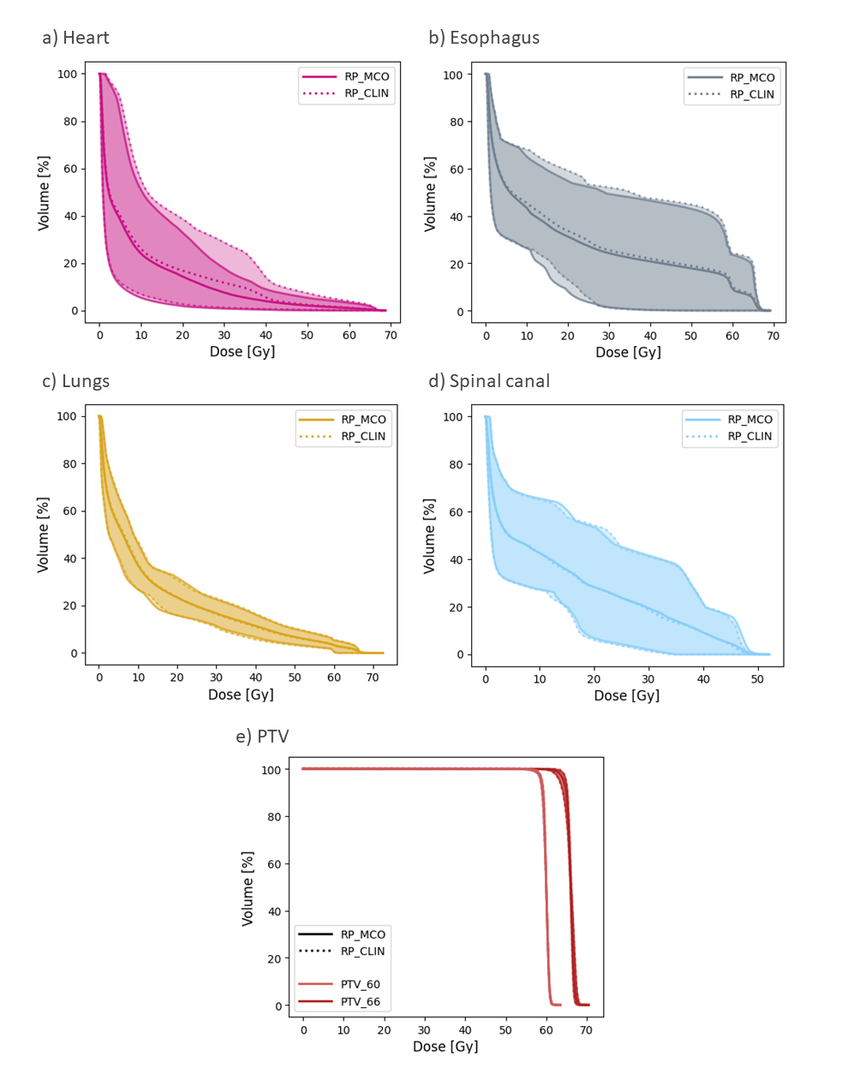
Population average DVHs with confidence intervals
Figure S1. Population average DVHs for PTV and OARs for RP_CLIN and RP_MCO plans. The central lines show the average, and the shaded areas indicate the 90% confidence interval.

References
[1] Appelt AL, Vogelius IR, Farr KP, et al. Towards individualized dose constraints: Adjusting the QUANTEC radiation pneumonitis model for clinical risk factors. Acta Oncologica. 2014;53:605–612.
[2] Nederlandse Vereniging voor Radiotherapie en Oncologie. Landelijk Indicatie Protocol Protonen Therapie - Longcarcinoom [Internet]. 2019. Available from: nvro.nl/images/documenten/rapporten/LIPP_longen_final_01122019.pdf.
[3] Defraene G, Dankers FJWM, Price G, et al. Multifactorial risk factors for mortality after chemotherapy and radiotherapy for non-small cell lung cancer. Radiotherapy and Oncology. 2020;152:117–125.
[4] Wijsman R, Dankers F, Troost EGC, et al. Multivariable normal-tissue complication modeling of acute esophageal toxicity in advanced stage non-small cell lung cancer patients treated with intensity-modulated (chemo-)radiotherapy. Radiotherapy and Oncology. 2015;117:49–54.

