Supplementary online content

Table of contents:
Figure S1: DVH's for all OARs
Figure S2: Scatter plot: Mean dose comparison
Figure S3: Scatter plot: EAR vs mean dose
Table S1: Absolute EAR.

Figure S1:

DVH's for all analysed OAR's: Bladder, Duodenum, Pancreas, Stomach, Bowel Bag, Body Outline, Kidney L, Kidney R, Spinal Cord. IMPT (Red), IMRT (Blue), VMAT (Green).
This figure displays the increased low dose bath for several of the OARs (bladder, stomach, bowel bag and Kidneys) with VMAT.

Figure S2:

Mean dose (Gy) comparison for all analysed OAR's. IMPT vs IMRT and IMPT vs VMAT. Bladder (red circle), Duodenum (black x), Pancreas (pink x), Stomach (blue x), Bowel Bag (blue circle), Body Outline (green circle), Kidney L (Blue star), Kidney R (red star), Spinal cord (green star).
Kidneys favours IMRT and spinal cord favours VMAT, all others IMPT.

Figure S3:
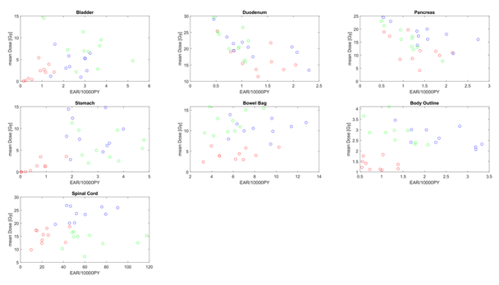

EAR vs mean dose for Bladder, Duodenum, Pancreas, Stomach, Bowel Bag, Body Outline, Spinal Cord.
IMPT (Red), IMRT (Blue), VMAT (Green).
This figure displays the paradox in the model by Schneider et al that a low mean dose gives a high risk of secondary cancer.

Table S1: Results - Median (range) absolute EAR.
OAR | IMPT (EAR) | IMRT (EAR) | VMAT (EAR) | p (IMPT vs IMRT) | p (IMPT vs VMAT)
Body Outline | 17 | 31 | 51 | 0.002* | 0.002*
Body Outline | (11.7 - 29.1) | (20.4 - 42.4) | (33.8 - 89.7)
Bladder | 0.9 | 2.6 | 3.1 | 0.002* | 0.002*
Bladder | (0.1 - 1.6) | (1.4 -3.2) | (1.1 - 5.2)
Duodenum | 1.3 | 1.1 | 0.9 | 0.625 | 0.002*
Duodenum | (0.6 - 2.1) | (0.5 - 2.3) | (0.5 - 1.1)
Pancreas | 1.3 | 1.5 | 1.2 | 0.322 | 0.193
Pancreas | (0.6 - 2.1) | (0.5 - 2.7) | (0.5 - 1.9)
Stomach | 0.5 | 2.7 | 3.2 | 0.002* | 0.002*
Stomach | (0 - 1.8) | (1.8 - 4.0) | (2.0 - 4.8)
Spinal Cord | 6.4 | 8.7 | 5.7 | 0.002* | 0.160
Spinal Cord | (3.2 - 10.3) | (5.6 - 12.8) | (3.3 - 8.9)
Bowel Bag (small intestine) | 0.8 | 2.3 | 1.3 | 0.002* | 0.0027*
Bowel Bag (small intestine) | (0.5 - 1.4) | (1.3 - 3.3) | (0.6 - 2.7)
Bowel Bag (Colon) | 20.7 | 51.2 | 56.5 | 0.002* | 0.002*
Bowel Bag (Colon) | (9.9 - 45.8) | (32.5 - 90.5) | (39.0 - 117.5)
p<0.05: statistically significant. *p<0.05 after Holm-Bonferroni correction
EAR: excess absolute risk

