Appendix A. Supplementary data

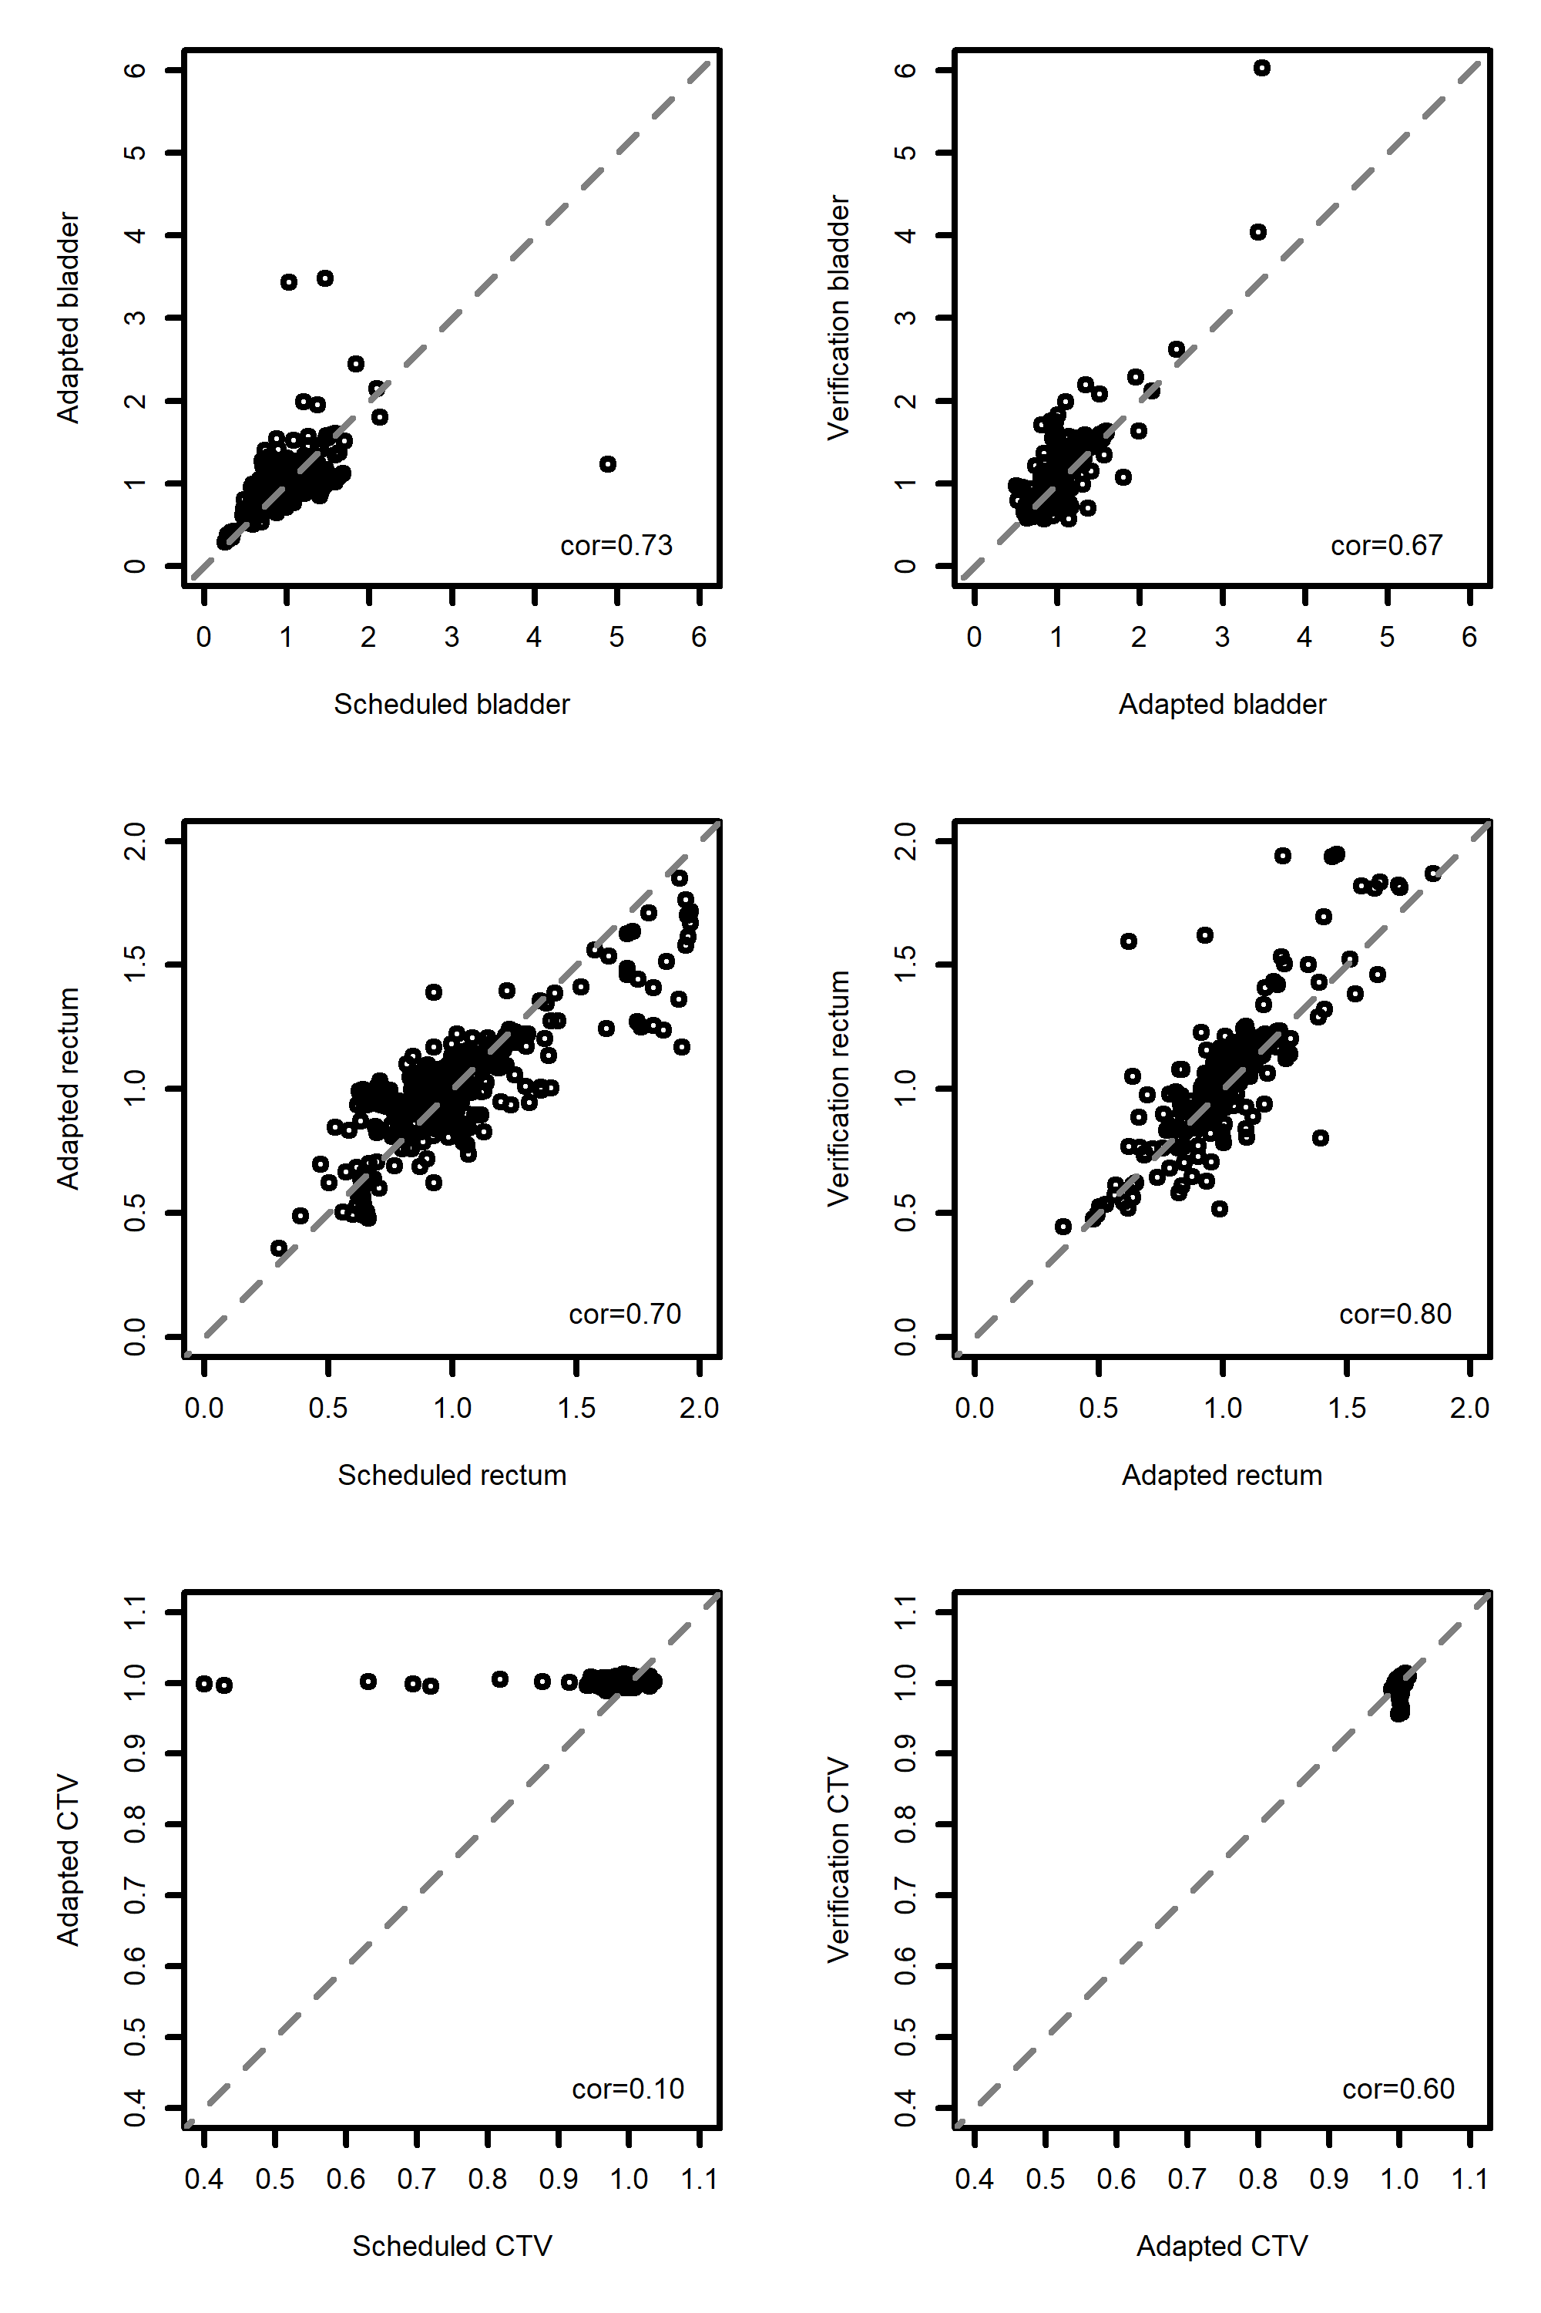
Figure 5 - Scatter plots visualizing normalized doses (D2% and D95%) for scheduled plans versus adaptive plans as well as adaptive plans versus verification plans for OARs and CTV. The robustness of the adapted plans is clearly visualized in the lower row. Correlation factors are shown in the bottom of each plot.
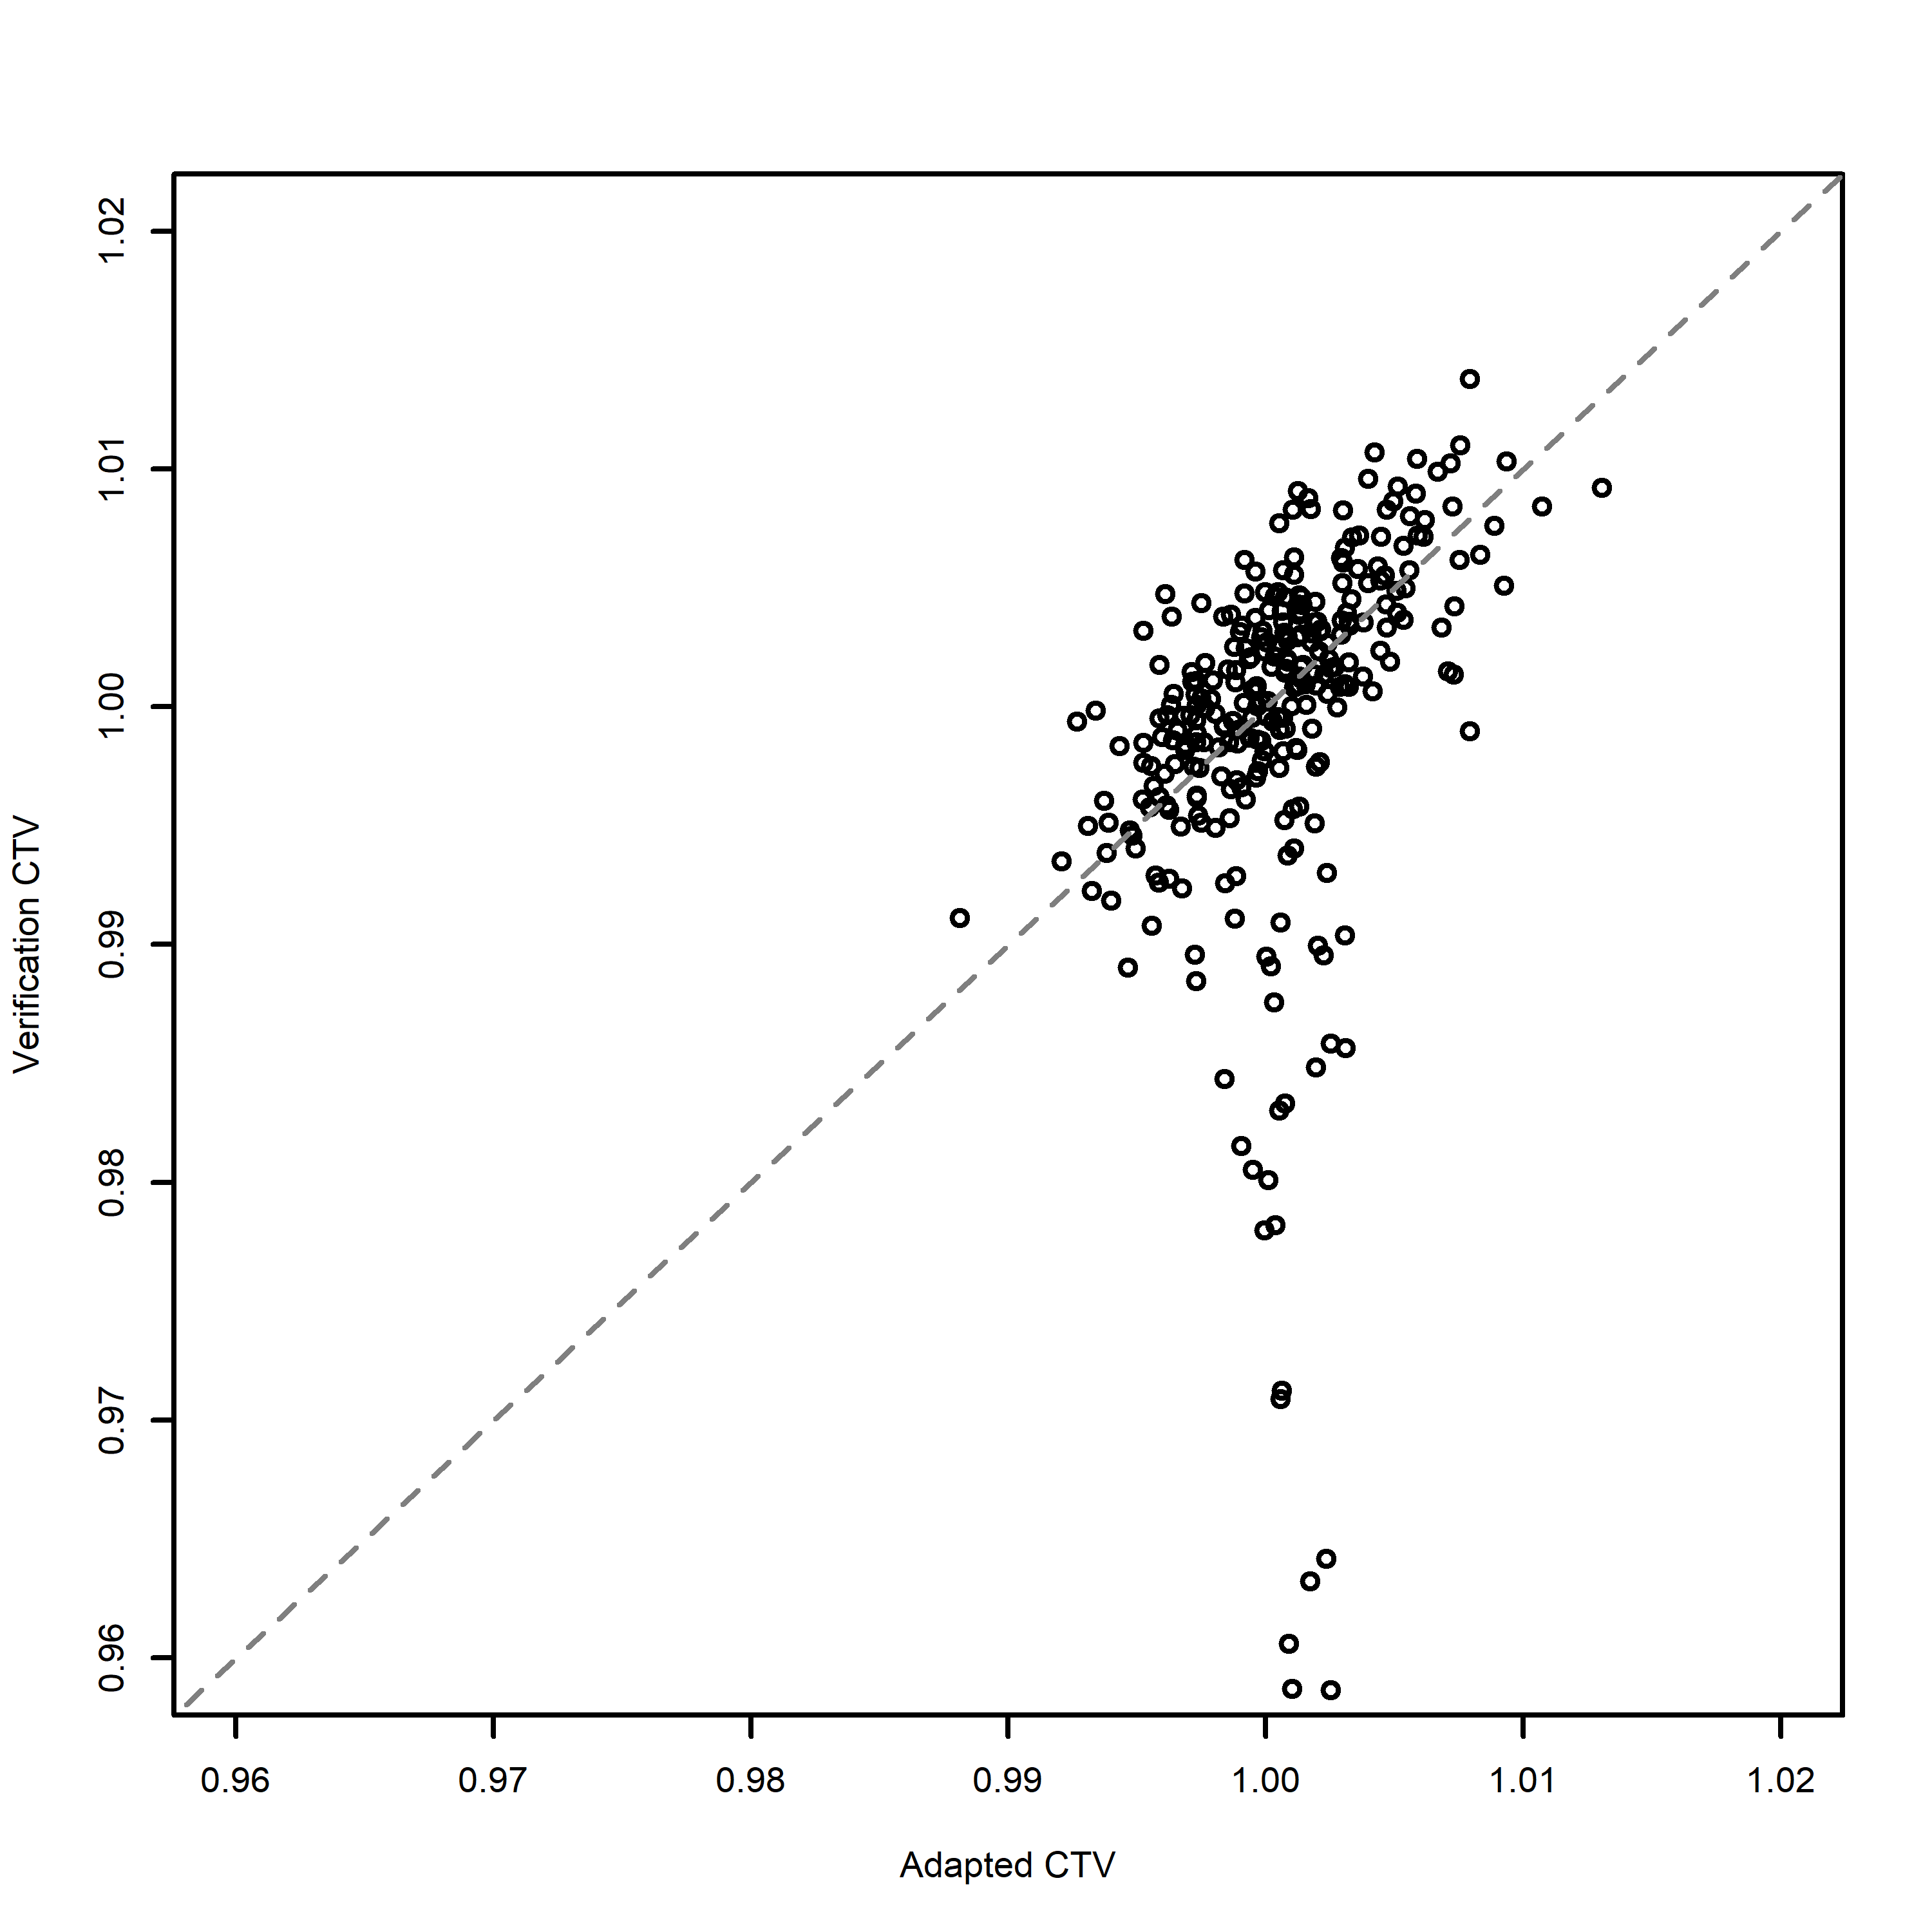
Figure 6 - Scatter plot visualizing normalized doses for adapted plans versus verification plans with narrower axis. Here, the positive linear correlation is seen more clearly.

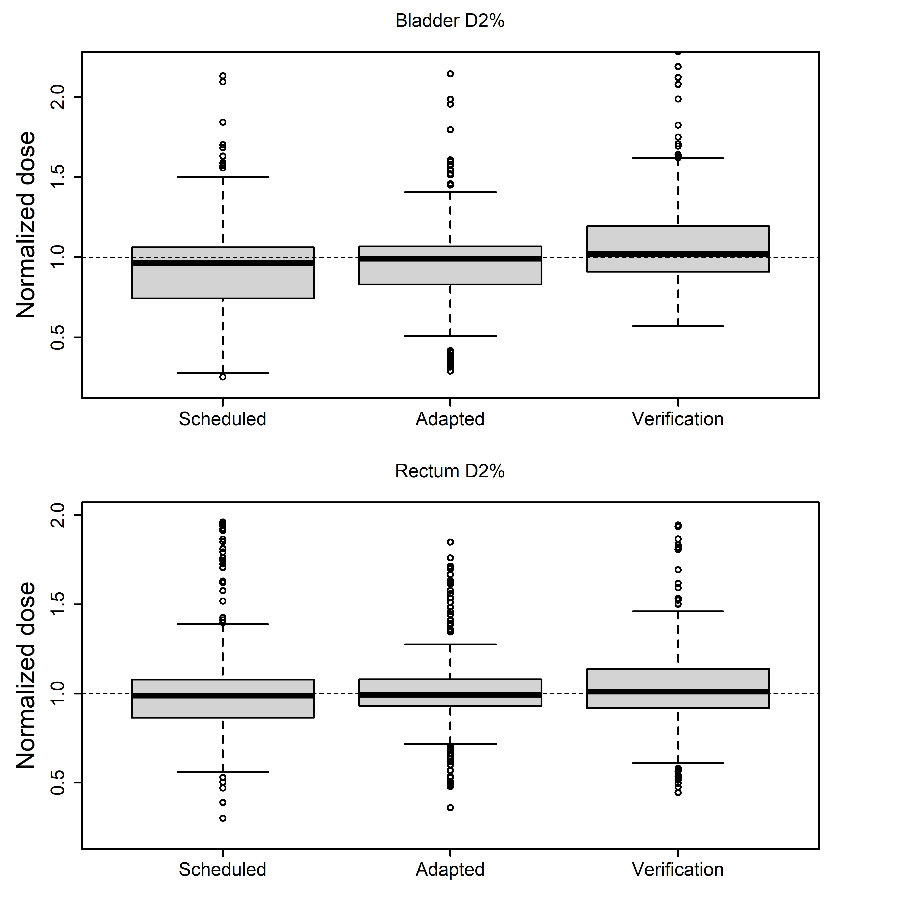
Figure 7 - The dose received by to the 2% hottest volume of bladder was significantly increased from 95 ± 35% on the scheduled plan to 97 ± 31% (signrank p=0.0001), this increase was retained at verification with mean 110 ± 45% (signrank p<0.0001). Rectum dose was unchanged by adaptation with mean 101 ± 27% on the scheduled plan and 101 ± 20% on the adapted plan (signrank p=0.43), however at verification it was significantly higher than scheduled plan with mean 104 ± 25% (signrank p=0.002)

