**Supplemental material for: “Longitudinal development of fatigue after treatment for childhood cancer: A national cohort study”.**

Contents

Supplemental figure 1A-C. Growth-curves for proxy-reports, with mean values and +/- 1SD. 2

Supplemental Figure 2A-C. Growth-curves for self-reports, with mean values and +/- 1SD. 3

Supplemental Figure 3. Flowchart of participation in KLIK and inclusion process. 4

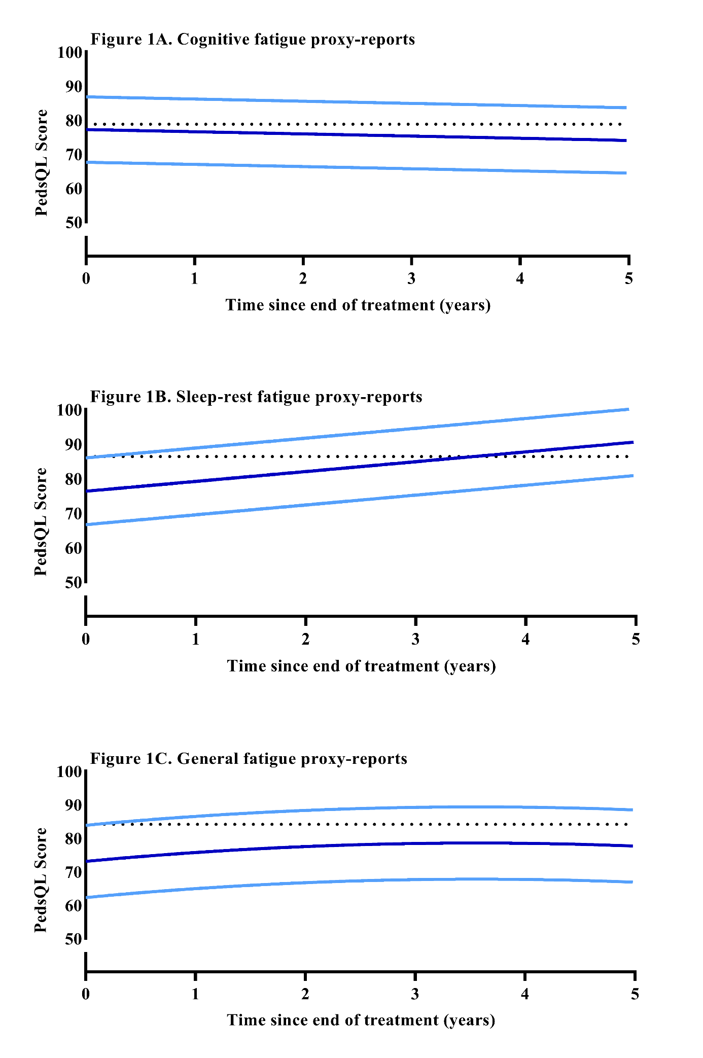

Supplemental figure 1A-C. Growth-curves for proxy-reports, with mean values and +/- 1SD.All diagnosis groups are combined. SD lines based on residual standard error, calculated as the square root of the sum of squared residual errors divided by the degrees of freedom: √(∑(residual)2)/df. The scale is 0-100, where a higher score represents less fatigue. The dotted line represents the weighted mean of healthy norms.

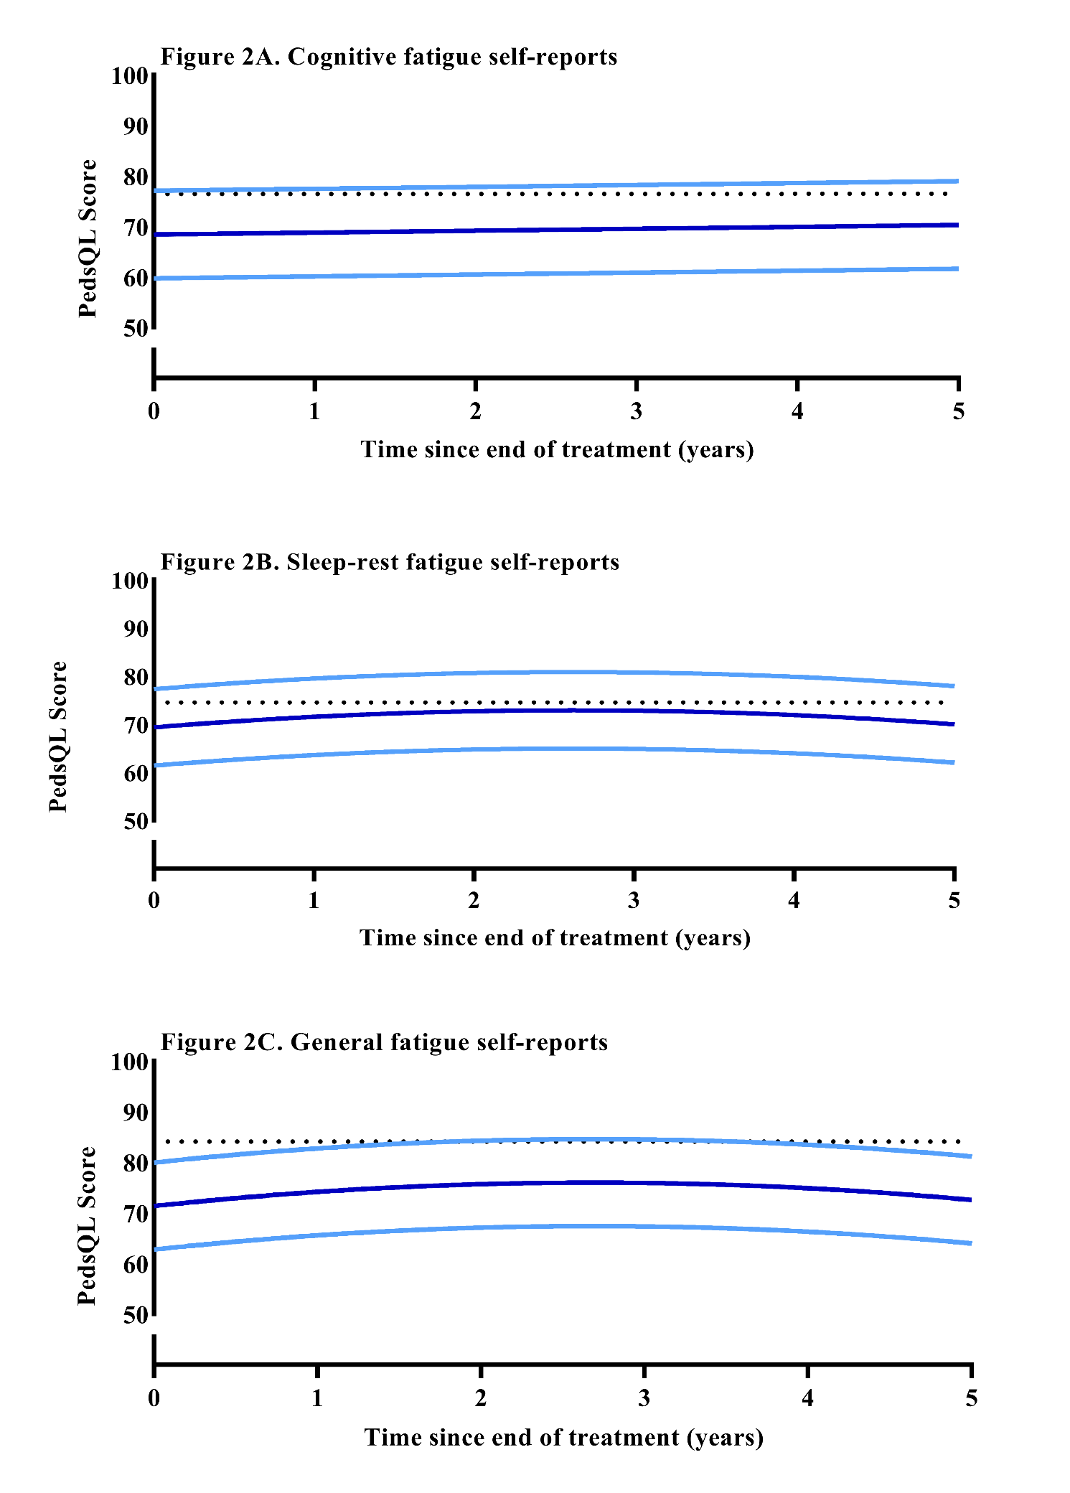

Supplemental Figure 2A-C. Growth-curves for self-reports, with mean values and +/- 1SD.All diagnosis groups are combined. SD lines based on residual standard error, calculated as the square root of the sum of squared residual errors divided by the degrees of freedom: √(∑(residual)2)/df. The scale is 0-100, where a higher score represents less fatigue. The dotted line represents the weighted mean of healthy norms.

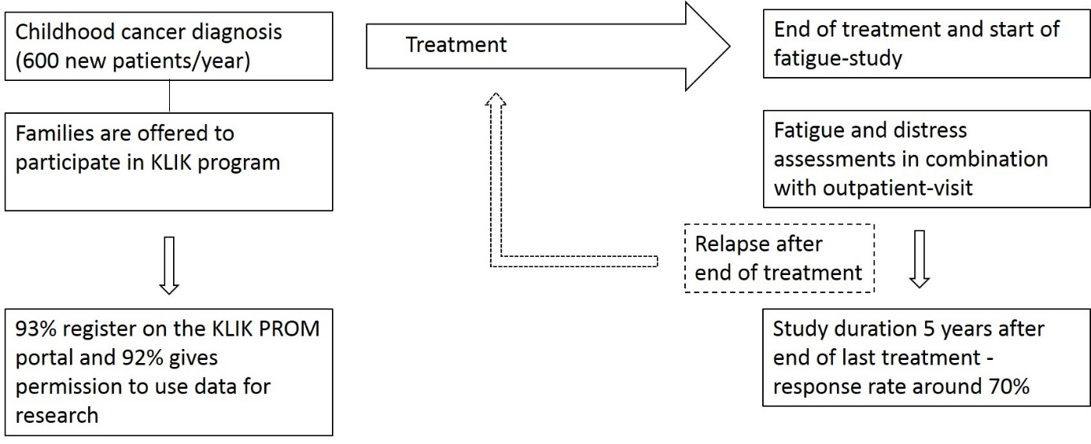

Supplemental Figure 3. Flowchart of participation in KLIK and inclusion process. Abbreviations: PROM= Patient-Reported Outcome Measure.