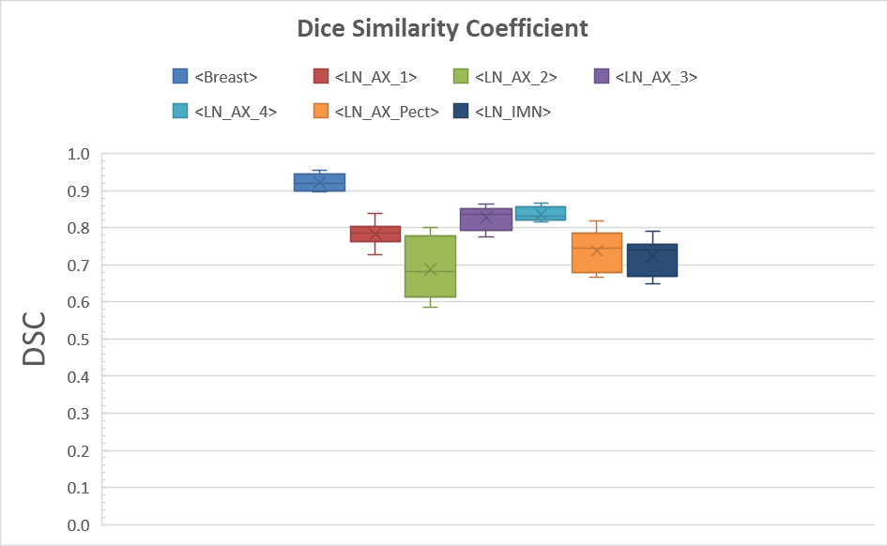
*
*
*
*
*
*
*
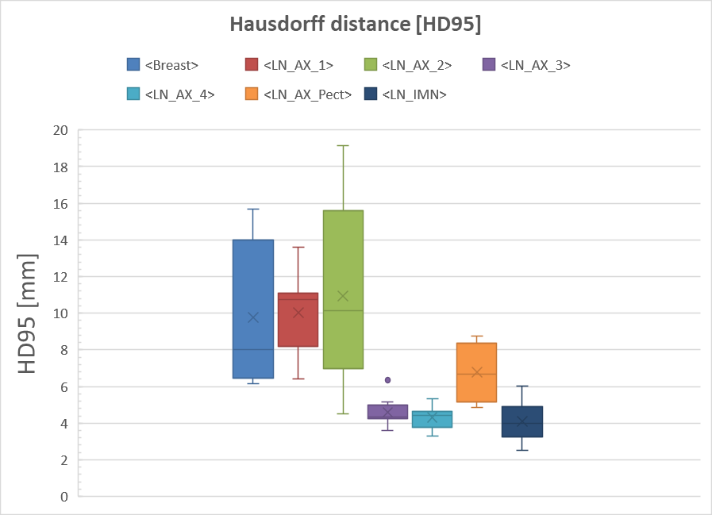
*
*
*
*

Supplementary Figure 1: Similarity indices comparing manual contours to corrected DLS- generated contours. Dice Similarity Coefficient (A) and 95th percentile Hausdorff distance (B) are shown for all target volumes. Compared to similarity indices for uncorrected volumes, the DSC and HD95 values were improved for the corrected DLS volumes in most cases Statistifically significant differences are marked with an asterisk (p< 0.05, using a paired difference t-test). Median values are marked with a line, average values are marked with a cross, 1st and 3rd quartile are marked in the boxplot, and outliers are shown as dots. Average volumes for each contour are denoted above the boxplot.

