Supplementary material

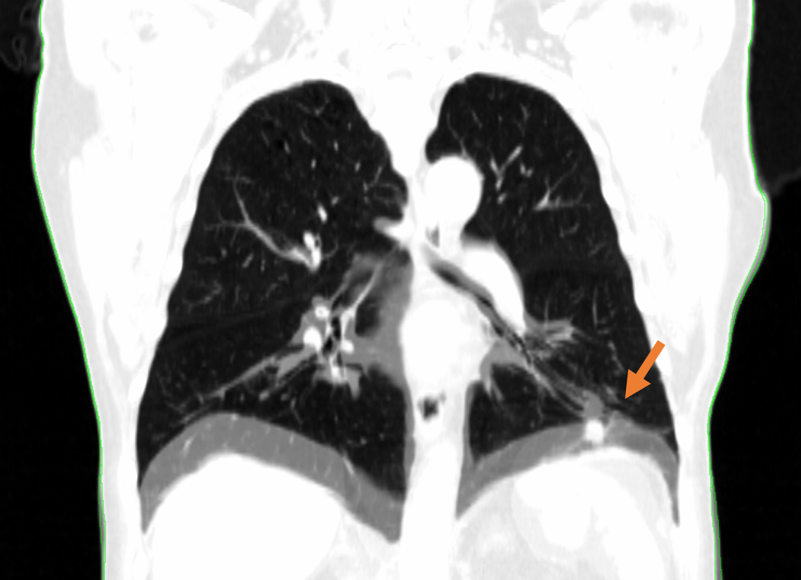
Figure S1. Overlay of the first (DIBH #1) and third (DIBH #3) consecutive DIBH for the patient with the worst reproducibility (pt #1). The orange arrow points at the position of the T-site lesion.

Table S1. The random DIBH scans (each patient has CT scans in 3 consecutive DIBHs), assigned to each sub-arc by the script.
Patient #1
Fraction | DIBH scan #
 | Field 1, sub-arc 1 | Field 1, sub-arc 2 | Field 2, sub-arc 1 | Field 2, sub-arc 2
1 | 2 | 1 | 1 | 2
2 | 3 | 3 | 1 | 2
3 | 3 | 2 | 3 | 2
4 | 2 | 3 | 2 | 3
5 | 1 | 1 | 2 | 3
6 | 2 | 2 | 3 | 1
7 | 2 | 1 | 3 | 2
8 | 1 | 3 | 3 | 2
9 | 1 | 1 | 3 | 3
10 | 2 | 2 | 2 | 1
11 | 1 | 1 | 2 | 2
12 | 2 | 2 | 2 | 1
13 | 1 | 3 | 1 | 3
14 | 3 | 2 | 3 | 2
15 | 1 | 3 | 2 | 1
16 | 2 | 1 | 3 | 3
17 | 3 | 2 | 3 | 3
18 | 1 | 1 | 3 | 2
19 | 1 | 2 | 2 | 3
20 | 2 | 2 | 2 | 3
21 | 2 | 1 | 3 | 2
22 | 3 | 3 | 1 | 1
23 | 2 | 2 | 1 | 1
24 | 2 | 1 | 1 | 3
25 | 2 | 2 | 2 | 2
26 | 1 | 3 | 2 | 1
27 | 3 | 1 | 1 | 1
28 | 1 | 3 | 2 | 2
29 | 2 | 2 | 2 | 1
30 | 2 | 3 | 2 | 1
31 | 3 | 2 | 2 | 2
32 | 1 | 3 | 1 | 3
33 | 1 | 3 | 1 | 1
Patient #2
Fraction | DIBH scan #
 | Field 1, sub-arc 1 | Field 1, sub-arc 2 | Field 2, sub-arc 1 | Field 2, sub-arc 2
1 | 2 | 2 | 2 | 1
2 | 1 | 2 | 3 | 3
3 | 1 | 2 | 1 | 2
4 | 2 | 3 | 2 | 3
5 | 3 | 2 | 1 | 3
6 | 3 | 2 | 2 | 2
7 | 1 | 3 | 1 | 1
8 | 1 | 2 | 2 | 2
9 | 1 | 3 | 1 | 3
10 | 1 | 3 | 3 | 2
11 | 2 | 2 | 2 | 1
12 | 3 | 2 | 2 | 2
13 | 1 | 2 | 2 | 2
14 | 2 | 1 | 2 | 3
15 | 3 | 1 | 2 | 3
16 | 1 | 1 | 1 | 3
17 | 3 | 3 | 3 | 1
18 | 2 | 2 | 2 | 2
19 | 1 | 3 | 2 | 1
20 | 2 | 1 | 3 | 3
21 | 3 | 3 | 1 | 2
22 | 2 | 3 | 3 | 1
23 | 3 | 1 | 2 | 3
24 | 3 | 1 | 1 | 1
25 | 3 | 1 | 2 | 1
26 | 2 | 2 | 3 | 3
27 | 2 | 1 | 3 | 2
28 | 1 | 2 | 1 | 2
29 | 1 | 1 | 1 | 3
30 | 3 | 3 | 1 | 1
31 | 3 | 1 | 1 | 1
32 | 1 | 2 | 2 | 2
33 | 2 | 1 | 3 | 1
Patient #3
Fraction | DIBH scan #
 | Field 1, sub-arc 1 | Field 1, sub-arc 2 | Field 2, sub-arc 1 | Field 2, sub-arc 2
1 | 1 | 2 | 2 | 2
2 | 1 | 3 | 3 | 2
3 | 3 | 1 | 2 | 1
4 | 1 | 2 | 2 | 1
5 | 3 | 1 | 3 | 1
6 | 2 | 2 | 1 | 3
7 | 2 | 2 | 3 | 2
8 | 1 | 2 | 2 | 1
9 | 1 | 3 | 3 | 2
10 | 2 | 1 | 2 | 2
11 | 1 | 2 | 3 | 3
12 | 1 | 2 | 3 | 1
13 | 1 | 3 | 2 | 2
14 | 2 | 3 | 1 | 2
15 | 2 | 3 | 3 | 3
16 | 2 | 2 | 3 | 3
17 | 2 | 3 | 3 | 3
18 | 2 | 3 | 2 | 3
19 | 3 | 1 | 1 | 2
20 | 1 | 3 | 2 | 1
21 | 1 | 1 | 2 | 1
22 | 3 | 1 | 1 | 2
23 | 2 | 1 | 1 | 2
24 | 3 | 2 | 3 | 2
25 | 1 | 3 | 2 | 3
26 | 3 | 3 | 3 | 3
27 | 2 | 3 | 1 | 1
28 | 2 | 3 | 2 | 1
29 | 1 | 3 | 3 | 2
30 | 1 | 3 | 2 | 2
31 | 3 | 1 | 3 | 1
32 | 1 | 3 | 3 | 2
33 | 2 | 3 | 3 | 1
Patient #4
Fraction | DIBH session
 | Field 1, sub-arc 1 | Field 1, sub-arc 2 | Field 2, sub-arc 1 | Field 2, sub-arc 2
1 | 3 | 3 | 2 | 2
2 | 3 | 1 | 3 | 3
3 | 2 | 1 | 1 | 2
4 | 3 | 1 | 3 | 1
5 | 3 | 2 | 3 | 1
6 | 1 | 2 | 3 | 2
7 | 1 | 3 | 2 | 3
8 | 3 | 1 | 1 | 1
9 | 1 | 3 | 1 | 2
10 | 1 | 3 | 3 | 3
11 | 1 | 3 | 2 | 2
12 | 2 | 2 | 1 | 3
13 | 2 | 2 | 1 | 3
14 | 2 | 1 | 3 | 3
15 | 3 | 2 | 1 | 2
16 | 1 | 1 | 2 | 1
17 | 1 | 2 | 2 | 2
18 | 3 | 2 | 1 | 3
19 | 3 | 2 | 2 | 1
20 | 2 | 2 | 3 | 2
21 | 2 | 1 | 3 | 2
22 | 2 | 1 | 3 | 1
23 | 1 | 1 | 2 | 3
24 | 2 | 3 | 3 | 1
25 | 2 | 1 | 1 | 2
26 | 2 | 1 | 1 | 2
27 | 3 | 1 | 1 | 3
28 | 2 | 1 | 1 | 2
29 | 2 | 2 | 2 | 2
30 | 1 | 2 | 2 | 2
31 | 2 | 1 | 2 | 3
32 | 2 | 2 | 3 | 2
33 | 3 | 3 | 2 | 3

Table S2. Detailed description of the different settings for the six repeated deformations of patient #1´s DIBH CT scans.

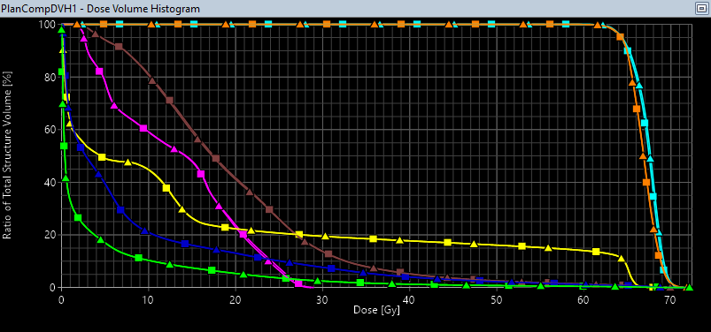
Figure S2. Dose-volume histogram presenting the quality control of the script´s ability to correctly divide a plan into four sub-arcs, paste these randomly on different scans and calculate a sum dose. In this quality control, the sub-arcs were pasted onto three identical copies of the same scan and should therefor result in the same dose as the original plan. Turquoise: PTV-T, Orange: PTV-N, Brown: Heart, Pink: Spinal cord, Yellow: Esophagus, Blue: Lung R+L minus GTV, Green: Body. Squares are the original plan, triangles are the quality control plan.

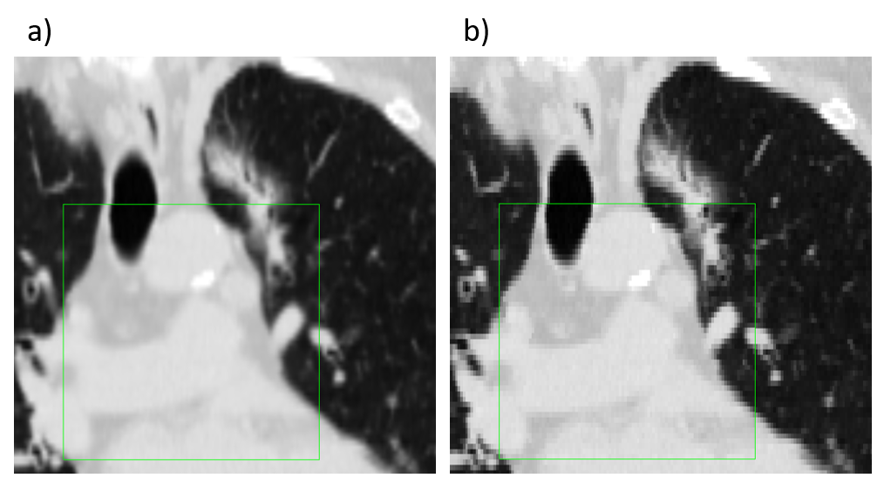
Figure S3. Illustration of the amount of discordance accepted for registration accuracy (< 2mm discordance, i.e. maximum two pixels in anterior-posterior and left-right directions and one pixel in slice (cranio-caudal) direction). Discordance is shown with (a) and without (b) image interpolation. Outside the green window: Plan image (DIBH1) for pt #3. Inside the green window: DIBH2 for pt #3, deformably registered to DIBH1.

Table S3. Dose-volume metrics for patient #1, with the intra-observer deformation uncertainty of the simulated sum dose represented by the median and range over six repeated deformable registrations, using the settings specified in Table 1.
 |  |  | Original Plan |  | Simulated sum dose (Median [range])
PTV-T | V95% [%] |  | 97.0 |  | 72.2 [70.6, 75.6]
PTV-N | V95% [%] |  | 97.1 |  | 90.2 [88.2, 91.6]
Medulla | D0.1cc [Gy] |  | 27.4 |  | 27.4 [27.2, 27.5]
Lungs - GTV | V20Gy [%] |  | 13.8 |  | 12.9 [12.9, 13.0]
 | Mean dose [Gy] |  | 7.8 |  | 7.9 [7.8, 7.9]
Heart | V25Gy [%] |  | 24.8 |  | 24.1 [23.4, 24.7]
Oesophagus | D0.1cc [Gy] |  | 65.9 |  | 65.5 [65.4, 65.6]
Body | D0.1cc [Gy] |  | 70.2 |  | 70.9 [70.6, 71.0]

The script
using System;
using System.Linq;
using System.Text;
using System.Collections.Generic;
using System.Reflection;
using VMS.TPS.Common.Model.API;
using VMS.TPS.Common.Model.Types;
using System.Threading;

// TODO: Replace the following version attributes by creating AssemblyInfo.cs. You can do this in the properties of the Visual Studio project.
[assembly: AssemblyVersion("1.0.0.*")]
[assembly: AssemblyFileVersion("1.0.0.1")]
[assembly: AssemblyInformationalVersion("1.0")]

// TODO: Uncomment the following line if the script requires write access.
[assembly: ESAPIScript(IsWriteable = true)]

namespace Intrafraction_DIBH_robustness_script
{
class Program
{
[STAThread]
static void Main(string[] args)
{
try
{
using (Application app = Application.CreateApplication())
{
Execute(app);
}
}
catch (Exception e)
{
Console.Error.WriteLine(e.ToString());
}
}
static void Execute(Application app)
{
//// 3. Open patient. By Id for now.
Patient pat = app.OpenPatientById("99kah_IntraProton1");

if (pat == null)
{
Console.WriteLine("Could not open patient.");
Console.WriteLine("Execution ended.");
return;
}
//// 4. Open course containing plan to analyze.

Console.WriteLine("Available courses: ");

////create list of course names
var courseList = new List<string>();

foreach (var x in pat.Courses)
{
try
{
courseList.Add(x.Id);

}
catch (ApplicationException exception)
{
//// In case of any error
string errorMsg = string.Format("Exception was thrown. Exception: {0}", exception.Message);
Console.WriteLine(errorMsg);
}
}

////display list of courses, tab separated.
courseList.ForEach(i => Console.WriteLine("{0}\t", i));

//// Choose course
Console.WriteLine("Which course contains the plan you want to analyze? Please enter.");
string inputCourse = Console.ReadLine();
if (!courseList.Contains(inputCourse))
{
Console.WriteLine("Could not open course. Did you enter course name correctly?");
Console.WriteLine("Execution ended.");
return;
}
Course plancourse = pat.Courses.Where(c => c.Id == inputCourse).Single();

//// 5. Open plan.
Console.WriteLine("Available plans: ");

//create list of course names
var planList = new List<string>();

foreach (var y in plancourse.PlanSetups)
{
try
{
planList.Add(y.Id);

}
catch (ApplicationException exception)
{
//// In case of any error
string errorMsg = string.Format("Exception was thrown. Exception: {0}", exception.Message);
Console.WriteLine(errorMsg);
}
}

////display list of plans, tab separated.
planList.ForEach(i => Console.WriteLine("{0}\t", i));

//// Choose plan
Console.WriteLine("Which plan do you want to analyze? Please enter.");
string inputPlan = Console.ReadLine();
if (!planList.Contains(inputPlan))
{
Console.WriteLine("Could not open plan. Did you enter plan name correctly?");
Console.WriteLine("Execution ended.");
return;
}
ExternalPlanSetup originalPlan = plancourse.ExternalPlanSetups.Where(c => c.Id == inputPlan).Single();
int fractions = Convert.ToInt32(originalPlan.NumberOfFractions);

//// Choose structure set to copy the subfields onto
Console.WriteLine("Available structure sets: ");
var structList = new List<string>();

foreach (var z in pat.StructureSets)
{
try
{
structList.Add(z.Id);

}
catch (ApplicationException exception)
{
//// In case of any error
string errorMsg = string.Format("Exception was thrown. Exception: {0}", exception.Message);
Console.WriteLine(errorMsg);
}
}

////display list of structure sets.
structList.ForEach(i => Console.WriteLine("{0}\t", i));
//choose structures
Console.WriteLine("Which structure sets do you want to copy your plan onto? Please enter maximum three, comma separated.");
string inputStruct = Console.ReadLine();
string[] inputStructPart = inputStruct.Split(',').Select(sValue => sValue.TrimStart()).ToArray(); //split line into separate structure set names, delete blanks after comma
var structIndexes = new List<int>();
var structNamingCharacters = new List<char>();
string alphabet = "ABCDEFG";
for (int k = 0; k < inputStructPart.Length; k++) //check if they exist for the patient, and find their indexes in StructList
{
if (!structList.Contains(inputStructPart[k]))
{
Console.WriteLine("Could not find structure set " + inputStructPart[k] + ". Did you enter plan name correctly?");
Console.WriteLine("Execution ended.");
return;
}
else
{
structIndexes.Add(structList.IndexOf(inputStructPart[k]));
structNamingCharacters.Add(alphabet.ElementAt(k));
}
}

List<StructureSet> structsChosen = new List<StructureSet>();
for (int l = 0; l < structIndexes.Count; l++) // need to find right indexes
{
structsChosen.Add(pat.StructureSets.ElementAt(structIndexes.ElementAt(l)));
}

//Test random structure sets (breathholds) for the different sub-arcs

int fieldCount = 0; //to get the number of subfields
for (int j = 0; j < originalPlan.Beams.Count(); j++)
{
if (originalPlan.Beams.ElementAt(j).ArcLength > 0) //excludes setup fields
{
fieldCount = fieldCount + 1;
}
}

Random rand = new Random();
List<int[]> listOfRandomNumbers = new List<int[]>();

for (int i = 0; i < fieldCount; i++)
{
int[] arrayOfRandomNumbers = new int[fractions * 2];

for (int n = 0; n < arrayOfRandomNumbers.Length; n++)
{
arrayOfRandomNumbers[n] = rand.Next(1, structIndexes.Count + 1); //2*fractions random breathholds, since we know we are going to divide each sub
}
listOfRandomNumbers.Add(arrayOfRandomNumbers);
}

List<Array> listOfBreathholdCounts = new List<Array>();
List<double[]> listOfBreathholdFractions = new List<double[]>();
for (int i = 0; i < fieldCount; i++)
{
int[] arrayOfBreathholdCounts = new int[structIndexes.Count * 2];
double[] arrayOfBreathholdFracs = new double[structIndexes.Count * 2];
int[] temp = new int[fractions * 2];
temp = listOfRandomNumbers.ElementAt(i);
for (int j = 1; j < structIndexes.Count + 1; j++)
{
int bhCounter = 0;
int bhCounter2 = 0;
for (int k = 0; k < fractions; k++)
{
if (temp[k] == j)
{ bhCounter++; }
}
for (int k = fractions; k < fractions * 2; k++)
{
if (temp[k] == j)
{ bhCounter2++; }
}
double fractionTemp = (double)bhCounter / fractions; //subfield i1, breathhold j
double fractionTemp2 = (double)bhCounter2 / fractions; //subfield i2, breathhold j
arrayOfBreathholdCounts[(j - 1) * 2] = bhCounter;
arrayOfBreathholdCounts[(j - 1) * 2 + 1] = bhCounter2;
arrayOfBreathholdFracs[(j - 1) * 2] = fractionTemp;
arrayOfBreathholdFracs[(j - 1) * 2 + 1] = fractionTemp2;
}
listOfBreathholdCounts.Add(arrayOfBreathholdCounts);
listOfBreathholdFractions.Add(arrayOfBreathholdFracs);
}

pat.BeginModifications();

//New course
Course newcourse = pat.AddCourse();
newcourse.Id = "DIBH robust1";

//6. Extract information from the plan and the field you wish to divide into subfields
var normalization = originalPlan.PlanNormalizationValue;

double prescribedPercentage = 1.0;
DoseValue fractiondose = originalPlan.DosePerFraction;

//loop over stucture sets
for (int m = 0; m < structsChosen.Count; m++)
{
ExternalPlanSetup planToCopyOnto = newcourse.AddExternalPlanSetup(structsChosen.ElementAt(m));
planToCopyOnto.SetPrescription(fractions, fractiondose, prescribedPercentage);
planToCopyOnto.Id = structNamingCharacters.ElementAt(m) + "_" + originalPlan.Id; //might have to truncate original plan name to not exceed limit

//loop over beams
int subfieldCounter = 1;
int fieldCounter = 1;

for (int j = 0; j < originalPlan.Beams.Count(); j++)
{
Beam F1 = originalPlan.Beams.ElementAt(j);
if (F1.ArcLength > 0) //excludes setup fields
{ //new plan for each subfield:

// Beam F1 = originalPlan.Beams.Where(b => b.Id == "Field 1").Single();
int numberOfControlPoints = F1.ControlPoints.Count;
int breakPoint = numberOfControlPoints / 2;
int breakPointIndex = breakPoint - 1;
//int test = 115 / 2; //seems that the default is to round down to nearest integer

ExternalBeamMachineParameters MachineParameters =
new ExternalBeamMachineParameters(F1.TreatmentUnit.Id, F1.EnergyModeDisplayName, F1.DoseRate, F1.Technique.Id, string.Empty);

//3. Settings from the original beam, to be used in the creation of subfields
var collimatorAngle = F1.ControlPoints.First().CollimatorAngle;
var gantryAngle = F1.ControlPoints.First().GantryAngle;
var gantryAngle2 = F1.ControlPoints.ElementAt(breakPointIndex).GantryAngle;
var gantryStop1 = F1.ControlPoints.ElementAt(breakPointIndex).GantryAngle;
var gantryStop2 = F1.ControlPoints.Last().GantryAngle;
var gantryDirection = F1.GantryDirection;
var couchAngle = F1.ControlPoints.First().PatientSupportAngle;
VVector iso = F1.IsocenterPosition;
var fieldWeight = F1.WeightFactor;
var part1MetersetWeight = F1.ControlPoints.ElementAt(breakPointIndex).MetersetWeight;
var fieldWeight1 = fieldWeight * part1MetersetWeight;
var fieldWeight2 = fieldWeight - fieldWeight1;

//to set the random field weights. Note: working with field weights because “Calculate with present MUs” is not available for VMAT in ESAPI.
double[] weightTemp = new double[structIndexes.Count * 2];
weightTemp = listOfBreathholdFractions.ElementAt(fieldCounter - 1);
double randomWeighting1 = weightTemp[(m * 2)];
double randomWeighting2 = weightTemp[m * 2 + 1]; //works!!! now they just have to be applied to the subplans...
var fieldWeight_random1 = fieldWeight1 * randomWeighting1;
var fieldWeight_random2 = fieldWeight2 * randomWeighting2;

//First set of control points (field 1, part 1). Get metersetWeights.
List<ControlPoint> cplist1 = new List<ControlPoint>();
for (var i = 0; i < breakPoint; i++)
{
cplist1.Add(F1.ControlPoints.ElementAt(i));
}

var metersetWeights1 = cplist1.Select(cp => cp.MetersetWeight);

//Second set of control points (field 1, part 2). Get/set metersetWeights.
List<ControlPoint> cplist2 = new List<ControlPoint>();
for (var i = breakPoint; i < F1.ControlPoints.Count; i++)
{
cplist2.Add(F1.ControlPoints.ElementAt(i));
}
var metersetTemp = cplist2.Select(cp => cp.MetersetWeight);
List<double> metersetWeights2 = new List<double>();
metersetWeights2.Add(0);
double metersetToSubtract = F1.ControlPoints.ElementAt(breakPointIndex).MetersetWeight;
for (var i = 0; i < metersetTemp.Count(); i++)
{
metersetWeights2.Add(metersetTemp.ElementAt(i) - metersetToSubtract);
}

//Add the "sub-arcs" to the plan
var beam = planToCopyOnto.AddVMATBeam(MachineParameters, metersetWeights1, collimatorAngle, gantryAngle, gantryStop1, gantryDirection, couchAngle, iso);
var beam2 = planToCopyOnto.AddVMATBeam(MachineParameters, metersetWeights2, collimatorAngle, gantryAngle2, gantryStop2, gantryDirection, couchAngle, iso);

string id1 = F1.Id + "_A";
beam.Id = id1;
string id2 = F1.Id + "_B";
beam2.Id = id2;

//Field 1, part 1: Leaf positions for each controlpoint.
var editableParams = beam.GetEditableParameters();
for (var i = 0; i < breakPoint; i++)
{
editableParams.ControlPoints.ElementAt(i).LeafPositions = F1.ControlPoints.ElementAt(i).LeafPositions;
editableParams.ControlPoints.ElementAt(i).JawPositions = F1.ControlPoints.ElementAt(i).JawPositions;
//editableParams.ControlPoints.ElementAt(i).GantryAngle = F1.ControlPoints.ElementAt(i).GantryAngle; //Does not work - GantryAngle is read only
}
editableParams.WeightFactor = fieldWeight_random1;
// editableParams.WeightFactor = fieldWeight1;
beam.ApplyParameters(editableParams);

//Field 1, part 2: Leaf positions for each controlpoint.
var editableParams2 = beam2.GetEditableParameters();
int counter = 0;
for (var i = breakPointIndex; i < F1.ControlPoints.Count; i++)
{
editableParams2.ControlPoints.ElementAt(counter).LeafPositions = F1.ControlPoints.ElementAt(i).LeafPositions;
editableParams2.ControlPoints.ElementAt(counter).JawPositions = F1.ControlPoints.ElementAt(i).JawPositions;
counter = counter + 1;
}
editableParams2.WeightFactor = fieldWeight_random2;
// editableParams2.WeightFactor = fieldWeight2;
beam2.ApplyParameters(editableParams2);

//6. Calculate dose.

subfieldCounter = subfieldCounter + 2;
fieldCounter = fieldCounter + 1;
}
} // end of loop over beams

planToCopyOnto.SetCalculationModel(CalculationType.PhotonVolumeDose, originalPlan.GetCalculationModel(CalculationType.PhotonVolumeDose));
planToCopyOnto.CalculateDose();
planToCopyOnto.PlanNormalizationValue = normalization;

} // end of loop over structure sets

app.SaveModifications();
}
}
}

