Supplementary data and figures

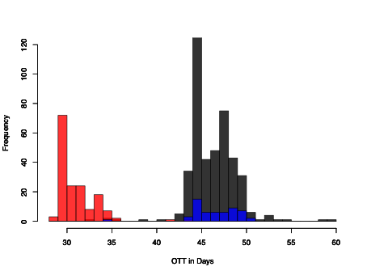

  - Supplementary Fig 1.

Individual overall treatment time in days for the patients treated with 68.0 Gy in 34 fractions (black), 68.0 Gy in 43 fractions (1.1+2.0 Gy, red), and 73.1 Gy in 34 fractions (blue).

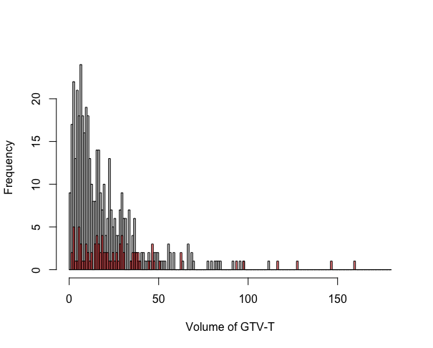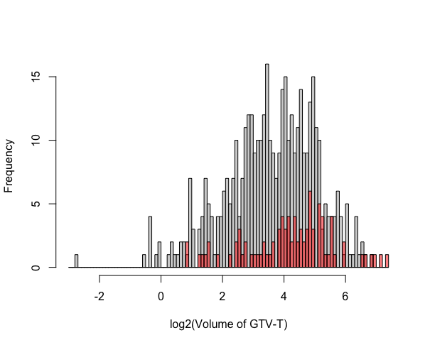

  - Supplementary Fig 2.
Volume of primary tumor volume (GTV-T) for p16-positive patients (grey) and p16-negative patients (red), before log2-transformation (upper panel, unit: cm³) and with log2-transformation (lower panel).

  - Supplementary Fig 3.
Omitting OTT from Eq 2 results in negative $β$-estimates and, hence, a negative α$/β$-ratio.
(for different A-values, the range of the estimates were: α_{min} = 0.12109, α_{max} = 0.24735 and $β$_{min} = -0.02314, $β$_{max} = -0.01183).

The negative $β$-values arise due to the lower biologically effective dose (BED) in the
(1.1 + 2.0) Gy schedule (79.6 Gy compared with 81.6 Gy for the 2.0 Gy schedule, same total dose, 68.0 Gy (α$/β$=10Gy)) if not taking the treatment time into account. Since there was an increased efficacy in the experimental arm for large tumors (Adrian et al. Head Neck 2020), a model (without OTT) will result in negative $β$-values.

  - Supplementary Fig 4.

Illustration of the inclusion of both A and Kick-off time, $T_{kickoff}$, as free parameters in the model:
$TCP=\exp\left(-exp(\ln\left(a_{1}\right)+c\ln{(V}\right)-{(n}_{1}\left(αd_{1}+β{d_{1}}^{2}\right)+n_{2}\left(αd_{2}+β{d_{2}}^{2}\right))+γ(OTT-T_{kickoff})))$

The two parameters are interrelated and no specific minimum of the minimization method was found. Noteworthy, the α$/β$-ratio, time constant and volume exponent remain the same.

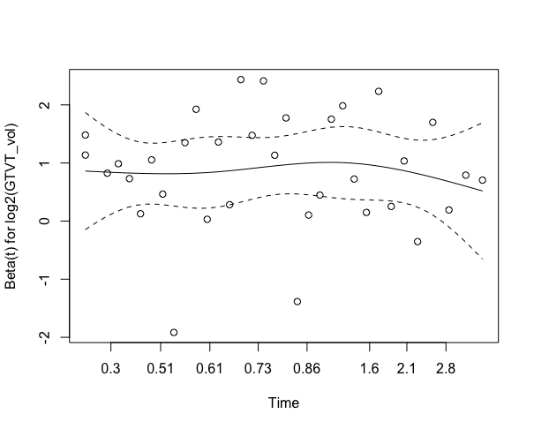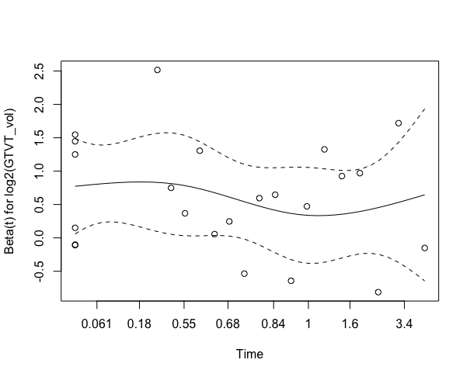

  - Supplementary Fig 5.

Figures illustrating the Schönfeld residuals for p16-positive patients (left panel, non-significant) and p16-negative patients (right panel, non-significant) in the Cox-Regression models.

  - Supplementary Table 1
Patient and treatment characteristics

 | p16-positive |  | p16-negative
No of patients | 433 |  | 90
Year of treatment
range | 1998-2018 |  | 1998-2018
Follow-up Time in years
Local tumor response: median (interquartile range) | 4,2 | (2,4--5.3) | 4,2 | (1,7--5.3)
age (y)
median (interquartile range) | 59 | (53-64) | 61 | (56-67)
sex
male no (%) | 342 | 79,0% | 64 | 71,1%
T
1 | 78 | 18,0% | 12 | 13,3%
2 | 195 | 45,0% | 23 | 25,6%
3 | 76 | 17,6% | 28 | 31,1%
4 | 84 | 19,4% | 27 | 30,0%
N
0 | 40 | 9,2% | 17 | 18,9%
1 | 57 | 13,2% | 14 | 15,6%
2A | 56 | 12,9% | 12 | 13,3%
2B | 198 | 45,7% | 29 | 32,2%
2C | 59 | 13,6% | 18 | 20,0%
3 | 23 | 5,3%
GTV-T (cm^3)
median (interquartile range) | 12,8 | 6,5-25,6 | 20,2 | 10,3-35,2
GTV-N (cm^3)
median (interquartile range) | 12,7 | 5,6-23,2 | 7,8 | 1,5-20,7
Hb
median (interquartile range) | 143 | 135-150 | 142 | 130-149
Perfomance status
WHO 0 or karnofsky 90-100 | 401 | 92,6% | 62 | 68,9%
WHO ≥1 or karnofsky ≤80 | 32 | 7,4% | 28 | 31,1%
Smoker
Non-smoker | 195 | 45,0% | 13 | 14,4%
Previous smoker | 155 | 35,8% | 17 | 18,9%
Daily smoker* | 56 | 12,9% | 47 | 52,2%
Unknown | 27 | 6,2% | 13 | 14,4%
Radiotherapy
68.0 Gy / 34 fx (2.0 Gy/day) | 313 | 72,3% | 59 | 65,6%
68.0 Gy / 43 fx (1.1+2.0 Gy/day) | 73 | 16,9% | 24 | 26,7%
73.1 Gy / 68 Gy (2.15 Gy/day) | 47 | 10,9% | 7 | 7,8%
Concomittant drugs
No drugs | 214 | 49,4% | 60 | 68,2%
cisplatin | 107 | 24,7% | 17 | 19,3%
cetuximab | 112 | 25,9% | 11 | 12,5%
cisplatin + 5FU, induction |  |  | 2 | 2,3%

  - Supplementary Table 2

Univariable Cox-Regression analysis of local failure in p16-positive and p16-negative patients.

p16-positive p16-negative
 | Estimates | 95%CI | P | Estimates | 95%CI | P
GTV-T  (per log2) | 2.51 | 1.85 – 3.41 | <0.001 | 1.88 | 1.33 – 2.64 | <0.001
Age  (per y) | 1.02 | 0.98 – 1.06 | 0.405 | 1.04 | 1.00 – 1.09 | 0.040
Perfomance status  WHO ≥1/Karnofsky ≤80 vs. better [ref] | 2.90 | 1.21 – 6.96 | 0.017 | 2.51 | 1.16 – 5.44 | 0.020
Sex  Female vs male [ref] | 1.21 | 0.57 – 2.57 | 0.621 | 1.12 | 0.48 – 2.57 | 0.797
Smoker  Current/previous vs. no smokers [ref] | 1.88 | 0.93 – 3.81 | 0.079 | 6.00 | 0.81 – 44.72 | 0.080
Chemo  yes vs. no [ref] | 0.80 | 0.41 – 1.55 | 0.504 | 1.57 | 0.71 – 3.48 | 0.269

